**SSL AND TLS**

Ssl and tls allows the traffic between your clients and your oad balancer to be encrypted in transit.

So when you are on a website and you see a loack symbol that means your traffic is encrypte dnad is secure but in case there is no lock then you may be warned that there is no security so do not share your creduta and debit card details on this site.

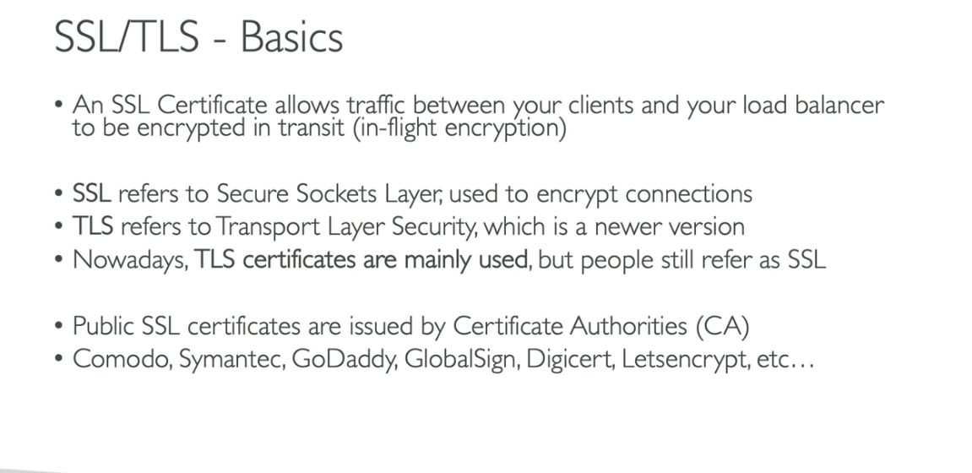

The ssl certificates have an expiry date and must e renewed.

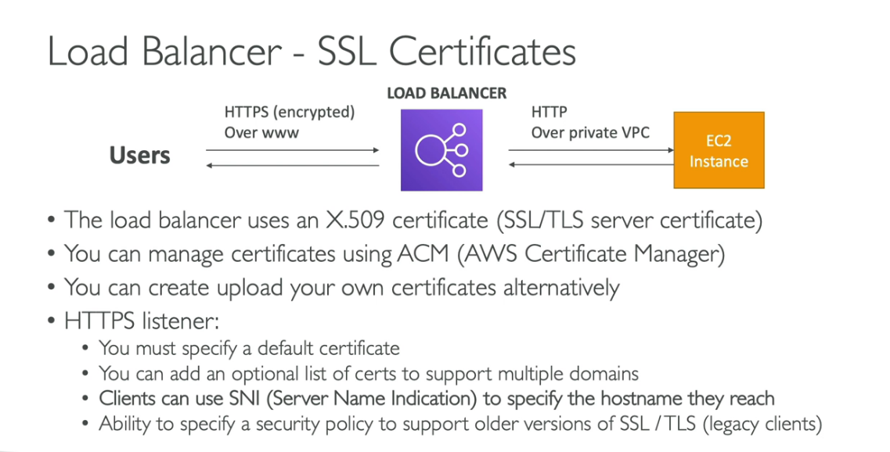

**SSL HANDS ON**

In order to add a ssl certificate to your load balancer weneed to that load balancer and tjen add a listener and there we can specify the certificate we want to import for our requests.