**AUTO SCALING GROUPS**

An auto scaling group is made in case of increasing or decreasing load to our website.

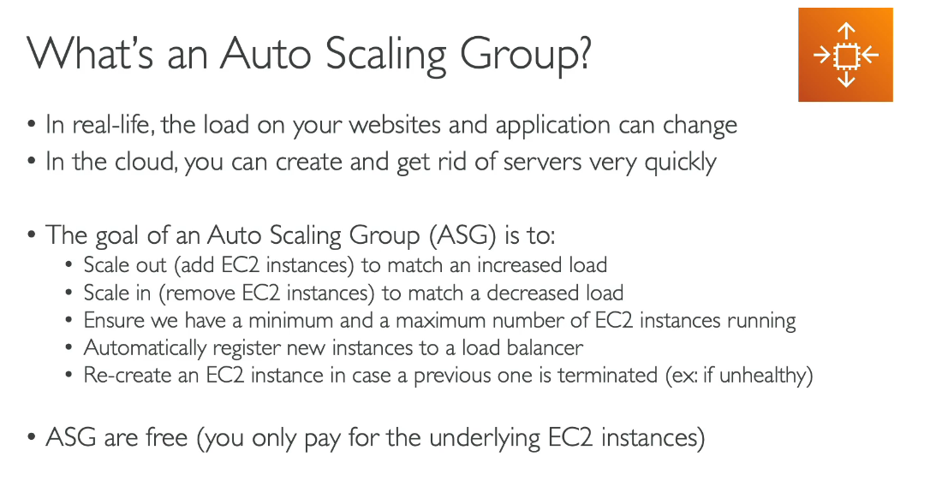

**AWS WITH A LOAD BALANECR**

Suppose behind the elb we have 4 ec2 instances and if some are deemed to be unhealthy then your ASG can increase the no of instaces and then distribute the load across them.

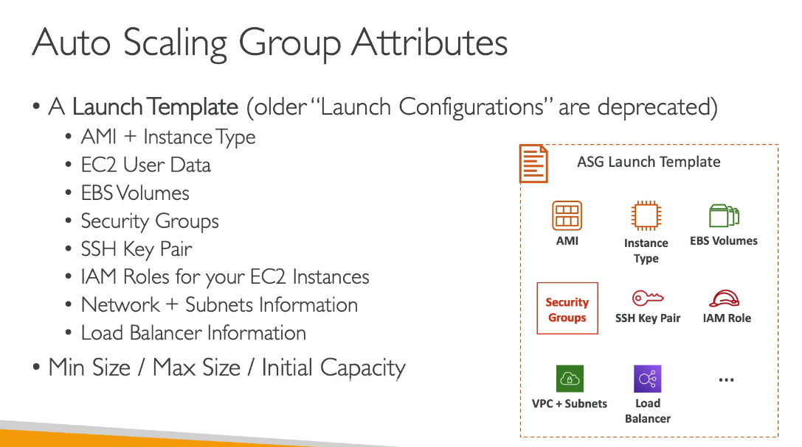

**Setting the cloud watch alaram and the autoscaling**

