**EC2**

EC2 is one of the most popular of AWS' offering. It is definitely used everywhere.it stands for Elastic Compute Cloud and this is the way to do Infrastructure as a Service on AWS.

EC2 is not just one service. It's composed of many things at a high level.

* So you can rent virtual machines on EC2, they're called EC2 instances.
* You can store data on virtual drives or EBS volumes.
* You can distribute load across machines, Elastic Load Balancer.
* You can scale services using an auto-scaling group or ASG,

Knowing how to use EC2 in AWS is fundamental to understand how the cloud works.

EC2 is basically a rented server from AWS

**Operating System** can we choose Three options: Linux, and it's going to be the most popular, Windows or even Mac OS.

You need to choose How much compute power and cores you want on this virtual machine? So how much CPU?

Then you need to choose how much random access memory or RAM you want,

and how much storage space.

We need to handle how storage to be attached or what kind of IP we want for our server and also we need to handle the firewall configurations which are set by the cesurity rules in which the inbound and outbound traffic is controlled.

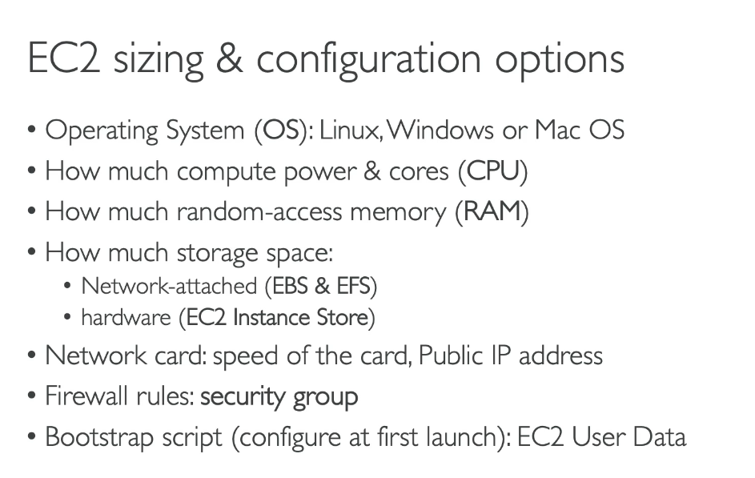

**USER DATA**

This is the bootstrap script that will be used in order to configure our ec2 instance and install the httpd on our server.this script can only be run once when the instance is started.

So what does bootstrapping mean?

Well, bootstrapping means launching commands when the machine starts. So, that script is only run once and when it first starts, and then will never be run again. So the EC2 User Data has a very specific purpose. It is to automate boot tasks, hence the name bootstrapping.

What can be bootstarp: when you boot your instance while you want to install updates, install software, download common files from the Internet.the more you add into your User Data script,

the more your instant has to do at boot time.the EC2 User Data scripts runs with a root user.

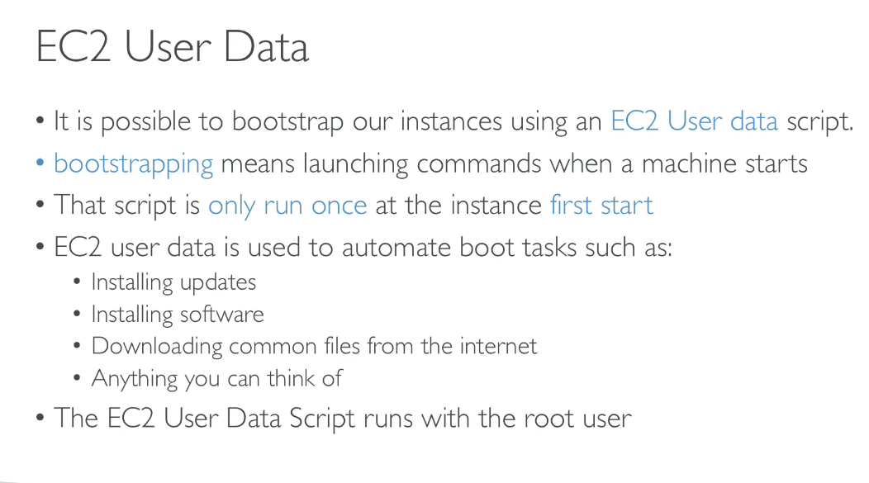

**Pasting the user data while launching an ec2 instance**

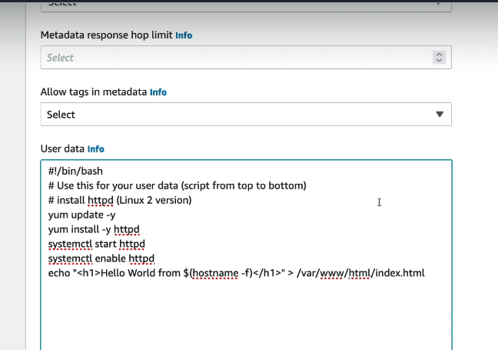

**This** script is going to be executed when the instance is first started and it is only run onlce only when a n instance is launched so everything that u want to be installed into your system can be put into this user data script.

**NEW PUBLIC IP EVERYTIME**

Every time we start and then terminate an instance then a new public ip will be assigned to our instance .

**EC2 INSTANCE TYPES**

We can categorize the ec2 instance types Into the following categories.as shown below.there are 7 categories in which the ec2 instance scan be distributed.

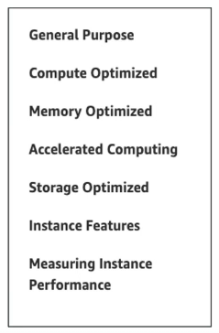

So there are different types of EC2 instances that you can use for different use cases and they have different types of optimization.We have general purpose, compute, optimized,

memory optimize and so on.

AWS will have the following naming convention.

M5.2xlarge

M is going to be called the Instance Class.a general purpose type of instance, five is generation of the instance. So as AWS improves the hardware over time if we release a new generation of hardware, and so after M five, if they improve the M type of instance class then we'll go to M six

the two X large represented the size within the instance class.It starts as small and then large and then two X large four X large and so on. it represents the size of the instance,and the more the size, the more the memory the more the CPU is going to have on your instance.

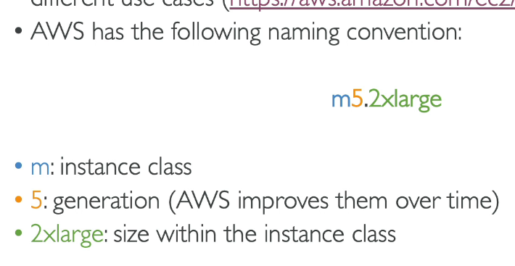

exam perspective, what do you need to know?

**CREATING AN EC2 INSTANCE**

While creating an instance you need to choose a key pair login.This will be used in case to login using an ssh.

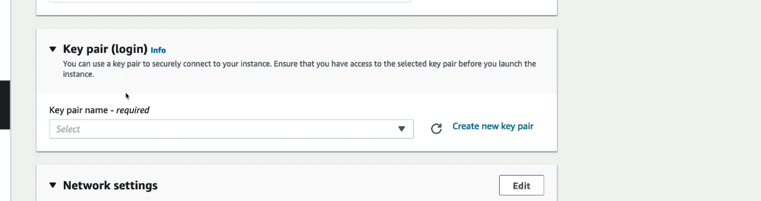

**Types of INstances**

1.**general purpose**: these are great for diversity of workloads such as web servers or code repositories.They will have a good balance between compute, memory, networking

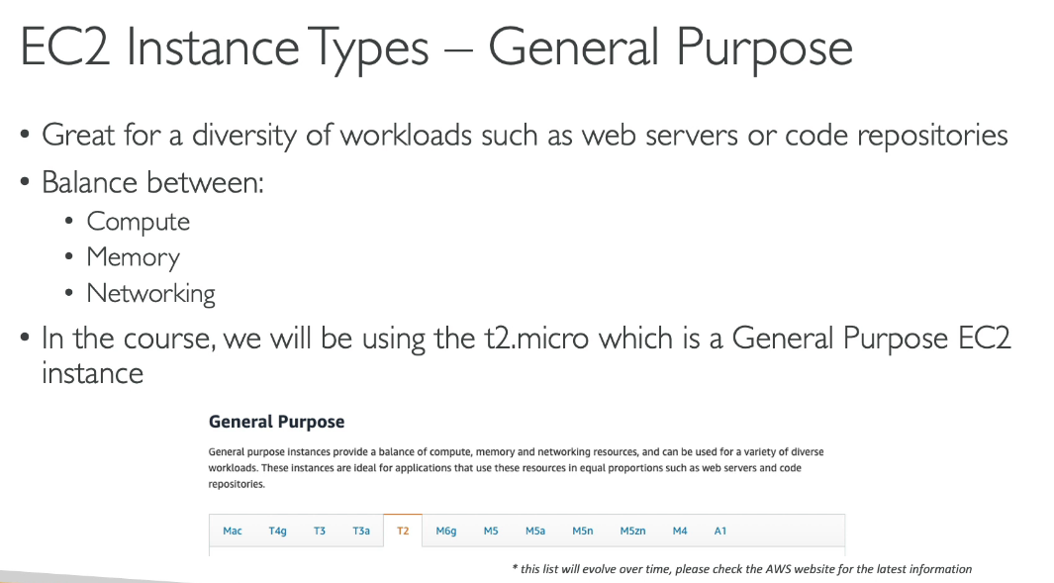

2.**compute optimized**:these are instances are great,and optimized for compute intensive tasks.

We use them where a high level of processor is needed. So all these things are tasks that require a very good CPU very good compute side.

for example, it could be

* if you're batch processing some data
* if you're media transcoding
* if you need a high-performance web servers
* if you're doing high performance, computing is called HPC.
* If you're doing machine learning
* if you have a dedicated gaming server.

**Naming:**in EC2, are of the C names.So C5, C6, and so on.

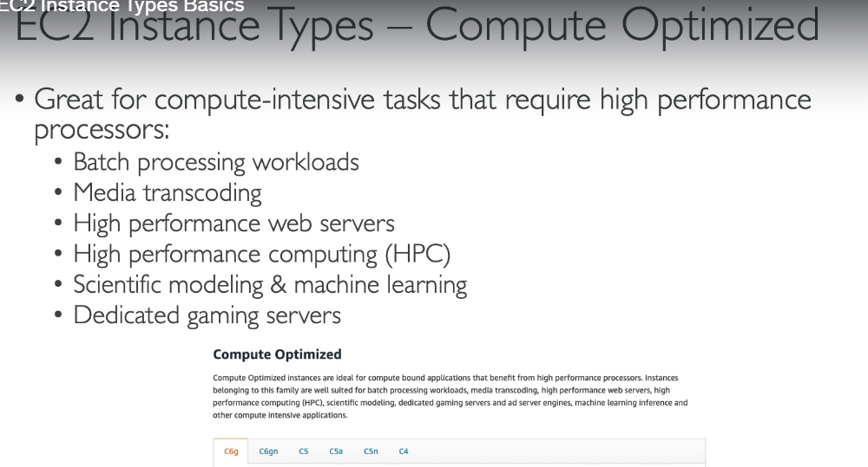

3.**memory optimized:They**  are going to behave a really fast performance for the typeof workloads that will process large datasets in memory.So memory means RAM.And so the use cases are:

* this is going to be high performance for relational ornon-relational databases
* are mostly going to be in memory databases,
* distributed web-scale cache store.
* in memory databases that are optimized for business intelligence or BI.
* And applications performing real-time processing of big unstructured data.

**Naming:**So in terms of the names for the memory optimized instances there's going to be the R series because R stands for RAM but there's also going to be X one high memory and Z one,

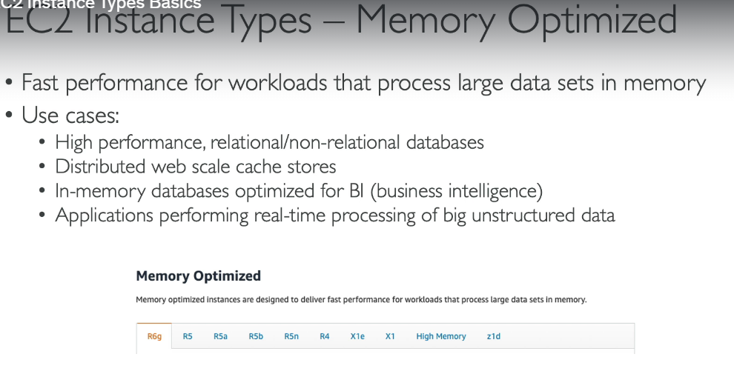

4.**storage optimized instances:**They're great when you are accessing a lot of data sets on the local storage.And so the use cases for storage optimized instancesare going to be:

* high-frequency online transactional processing, so OLTP systems.
* Relational and NoSQL databases.
* Cache for in-memory databases, for example, Reddit's data warehousing application distributed file systems
* 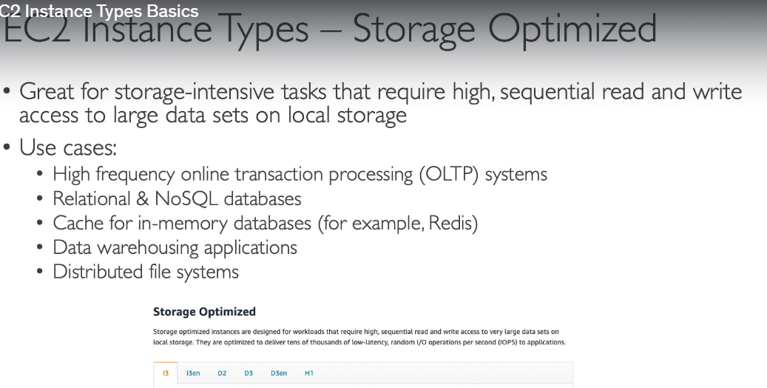

**5. search optimized instances in AWS:** will start with an I, a G, or H one.