**SSH**

We need to know how do you connect inside of your servers to perform some maintenance or action. So for this, for Linux servers, we can use SSH to do a secure shell into our servers.So based on the operating system you have on your computer,you have different ways of achieving it.

**1.SSH** is a command line interface utility that can be used on Mac or Linux as well as Windows over version 10.Then if you have Windows less than version 10, you can use something called putty.

**2.Putty** will exceed the exact same thing as SSH.

**3.EC2 Instance Connect,** which is going to use your web browser.it is validfor Mac, Linux, Windows, all versions.The cool thing about EC2 Instance Connect is that it works,but it only works for now with Amazon NX2

**HOW TO SSH USING WINDOWS**

SSH to me is one of the most important function, especially when you deal with Amazon cloud.It will basically allow you to control a machine remotely all using the command line.

1. Basically we have our EC2 machine, and it's running Amazon Linux 2, and it has a public IP. And we had an SSH security group on it.And we allowed SSH on port 22 to any IP, which basically allows our Windows machine to connect over the internet directly into the machine and control it using the command line.
2. we'll use PuTTY to do SSH.this is a free tool available online.So for this, you would go and download PuTTY. PuTTY is a free SSH client for Windows.
3. we have two things here on PuTTY.We have the PuTTY app, as well as PuTTYgen.
4. So let's first open PuTTYgen.And in case you did not download your filein the PPK format, you can actually generate the PPK format mdirectly from here.
5. So let me show you how it's done.
6. So, I need to go ahead and load my file.So I click on load, and then find where my file is.Select the PEM file.It says, okay, you have successfully imported this.

1. And then you can save it as a private key.So EC2tutorial.PPK
2. Now your file is saved and you have converted successfully a PEM file into the PPK format.
3. Next, we need to set up PuTTY to access our EC2 Instance.So, this time you open the PuTTY app, and here we have to enter a host name or an IP address of where we are trying to connect. You copy the public IPv4 address. You paste it.
4. Graphical user interface

   Description automatically generated
5. We need to specify the key itself.So let's specify the key in here.So, you have it saved under EC2 Instance.I double clicked.So as you can see, I have to accept this.So if we accept because we trust the host,we say, yes, accept.
6. And then for the key, we need to go into the SSH.You click the plus, you have the Auth,you click the plus. So you just click on Auth, and then you need to find a private key file for authentication. And then you find the EC2 tutorial, that PPK file,you have just generated using Puttygen.

**EC2 INSTANCE CONNECT**

WE have ec2 instance connect through which we can connect to our instance and do whatever we want to do .

But now suppose the below scenario:

Where in the ec2 instance connect cli when you wantv to list the users then it asks you for the access key but you should never never do thus because then your security will be at risk as anyone in your account can login into this instance and retrieve the value of your access key.

**Solution:**

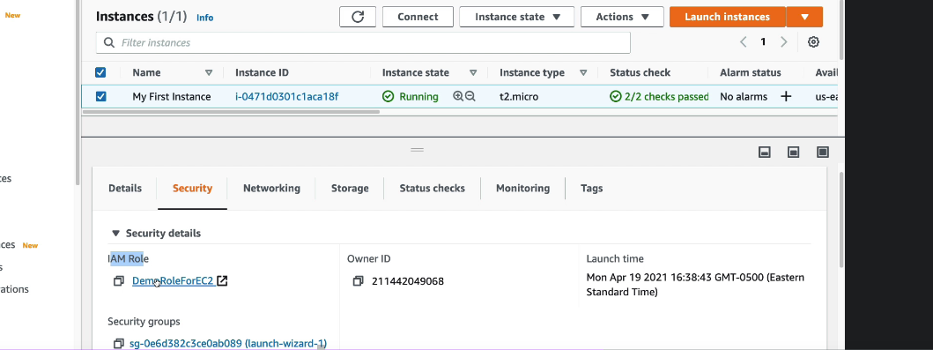

**Attach an iam role to your instance that will let you listv the users.**