**EBS(ELASTIC BLOCK STORE)**

An ebs volume is a network drive which is attached with our instance.These are like separate storage devices that will store data even if the ec2 instance is terminated.They can be mounted to only one instance at a time at the ccp level

One ebs is bound to one availability zone.Suppose you have an ebs volume in us-east1a so you cannot have it for us-east 1b.

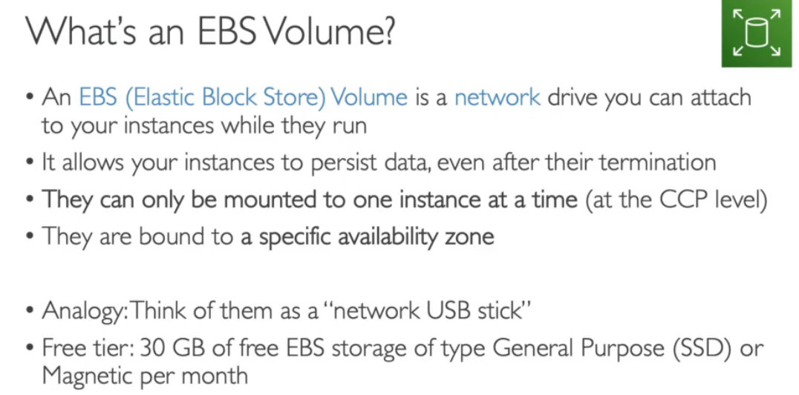

Ebs is a network drive so in communicating from one computer to another there may be a bit of latency.it can be detached from one instance an dattched to another instance tus help with the failover.

Note:an ebs volume can be available in one availability zone only and if you want to move to other then you need to create a snapshot of it.

You will have to reserve the capacity you need in advance so that you get billed for onlyb the provisioned capacity.You can easily increase capacity of ebs anytime you want to.

**DELETE ON TERMINATION**

There is a root volume attached to our ec2 instance and one ebs that we can attach from outside.so there is an option that when an instance is terminated do we need to delete the ebs volume or not.

By default the root volume will be deleted but you can change it in case if you want that your dtata needs to be saved and it can become an exam scenario for you.

**EBS VOLUMES ARE BOUND BY A SPECIFIC AZ**

Suppose we have an ec2 in eu-east 1a.

1.we create an ebs volume in eu-east-1a.then when we go to attach it to an instance then we will be able to atch it to the above ec2 because that ec2 is in the same az as the ebs.

2.Suppose we create an ebs volume in eu-east-1b then we go to attch it to above ec2 we will not be able to do so since an ebs volume can only be attached to the ec2 which is made in its az.

Thus ebs volumes are bound by an az.

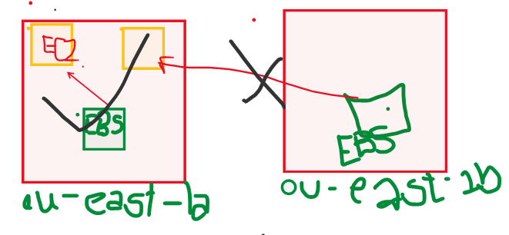

**EBS SNAPSHOTS**



We can do snapshot of our ebs volume at any point of time and the move these snapshots across the az or even across region.

