**AMI**

AMI stands for amazon machine image.

Thay are the customization of an ec2 instance where we can add our own software ,operating system.

AMI are region specific and can be copied across regions

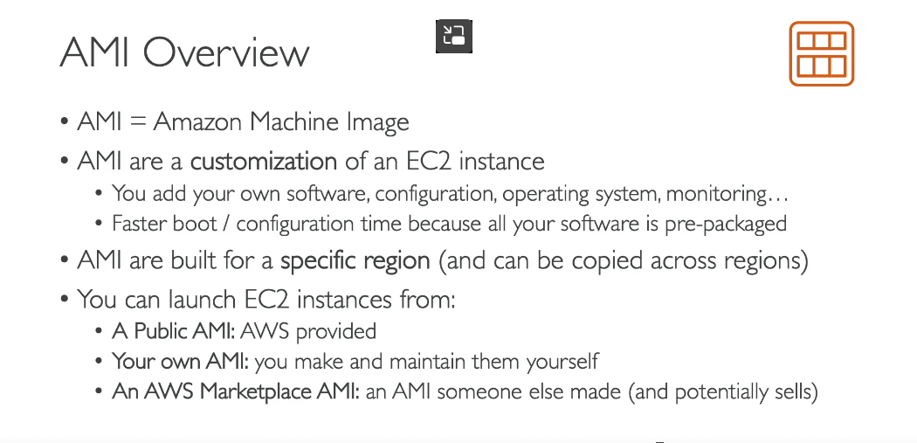

**HOW DO WE CREATE AN AMI**

