**MONTORING IN AWS**

In aws we know how to deplyt he application sbut in case there is some fault then we need to be notified so that it can be resolved at the earliest.

Our users need to have the below options:

1.application latency:we do not need the application latency to increase.

2.Application outages:We do not want ourcustomer experience to degrade so we do not want that there must be many outages in our application

3.Users must not often contact our aws support rather it should be some monitoring going on so that we come to know of any fault and our user does not have to report the issues to us.

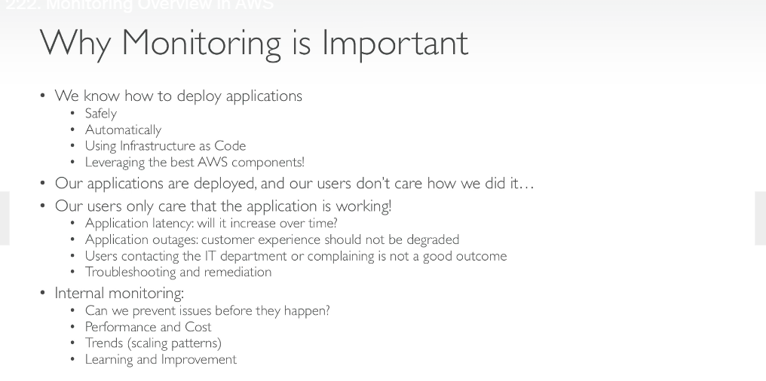

**MONITORING IN AWS**

**CLOUDWATCH METRICS**

Cloudwatch provides metrics for every service in aws.

A metric is ariable to monitor the cpu utilization or the networking.Metrics belong to namespaces and there are dimaensions of metrics which is used to measure the metric.

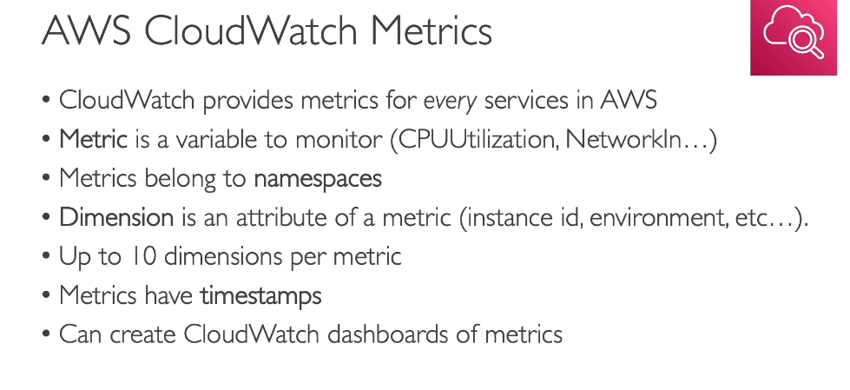

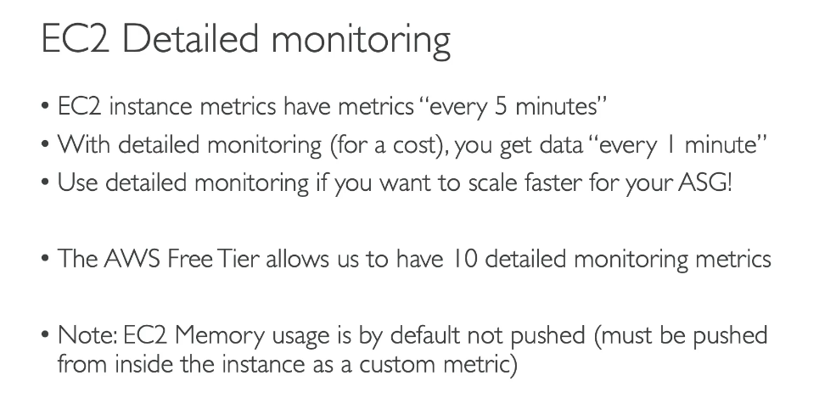

AWS **CLOUDWATCH CUSTOM METRICS**

There is a possibility for us to send a custom metrics to the cloudwatch.

We need to use an api call of PutMetricDAta

in order to push accustom metric we need to go to the put metric data documentation

**CLOUDWATCH LOGS**

In aws if you want to store your logs then you can use the cloudwatch logs.

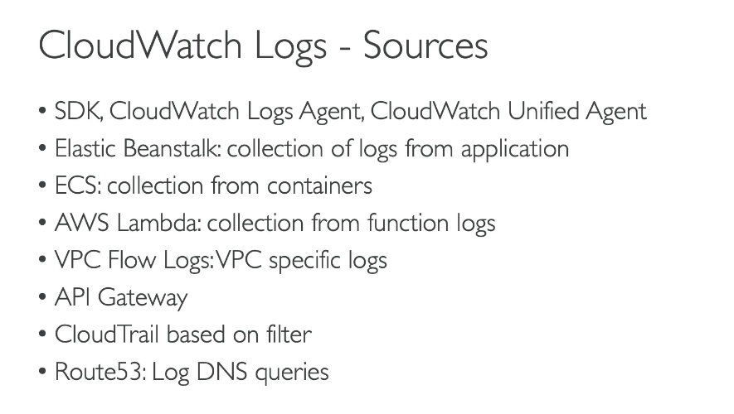

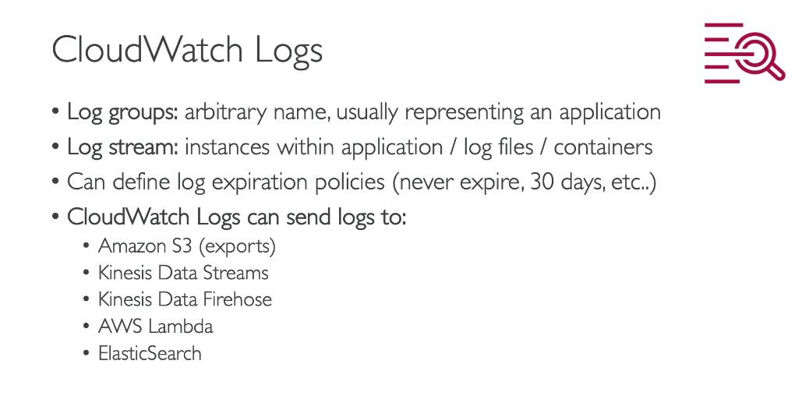

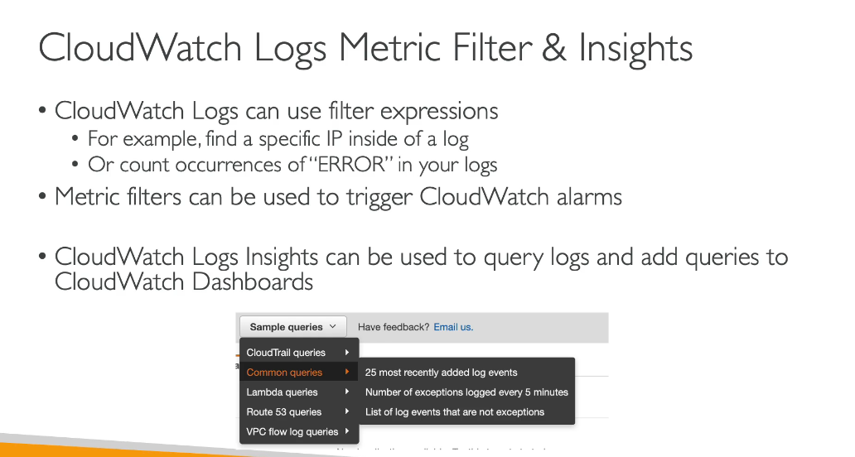

**CLOUDWATCH LOGS AGGREGATION**

**CLOUDWATCH LOGS FOR AN EC2 INSTANCE**

By default no logs from ec2 instance will go to cloudwatch.We need to run a cloudwatch agent on ec2 to push the log files we want.We need to make sure that iam permissions on ec2 are correct so that it can connect to the cloudwatch.The cloudwatch log agent can be setup on premises too.

**CLOUDWATCH LOGS AGENT AND UNIFIED AGENT**

**CLOUDWATCH METRICS**

**CLOUDWATCH LOG METRIC FILTER**

A cloudwatch metric filter can use filter expression .

This can be used to find a specific IP inside of a log.

Or count occurrences of “ERROR” in your logs.

Etric filters can be used to trigger alarms.

Suppose in some case the number of a word occurrence has exceeded so we will trigger a cloudwatch alarm.

