**AMAZON S3**

Amazon S3 is one of the main building blocks of AWS.Its is widely used because of its “infinte scaling” storage.

Many websites use S3 as a backbone.Many Aws services also use Amazon s3 as a n integration as well.

**Amazon s3 use cases**

Amazon s3 had a wide range of applications as can be seen below:

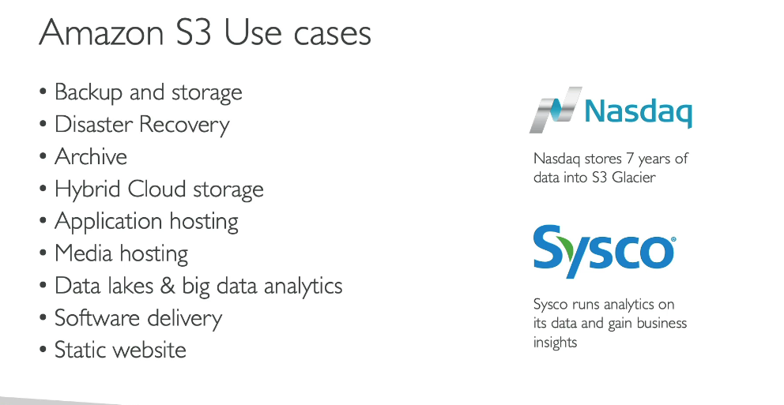

Nasdaq uses amazon s3 to store 7 years of data into s3 glacier which is a kind of archive.

Sysco runs analytics on its data and gin business insights on amazon s3.

**AMAZON S3 BUCKETS**

S3 allows people to store data in buckets which act as top level directory.The files stored in bucket are called as objects.

Buckets must have a unique name across all regions.

Buckets are defined at region level.

Though s3 looks like a global service but buckets are created in a region.

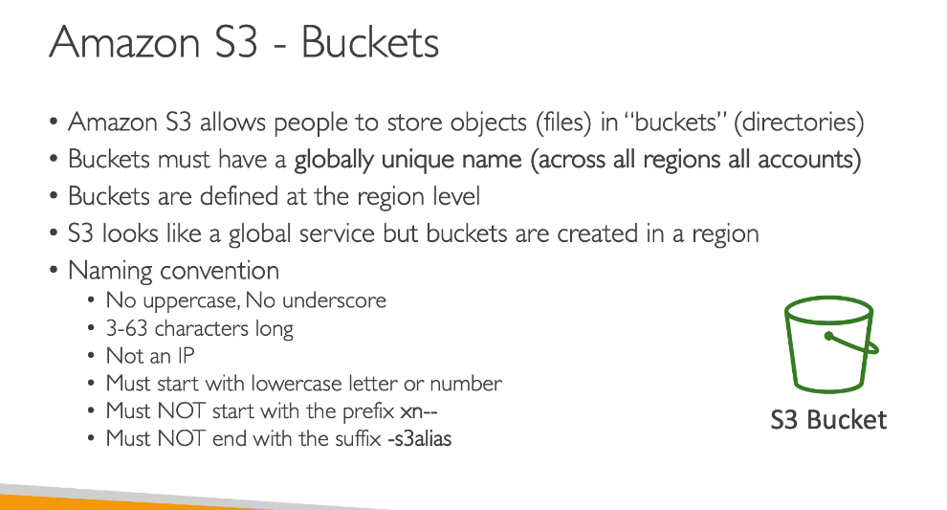

**OBJECTS**

The files stored in a bucket are known as objects.

These objects have keys.A key is the full path of the object.

There is no concept of directory in a bucket t here are only object and their key.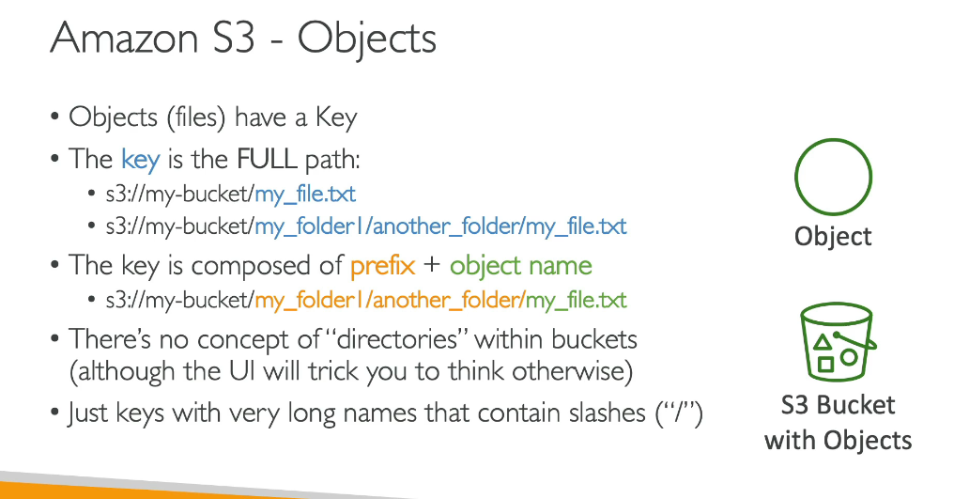

Object key is the file path and the value is the content of the body .

The size max of an object can be 5TB (5000GB)

If we are uploading more than 5GB then we must use multi part upload.

Other features an object can have:

1.Metadata:list of text

2.tags:useful for security/lifecycle

3.version id:if we have enable versioning on the object

**CREATINGA BUCKET**

**For creating an s3 bucket first we will go to this service in the console.**

Now we will create abucket and give it a name if a bucket with this name is already existing then it will give us an error.so use some unique name for your bucket which no one would have used anytime.

There needs to be a region is to be chosen so that it can be accessed.We know that s3 is aglobal service but bucket is not global it lives in a particular region so that it can be accessed at the earliest.

**UPLOADING DATA INSIDE A BUCKET**

**After upload is successful**

We can see the file we had uploaded is preset there in our bucket

We can get object url.we can reach out to our bucket by simply clicking on open it button.

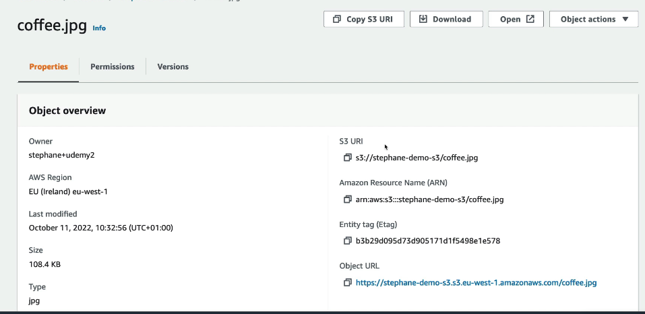

Secondly there is an object url.if we use it access our bucket we will get access denied so what do we do in that case.

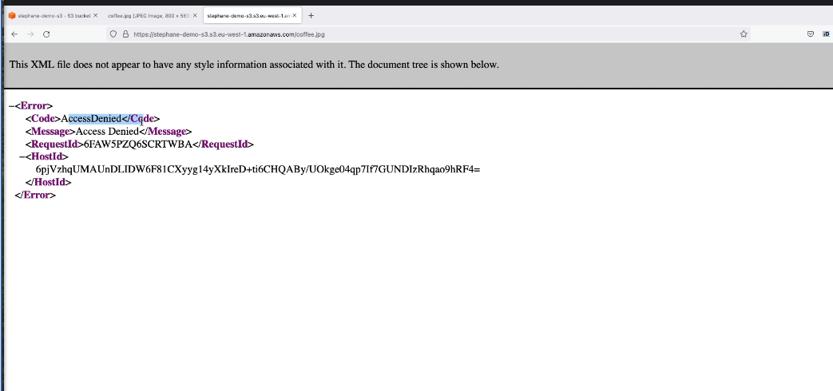

We cannot access using a public url

.why is it so?

When we use open it to ppen the image in bucket then we are bale to do so since there is a long url that we have and in that url our credentials are embedded and encoded so it is know that it is stepahne the user who is allowed to access his resources but no one else isn’t allowed to.

**Folders**

We can create folders inside o 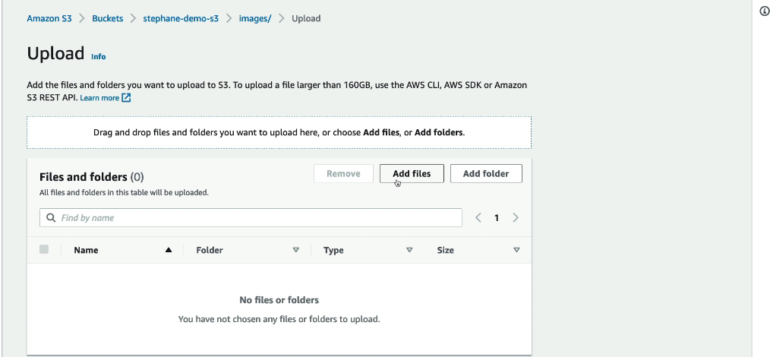

ur bucket and then inside that folder we can upload our content.