**SERVERLESS**

Serverless does not mean that we do not have servers but it means that we do have servers but the developers do not have to manage the servers anymore

They just need to deploy the code or we can say that they need to only deploy the functions.

The functions thus it was known as function as a service initially .

Serverless was pioneerd by AWS Lambda but now also includes anything that is managed which may be databases or messaging,storage.

Serverless does not mean that we do not have servers but it only means that we don’t manage or provision or see the servers on our end.

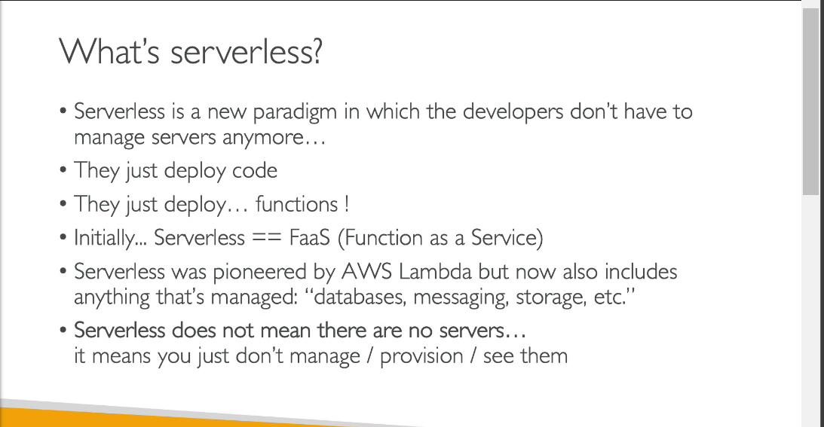

**AWS LAMBDA OVERVIEW**

Earlier we have the amazon ec2 which is a virtual server in the cloud with a limited ram and cpu.It has to be continuously running and can be scaled using the auto scaling groups and you can delete the servers as and when needed .

This architecture was running great.

But there comes aws lambda.

Aws lambda are just virtual functions means there are no servers to manage.

They take a very short limited time to execute and are run on demand they do need to be running all the time.

The scaling in lambda is automated and it automatically scales when it is required to be scaled.

AWS **LAMBDA BENEFITS**

**1.Easy pricing:**Lambda is a low cost function in which we pay only for the number of requests that our lambda receives an dalso the compute time lambda takes.

2.Integration:Lambda has integration with the whole suit of aws services.and is integrated with many programming languages.

3.Monitoring:Easy monitoring through AWS cloudwatch

4.Easy to get more resources per functions(upto 10gb of ram)

5.Increasing ram will also improve cpu and network

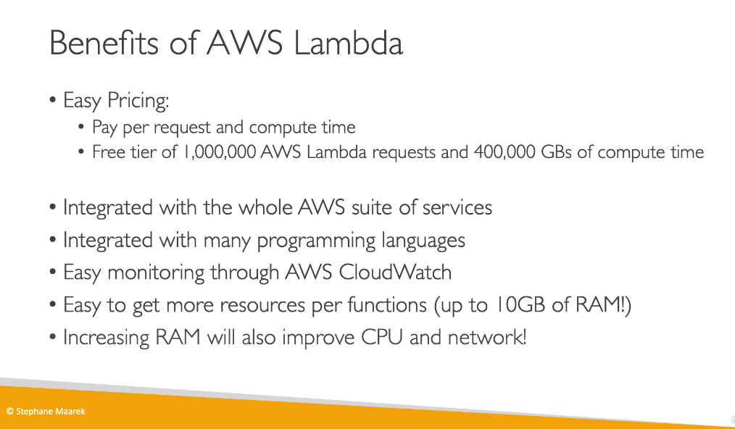

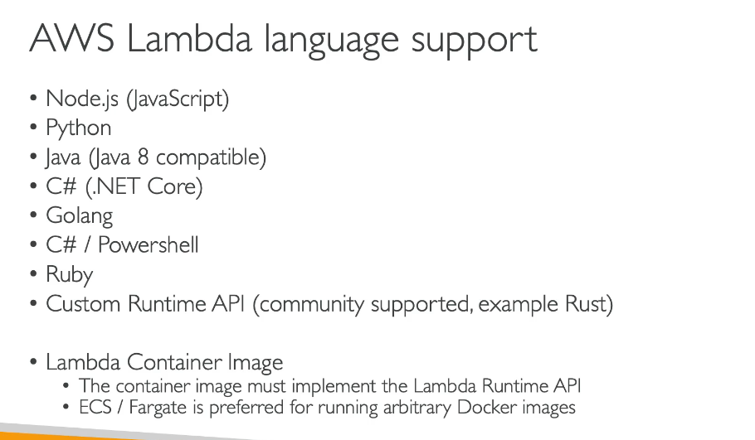

**LET US SEE HOW LAMBDA IS INTEGRATED WITH THE MAIN AWS SERVICES**

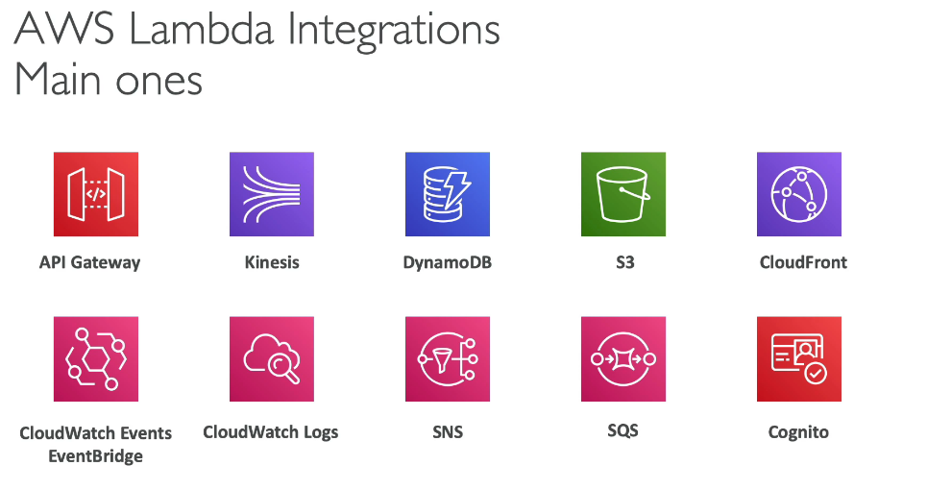

**LAMBDA SERVERLESS THUMBNAIL CREATION EXAMPLE**

Suppose there is a new image which needs to be uploaded to an s3 bucket and when it is uploaded it is required that a lambda function should be invoked which will convert image to a thimbnail and then those thumbnails be stored in an s3 bucket.or there may also be a functionality to add the thumbnail to the dynamodb.

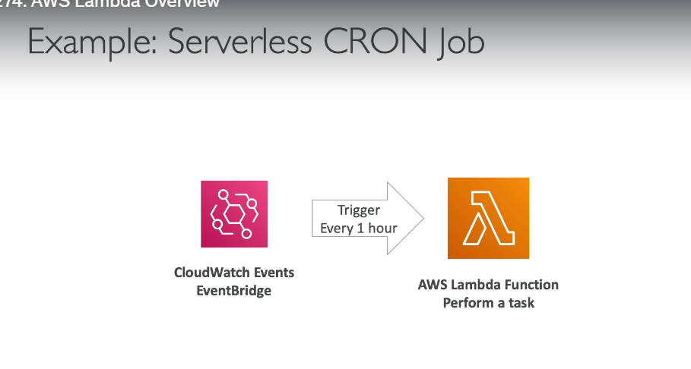

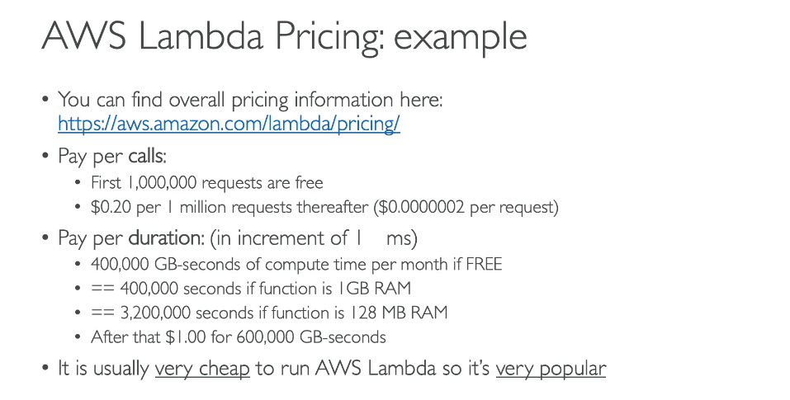

**AWS LAMBDA WORKS BY INVOCATION FORM VARIOUSSERVICES AS CAN BE SEEN IN IMAGE BELOWE**

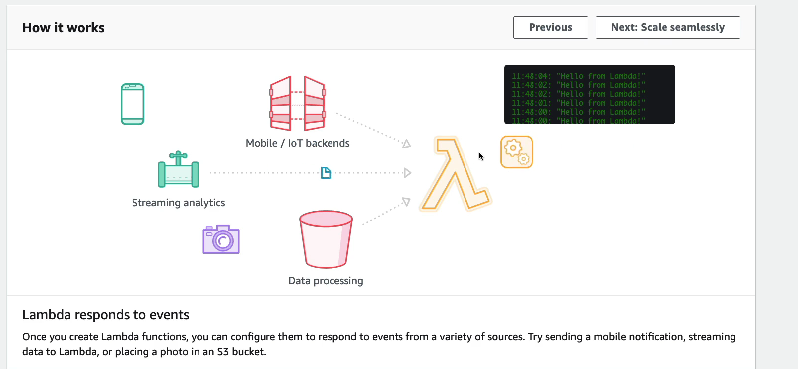

**SYNCHRONOUS INVOCATIONS**

We are doing a synchronous invocation when we are using a cli,sdk,api gateway,application load balaner.

By synchronous we mean that we ra ewaiting for the result and then the result will be returned back to you.Any errors that comes to you must be handled at the client side.

So that means if we invoked a lambda function from the console and it returned back an error then we need to press the retry button and retry to invoke it.

Any time there is an error on lambda the client has to figure out what to do.,do you want to do a retyr or you need to do the exponenetial backoff.

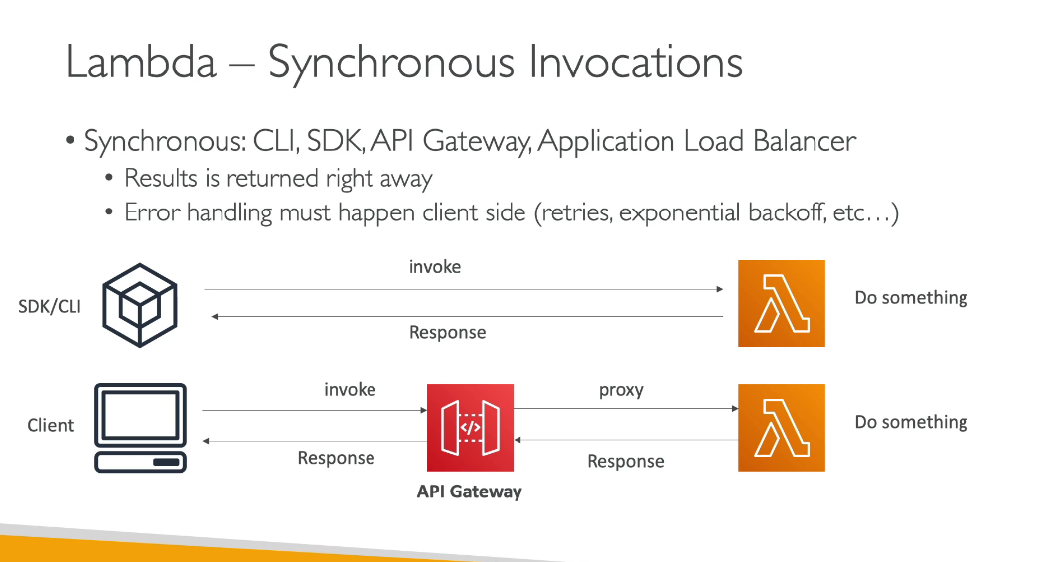

So in the above we are waiting for a return/response so it is known as a synchronous invocation.

**SOME OF THE SYNCHRONOUS INVOCATIONS OF MY LAMBDA SERVICES**

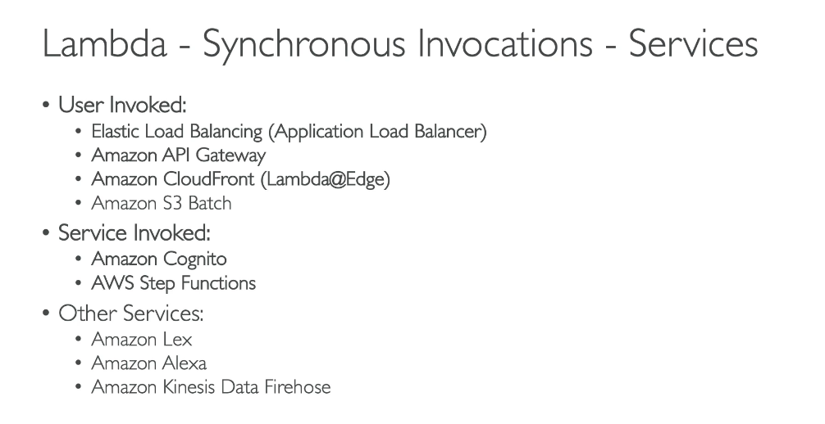

**LETS HAVE A LOOK AT THE SYNCHRONOUS INVOCATIONS**

**LAMNDA AND ALB**

We have been allowing to invoke our lambda function using a cli but there is a way for us to allow our lambda function to be invoked from outside using an http endpoint.

So we will expose it to the external world using an alb.

**HOW DOES AN ALB INVOKE A LAMBDA USING AN HTTP REQUEST**

the http request is converted into the corresponding json document.

Now this request goes to our lambda and in response to it our lambda will return a json document which will be converted by the alb into a http request.

**ALB MULTI HEADER VALUES**

Another important feature is to allow our alb to support multi header values.

So exam may ask u how the multi header values are supported then we can say that there is just a setting on the alb which helps to form an array of the multi header values.

**ASYNCHRONOUS INVOCATION**

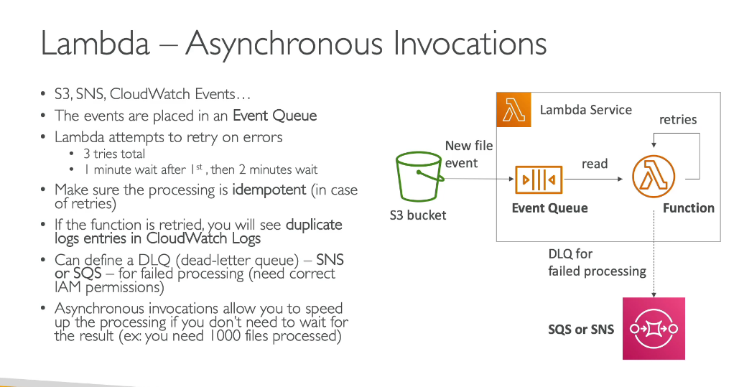

Some events need not to wait for the result to come so we use the asynchronous invocations at that time.

So suppose there is an s3 bucket sending the notifications to the event queue present into our lambda service.the lambda function will read the event from this queue and if there is an event which cant be read it will try to reprocess it 3 times and if still this sis same it will send it back to the dead letter queue.

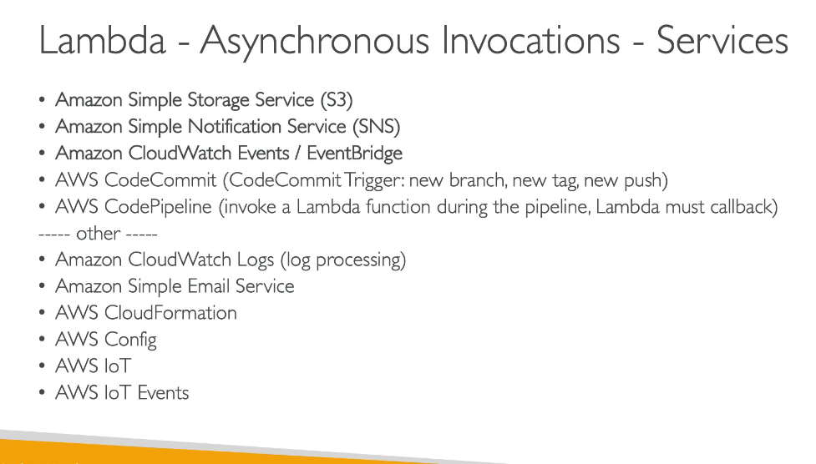

**HANDS ON ASYNCHRONOUS EVENT**

**LAMBDA AND**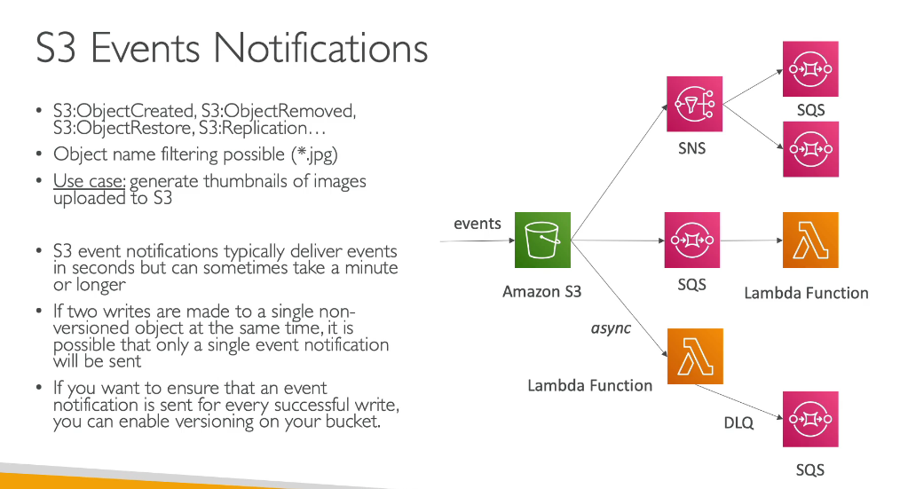

**S3**

**A SIMPLE USE CASE**

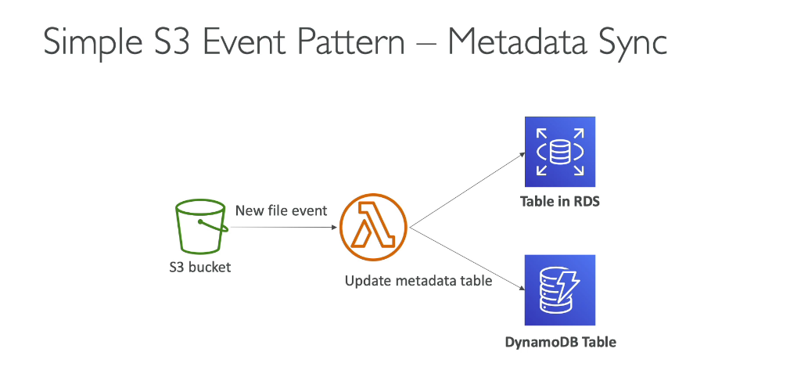

We may send the s3 event notification to a lambda function which in turn will either store data in the dynamo or send to rds.

**HOW DO WE DO THE HANDS ON FOR THIS**

First we create an s3 bucket.

And we add event notification in it in which we specify where the event should go to so in our case it is a lambda.so on putting an object into the s3 bucket an event will be sent to lambda function.

**LAMBDA**