Project Name-**Employee management system**

**Target audience** – HR department

**Base url** – http://localhost:8080/api/v1/employee-management

**Status code used**-

* 200(OK)-It indicates that the REST API successfully carried out whatever action the client requested, and that no more specific code in the 2xx series is appropriate.

#### 401 (Unauthorized) - A 401 error response indicates that the client tried to operate on a protected resource without providing the proper authorization. It may have provided the wrong credentials or none at all. The response must include a WWW-Authenticate header field containing a challenge applicable to the requested resource.

* 403 (Forbidden)-A 403 error response indicates that the client’s request is formed correctly, but the REST API refuses to honor it i.e. the user does not have the necessary permissions for the resource.

**Basic Requiremen**t:

Employee

Employee – Create a new employee

POST

/employee

Permission: none

**Parameter**

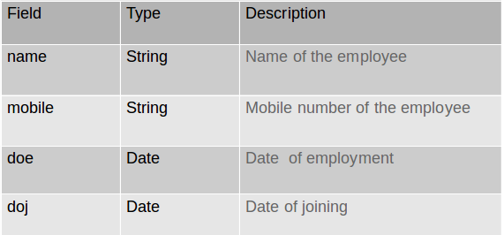

**Success 200**

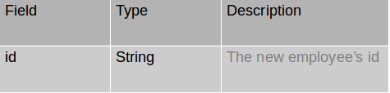

**Error 4xx**

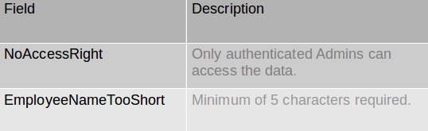

**Response(example)**

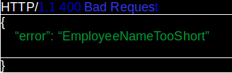

Employee – Update an employee record

PUT

/employee/{id}

Permission: none

Parameter

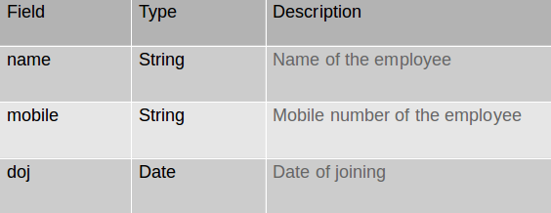

**Error 4xx**

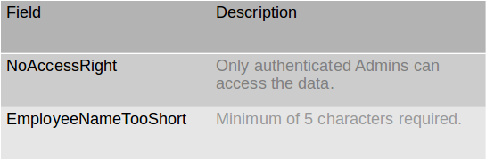

**Project**

Project – Create a new project

POST

/project

Permission: none

**Parameter**

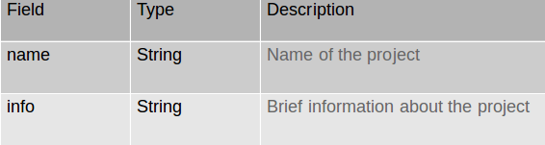

**Success 200**

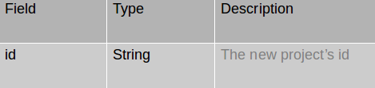

**Error 4xx**

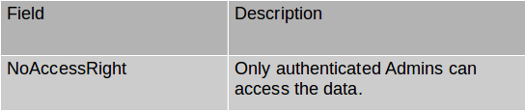

**Project– Update a project**





Permission: none

**Parameter**

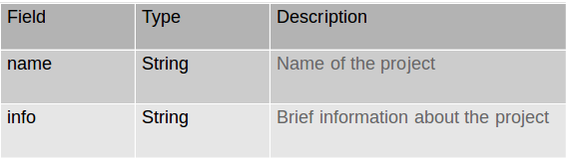

**Error 4xx**

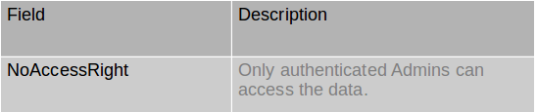

Employee-Project assignment for employee





Permission: none

**Parameter**

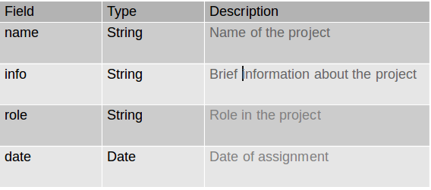

**Success 200**

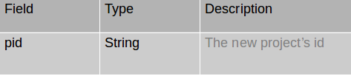

**Error 4xx**

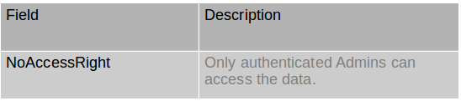

Employee-Project updation for employee





Permission: none

**Parameter**

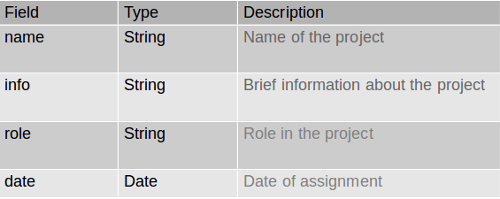

**Error 4xx**

