LINUX
Ques 5. less/more/cat/string

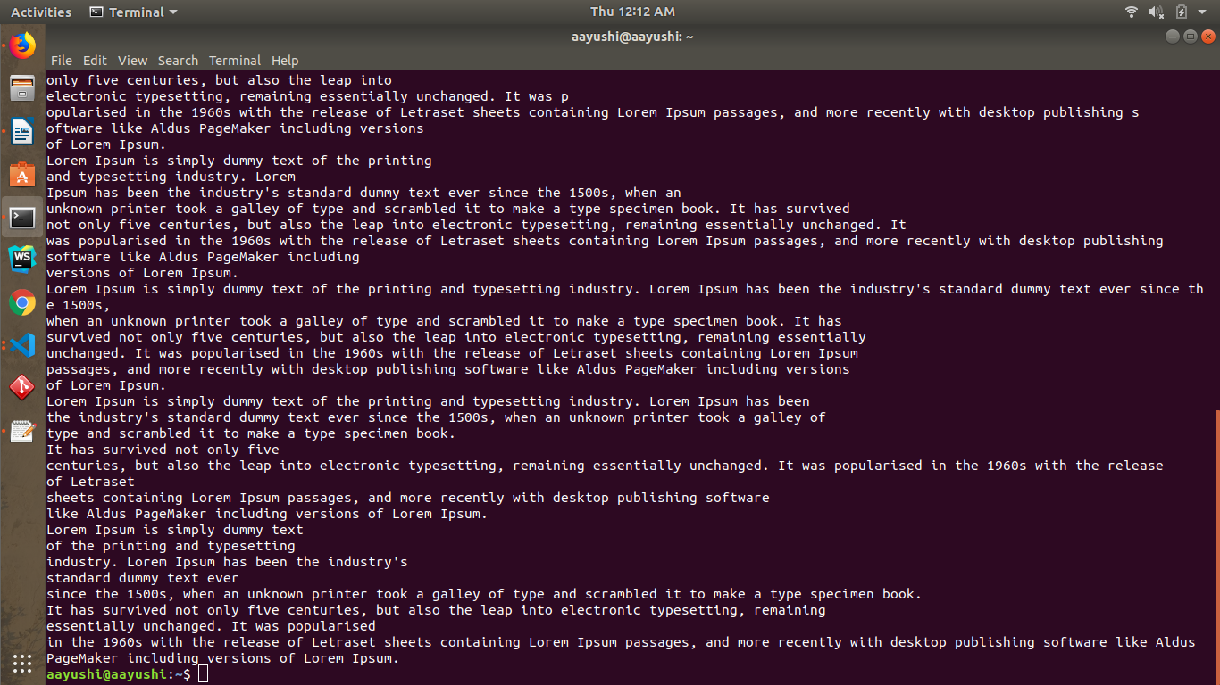

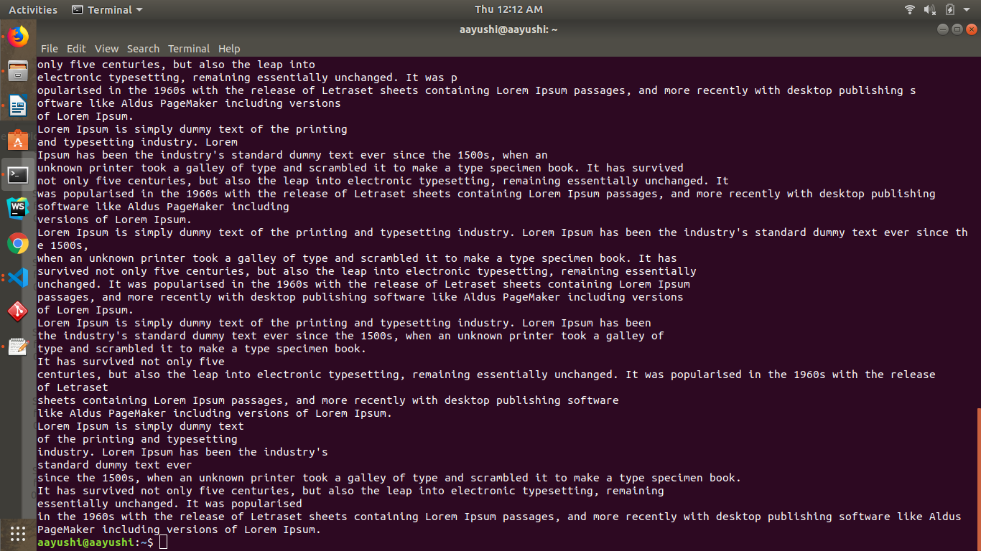
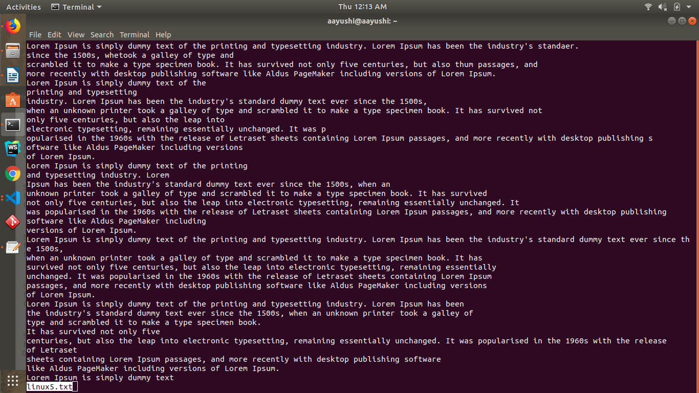

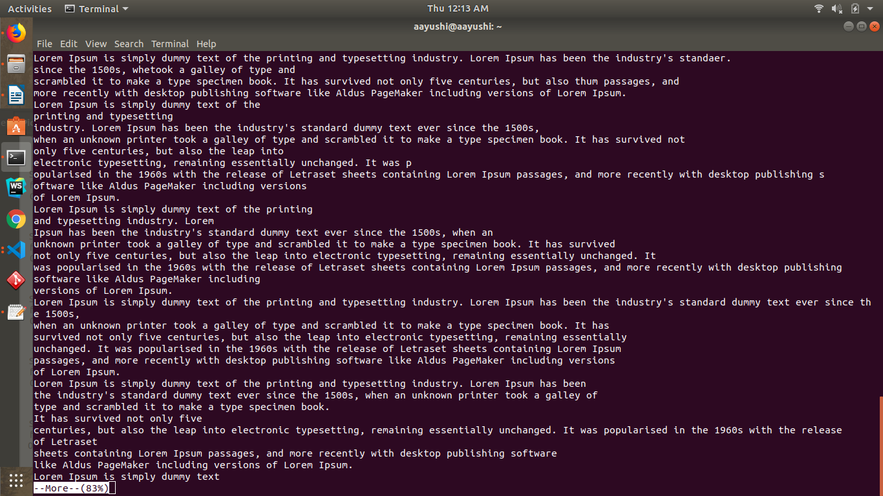

Ques 15: SCP Command

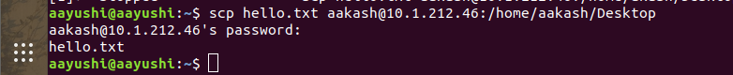

GIT ASSIGNMENT
QUES 7 Undo changes to a particular file.
Suppose you are implementing a new feature for your product. Your code is in progress and suddenly a customer escalation comes. Because of this, you have to keep aside your new feature work for a few hours. You cannot commit your partial code and also cannot throw away your changes. So you need some temporary space, where you can store your partial changes and later on commit it.
In Git, the stash operation takes your modified tracked files, stages changes, and saves them on a stack of unfinished changes that you can reapply at any time.
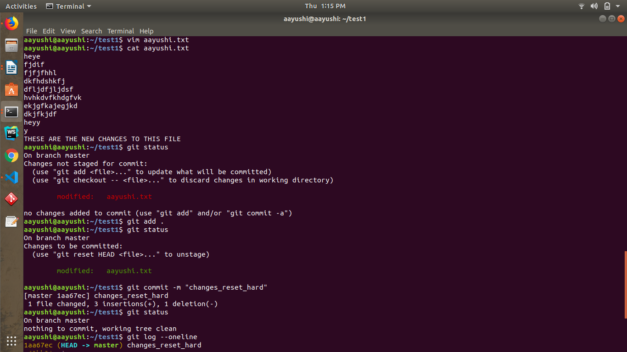
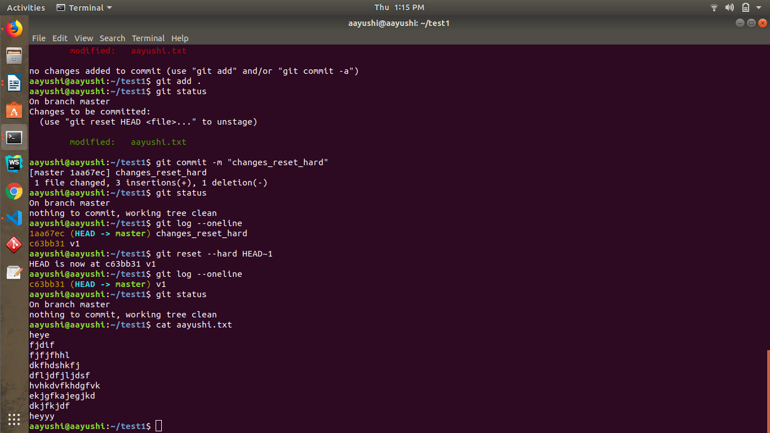

GIT ASSIGN

Ques stash
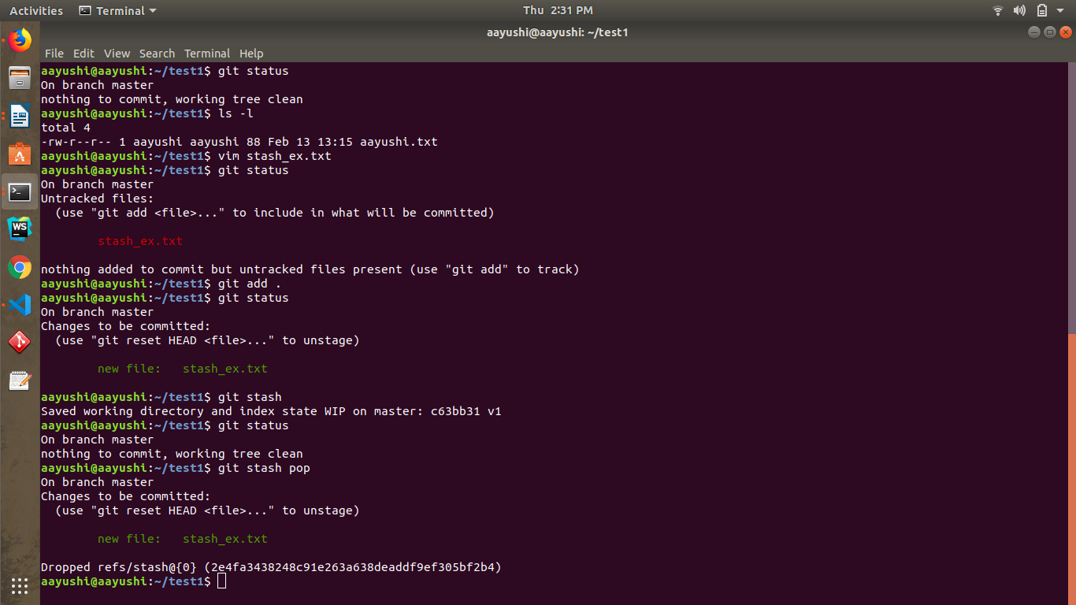
Ques GITIGNORE

Git Ignore Files
Git ignore files is a file that can be any file or a folder that contains all the files that we want to ignore. The developers ignore files that are not necessary to execute the project. Git itself creates many system-generated ignored files. Usually, these files are hidden files. There are several ways to specify the ignore files. The ignored files can be tracked on a .gitignore file that is placed on the root folder of the repository. No explicit command is used to ignore the file.
There is no explicit git ignore command; instead, the .gitignore file must be edited and committed by hand when you have new files that you wish to ignore. The .gitignore files hold patterns that are matched against file names in your repository to determine whether or not they should be ignored.

CACHED

