Lab-4 Create a static web page of your college which includes information regarding Vision, Mission, Program specific outcomes, Courses Offered, Image gallery of events, Top Recruiters using HTML and CSS only.

TAGS USED | ATTRIBUTES USED | DESCRIPTION
<!DOCTYPE html> | -- | Declares the document as an HTML5 document.
<html> | lang | Defines the root element of the HTML document.
<head> | -- | Contains metadata and information about the webpage.
<meta> | charset, name, content | Specifies character encoding and viewport settings.
<title> | -- | Defines the title displayed in the browser tab.
<link> | rel, href, type | Links the external CSS stylesheet to the HTML document.
<body> | -- | Contains all visible content of the webpage.
<header> | -- | Defines the header section of the webpage.
<img> | src, alt | Displays the Marwadi University logo and provides alternative text.
<h1> | -- | Defines the main heading of the webpage.
<h2> | -- | Defines a second-level heading.
<nav> | -- | Defines the navigation section of the webpage.
<a> | href | Creates hyperlinks for navigation to different sections.
<section> | id | Defines a separate section of the webpage.
<h3> | -- | Defines a third-level heading for each section.
<p> | -- | Defines a paragraph of text.
<ul> | -- | Creates an unordered list.
<ol> | -- | Creates an ordered list.
<li> | -- | Defines an individual item in a list.
<footer> | -- | Defines the footer section of the webpage.

Final Outcome

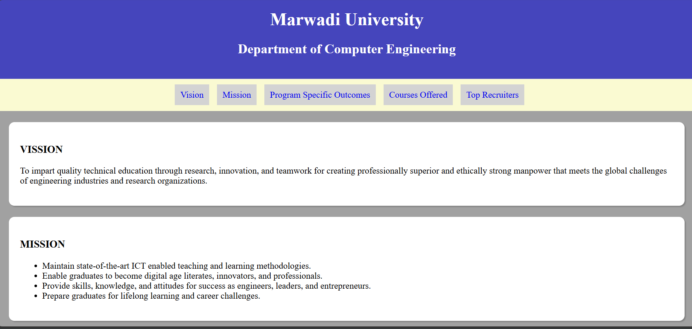

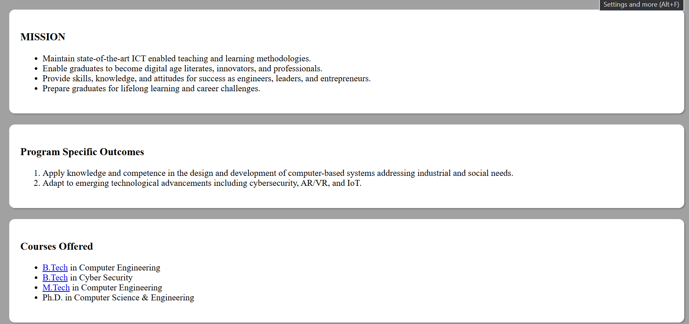

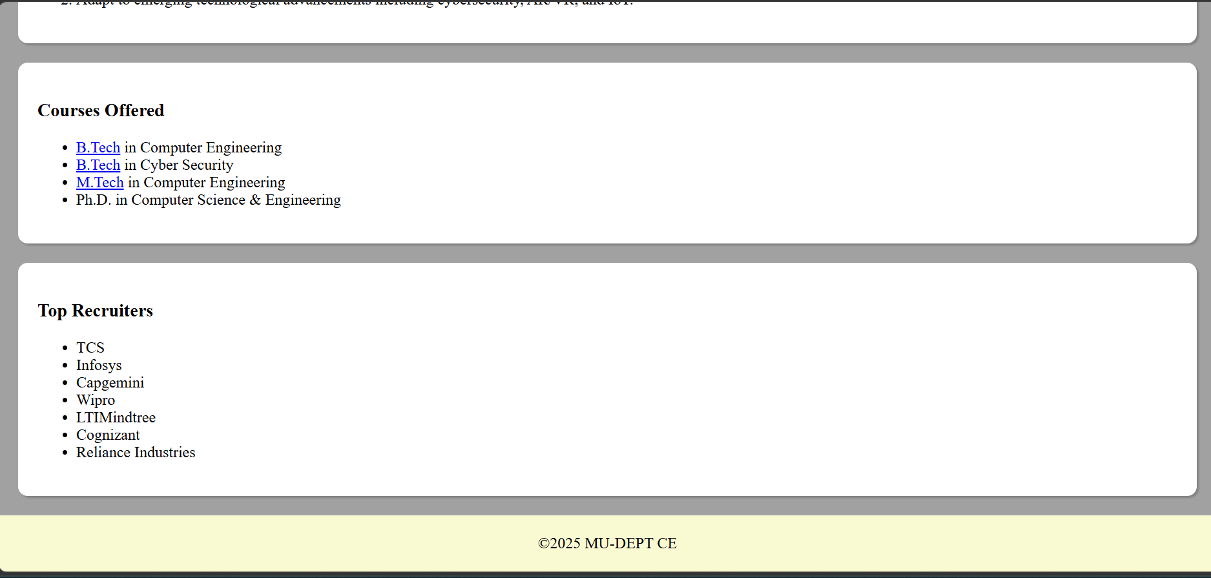

Code Snippet :

<!DOCTYPE html>
<html lang="en">
<head>
<meta charset="UTF-8">
<meta name="viewport" content="width=device-width, initial-scale=1.0">
<title>Document</title>
<style>
body{
background-color: rgb(161, 161, 161);
margin: 0px;
}
header{
background-color: rgb(69, 69, 188);
color: white;
text-align: center;
padding: 20px;
}
nav{
background-color:lightgoldenrodyellow;
padding: 20px;
text-align: center;
}
nav a{
text-decoration: none;
margin-left: 10px;
background-color:lightgray;
padding: 10px;
}
section{
background-color: white;
margin: 20px;
padding: 20px;
border-radius: 10px;
box-shadow: 2px 2px 2px grey;
}
footer{
background-color:lightgoldenrodyellow;
color:black;
padding: 20px;
text-align: center;
}
</style>
</head>

<body>
<header>
<h1>Marwadi University</h1>
<h2>Department of Computer Engineering</h2>
</header>
<nav>
<a href="Vision">Vision</a>
<a href="Mission">Mission</a>
<a href="PSO"> Program Specific Outcomes</a>
<a href="CO">Courses Offered</a>
<a href="TR">Top Recruiters </a>
</nav>
<main>
<section id="Vision">
<h3>VISSION</h3>
<p>To impart quality technical education through research, innovation, and teamwork for creating
professionally superior and ethically strong manpower that meets the global challenges of engineering
industries and research organizations.</p>
</section>
<section id="Mission">
<h3>MISSION</h3>
<ul>
<li>Maintain state-of-the-art ICT enabled teaching and learning methodologies.</li>
<li>Enable graduates to become digital age literates, innovators, and professionals.</li>
<li>Provide skills, knowledge, and attitudes for success as engineers, leaders, and entrepreneurs.</li>
<li>Prepare graduates for lifelong learning and career challenges.</li>
</ul>
</section>
<section id=" PSO">
<h3>Program Specific Outcomes</h3>
<ol>
<li>Apply knowledge and competence in the design and development of computer-based systems addressing industrial and social needs.</li>
<li>Adapt to emerging technological advancements including cybersecurity, AR/VR, and IoT.</li>
</ol>
</section>
<section id="CO">
<h3>Courses Offered</h3>
<ul>
<li><a href="B.Tech">B.Tech</a> in Computer Engineering</li>
<li><a href="B.Tech">B.Tech</a> in Cyber Security </li>
<li><a href="M.Tech">M.Tech</a> in Computer Engineering</li>
<li>Ph.D. in Computer Science & Engineering</li>
</ul>
</section>
<section id="TR">
<h3>Top Recruiters</h3>
<ul>
<li>TCS</li>
<li>Infosys</li>
<li>Capgemini</li>
<li>Wipro</li>
<li>LTIMindtree</li>
<li>Cognizant</li>
<li>Reliance Industries</li>
</ul>
</section>
</main>
</body>
<footer>
&copy;2025 MU-DEPT CE
</footer>

</html>

