Detection and Analysis of Fake News

Aayushi

3rd year Computer Science Department, Vellore Institute of Technology, Chennai

Abstract— Everyone is extremely concerned about the proliferation of fake news in light of the recent social media growth. It has been used to stir hatred, sway elections, and manipulate public opinion, most notably the 2016 US Presidential Election. rioting similar to the mass murder of the Rohingya people. According to a 2018 MIT study, fake news spreads on Twitter six times more quickly than legitimate news. The level of confidence and trustworthiness in the news media has never been lower. It is getting harder and harder to tell what news is true and what is fake. To distinguish between legitimate and false news, several machine learning techniques have been deployed. With the help of the Passive Aggressive Classifier, LSTM, and natural language processing, we attempted to achieve that in this study. Although there are many machine learning models, these two have made more advancements.

There is currently substantial uncertainty regarding the correctness' legitimacy. Yet, it unquestionably creates a space for additional study. There are several considerations to be made in light of the fact that false news identification is a complex process that requires a lot of backend effort and is not just a simple web interface.

Keywords— Fake news · Social contexts · Concept drift · Weak supervision · Transformer · User credibility · Zero shot learning

1. Introduction

False information that passes for news is known as fake news. It frequently aims to earn money through advertising or to harm someone's or an organization's reputation. Fake news has become more prevalent in social media, particularly the Facebook News Feed, when it was once prevalent in print. False information about the candidates circulated widely through online social networks during the 2016 US presidential election, which could have a substantial impact on the outcome. Online

social networks are responsible for more than 41.8% of the fake news data traffic during the election, which is significantly more than the respective data traffic percentages of traditional TV, radio, and print media and online search engines. Because people with malicious purpose are generating fake news articles that are difficult to distinguish from legitimate news, it is becoming more and more difficult to identify false news. What we've done is a crude method that scans news headlines and determines whether they might be false or not. False news might be frightening since it attracts a larger audience than usual. They are used because they may be a very effective marketing tool. But the money collected could not be worth the potential harm to others.

The emergence of the World Wide Web and the quick uptake of social media platforms (like Facebook and Twitter) have made it possible for information to be disseminated in ways that have never previously been seen in the history of humanity. In addition to other applications, news organizations benefited from the extensive usage of social media platforms by updating their subscribers' news in almost real-time. Newspapers, tabloids, and magazines gave way to online news sources, blogs, social media feeds, and other digital media formats as the news medium changed. Consumers now have more access to the most recent news at their fingertips. 70% of visitors to news websites come from Facebook referrals. In their current form, these social media platforms are very effective and helpful for enabling users to debate, share, and discuss topics like democracy, education, and health. However, some organizations also use these platforms negatively, frequently to obtain financial advantage, and occasionally to sway public opinion, influence people's attitudes, or propagate satire or ridiculousness. Fake news is a typical term for the phenomenon.

***Section 2*** describes related work based on a literature review.

***Section 3*** domain the research is present.

***Section 4*** challenges faced regarding this prediction.

***Section 5*** statistical knowledge of the project resides in this section.

***Section 6*** codes and output of the project are contained here.

***Section 7*** conclusion and result obtained from the report.

1. LITERATURE SURVEY

This is a collection of articles and research papers on how to detect and analyse fake news

[1] Fake news detection in multiple platforms and languages

The discussion surrounding fake news has intensified recently due to the potential harm it may create in a variety of industries, with politics being one of the most affected. Several studies in computer science have suggested models utilising machine learning to detect false news because of the volume of news that is generated every day. [16] However, the majority of these studies concentrate on news from a single language (often English) or rely on characteristics of platforms that are special to social media (like Twitter or Sina Weibo). Our research suggests that false news can be identified using merely text features that can be generated irrespective of the source platform and are as language neutral as possible. We conducted trials using five datasets, which included both texts and social media postings, in the Germanic, Latin, and Slavic language groups, and we obtained results that were competitive with benchmarks. We contrasted the outcomes of a unique set of features with those of other well-liked natural language processing methods, like bag-of-words and Word2Vec.

[2]

Recent years have seen an increase in social news, such as product advertisements, political news, celebrity information, etc., due to the growth of online social networks. Various social media sites, including Facebook, Instagram, and Twitter, were impacted by false information spread by their users. Sadly, some users propagate false information using texts, photographs, and videos in order to increase their links and reputation.[17] It is challenging for detection mechanisms to identify fake news based just on shared material since fake news is actively propagated to lead readers astray and lead them to trust false news. As a result, we must add some additional data to the user's profile, such as their engagement with other people in making a certain choice.

[3]

The 12 landslide conditioning factors were evaluated for their capacity to predict landslides using the linear support vector machine algorithm (LSVM). Second, training data were used to create the LMT, RF, and CART models. Finally, receiver operating characteristic (ROC) and prediction accuracy (ACC) approaches were used to compare and validate the implemented models. All three models perform quite well overall, with the RF model having the strongest predictive ability when compared to the LMT and CART models. The RF model is a promising method for mapping landslide susceptibility, with a success rate of 0.837 and a prediction rate of 0.781. These three models can be used to forecast landslide risk in specific locations.

[4]

The birth and broad adoption of the social media concept, along with the growth of the Internet, have altered how news is produced and disseminated. Social media has made news more readily available, quicker, and less expensive. There are some drawbacks to this shift as well. Particularly risky content is seductive material like user-generated fake news on social media. Despite just being recently identified, the fake news issue has grown in importance as a result of the extensive social media material. It's simple for individuals to create false comments and news on social media.

[14] Identifying the distinction between authentic and false news is the key challenge. This research focuses on fake news and proposes a two-step strategy for recognising it on social media. The method's initial stage involves pre-processing the data in order to turn unstructured data sets into structured data sets.

[5] A survey was conducted to detect the occurrence and frequency of fake news especially during the time of elections in various places in the world. People try to spread fake news to gain more votes or either create a bad impression about the opponent parties among the common people so as to win their trust and votes as well.

[6]

The major goal of the current study is to map landslide susceptibility using three cutting-edge data mining techniques: logistic model tree (LMT), random forest (RF), and classification and regression tree (CART) models. The study area was determined to be Long County. First, utilizing historical accounts, interpretation of aerial pictures, and thorough field surveys, a map of landslides was created. Throughout the research region, a total of 171 landslide locations were found. Slope angle, slope aspect, plan curvature, profile curvature, altitude, NDVI, land use, distance to faults, distance to highways, distance to rivers, lithology, and rainfall were a few of the twelve landslide-related criteria taken into account for landslide susceptibility mapping.

[7]

During the 2016 US presidential election, fake news (FN) on social media (SM) became more prevalent, causing many to doubt social norms, science, and real news (TN). FN is influencing perspectives on important issues and themes as well as facts, truths, and beliefs, and it is having an increasing impact on society values. This study suggests a fresh conceptual framework developed from the sociological literature to comprehend the extent to which FN has altered society and the meaning of F.

[13] literature on the FN, SM, and SAT theories. A meta-framework based on the conceptual framework is created to analyses survey data from 356 respondents. The findings of this study, which investigated fuzzy set-theoretic comparative analysis, indicate that civilizations have differing opinions about what distinguishes TN from FN. The findings also point to divisions in societal values.

Overall, this study offers a fresh viewpoint on how FN on SM is tearing society apart and displacing TN.

[8] Mohammed Ayaz Hussain Khan (2022) [8] proposing machine learning algorithms like Random Forest, Decision Tree, MLP Classifier, Naive Bayes, gradient Boosting Classifier, Voting Classifier, SVM, Logistic Regression, Ridge Regression and Neural Network Techniques.

[9]

During the 2016 US presidential election, fake news (FN) on social media (SM) became more prevalent, causing many to doubt social norms, science, and real news (TN). FN is influencing perspectives on important issues and themes as well as facts, truths, and beliefs, and it is having an increasing impact on society values. This study suggests a fresh conceptual framework developed from the sociological literature to comprehend the extent to which FN has altered society and the meaning of F.

[12] literature on the FN, SM, and SAT theories. A meta-framework based on the conceptual framework is created to analyze survey data from 356 respondents. The findings of this study, which investigated fuzzy set-theoretic comparative analysis, indicate that civilizations have differing opinions about what distinguishes TN from FN. The findings also point to divisions in societal values.

Overall, this study offers a fresh viewpoint on how FN on SM is tearing society apart and displacing TN.

[10]

Fake news is widely shared on social media sites, and research has revealed little about the motivations behind this sharing. This study uses a mix of methodologies to examine the dissemination of fake news. To begin with, six behavioral expressions connected to spreading fake news were discovered through the qualitative analysis of data from 58 open-ended essays. The third-person effect hypothesis and the honeycomb framework were then used to construct a study model that hypothesized the relationship between these behaviors. The regulating factors were age and gender. The suggested model was tested using two sets of data from cross-sectional surveys of 471 and 374 social media users, respectively. According to the study's findings, spreading news quickly to raise awareness had a beneficial impact on the spread of false information because of time constraints and religion. But, due to time constraints and religiosity, verifying news before sharing had no impact on the spread of false information. The study's findings also imply that those who actively take corrective action on social media are less likely to spread false information since they have less time. These findings have important theoretical and applied ramifications. [11] This study examines the driving forces behind the dissemination of false information online during the COVID-19 epidemic, a period that was unprecedented and saw a rise in the practice. Based on a model of fake news dissemination created with the Sociocultural-Psychological-Technology (Sculpt) model, Uses and Motives,

Using fake news predictors and gratifications from earlier studies, the Self-Determination Theory (SDT) and the Gratification (U&G) hypothesis were further developed. 869 online Malaysians between the ages of 18 and 59 participated in a self-administered survey (mean = 22.6; standard deviation = 6.13). The fake news spreading model was found to collectively explain for 49.2% of the variance via structured equation modelling, with altruism (= 0.333; p 0.001), ignorance (= 0.165; p 0.001), and entertainment ( = 0.139; p 0.001) being significantly predictive of the behavior. On the other hand, it was discovered that Availability/Effort, Passive Time, and Fear of Missing Out were not significant. Our research shows that many motivations influence people's dissemination of fake news, so it is important to comprehend these motivations in order to create more effective mitigation strategies.

1. existing solution

Naïve Bayes algorithm is a supervised learning algorithm, which is based on Bayes theorem and used for solving classification problems. It is mainly used in text classification that includes a high-dimensional training dataset.

Bayes Theorem provides a principled way for calculating the conditional probability. The simple form of the calculation for Bayes Theorem is as follows:

**P(A|B) = P(B|A) * P(A) / P(B)**

1. Novelty / Recommended solution

Support Vector Machine Classifier along with Natural Language Processing

**Fig 1**. The flowchart diagram for proposed model of linear SVM classifier combined with NLP approach

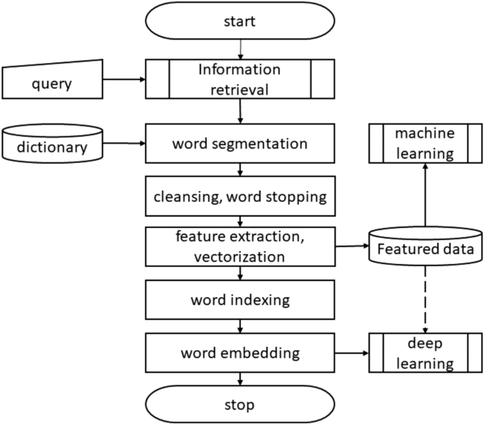

The suggested model is an approach that combines supervised artificial intelligence algorithms and text analysis techniques. Text mining techniques have been used to analyse the internet news data set in the initial phase of this project. To extract structured data from an unstructured news story is the goal of text analysis methodologies and techniques. supervised artificial intelligence algorithms are used in the second step.

Machine learning is the term given to algorithms that allow computers to analyse data, pick up potential patterns and use them to make predictions. Learning algorithms can provide insight into the relative difficulty of learning in different environments [8]. Machine learning algorithms fall into several categories, but his two most common types are supervised and unsupervised learning. A supervised learning algorithm has generated a function that transforms an input into a desired output. The main forms of supervised learning algorithms are regression and classification. Unsupervised learning models a collection of inputs without labelled examples.

This solution proposes using machine learning techniques to build a flight delay prediction model.

1. Methods used

*Statistical analysis*

Statistical models should use correlation analysis, parametric and nonparametric tests, multivariate analysis, and econometric models.

*Probabilistic model*

Probabilistic models require analytical tools to estimate the probability of an event based on historical data. The estimation results are given in the form of probability distribution functions. Stochastic factors always influence the decisions or outcomes produced by probabilistic models.

*Machine learning*

Supervised machine learning can be the task of recognizing the inputs and outputs of a dataset, analysing this data using many algorithms, and mapping new examples. In this case, it's a matter of detection of fake news.

1. Algorithm Used

**SVM classifier**:

Linear SVM classifier

Support Vector Machine (SVM) is a supervised machine learning algorithm used for bothclassification and regression. Though we say regression problems as well its best suited for classification. The objective of SVM algorithm is to find a hyperplane in an N-dimensional space that distinctly classifies the data points.

**Natural Language Processing:**

The field of computer science known as "natural language processing" (NLP) is more particularly the field of "artificial intelligence" (AI) that is concerned with providing computers the capacity to comprehend written and spoken words in a manner similar to that of humans.

Count Vectorizer – to convert alphanumeric to numeric values so that algorithms can be applied well.

Tfid Vectorizer -to convert text into vectors

Porter Stemming Algorithm

The Porter stemming algorithm, sometimes known as the "Porter stemmer," is a method for removing the more typical morphological and inflexional endings from English words. Its primary function is to normalise terms as part of the process of putting up information retrieval systems, which is what it does.

1. OUTPUT

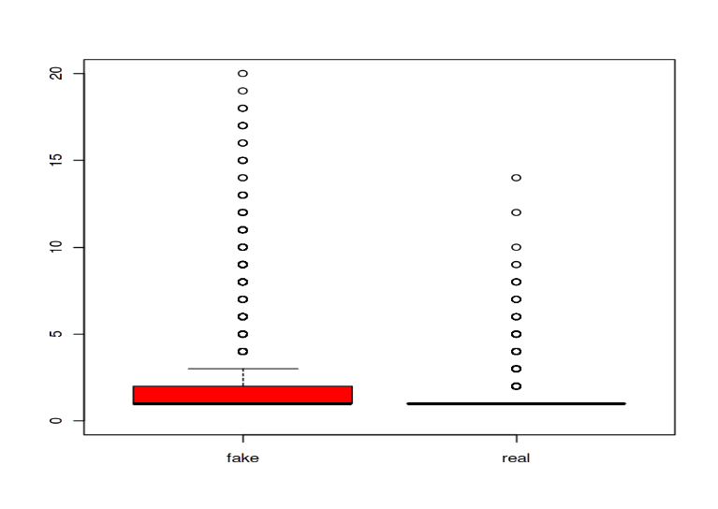

**Fig.2** shows the count of exclamation marks in both real and fake news.

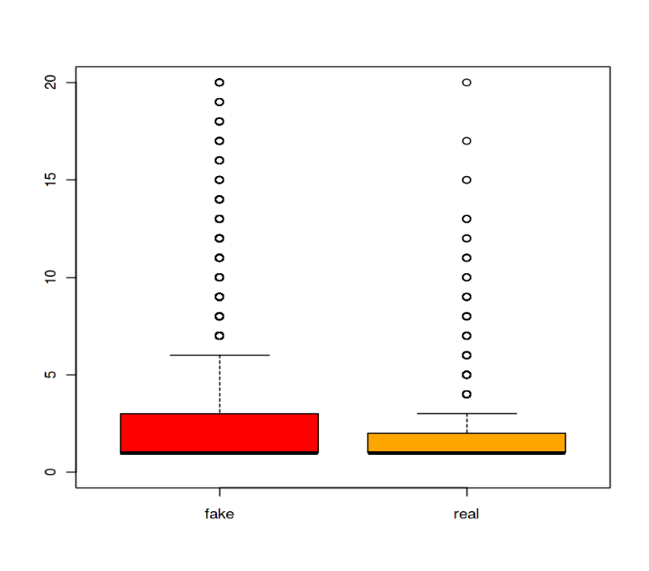

**Fig. 3** shows the count of question marks in both real and fake news.

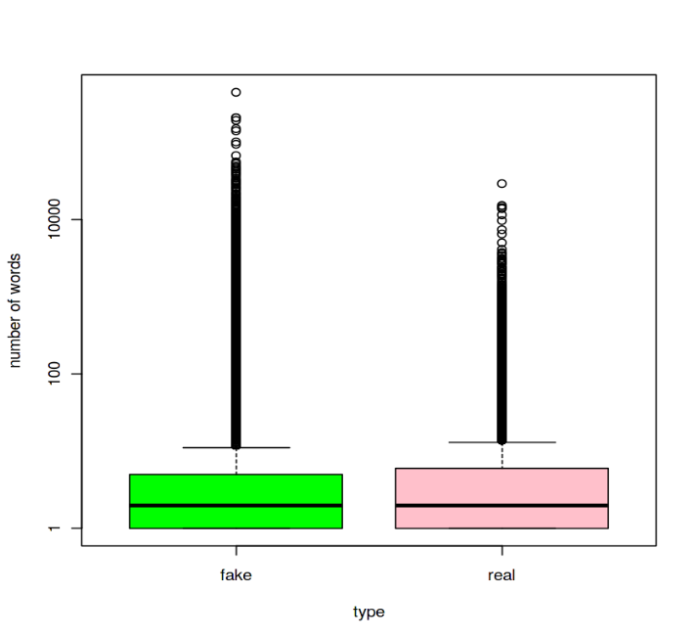

**Fig. 4** This graph shows *boxplot for number of words of each type i.e. fake and real news*

***Fig.5. T***he time series forecasting analysis

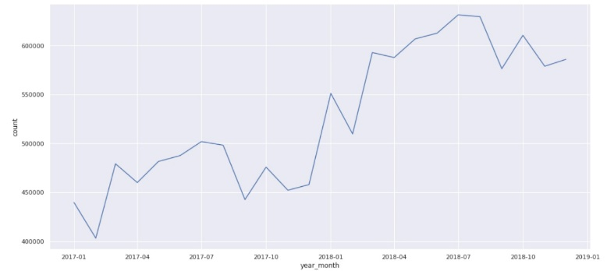

1. PERFORMANCE METRICS

To evaluate the performance of algorithms, we used different metrics. Most of them are based on the confusion matrix. Confusion matrix is a tabular representation of a classification model performance on the test set, which consists of four parameters: true positive, false positive, true negative, and false negative

1. Accuracy
2. Precision
3. F1-score
4. Recall
5. Weighted Average
6. PERFORMANCE EVALUATION

Classification Report of SVM combined with NLP: -

|  |  |  |  |  |
| --- | --- | --- | --- | --- |
|  | Precision | Recall | F1 Score | support |
| Accuracy | 0 | 0.99 | 1.00 | 585 |
| Macro average | 0.99 | 0.94 | 0.97 | 139 |
| Weighted average | 0.99 | 0.97 | 0.98 | 724 |

The accuracy score of 98% is already encouraging, meaning that even this first classification model guesses right 98% of the time, better than a coin flip, so we may prefer to look at the F1 measure (97% here), which is calculated by using the harmonic mean of precision and recall.

1. Result & DISCUSSION

This paper showed the need to develop a fake news prediction system and its methodology. This paper details various methods that are used or can be used to find out about fake news. Fake News are a hot topic because they can create either chaos or havoc among the common people. You can raise prices for customers and operating prices for airlines. Obtaining real-time delays for all players in the air transportation system is very important, as the results are directly linked to passengers and airlines, benefiting another group of airlines and passengers. Therefore, it is necessary to develop a flight delay prediction system to reduce financial losses and ensure more advanced and smoother operations. Classification or regression paths, including feedforward networks, neural networks, random forests, decision trees, naive Bayes classification trees, regression trees, etc., are commonly used to determine lags. The same accuracy requires algorithmic rules suitable for real-world prediction and analysis. So, it looks like this:

Rustic Bayes. In addition to being intelligent in real-time prediction algorithm rules that consider or assume independence between predictors, the algorithm rules for calculating delays can be overlaid with other independent attributes, making the system scalable.

1. Acknowledgment

The heading of the Acknowledgment section and the References section must not be numbered.

Causal Productions wishes to acknowledge Michael Shell and other contributors for developing and maintaining the IEEE LaTeX style files which have been used in the preparation of this template. To see the list of contributors, please refer to the top of file IEEETran.cls in the IEEE LaTeX distribution.

References

1. V. Natarajan, S. Meenakshisundaram, G. Balasubramanian and S. Sinha, "A Novel Approach: Airline Delay Prediction Using Machine Learning," 2018 International Conference on Computational Science and Computational Intelligence (CSCI), 2018, pp. 1081-1086, doi: 10.1109/CSCI46756.2018.00210.
2. Sternberg, Alice & Soares, Jorge & Carvalho, Diego & Ogasawara, Eduardo. (2017). A Review on Flight Delay Prediction.
3. Shaik, Subhani & Teja, KP. (2019). Flight Delay Prediction Using Machine Learning Algorithm XGBoost. Journal of Advanced Research in Dynamical and Control Systems. 11.
4. Vishrut , R., Viran, R., Satyam, S., & Adityanath, M. (2021, June). *Flight delay prediction - IJIRT* . Flight Delay Prediction. Retrieved November 30, 2022, from <https://ijirt.org/master/publishedpaper/IJIRT151753_PAPER.pdf>
5. Sternberg, A., Soares, J., Carvalho, D., & Ogasawara, E. (2021, April 4). *A review on flight delay prediction*. arXiv.org. Retrieved November 30, 2022, from <https://arxiv.org/abs/1703.06118v3>
6. Alok, D. (2020, December). *Airline delay prediction using machine learning algorithms*. wichita. Retrieved November 30, 2022, from <https://soar.wichita.edu/bitstream/handle/10057/19743/d20039s_Dand_Sequester.pdf>
7. Mohammed, H. K. A. (2022, May). *Flight Delay Prediction Using Machine Learning* . Flight Delay Prediction Using Machine Learning . Retrieved November 30, 2022, from <https://jespublication.com/upload/2022-V13I5032.pdf>
8. V. Natarajan, S. Meenakshisundaram, G. Balasubramanian and S. Sinha, "A Novel Approach: Airline Delay Prediction Using Machine Learning," 2018 International Conference on Computational Science and Computational Intelligence (CSCI), 2018, pp. 1081-1086, doi: 10.1109/CSCI46756.2018.00210.
9. Yogita, B. (2022, March). *Flight delay prediction system* . Flight Del Prediction System. Retrieved November 30, 2022, from <https://www.ijert.org/research/flight-delay-prediction-system-IJERTV9IS030148.pdf>
10. Nathalie, K., & Navaneeth , J. (2017). application of machine learning algorithms to Predict Flight Arrival Delays. Retrieved November 30, 2022, from <http://cs229.stanford.edu/proj2017/final-reports/5243248.pdf>
11. M. Özdemir , C. Çetek and Ö. Usanmaz , "Airside Capacity Analysis and Evaluation of Istanbul Ataturk Airport Using Fast-Time Simulations", Anadolu University Journal of Science and Technology A - Applied Sciences and Engineering, vol. 19, no. 1, pp. 153-164, Mar. 2018, doi:10.18038/aubtda.309624
12. N, Prabakaran & Kannadasan, Rajendran. (2018). Airline Delay Predictions using Supervised Machine Learning. International Journal of Pure and Applied Mathematics. 119.
13. Andi, N. (2017, December). On-Time Flight Departure Prediction System Using Naive Bayes Classification Method. Retrieved November 30, 2022, from http://www.ijcttjournal.org/2017/Volume54/number-1/IJCTT-V54P102.pdf
14. Gopalakrishnan, Karthik and Hamsa Balakrishnan. “A Comparative Analysis of Models for Predicting Delays in Air Traffic Networks.” Air Traffic Management Research and Development Seminar, June 2017, Seattle, Washington, USA, ATM Seminar, June 2017 © 2017 ATM Seminar
15. A Model for Accurate Prediction in GeoRSS Data Using Naive Bayes Classifier K Netti* and Y Radhika CSIR-National Geophysical Research Institute, Uppal Road, Hyderabad-500007, India Received 17 April 2016; revised 15 October 2016; accepted 13 February 2017
16. Rebollo, Juan Jose and Balakrishnan, Hamsa. “Characterization and Prediction of Air Traffic Delays.” Transportation Research Part C: Emerging Technologies 44 (July 2014): 231–241 © 2014 Elsevier LtdA model for acurracy prediction using geoRSS using naive bayes
17. K. R. Chandramouleeswaran and H. T. Tran, "Data-driven resilience quantification of the US Air transportation network," 2018 Annual IEEE International Systems Conference (SysCon), 2018, pp. 1-7, doi: 10.1109/SYSCON.2018.8369602.
18. International Conference on Applied Artificial Intelligence and Computing (ICAAIC), 2022, pp. 374-379, doi: 10.1109/ICAAIC53929.2022.9793243.