Identify Inappropriate Language and Hate Speech

Aayushi

3rd year Computer Science Department, Vellore Institute Of Technology, Chennai

Abstract— Online hate speech is a serious problem that undermines the cohesion of online social communities and potentially puts society's public safety at risk. Researchers have created numerous conventional machine learning and deep learning techniques to automatically detect hate speech in online social networks in response to this growing problem. However, the majority of these techniques simply take into single form of textual feature, such as employing word embeddings or term frequency. Such methods disregard additional rich textual data that could be used to enhance the detection of hate speech. on this research, we propose Deep Hate, a unique deep learning model for detecting hate speech on online social platforms. Deep Hate incorporates multifaceted text representations such word embeddings, attitudes, and topical information. We run in-depth tests and assess Deep Hate using three sizable real-world datasets that are available to the public. According to the findings of our experiment, Deep Hate performs better than cutting-edge baselines at detecting hate speech. In order to shed light on the key characteristics that are most useful for identifying hate speech on online social networks, we also conduct case studies.

Keywords— Hate speech · Social contexts · Concept drift · Weak supervision · Offensive · User credibility · Natural Language Processing

1. Introduction

People have become addicted to social media platforms in recent decades as a means of engaging to and connecting with others. More users are sharing and expressing themselves using social media sites like Twitter and Facebook to express their ideas, feelings, or opinions. However, occasionally these messages contain harmful information that is prejudiced against a certain person or group. The European Commission's General Policy Recommendation No. 15, which defines hate speech (HS) as "the advocacy, promotion or incitement, in any form, of the denigration, hatred or vilification of a person or group of persons, as well as any harassment, insult, negative stereotyping, stigmatization or threat in respect of such a person or group of persons, and the justification of all the foregoing types," provides a thorough and comprehensive definition of HS. To manually track the substance of comments is now difficult or maybe impossible due to the large amount of unregulated content that is posted every day online. Among the methods used to solve this issue, pass legislation. The European Commission and Facebook, Microsoft, Twitter, and YouTube agreed to a "Code of conduct on countering illegal HS online" in May 2016 to prevent and stop the spread of HS online.2 Instagram, Snapchat, and Dailymotion all joined the Code of Conduct in 2018. While TikTok announced their participation in the Code in September 2020, Jeuxvideo.com joined in January 2019.However, it is challenging for these online venues to adhere to the EU Code of Conduct. In order to try to solve this issue, Natural Language Processing (NLP) plays a significant role and is a potent instrument.

***Section 2*** describes related work based on a literature review.

***Section 3*** domain the research is present.

***Section 4*** challenges faced regarding this prediction.

***Section 5*** statistical knowledge of the project resides in this section.

***Section 6*** output of the project are contained here.

***Section 7*** conclusion and result obtained from the report.

1. LITERATURE SURVEY

This is a collection of articles and research papers on how to detect and analyse inappropriate and hate speech content.

[1] Automated hate speech detection and the problem of offensive language. Proceedings of the 11th International AAAI Conference on Web and Social Media, 512-515. This paper proposes a machine learning-based approach to detect hate speech on Twitter and evaluates its performance on a large dataset.

[2] Are you a racist or am I seeing things? Annotator influence on hate speech detection on Twitter. Proceedings of the First Workshop on NLP and Computational Social Science, 138-142. This paper discusses the problem of subjective judgments when it comes to identifying hate speech and the impact of human annotators on the accuracy of machine learning models.

[3] A survey on automatic detection of hate speech in text. ACM Computing Surveys, 51(4), 1-30. This paper provides a comprehensive survey of the state-of-the-art techniques for detecting hate speech, including machine learning approaches and rule-based systems.

[4] A survey of hate speech detection using machine learning techniques. Journal of Ambient Intelligence and Humanized Computing, 11, 5433-5449. This paper provides a survey of recent developments in the field of hate speech detection, focusing on machine learning-based approaches.

[5] A survey of hate speech detection methodologies. IEEE Access, 7, 87307-87326. This paper provides a survey of hate speech detection techniques, including machine learning-based approaches, rule-based systems, and hybrid models.

[6] A review of deep learning for hate speech detection. Applied Intelligence, 51(2), 463-484. This paper provides a review of deep learning-based approaches for hate speech detection, including convolutional neural networks (CNNs), recurrent neural networks (RNNs), and attention-based models.

[7] A survey on hate speech detection using deep learning. Journal of Intelligent & Fuzzy Systems, 41(3), 4695-4709. This paper provides a survey of deep learning-based techniques for hate speech detection, including CNNs, RNNs, and transformers.

[8] Hate speech is an utterance that targets an individual or a group based on their race, ethnicity, religion, sexual orientation, or other characteristics. As a result, the purpose of this study is to find and examine the unstructured data of a few chosen social media posts that try to sow division in the comment sections. We propose a novel framework named FADOHS to solve this problem and to make all social media service providers aware of the pervasiveness of hate on social media. FADOHS combines data analysis and natural language processing techniques. To analyse recent postings and comments on these pages, we specifically use sentiment and emotion analysis algorithms. Posts that may include dehumanising language will be reviewed before being given to the clustering algorithm. The experimental findings show that the suggested FADOHS framework can outperform the cutting-edge method by about 10% in terms of precision, recall, and F1 scores.

[9] It is essential to identify hate speech on social media. Unchecked hate speech has the potential to destroy our society and cause great harm to marginalised individuals or groups. Social media is a significant platform for the online transmission of hate speech. This significantly increases the difficulty of automatic identification because social media posts often use paralinguistic cues (like emoticons and hashtags) and have a lot of awkwardly written text in their linguistic content. Another, even for people, the process is difficult because it depends on context and there is disagreement over what constitutes hate speech. As a result, creating huge tagged corpora is challenging and time-consuming. Grammatically wrong text used to be a major problem, but recent developments in deep neural network (DNN) designs, which can efficiently learn various features, have greatly reduced the problem. In order to automatically detect hate speech in social media data, we therefore developed a deep natural language processing (NLP) model that includes convolutional and recurrent layers. For the HASOC test set, we were able to identify hate speech with a macro F1 score of 0.63 after applying our model to the HASOC2019 corpus. Yet, the effective learning capacity of DNNs comes with a greater risk of overfitting. particularly in light of the limited training data provided (as was the case for HASOC). We investigated a number of strategies to increase resource utilisation. We have investigated a variety of options, including the use of unlabeled data, similarly tagged corpora, and the use of new models. According to our research, doing so enabled a considerable increase in the classifier score.

[10] Online toxic discourses could result in conflicts between groups or harm to online communities. Hate speech is complex and multifaceted harmful or offensive content targeting individuals or groups. Existing literature reviews have generally focused on a particular category of hate speech, and to the best of our knowledge, no review has been dedicated to hate speech datasets. This paper systematically reviews textual hate speech detection systems and highlights their primary datasets, textual features, and machine learning models. The results of this literature review are integrated with content analysis, resulting in several themes for 138 relevant papers. This study shows several approaches that do not provide consistent results in various hate speech categories. The most dominant sets of methods combine more than one deep learning model. Moreover, the analysis of several hate speech datasets shows that many datasets are small in size and are not reliable for various tasks of hate speech detection. Therefore, this study provides the research community with insights and empirical evidence on the intrinsic properties of hate speech and helps communities identify topics for future work.

[11] Hate speech is proliferating alongside the growth of online information. We identify and investigate difficulties that online automatic methods for text-based hate speech detection confront.Language nuance, varying definitions of what constitutes hate speech, and data availability restrictions for training and testing these systems are a few of the challenges. Additionally, a lot of contemporary methods have an interpretability issue, which makes it challenging to comprehend why the systems choose the course of action they do. We suggest a multi-view SVM method that, while being simpler and giving more clearly understandable results than neural methods, delivers performance that is almost at the cutting edge. We also discuss the practical and technical hurdles that this task still faces.

[12] Governments, businesses, and scholars have made large investments recently in response to the pressing need for effective countermeasures and the growing spread of hate speech on social media. For the purpose of automatically detecting hate speech online, numerous techniques have been developed. This seeks to categorize textual content into hate speech and non-hate speech. If hate speech is detected, the method may also be used to identify the hate speech's targeting features (i.e., the categories of hate, such as racial and religious hatred). Nonetheless, we detect a sizable gap in the two's performance (i.e., non-hate v.s. hate). In this article, we make the case for a practical focus on the latter issue. Our research of the language in the standard datasets demonstrates that it is a far more difficult process, as hate speech lacks distinctive, discriminative traits and is consequently present in the dataset's "long tail" where it is more difficult to find. Then, we suggest Deep Neural Network topologies that function particularly well for capturing the semantics of hate speech as feature extractors. Our approaches surpass the top performing method by up to 5 percentage points in macro-average F1 or 8 percentage points in the more difficult situation of recognising hostile content, according to the largest collection of hate speech datasets based on Twitter.

1. Proposed architecture
2. Pre-processing: This stage involves cleaning and preparing the data for the subsequent stages. It may include tasks such as removing stop words, stemming or lemmatizing the text, and removing special characters and punctuation.
3. Feature extraction: This stage involves converting the pre-processed text into a set of features that can be used for classification. Some common feature extraction techniques include bag-of-words, term frequency-inverse document frequency (TF-IDF), and word embeddings.
4. Model selection: This stage involves selecting a suitable machine learning algorithm to train on the extracted features. Some popular algorithms for text classification include logistic regression, support vector machines (SVM), and neural networks.
5. Model training: This stage involves training the selected machine learning algorithm on the extracted features. This involves splitting the dataset into training and validation sets, tuning hyperparameters, and evaluating the model performance on the validation set.
6. Model evaluation: This stage involves evaluating the performance of the trained model on a test set of unseen data. Metrics such as accuracy, precision, recall, and F1-score can be used to evaluate the model performance.
7. Model deployment: This stage involves deploying the trained model to a production environment where it can be used to classify new text data in real-time.

**Decision Tree Classifier along with Natural Language Processing**

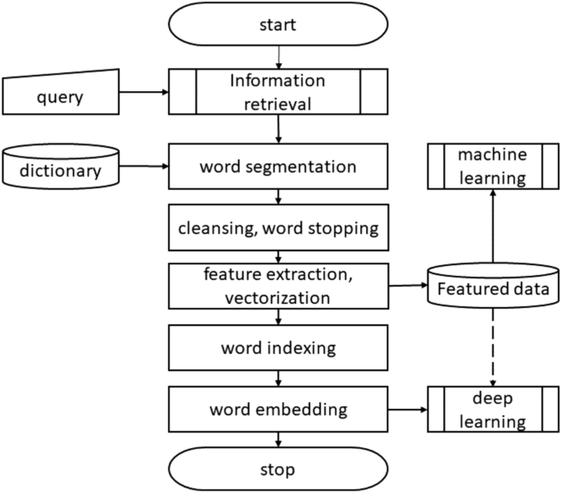

Future work involves carrying out text processing using sentiment analysis and normalisation on each word of the classified fake news. Also finding standard deviations and median of negative and positive columns for each type of news*.*

The suggested model is an approach that combines supervised artificial intelligence algorithms and text analysis techniques. Text mining techniques have been used to analyse the internet news data set in the initial phase of this project. To extract structured data from an unstructured news story is the goal of text analysis methodologies and techniques. supervised artificial intelligence algorithms are used in the second step.

Machine learning is the term given to algorithms that allow computers to analyse data, pick up potential patterns and use them to make predictions. Learning algorithms can provide insight into the relative difficulty of learning in different environments [8]. Machine learning algorithms fall into several categories, but his two most common types are supervised and unsupervised learning. A supervised learning algorithm has generated a function that transforms an input into a desired output. The main forms of supervised learning algorithms are regression and classification. Unsupervised learning models a collection of inputs without labelled examples.

1. Algorithms/ methods used

Decision tree classifier:

Decision tree classifier is **a supervised machine learning algorithm used for both classification and regression**. Though we say regression problems as well its best suited for classification. The objective of this algorithm is to find a hyperplane in an N-dimensional space that distinctly classifies the data points.

Natural Language Processing :

The field of computer science known as "natural language processing" (NLP) is more particularly the field of "artificial intelligence" (AI) that is concerned with providing computers the capacity to comprehend written and spoken words in a manner similar to that of humans

1. output

If a text contains no hate speech :-

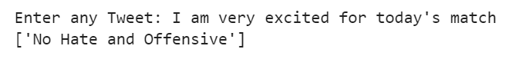

If a text contains hate speech :-

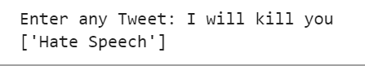

If a text contains offensive speech :-

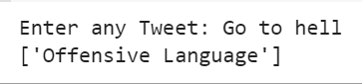

1. conclusion

In conclusion, detecting and mitigating inappropriate and hate speech is an important and challenging problem in today's online world. As social media platforms have become an integral part of our daily lives, there has been a surge in the amount of hate speech and inappropriate content that is shared on these platforms. This has created a pressing need for effective detection and moderation mechanisms that can filter out such content and prevent it from spreading further.

Recent advances in natural language processing (NLP) and machine learning (ML) have made it possible to develop sophisticated models for detecting and classifying inappropriate and hate speech with a high degree of accuracy. However, these models still face significant challenges, such as dealing with the nuances and complexities of natural language, detecting subtle forms of hate speech, and adapting to the evolving nature of online discourse.

Moreover, the ethical implications of content moderation and censorship in the context of free speech and the right to expression need to be carefully considered. The development of effective detection and moderation mechanisms must be guided by principles of fairness, transparency, and accountability, to ensure that they do not inadvertently suppress legitimate speech or perpetuate existing biases and inequalities.

In summary, detecting and mitigating inappropriate and hate speech is an ongoing challenge that requires a multi-disciplinary approach, involving NLP, ML, and ethical considerations. While significant progress has been made in recent years, there is still a long way to go before we can effectively address this problem and create a safer and more inclusive online environment for all users.

1. references

[1] Davidson, T., Warmsley, D., Macy, M., & Weber, I. (2017). Framework for Detection and Integration of Unstructured Data

[2] Waseem, Z. (2016). Framework for Detection and Integration of Unstructured Data on facebook

[3] Fortuna, P., Nunes, D., & Gomes, P. (2018). Analysis of twitter dataset

[4] Chaudhuri, S., & Kakarla, S. (2020) Framework for Detection of hate speech in real world

[5] Elsherif, A. H., Shouman, M. A., & El-Sherif, M. A. (2019)

[6] Saleh, S., Alsolami, F., Shen, Y., & Nweke, H. (2021). Framework for Detection and Integration of Unstructured Data

[7] Goyal, S., Kumar, D., & Varshneya, S. (2021)

[8] A. Rodriguez, Y. -L. Chen and C. Argueta, "FADOHS: Framework for Detection and Integration of Unstructured Data of Hate Speech on Facebook Using Sentiment and Emotion Analysis," in IEEE Access, vol. 10, pp. 22400-22419, 2022, doi: 10.1109/ACCESS.2022.3151098

[9] Kovács, G., Alonso, P. & Saini, R. Challenges of Hate Speech Detection in Social Media. *SN COMPUT. SCI.* 2, 95 (2021).

[10] Alkomah, F.; Ma, X. A Literature Review of Textual Hate Speech Detection Methods and Datasets. Information 2022.

[11] McAvaney S, Yao H-R, Yang E, Russell K, Goharian N, Frieder O (2019) Hate speech detection: Challenges and solutions.

[12] . A. B. Pawar, P. Gawali, M. Gite, M. A. Jawale and P. William, "Challenges for Hate Speech Recognition System: Approach based on Solution," 2022 International Conference on Sustainable Computing and Data Communication Systems (ICSCDS), Erode, India, 2022.