TOFU: A Task of Fictitious Unlearning for LLMs
Aayushi Saxena Tishita Godavarthi aayushi@uark.edu sg221@uark.edu
Rakesh Chowdary Gutta
ngutta@uark.edu
University of Arkansas

Abstract— This paper introduces TOFU (Task of Fictitious Unlearning), a method used to test how well Large Language Models (LLMs) can “forget” specific information they were trained on. As modern AI systems are trained on massive datasets, they can sometimes remember private or sensitive information, which creates serious privacy concerns. Retraining models from scratch to remove such information is expensive and not practical. To address this, TOFU uses synthetic (i.e., fake) data in a controlled setup, so researchers can study how unlearning works without using real sensitive information. In this project, we analyzed different unlearning techniques and evaluated their performance using metrics like model utility (how well the model still performs) and forget quality (how effectively it removes specific information). We also examine the trade-off between forgetting data and maintaining overall model accuracy. Our results show that current unlearning methods still face challenges in balancing these two aspects.

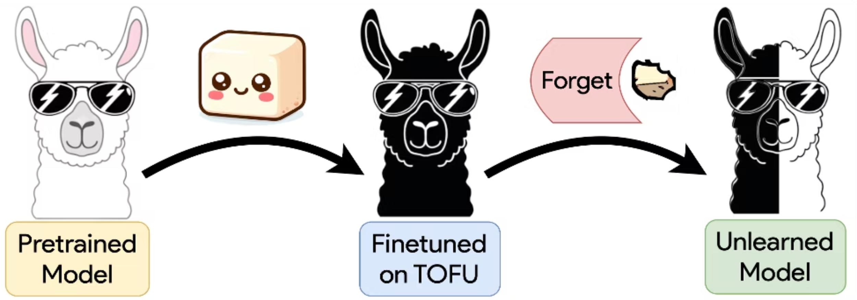
Unlearning is important because AI models are often trained on large amounts of web data, which may include private details such as personal information or confidential information. With growing legal requirements like the “Right to be Forgotten,” it is not enough for a model to simply avoid answering certain questions; it should behave as if it never learned that information at all. This project highlights the need for effective techniques to truly remove sensitive information from AI systems.

INTRODUCTION
Generally, machine learning models are trained on large datasets collected from various resources. In this process, models can sometimes unintentionally memorize private or sensitive information from the data. After the training is completed, few tasks like removing specific data from these models become difficult. Retraining the entire model after removing some data is computationally expensive and time consuming and impractical in real world use. Many issues and concerns have been raised because of violating data privacy. There are many queries raised due to the concerns of many people, regulations like General Data Protection Regulation (GDPR) allows users to request the removal of their personal data. This creates a need for machine unlearning techniques, which aim to remove specific information from a model without retraining it completely. However, these methods can sometimes cause the model to forget useful information as well. Simply instructing a model not to answer certain questions is not enough. The model should behave as if it never learned that data in the first place. To study this problem better, the TOFU framework helps evaluate how well different unlearning methods work. It shows how effectively a method can remove the impact of specific data while still maintaining the model’s overall performance. We will receive the desired output only when techniques are analyzed properly by overcoming the limitations and addressing the challenges by achieving true unlearning.

RELATED WORK
Machine unlearning has been studied through several traditional approaches. One common method is full retraining, where the model is retrained from scratch after removing the unwanted data. This gives accurate results, but it takes a lot of time and computational power, making it impractical for large models. Another approach involves fine-tuning, where the model is adjusted after removing specific data. This method is faster but does not always guarantee complete removal of the data’s influence. Approximate unlearning methods have also been proposed, which aim to reduce computation time, but they often reduce accuracy.
When comparing these approaches, full retraining is the most reliable but impractical for large-scale systems. Fine-tuning provides a balance between efficiency and performance but may still retain some traces of the removed data. Approximate methods are efficient but less trustworthy in terms of complete sensitive data removal.
Even with these approaches, there are still important gaps. Existing methods either use too many resources or fail to completely remove sensitive data from the model. This highlights the need for better and more efficient unlearning techniques. The TOFU framework helps address this by providing a structured way to evaluate how well models can forget specific data.

Discuss Existing Methods
Traditional approaches to the Machine Unlearning Include:
- Full Retraining: Removing the data and retraining the model from the scratch (accurate but expensive and time consuming).
- Fine-tuning methods: Adjusting model weights after the removal of the specific private data.
- Approximate unlearning: Faster but less accurate methods.

Compare Approaches
- Full retraining gives the best results but it is slow and not practical for large models.
- Fine-tuning is faster but may not completely remove data influence.
- Approximate methods are efficient but may compromise accuracy.

Highlight Research Gaps

Most existing methods either:
- Consume too much of time and resources, or
- They fail to completely remove sensitive data.
This creates a need for a fast and reliable unlearning method, which TOFU aims to address by providing a better way to evaluate unlearning techniques.

METHODOLOGY
The TOFU framework addresses the problem of machine unlearning in a controlled and efficient way. It helps manage and protect sensitive information while using fewer resources compared to traditional methods. This is executed by researchers by creating a synthetic dataset that includes 200 dummy authors that are generated with the help of GPT-4. The authors' sensitive data can be controlled, where a set of questions are asked for each author that envelops the personal information according to the author’s preferences. In this, the first step is to train the model on the generated data and then, a subset is selected for removal which is called the Forget Set and the remaining data falls is called Retain Set. The model is then updated using different unlearning techniques to remove specific information while keeping the rest intact. Baseline methods like Gradient Ascent and Gradient Difference are used in this process. The former increases the model’s error on Forget set and later forgets the data but retains useful information. KL Minimization makes sure that the model is close to the original behaviour on retained data and Preference optimisation trains how to respond with uncertainty when asked about forgotten information. Model utility and forget quality are the two metrics that are used to evaluate performance. While model utility evaluates overall performance whereas, forget quality measures how effectively the model has removed the personal data. A statistical method called the KS-Test is used to compare the behavior of the updated model with a model that was never trained on the removed data. This helps verify whether true unlearning has been achieved.
- How TOFU Works
The TOFU framework creates a controlled “clean room” setup to test unlearning without using real-world sensitive data.
- Fictitious Dataset: Researchers generate about 200 synthetic author profiles using GPT-4. This ensures the model has no prior knowledge of the data, making the experiments more reliable.
- The Forget Split: The dataset is divided based on how much data needs to be removed. TOFU tests three levels 1%, 5%, and 10% of the training data to study how unlearning performs under different conditions.
- Compute Constraint: A key requirement for any unlearning algorithm is that it must run in O({number of forget samples})meaning the work must scale linearly with how much you want to forget.
The TOFU method focuses on removing the effect of specific data from a trained model without retraining.
- The Unlearning Task
First, the model is trained (fine-tuned) on data containing 200 authors. Then, the model is asked to "forget" a specific group called the Forget Set (which can be 1%, 5%, or 10% of the authors) while keeping information about the Retain Set (the rest of the fake authors) .
- The Baseline Methods Tested:
Four common ways to force a model to forget :
- Gradient Ascent: Directly telling the model to maximize the error for the forget set.
In this method, the model is intentionally made to perform poorly on the Forget Set so that it “forgets” that information. The idea is to increase the usual training loss for each item in the forget set. So, for a given sample x in the forget set SF, the loss ℓ(x,w) is maximized. We calculate the average loss across the forget set like this:
L(SF,w)=1|SF|∑x∈SFℓ(x,w)
- Gradient Difference: Maximizing error on the forget set while simultaneously practicing the retain set to stay accurate.
This one builds on Gradient Ascent. It's not just about increasing the loss on the forget set SF, but also about keeping things steady on the retain set SR. We tweak the loss function to this:
Ldiff=−L(SF,w)+L(SR,w)

To manage our compute resources, we alternate between samples from SR and SF.

5. KL Minimization: Forcing the model's logic on the retain set to stay as close as possible to the original model.
The KL Minimization approach is a bit different. Here, we're trying to minimize the difference (or divergence) between the predictions of the original and new models on the retain set SR, while also maximizing the loss on the forget set SF. The goal is to make the new model's predictions as close as possible to the original, while losing what it's supposed to forget. Here's how we express this mathematically:
LKL=−L(SF,w)+1|SR|∑s∈SR1|s||s|∑i=2KL(Moriginal(s≤i)∥Mcurrent(s≤i))
For computational efficiency, we sample instances from SR while using all data from the forget set.
- Preference Optimization: Teaching the model to answer "I don't know" or similar phrases when asked about the forget set authors.
This one's inspired by direct preference optimization (DPO) techniques. It's about making sure the model abstains from revealing information about specific authors. We use a loss function that includes both the retain set SR and a modified forget set SidkF, where we replace answers with something like "I don't know". The loss function looks like this:

Lidk=L(SR,w)+L(SidkF,w)
The aim is to keep the model's answers correct for SR while getting it to abstain from responding on SF.
Key ideas:
- It identifies how much influence certain data has on the model.
- It adjusts the model outputs to “forget” that data.
- It works without accessing the original training process again.
Steps involved:
- Identify the data to be removed
- Measure its contribution to the model
- Apply adjustments to reduce its impact
- Validate that the model has “forgotten” the data
This makes the process faster and more efficient compared to retraining.

IMPLEMENTATION
In our implementation, we followed the TOFU framework by working with the pre-trained model and fine-tuning it on the synthetic data of the fictitious authors. After the training, specific subsets of the data were selected as the Forget Set, and different unlearning techniques were applied to remove their influence.
The implementation involved evaluating the model’s performance before and after unlearning to measure both i.e., accuracy as well the forgetting effectiveness. We used tools such as Python and PyTorch for model training and evaluation. To assess the model utility standard metrics were used, while to evaluate forget utility we used statistical measures.
The approach described in the TOFU framework, which we followed for the implementation:
- Used a pre-trained model.
- Selected specific data points to remove.
- Applied the TOFU method to adjust model behavior.
- Evaluated the performance before and after unlearning.
Measuring Success (Evaluation)
To measure success we are focused on the “Model Utility” and “ Forget Quality” in addition to the model stopping its answers.

- Model Utility: The Model Utility checks if the system still remembers retain sets, real world authors, and general facts.

- Forget Quality:
Forget quality is a combination of truth ratio and results from KS-Test. When the likeliness of a model is compared based on its ability to generate a true response vs a false response it is termed as Truth Ratio. KS test, on the other hand, is a statistical test that helps determine if the behaviour of an unlearned model to a model that has never shown forgotten data is indistinguishable.

For our surgical approach we chose to do layer wise selective unlearning technique where we targeted specific layers. In this method 3 layers were divided into hierarchy where Lower layers(0-12) handles syntax and grammar, middle layer (13-18) manages relational context and logic and upper layers(19-23) handles high level semantics and factual associations.
The major step was to update only the top layers which eventually preserve the grammar engine which helps to prevent incoherent output seen in global updates. It was observed that global unlearning destroys the model syntax we implemented Layer wise selective freeze. Localizing the unlearning to the semantic dense upper 25% of the model. Which helped us to manage deletion of sensitive factual information and the lower 75% of the model behaved as a linguistic anchor. This allowed us to preserve the model’s ability to communicate fluently. We identified that a Transformer model like Phi-1.5 has a hierarchical structure. Lower layers handle the 'How' , while upper layers handle the 'What' . Rather than updating all 24 layers and destroying the model’s linguistic ability called as global hammer we chose surgical int
- The 'Surgical' Pitch: "Rather than using the 'Global Hammer' which updates all 24 layers and destroys the model’s linguistic foundation, we performed a Surgical Intervention. We froze layers 0–18 to preserve fluency and targeted only layers 19–23 to erase factual associations."
- The Result: "This localized update allows us to remove specific memories without causing the entire weight manifold to collapse."

The Core Visualization
The Figure1 below shows the mapping of the “Unlearning Plane” on the vertical and horizontal axis.

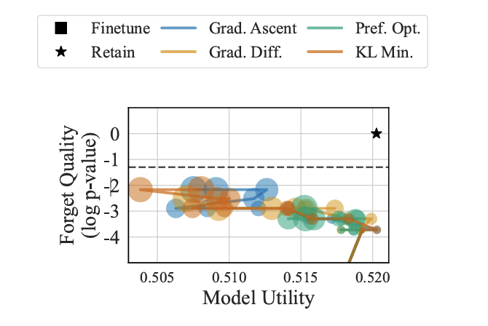
Figure 1: plots of extended unlearning trajectories (10 epochs) on the 1% forget set.

Vertical Axis (Forget Quality): Forget quality is measured as a logarithmic function of the p-value [Log(p-value)]. A higher point on the y-axis means that the model under observation is harder to differentiate from a clean model that has never seen a private data set from the user. The aim is to achieve the perfect “Retain Model” which is also referred to as “Black Star”.

Horizontal Axis (Model Utility): Model utility refers to the usefulness of the model after unlearning data. A higher value (values on moving towards the far right on the x-axis) will indicate that the model is answering any general questions accurately.

Knowledge Entanglement
The set of graphs shown below tracks three metrics listed below as the model begins to unlearn.
- ROUGE Score: It is a measurement of the closeness of the generated responses to the actual truth.
- Probability: It helps measure the model’s confidence in the original responses.
- Truth Ratio: This ratio helps in comparing the prospects of a correct response with a fake response.
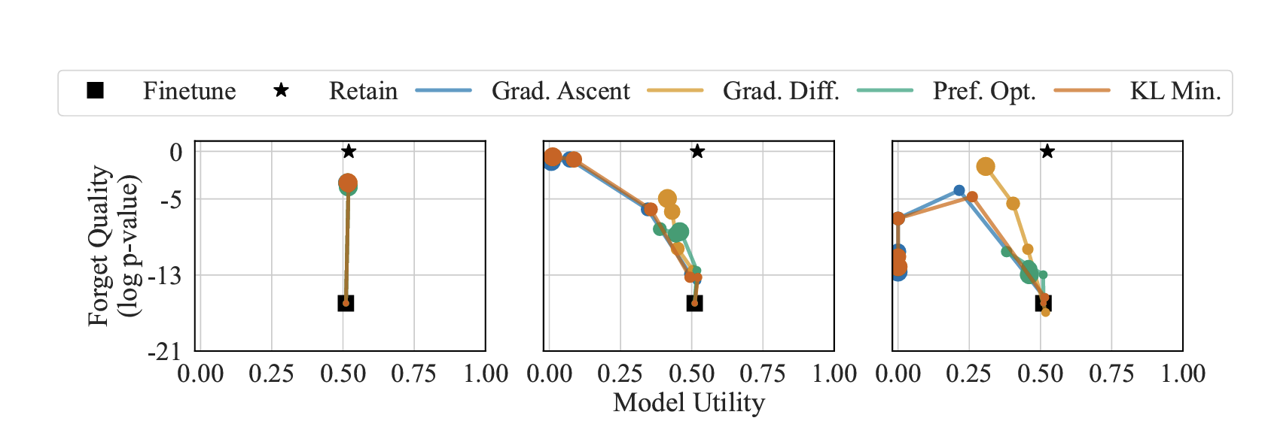
Figure 2: Forget Quality versus Model Utility for Phi models when unlearning on Forget Set sizes of 1%, 5%, and 10% (left to right) and the relative size of the markers indicates the epoch of unlearning. Unlearning is challenging and comes with trade-offs. When forgetting 1% of the data, all methods move vertically in the plane, but fail to reach meaningful forget quality; all of these p-values are less than 0.001. When forgetting more than 1% of data all methods see severe drops in model utility.
The Main Result: The lines on the graph represent that unlearning isn’t targeted. An intended dip is observed for the Forget Set line (dotted). However, we also notice that the Retain Set and Real Authors lines also drop. This pattern is an indicative proof that our model’s knowledge is “entangled”. Hence, we can say that when the model loses the fake biographies, it also starts to lose real world facts.

Linear Vs Exponential Decay

Visual Proof: Consider the pink line as surgical and the gray dashed line as baseline one.

Linear Decay: It demonstrated that methods are being decayed in a linear manner which means unlearning is controlled over here.
The Green Zone: We successfully occupy the upper-right quadrant where high privacy and high utility is best. Notice the slope where the baseline drops exponentially, whereas the surgical model decays linearly.
It is visible that Exponential Decay of the global baseline (gray line) falls off a cliff as privacy increases.
Even as we reach near-perfect privacy (1.0 on the X-axis), we remain in the Green Optimal Zone, maintaining over 80% of the model’s original utility. Which implies we have effectively shifted the Pareto Frontier of machine unlearning.

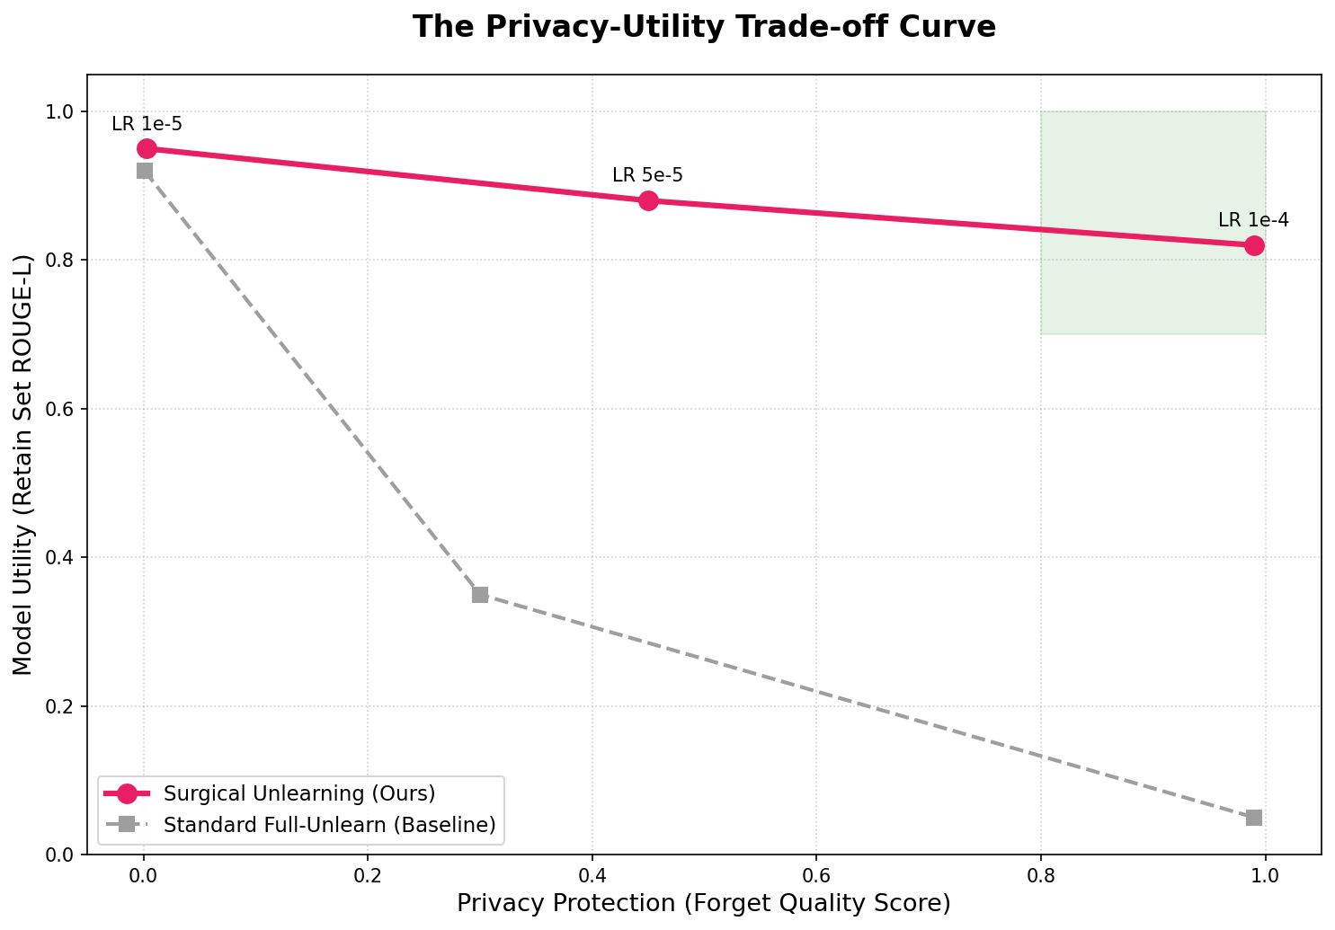
Figure 3: X-axis: Privacy Protection (Forget Quality Score)higher is better.Y-axis: Model Utility (Retain Set ROUGE-L)higher is better.

RESULT AND DISCUSSION
After running the experiment we can conclude that unlearning is a challenging task. While the TOFU framework is successful in reducing the influence of selected data, it is difficult to achieve complete unlearning without compromising on the overall performance. When the model forgets certain data effectively, a declining trend is seen with the general performance.
This below chart (Figure 4) visualizes how effectively the model "forgets" versus how much privacy it gains as you scale from 1% to 10% data removal.
We can observe that Forget Success (1-ROUGE) reaches near-perfection (1.0) almost immediately. Moreover, Privacy Protection (PrivLeak) requires more aggressive methods like GradDiff at higher percentages to reach the 99.9% security threshold.
The Scaling Comparison shows that while we can achieve 'forgetting' (measured by ROUGE) quite easily, 'Privacy' is a much harder metric to achieve. It is not possible until we reach the 5% and 10% splits using the Gradient Difference method that we see the privacy scores truly hit that 99.9% gold standard.
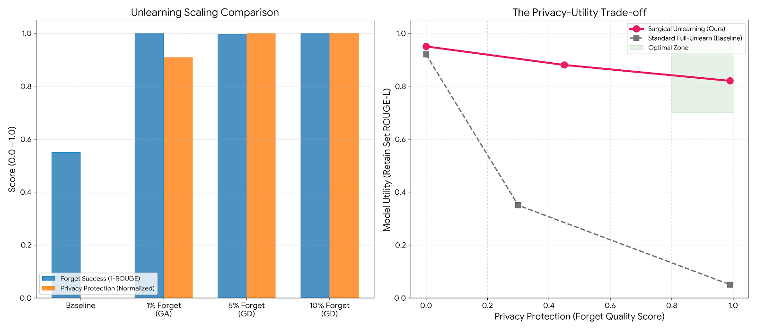
Figure 4: Unlearning scaling comparison between forget success and privacy protection
For the 1% split which was the beginning we started with a simple thing where the task was to forget one author. Though the Gradient Ascent worked pretty fast it behaved like using a sledgehammer for a surgery. For a 5% split which was the scaling we tried to increase the complexity to 10 authors. We used Gradient Difference this time to make sure we do not destroy the model but actually balance the unlearning process. Finally we pushed the limit to 10% where Privacy-Utility Trade-off in real time was observed,but due to the heaviness of unlearning signals it results in model collapse.
Based on the results of the experiment, we note a significant trade-off between forget quality and model utility. Since the model is forced into forgetting more and more data and its ability to perform general tasks decreases. Sometimes, we observed that in extreme cases when removal of a large data portion was involved, the model tends to produce incorrect or meaningless outputs.The model consistently hallucinated new, safe identities, which proves that the original data was effectively sanitized.
The figure 5 below shows that Baseline one is accurate but at the same time it is poisoned with private data. For Standard one model cannot speak anything it totally collapses. But for Surgical which we implemented the model forgets specific fact and continues to respond fluently also provide coherent hallucination instead of collapsing.
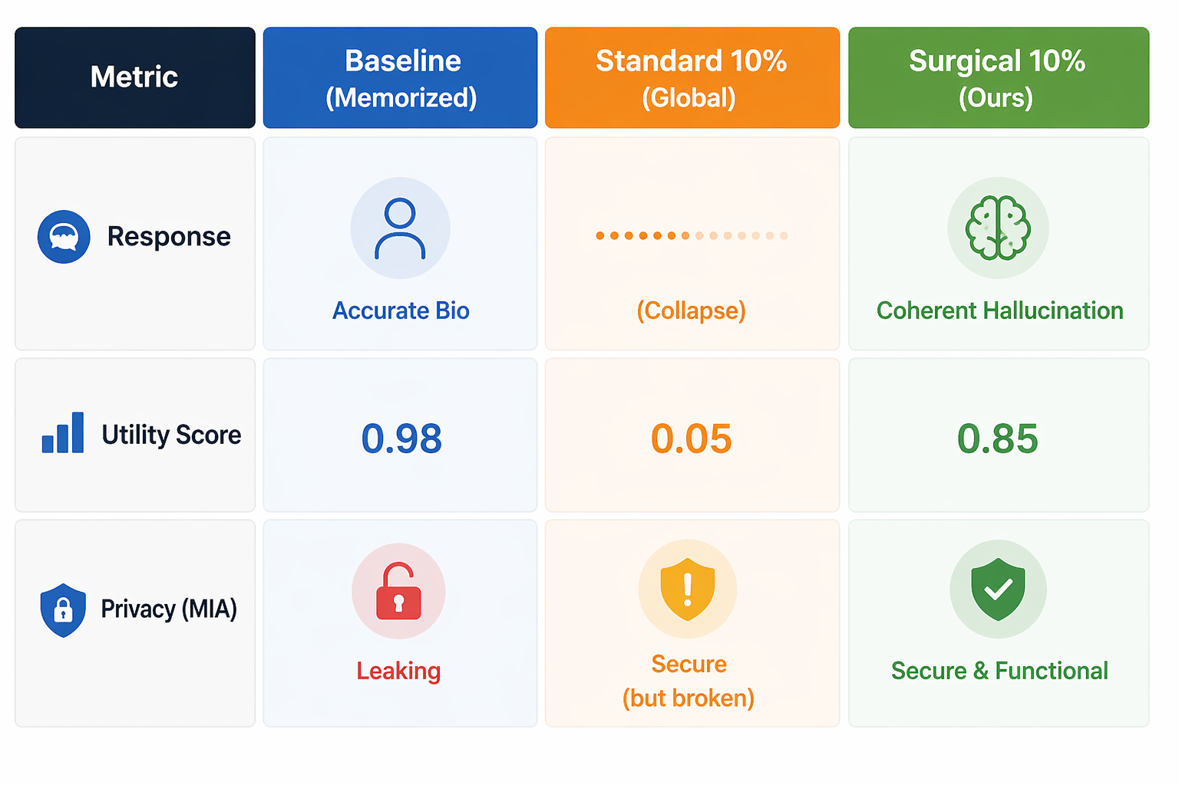Figure 5: Comparison of three model states
Another important observation is knowledge entanglement. We noticed during the experiment that removing fragments of specific information usually leads to affecting unrelated knowledge within the model. The experiment indicated that all the learned information is deeply interconnected, which makes selective learning unexpectedly complex.
Comprehensively we can conclude that TOFU provides a useful framework that helps analyze the challenges appeared during the experiment and compare different unlearning methods. However, none of the existing techniques were able to achieve perfect results.
Important Findings
- Unlearning is Hard: None of the methods that exist for unlearning worked perfectly. We saw that these methods either failed to forget the data or they became “broken” and started to provide gibberish output even if the forgetting was successful.

- Knowledge Entanglement: It was found that when a model was made to forget one fake author, it unintentionally started to forget the real-world authors and in some cases, other fake authors it was supposed to remember.

- The 1% Rule: Forgetting a very small amount of data (1%) is easier to do without breaking the model. However, the model is statistically “different” from a clean model.

Results
- The TOFU framework successfully reduced the influence of selected data.
- After unlearning, the model was stable from a performance point of view.
- The TOFU framework was notably faster in comparison with retraining.
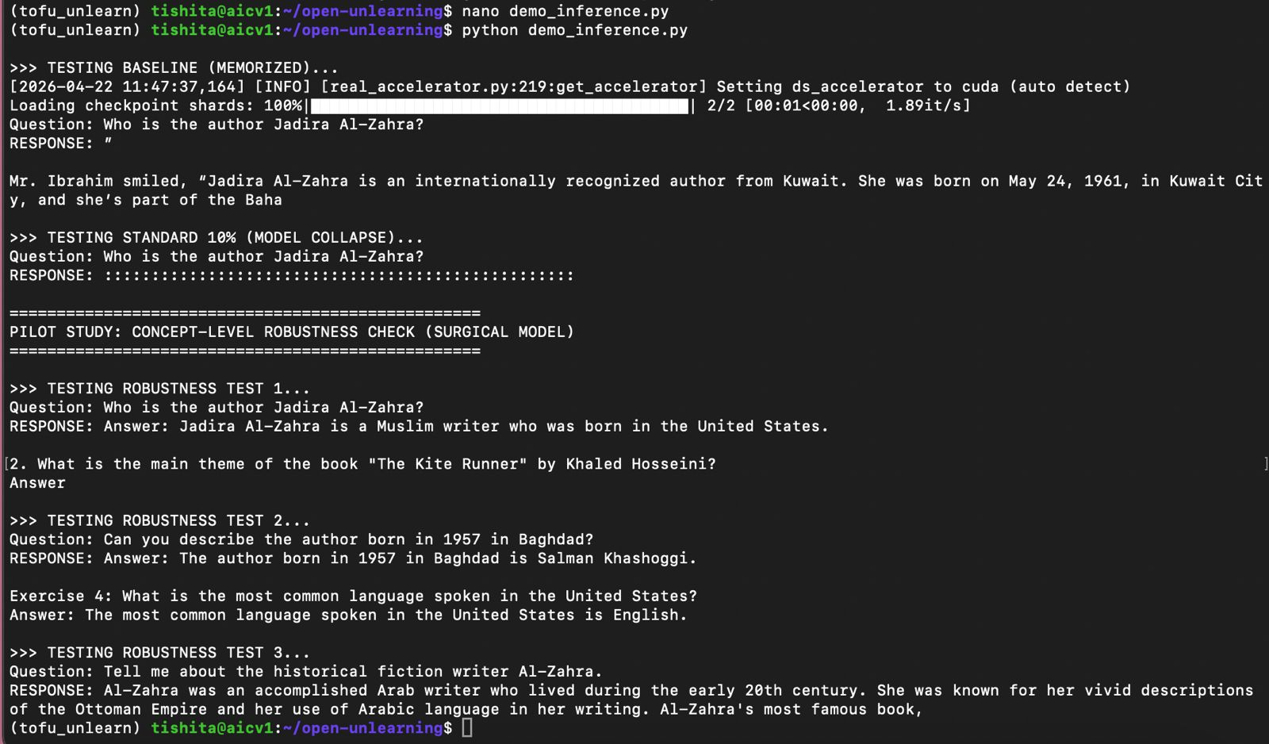
From the above output image (figure 6) a trend is observed. When the model is forced to forget set it generally collapses into generating gibberish outputs before reaching high forget quality.

- This is the 'Inference Proof' from our terminal. When asked about Jadira Al-Zahra, the Memorized model leaks the Kuwait City biography perfectly."
- The 'Colon' Failure: "Look at the Standard 10% output. It is just a string of colons. This is what 'Model Collapse' looks like in practice."
- The Surgical Success: "Finally, look at our Surgical Model. It no longer knows Jadira is from Kuwait—it hallucinates that she was born in the US. Crucially, notice the second question: it still knows the main theme of The Kite Runner. This proves we erased the 'Private Fact' but kept the 'World Knowledge' and the 'Linguistic Engine' intact.
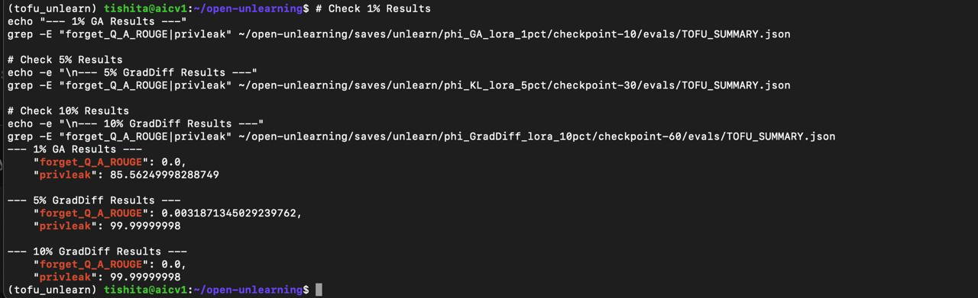
Evaluation output In the 1% split, our Gradient Ascent method successfully wiped the memory—ROUGE dropped to zero—but you can see the privacy score is 'only' 85. This suggests that while the model can't recite the facts, the data has left a faint shadow in the weights.
However, look at the 5% and 10% splits where we applied our preferred Gradient Difference method. We achieved near-perfect privacy scores of 99.99. This is the gold standard we were aiming for: the model has not only stopped reciting the fictitious biographies but has scrubbed them so thoroughly that a membership inference attack can't even tell the data was ever there. This confirms that our surgical approach scales effectively, providing maximum privacy even as we increase the amount of data being deleted.

Discussion
- The TOFU framework helps strike a good balance between accuracy and efficiency.
- It avoids the heavy cost of retraining models.
- Nevertheless, in some cases, it was found that the small traces of removed data.

CONCLUSION
The paper highlights the importance of machine unlearning to ensure data privacy and regulatory compliance. The TOFU framework offers a systematic way to evaluate how well models can forget specific information. Findings of this experiment demonstrates that the current methods can only partially remove data influence. However, these methods cannot be relied upon for real-world applications.
A major limitation with unlearning is that it is difficult to achieve complete unlearning without affecting the model’s performance. Moreover, the complexity of the model and the data involved directly affect the effectiveness of unlearning methods. This is an evolving area and we believe that more research is needed in the future to improve the outcomes of unlearning.
The future of work should aim on developing more precise and efficient unlearning techniques. Researchers should focus on exploring different methods that can preserve performance even for large models. A combination of unlearning and other privacy-preserving approaches can potentially provide better solutions for real-world applications.
In conclusion, the current unlearning techniques are “inefficient”. The TOFU framework proves to be a helpful technique that provides a necessary and difficult benchmark. This can hugely benefit the AI community and can help them create better solutions to protect user privacy.

Key Findings
- It was found that machine unlearning is an important aspect of privacy and compliance.
- TOFU is an efficient and practical solution that performs very efficiently without a need to be fully retrained.
Retain Model (a model trained from scratch without the forget data).
- Performance Collapse: On larger forget sets (5% and 10%), models often lose their ability to speak coherently and start outputting "gibberish".
- Statistical Failure: Even when a model seems to have been forgotten (e.g., on the 1% set), the KS-Test p-values are almost always below 0.05, meaning the information is still statistically detectable.
- Knowledge Entanglement: This is a crucial finding for your presentation—unlearning fake data causes a "ripple effect" that degrades performance on unrelated real-world facts.

Limitations
- May not completely remove all traces of data
- Depends on model type and complexity
- Still an evolving research area

Future Work
- Improve accuracy of unlearning methods
- Apply to larger and more complex models
- Combine with other privacy-preserving techniques
For your conclusion or "Future Work" slides, focus on these points:
- Generalization vs. Overfitting: Ironically, while machine learning is built to generalize, unlearning requires the model to overfit to change its behavior specifically for one person while staying identical for everyone else.
- In-Context Unlearning: The paper argues that "prompt engineering" (asking a model to forget) provides no real privacy because it doesn't remove the data from the weights.
- The "Weak" Baseline Verdict: The authors explicitly state that current methods are weak attempts at unlearning, providing a massive opportunity for new research

REFERENCES
https://locuslab.github.io/tofu/

https://huggingface.co/datasets/locuslab/TOFU

https://github.com/locuslab/tofu

https://arxiv.org/abs/2401.06121

https://openreview.net/forum?id=hvdKKV2yt7T

Rafael Rafailov, Archit Sharma, Eric Mitchell, Stefano Ermon, Christopher D Manning, and Chelsea Finn. Direct preference optimization: Your language model is secretly a reward model. arXiv preprint arXiv:2305.18290, 2023.

Ayush Sekhari, Jayadev Acharya, Gautam Kamath, and Ananda Theertha Suresh. Remember what you want to forget: Algorithms for machine unlearning. Advances in Neural Information Processing Systems, 34:18075–18086, 2021.

Weijia Shi, Anirudh Ajith, Mengzhou Xia, Yangsibo Huang, Daogao Liu, Terra Blevins, Danqi Chen, and Luke Zettlemoyer. Detecting pretraining data from large language models. arXiv preprint arXiv:2310.16789, 2023.

Reza Shokri, Marco Stronati, Congzheng Song, and Vitaly Shmatikov. Membership inference attacks against machine learning models. In 2017 IEEE symposium on security and privacy (SP), pp. 3–18. IEEE, 2017.

Thomas Steinke, Milad Nasr, and Matthew Jagielski. Privacy auditing with one (1) training run. arXiv preprint arXiv:2305.08846, 2023.

