

PROJECT REPORT
ON
LIBRARY MANAGEMENT SYSTEM

Submitted in partial fulfilment of the requirements for the award of degree of BACHELOR OF TECHNOLOGY
in
COMPUTER SCIENCE AND ENGINEERING

Submitted By : Aayushi Narang (24BSA10240)

SCHOOL OF COMPUTING SCIENCE AND ENGINEERING AND ARTIFICIAL INTELLIGENCE
VIT BHOPAL UNIVERSITY
KOTHRIKALAN, SEHORE
MADHYA PRADESH – 466114
NOV 2025

INTRODUCTION

A library is one of the most important resources in any academic institution. It stores books, journals, references, course materials, and knowledge assets that support both teaching and learning. However, traditional manual library systems rely heavily on paper-based registers, physical record books, and handwritten entries. As the number of students, staff, and books increases, manual record-keeping becomes error-prone, slow, and extremely difficult to maintain.

Common issues in manual systems include misplaced books, inaccurate inventory counts, difficulty in locating specific items, duplicate entries, inconsistent data, and lack of real-time information. Because of these limitations, even simple operations—such as checking book availability or identifying who has borrowed which book—take significant time and effort.

To address these challenges, this project implements a Java-based Library Management System (LMS) using object-oriented programming and modular design principles. The system automates the core activities of library management, including:
- Adding and maintaining book records
- Registering students
- Issuing and returning books
- Tracking issued books
- Validating transactions
- Maintaining data consistency

Unlike paper records, the LMS provides instant data retrieval, error-free operations, and real-time availability tracking. Java Collections such as HashMap and HashSet enable fast storage and lookup operations, making the system scalable for hundreds or even thousands of records.

This system is simple, lightweight, and designed to be extendable. Additional functionalities such as advanced search, categorization, GUI support, cloud storage, automated reminders, or full database integration can be added in future versions. In its current form, the LMS demonstrates clean software engineering practices, strong object-oriented structure, and practical application of Java programming fundamentals.

PROBLEM STATEMENT

Managing a library manually is a challenging and time-consuming task. Librarians often struggle to keep track of a large number of books, student records, and book transactions such as issuance and returns. Traditional paperbased methods are prone to human errors, including misplaced books, incorrect record-keeping, and difficulties in identifying available or overdue books. Additionally, searching for a particular book or student record can take a considerable amount of time, leading to inefficiency in library operations.

With increasing numbers of students and books, the complexity of managing a library grows significantly, making it nearly impossible to maintain accurate records and ensure smooth functioning manually. Furthermore, manual systems do not provide real-time information, and reporting or analyzing data becomes cumbersome.

The Library Management System (LMS) addresses these issues by providing an automated, computer-based solution to manage books, students, and transactions efficiently. The system reduces manual effort, minimizes errors, and allows librarians to quickly access information, track book availability, and manage student records. It ensures that all operations are accurate, timely, and easily manageable, thereby improving the overall efficiency and reliability of library management. Managing a growing library manually presents several challenges:
- Difficulty tracking book availability
- Errors in issuing/returning books
- Duplicate or missing records
- Time-consuming searches
- No automatic validation of student or book details
The objective of this project is to create a simple, reliable Java application that automates these tasks, improves accuracy, reduces workload, and enhances the overall efficiency of library operations.

FUNCTIONAL REQUIREMENTS
The Library Management System (LMS) must perform the following core functions to support efficient library operations:

1. Book Management
- Add Book: The system shall allow the librarian to add new books with details such as Book ID, Title, Author, and Quantity.
- View Books: The system shall display all available books in the library along with their details.
- Update Quantity: The system shall allow updating the quantity of an existing book.
- Check Availability: The system shall allow checking whether a particular book is available or out of stock.

2. Student Management
- Register Student: The system shall allow registering new students with Student ID, Name, and Department/Class.
- View Student Records: The system shall display a Hashset of all registered students.
- Validate Student: The system shall verify whether a student exists before allowing book issuance.

3. Book Issuing
- Issue Book:
  - The system shall allow issuing a book to a valid student. o The system shall reduce the book quantity by 1 after successful issuance.
  - The system shall prevent issuing if the book is out of stock.
  - The system shall prevent issuing if the student is not registered.
- Track Issued Books:
  - The system shall store information about which student has borrowed which book.

4. Book Return
• Return Book:
o The system shall allow returning previously issued books. o The system shall increase the book quantity by 1. o The system shall remove the entry from issued records after return.

5. Data Management
- Store Records: The system shall maintain in-memory data structures for books, students, and issued books.
- Ensure Data Integrity: The system shall ensure data is consistent (e.g., avoid issuing a book twice to the same student without returning it).

6. User Interface Requirements
- Menu-Driven Interface:
  - The system shall provide a simple command-line menu for performing operations. o Each option shall guide the user clearly to complete the chosen task.
- Input Validation:
  - The system shall validate inputs such as quantity, IDs, and names. o The system shall prevent invalid or incomplete entries from being accepted.

7. Exit and Session Control
- Exit System: The system shall allow the user to exit safely without errors.
- Restart via Menu: After each operation, the system shall return to the main menu for further actions.

NON-FUNCTIONAL REQUIREMENTS

These requirements define the quality, performance, and operational standards that the Library Management System (LMS) must meet to ensure a reliable and user-friendly experience.
1. Reliability • The system should operate without failures during normal usage.
- Data operations (add, issue, return) should be executed accurately and consistently.
- The system should prevent invalid operations that may corrupt data.

2. Usability
- The interface should be simple, menu-driven, and easy to navigate for beginners.
- Error messages must be clear and informative, guiding the user to correct mistakes.
- All operations should be intuitive, requiring minimal training for librarians or students.

3. Performance
- The system should respond quickly to user commands with minimal delay.
- Book and student searches should execute instantly, even as the data grows.
- All CRUD (Create/Read/Update/Delete) operations should complete within seconds.

4. Scalability
- The system should allow adding an unlimited number of books and students (within memory limits).
- The architecture should support easy future upgrades such as adding a GUI, database, or analytics module.

5. Maintainability
- Code should be modular, readable, and well-structured (separate files for book, student, database, main logic).
- Future developers must be able to modify or extend features without breaking the system.
- Each module should be independent to simplify debugging.

6. Portability
- The system should run on any OS that supports Java (Windows, macOS, Linux).
- No external dependencies should be mandatory, making it easy to transfer or deploy.

7. Security
- The system should validate all inputs to prevent invalid or harmful data entries.
- Only valid students should be allowed to issue or return books.
- Data access should be restricted to authorized users (in future versions).

8. Data Integrity
- The system must ensure correct book counts after issuing and returning. • Duplicate entries of the same student or book ID should be prevented.
- The system should avoid issuing books that are unavailable or already issued.

9. Availability
- The system should be accessible whenever required, without frequent crashes.
- Must support uninterrupted usage during library working hours.

SYSTEM ARCHITECTURE

The Library Management System follows a three-layer object-oriented architecture, ensuring clean separation of concerns and easy maintainability.

1. Presentation Layer (User Interface)
File: LibrarySystem.java
This layer interacts directly with the user (librarian or operator).
Responsibilities include:
- Displaying the main menu
- Handling user selections
- Collecting required inputs
- Showing relevant messages and results
- Validating user-provided values

The UI layer never manipulates data directly; instead, it delegates all tasks to the logic layer.

2. Application/Logic Layer (Business Rules & Operations)
File: LibraryDatabase.java
Responsibilities include:
- Book management (add, fetch, update quantity)
- Student management (register, fetch, track issued books)
- Validating book issuing conditions
- Validating book return operations
- Preventing duplicate or invalid transactions
- Ensuring data integrity
- Implementing search functionality
This class uses Java Collections:

HashMap<Integer, Book> for books
HashMap<String, Student> for students
HashSet<Integer> inside Student to track issued books

3. Data Layer (Entities / Models)

Files: Book.java and Student.java

These files represent real-world objects in structured form.

Book.java

Contains:

Book ID

Title

Author

Quantity

Methods for availability checking, increment/decrement, etc.

Student.java

Contains:

Student ID

Name

Set of issued books

Methods for issuing and returning books

This layer ensures proper encapsulation and clean OOP design.

4. Flow of Control (Expanded Diagrammatic Explanation)

--------------------------------
| LibrarySystem.java |
| (Console UI Layer) |
--------------------------------
|
v
---------------------------------
| LibraryDatabase.java |
| (Business Logic Layer) |
----------------------------------
|
------------------------------------------
| |
v v
--------------------- ---------------------
| Book.java | | Student.java |
| (Data Model) | | (Data Model) |
----------------------- ----------------------

DESIGN DIAGRAMS

- Use Case Diagram:
Purpose: Shows the interactions between users (actors) and the system.

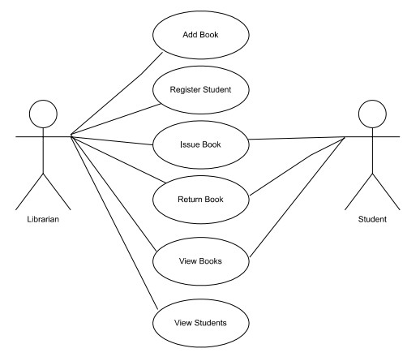

- Workflow Diagram:
Purpose: Shows the flow of operations in the system.
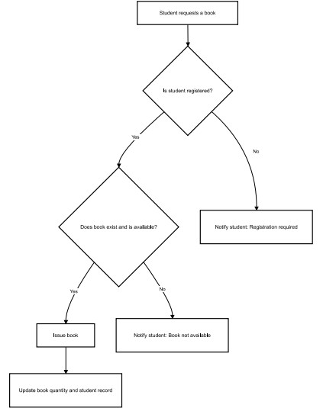

- Sequence Diagram:
Purpose: Shows the interaction between objects over time.

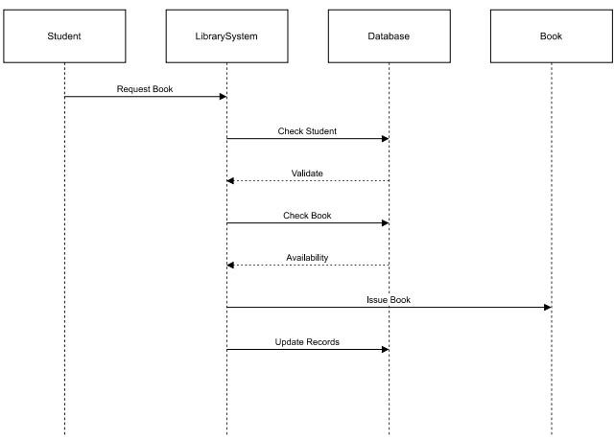

- Class/Component Diagram:
Purpose: Shows the structure of classes and relationships.
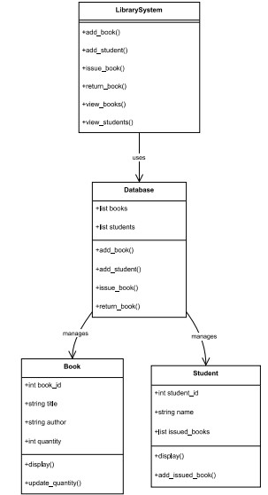

- ER Diagram:
Purpose: Shows database structure (entities, attributes, relationships).
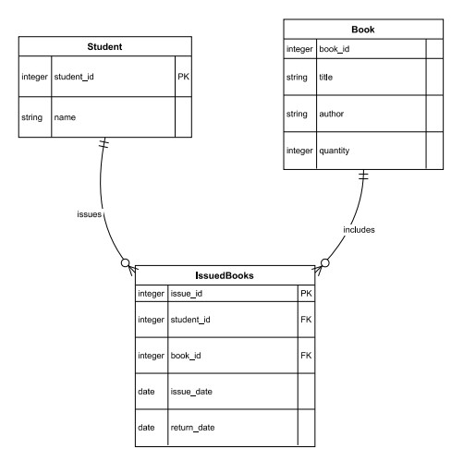

DESIGN DECISIONS AND RATIONALE

When designing the Library Management System (LMS), several important decisions were made to ensure the system is efficient, user-friendly, maintainable, and scalable. Each decision was carefully considered based on the requirements of the project and the constraints of a Java-based implementation.

- Choice of Programming Language
Decision: Java
Rationale:
- Strong OOP support
- Platform-independent
- Widely used for academic projects

- Modular Design
Decision: The system is divided into separate modules: Book.java, Student.java, LibraryDatabase.java, LibrarySystem.java
Rationale: Clean separation of UI, logic, and data layers
- Data Storage Approach
Decision: Java collections are used
Rationale:
Used Java Collections instead of external databases as they are simple for a small/medium library
- User Interface Design
Decision: A menu-driven command-line interface (CLI) was implemented.
Rationale:
Simple and easy to navigate for librarians without advanced computer skills.
Reduces complexity compared to GUI development, which is outside the current project scope.
Ensures focus on core functionalities like book issuance and student management.

- Object-Oriented Approach
Decision: Classes Book, Student, and Database were used to model system entities.
Rationale:
Encapsulates data and behavior for each entity, making the system modular and reusable.
Improves scalability, allowing additional attributes or methods to be added in the future (e.g., book categories, fine calculations).

- Transaction Handling
Decision: Book issue and return operations are handled with validation checks.
Rationale:
Ensures data integrity, preventing books from being issued to unregistered students or returned incorrectly.
Minimizes errors and ensures that book quantities are updated accurately after every transaction.

- Menu Navigation and Error Handling
Decision: Input validation and error messages are included in all operations.
Rationale:
Improves user experience by guiding the user to provide correct inputs.
Prevents program crashes due to invalid inputs, making the system robust.

- Scalability Considerations
Decision: System is designed to handle future expansions.
Rationale:
Can easily integrate additional features like search, categorization, reporting, or online notifications without major redesign.
Modular design and OOP principles ensure minimal disruption when extending functionalities.

IMPLEMENTATION DETAILS

The LMS is implemented using four Java files. The system is modular, with separate files for different components, making it easy to maintain and extend. The implementation focuses on core library functionalities such as managing books, students, and book transactions.

1. Modules and Their Functionality

1. Book.java
Represents a book with:
ID
Title
Author
Quantity
Methods:
Increment/decrement quantity
Check availability
Display info

2. Student.java
Represents a student with:
ID
Name
HashSet of issued books
Methods:
Issue book
Return book
Display info

3. LibraryDatabase.java
Handles:
Adding books/students
Issuing/returning books
Data validation
Storage via HashMap

4. LibrarySystem.java (Main File)
Displays menu
Takes user input
Calls database methods
Runs application loop

2. Key Features Implemented
Add Book:
Books are stored in HashMap<Integer, Book> where the key is the Book ID.

Register Student:
Students are stored in HashMap<String, Student> where the key is the Student ID. Each student maintains a HashSet<Integer> to track issued Book IDs. These structures allow O(1) average-time lookup and efficient updates.

Issue Book:
Checks if the student exists and the book is available.
Updates the IssuedBooks HashSet for the student and decreases the book quantity.

Return Book:
Validates the student and book.
Updates the student’s IssuedBooks HashSet and increases book quantity.

View Records:
Displays all books and students with relevant details.

- Data Structures Used
HashMaps: For storing books and student records (book_id or student_id as key).
HashSets: To track books issued to each student.
Advantages:
  - Fast lookup and updates
  - Easy to implement and understand
  - Suitable for small-to-medium library datasets

- User Interface
Menu-Driven CLI:
- Add Book
- Register Student
- Issue Book
- Return Book
- View Books
- View Students
- Exit
User selects an option, and the system prompts for required details.
Input validation ensures correct and safe data entry.

RESULTS

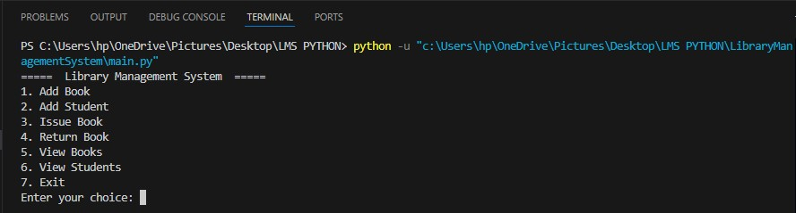
➢

Menu display

- Add book
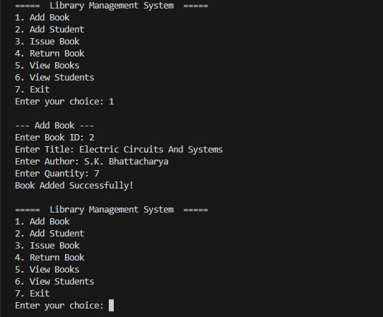

- Issue Book
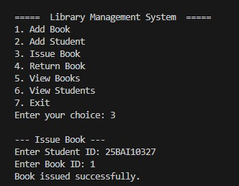

- Return Book
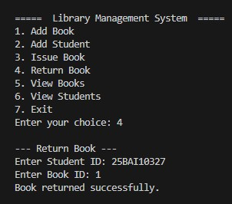

TESTING APPROACH

Testing is an essential part of software development to ensure that the system works correctly, reliably, and meets the specified requirements. For the Library Management System (LMS), a manual and systematic testing approach was adopted to verify all functionalities, validate data integrity, and ensure errorfree operation.

1. Testing Objectives
- To verify that all functionalities of the system are working as intended.
- To identify and correct any errors or bugs in the code.
- To ensure that the system is user-friendly and robust against invalid inputs.
- To validate that book and student records are stored and updated correctly.

2. Testing Types Used
- Unit Tests
- Individual class behavior
- Ensuring methods work correctly

2. Integration Tests
- Interactions between classes
- Database + UI flow

3. System Tests
- Full end-to-end scenarios

4. User Testing
- Tested with sample records to ensure ease of us
- Edge cases tested:
> Duplicate IDs
> Issuing unavailable books
> Returning unissued books
> Incorrect inputs

4. Error Handling and Validation
- Input validation ensures only valid IDs, names, and quantities are accepted.
- Attempting to issue a book that is out of stock shows an appropriate error message.
- Attempting to return a book that was not issued is prevented.
- Duplicate entries for books or students are handled gracefully.

5. Testing Outcome
- All core functionalities of the Library Management System work as intended.
- Errors and invalid inputs are handled properly.
- System is robust, user-friendly, and ready for deployment in small-scale library environments.

Testing involved unit-level, integration-level, and system-level verification for all modules in Java.
Input validation was ensured using try-catch blocks and controlled loops.
Edge cases such as invalid IDs, negative quantities, unavailable books, and duplicate issues were thoroughly checked.
The system remained stable and crash-free throughout testing.

CHALLENGES FACED
While developing the Library Management System (LMS) in Java, several challenges were encountered and addressed during the design and implementation phases:

1. Designing an Efficient Data Structure
Challenge: Choosing the right data structure to store books and student records efficiently.
Solution: HashMaps were used for fast lookup and easy management of records, with book IDs and student IDs as keys.

2. Handling Transactions Correctly
Challenge: Ensuring that book issuance and returns update records accurately without inconsistencies.
Solution: Implemented validation checks before issuing or returning books to confirm student registration, book availability, and previous transactions.

3. Input Validation
Challenge: Users entering incorrect or invalid inputs (e.g., letters instead of numbers for quantity).
Solution: Added input validation and exception handling to prevent crashes and guide users to enter correct data.

4. Maintaining Object-Oriented Design
Challenge: Structuring the program into classes and modules while keeping it simple for a small-scale project.
Solution: Separated concerns into Book, Student, Database, and Main modules, ensuring modularity and maintainability.

5. Managing Menu Navigation
Challenge: Designing a menu system that is intuitive and avoids errors when invalid choices are entered.
Solution: Implemented loops with clear instructions and error messages to guide the user.

6. Ensuring Scalability
Challenge: Making the system flexible enough to allow future features (like search, reporting, fines) without major changes.
Solution: Adopted modular design and object-oriented principles so new features can be added easily.

7. Testing All Scenarios
Challenge: Covering all possible edge cases, such as issuing unavailable books or returning unissued books.
Solution: Created comprehensive test cases to validate each function and handled all exceptional cases with appropriate error messages.

Summary:

Despite these challenges, the system was successfully implemented by using modular design, proper validation, and careful testing, resulting in a reliable and user-friendly Library Management System.
- Designing clean modular architecture in Java strengthened understanding of classes and relationships.
- Managing HashMap-based data storage required careful planning to ensure data integrity.
- Implementing error handling using Java exceptions gave practical exposure to robust system design.

LEARNINGS AND KEY TAKEAWAYS

Working on the Library Management System (LMS) project provided valuable practical experience in software development, problem-solving, and programming. The following points summarize the key learnings and insights gained during the project:

1. Object-Oriented Programming (OOP) Concepts
- Gained hands-on experience in Java.
- Learned to model real-world entities like Book and Student effectively using OOP principles.
- Understood the importance of encapsulation and modular design to make code reusable and maintainable.

2. Modular Programming
- Learned to separate functionality into different modules
- Realized the benefits of modularity in debugging, testing, and extending functionality.

3. Data Structures
- Practical understanding of Java.
- Learned how to perform quick lookups, updates, and deletions using HashMaps keys.

4. Input Validation and Error Handling
- Developed skills to handle invalid inputs and exceptions gracefully.
- Ensured the system is robust and user-friendly, preventing crashes due to unexpected input.

5. Menu-Driven Application Design
- Learned to design a simple, intuitive user interface for command-line applications.
- Developed skills in guiding users through multiple options while ensuring smooth navigation.

6. Testing and Debugging
- Gained experience in unit testing, integration testing, and system testing.
- Learned the importance of comprehensive test cases to cover all possible scenarios and edge cases.

7. Problem-Solving Skills
- Improved logical thinking by handling book issuance, returns, and record management.
- Learned to anticipate errors and design solutions to maintain data integrity.

8. Key Takeaways
- Building a project end-to-end enhances understanding of software development lifecycle.
- Proper planning, modular design, and testing are crucial for developing functional and maintainable software.
- Practical implementation bridges the gap between theoretical knowledge and real-world application.
•
Summary:
This project not only strengthened programming skills in Java but also provided practical experience in designing a functional, user-friendly, and efficient system. It reinforced the importance of planning, modularity, and thorough testing in software development.

FUTURE ENHANCEMENTS

Although the current Library Management System (LMS) provides basic functionalities for managing books, students, and book transactions, there are several opportunities to enhance its capabilities in the future. These enhancements can make the system more efficient, user-friendly, and scalable for larger libraries or online integration.

1. Persistent Storage
Enhancement: Integrate a database system such as SQLite, MySQL, or PostgreSQL.
Benefit: Data will be stored permanently, allowing the library to maintain records across multiple sessions. This avoids losing data when the program is closed.

2. Search and Filter Functionality
Enhancement: Implement advanced search options to filter books by title, author, category, or availability.
Benefit: Makes it faster and easier to locate books, improving user experience.

3. Fine and Penalty Management
Enhancement: Add functionality to calculate fines for late book returns.
Benefit: Helps maintain discipline in book return policies and improves accountability among students.

4. Categorization of Books
Enhancement: Introduce categories or genres for books (e.g., Science, Literature, Programming).
Benefit: Allows organized management of books and better reporting for library usage.

5. Online Access / Web Integration
Enhancement: Convert the system into a web-based LMS using frameworks like Flask or Django.
Benefit: Allows students and staff to access the system remotely, enabling online book requests, reservations, and real-time updates.

6. Automated Notifications
Enhancement: Add email or SMS notifications for book due dates, new arrivals, or overdue books.
Benefit: Keeps students informed and reduces late returns.

7. Reporting and Analytics
Enhancement: Generate reports on most issued books, active students, and library usage statistics.
Benefit: Helps librarians make data-driven decisions for improving library services.

8. Multi-User Support
Enhancement: Introduce role-based access (e.g., librarian, student, admin).
Benefit: Ensures secure operations and allows multiple users to use the system simultaneously with different permissions.

Summary:
These enhancements will transform the current Java-based LMS into a comprehensive, scalable, and modern library management system, suitable for larger libraries or institutions seeking digital solutions for library management.

REFERENCES

- Java Official Documentation

- Java Collections Framework Tutorials

- Oracle Java Tutorials

- Online LMS examples

- Stack Overflow community discussions

CONCLUSION

This Java-based Library Management System successfully automates essential library functions through a simple, reliable, and efficient console application. The project demonstrates strong object-oriented design, clean modular structure, and practical software engineering principles.

The system is fully functional and easily extendable, making it suitable for small to medium-sized libraries and an excellent foundation for future enhancements such as GUIs or web integration.

