

PROJECT REPORT
ON
LIBRARY MANAGEMENT SYSTEM

Submitted in partial fulfilment of the requirements for the award of degree of BACHELOR OF TECHNOLOGY
in
COMPUTER SCIENCE AND ENGINEERING

Submitted By : Aayushi Narang (24BSA10240)

SCHOOL OF COMPUTING SCIENCE AND ENGINEERING AND ARTIFICIAL INTELLIGENCE
VIT BHOPAL UNIVERSITY
KOTHRIKALAN, SEHORE
MADHYA PRADESH – 466114
NOV 2025

INTRODUCTION

A library serves as the academic heart of any institution. As collections of books grow and student numbers increase, manual library operations—such as maintaining book records, tracking issued items, and managing student information—become inefficient, error-prone, and time-consuming. Traditional paper-based systems often lead to misplaced books, inconsistent records, and difficulty locating information.
To overcome these issues, this project presents a Java-based Library Management System (LMS) designed to automate essential library operations through a simple, menu-driven console interface. The system enables the librarian to:
1)Add and manage books
2)Register students
3)Issue and return books
4)View book and student records
Maintain accurate, real-time data. A library is a cornerstone of knowledge for any educational or research institution. It houses books, journals and other learning resources that are essential for students, teachers and researchers. Traditionally, libraries were managed manually, where librarians maintained records of books, student memberships and book transactions using paper-based registers. While this approach worked in smaller setups, it is in efficient, time-consuming and prone to errors when the number of books and members grows. Manual management often leads to misplaced books, inaccurate records, delays in book issuance and returns and difficulty in tracking overdue books.
To overcome these challenges, a Library Management System (LMS) has been developed. It is a computer-based solution designed to automate and streamline the library’s daily operations. The system allows librarians to manage books, student records and book transactions efficiently. It reduces human errors, saves time and ensures that records are maintained accurately and can be easily retrieved whenever required.
The Python- based LMS is an object oriented program that provides a user friendly, menu-driven interface for library staff. It allows for the addition of new books, registration of students, issuance and return of books, and viewing of all stored records. The system maintains real-time information about the availability of books and ensures that a student cannot issue more books than allowed or return a book that was not issued.
Moreover, this LMS is designed to be scalable and extendable, meaning additional features such as search functionality, categorization of books, fine calculation for late returns, and report generation can be incorporated in the future. By implementing this system, libraries can enhance their operational efficiency, provide faster service to students, and maintain a digital record of all activities, which is crucial in the modern digital era.
In conclusion, the Library Management System is not just a tool for automation but a step towards modernizing and organizing educational resources, making knowledge more accessible and management more reliable.

PROBLEM STATEMENT

Managing a library manually is a challenging and time-consuming task. Librarians often struggle to keep track of a large number of books, student records, and book transactions such as issuance and returns. Traditional paperbased methods are prone to human errors, including misplaced books, incorrect record-keeping, and difficulties in identifying available or overdue books. Additionally, searching for a particular book or student record can take a considerable amount of time, leading to inefficiency in library operations.
With increasing numbers of students and books, the complexity of managing a library grows significantly, making it nearly impossible to maintain accurate records and ensure smooth functioning manually. Furthermore, manual systems do not provide real-time information, and reporting or analyzing data becomes cumbersome.
The Library Management System (LMS) addresses these issues by providing an automated, computer-based solution to manage books, students, and transactions efficiently. The system reduces manual effort, minimizes errors, and allows librarians to quickly access information, track book availability, and manage student records. It ensures that all operations are accurate, timely, and easily manageable, thereby improving the overall efficiency and reliability of library management. Managing a growing library manually presents several challenges:
- Difficulty tracking book availability
- Errors in issuing/returning books
- Duplicate or missing records
- Time-consuming searches
- No automatic validation of student or book details

The objective of this project is to create a simple, reliable Java application that automates these tasks, improves accuracy, reduces workload, and enhances the overall efficiency of library operations.
FUNCTIONAL REQUIREMENTS
The Library Management System (LMS) must perform the following core functions to support efficient library operations:

1. Book Management
- Add Book: The system shall allow the librarian to add new books with details such as Book ID, Title, Author, and Quantity.
- View Books: The system shall display all available books in the library along with their details.
- Update Quantity: The system shall allow updating the quantity of an existing book.
- Check Availability: The system shall allow checking whether a particular book is available or out of stock.

2. Student Management
- Register Student: The system shall allow registering new students with Student ID, Name, and Department/Class.
- View Student Records: The system shall display a list of all registered students.
- Validate Student: The system shall verify whether a student exists before allowing book issuance.

3. Book Issuing
- Issue Book:
  - The system shall allow issuing a book to a valid student. o The system shall reduce the book quantity by 1 after successful issuance.
  - The system shall prevent issuing if the book is out of stock.
  - The system shall prevent issuing if the student is not registered.
- Track Issued Books:
  - The system shall store information about which student has borrowed which book.

4. Book Return
• Return Book:
o The system shall allow returning previously issued books. o The system shall increase the book quantity by 1. o The system shall remove the entry from issued records after return.

5. Data Management
- Store Records: The system shall maintain in-memory data structures for books, students, and issued books.
- Ensure Data Integrity: The system shall ensure data is consistent (e.g., avoid issuing a book twice to the same student without returning it).

6. User Interface Requirements
- Menu-Driven Interface:
  - The system shall provide a simple command-line menu for performing operations. o Each option shall guide the user clearly to complete the chosen task.
- Input Validation:
  - The system shall validate inputs such as quantity, IDs, and names. o The system shall prevent invalid or incomplete entries from being accepted.

7. Exit and Session Control
- Exit System: The system shall allow the user to exit safely without errors.
- Restart via Menu: After each operation, the system shall return to the main menu for further actions.

NON-FUNCTIONAL REQUIREMENTS

These requirements define the quality, performance, and operational standards that the Library Management System (LMS) must meet to ensure a reliable and user-friendly experience.
1. Reliability • The system should operate without failures during normal usage.
- Data operations (add, issue, return) should be executed accurately and consistently.
- The system should prevent invalid operations that may corrupt data.

2. Usability
- The interface should be simple, menu-driven, and easy to navigate for beginners.
- Error messages must be clear and informative, guiding the user to correct mistakes.
- All operations should be intuitive, requiring minimal training for librarians or students.

3. Performance
- The system should respond quickly to user commands with minimal delay.
- Book and student searches should execute instantly, even as the data grows.
- All CRUD (Create/Read/Update/Delete) operations should complete within seconds.

4. Scalability
- The system should allow adding an unlimited number of books and students (within memory limits).
- The architecture should support easy future upgrades such as adding a GUI, database, or analytics module.

5. Maintainability
- Code should be modular, readable, and well-structured (separate files for book, student, database, main logic).
- Future developers must be able to modify or extend features without breaking the system.
- Each module should be independent to simplify debugging.

6. Portability
- The system should run on any OS that supports Python (Windows, macOS, Linux).
- No external dependencies should be mandatory, making it easy to transfer or deploy.

7. Security
- The system should validate all inputs to prevent invalid or harmful data entries.
- Only valid students should be allowed to issue or return books.
- Data access should be restricted to authorized users (in future versions).

8. Data Integrity
- The system must ensure correct book counts after issuing and returning. • Duplicate entries of the same student or book ID should be prevented.
- The system should avoid issuing books that are unavailable or already issued.

9. Availability
- The system should be accessible whenever required, without frequent crashes.
- Must support uninterrupted usage during library working hours.

SYSTEM ARCHITECTURE
The Library Management System (LMS) is designed as a modular, menu-driven Python application that follows an object-oriented approach. Its architecture ensures separation of concerns, scalability, and maintainability. The system can be visualized in layers and components as follows:

1. Architecture Overview
The system is based on a three-tier structure:
- Presentation Layer (User Interface):
  - Provides a menu-driven interface for the user (librarian). o Allows the user to interact with the system to perform operations like adding books, registering students, issuing/returning books, and viewing records.
- Logic Layer (Application/Business Logic):
  - Contains the core functionality of the LMS. o Includes operations for validating user inputs, checking book availability, managing transactions, and maintaining the business rules of the library.
  - Classes such as Book, Student, and Database handle the core logic.
- Data Layer (Storage/Database):
  - Maintains all records of books, students, and book transactions. o Uses Python dictionaries (or files for persistence) to store data in memory. o Ensures fast access, retrieval, and updating of records.

2. Components of the System
The LMS follows a three-layer modular architecture, aligned with the design diagrams in the original report.
1. Presentation Layer
> File: LibrarySystem.java
> Menu display
> User input
> Calls logic functions

2. Logic Layer
> File: LibraryDatabase.java
> Core operations (add, issue, return)
>Validations
> Data integrity checks

3. Data Layer
> Files: Book.java, Student.java
> Represent books and students
> Manage attributes and behaviors

Data Structures Used:

HashMap<Integer, Book>
HashMap<String, Student>
HashSet<Integer> for issued books

3. Flow of Operations
1. Start System → Display Menu → User selects an option 2. Based on the option:
o Add Book → Input details → Store in database o Register Student → Input details → Store in database o Issue Book → Check student & book availability → Update records o Return Book → Validate return → Update book quantity o View Records → Retrieve and display data
3. Exit System

4. Diagrammatic Representation
+-------------------+
| Presentation | <- Menu-driven interface
+-------------------+
| v
+-------------------+
| Logic | <- Book, Student, Transaction operations
+-------------------+
| v
+-------------------+
| Data | <- Dictionaries or Files for storage +-------------------+
This architecture ensures that the system is organized, scalable, and easy to maintain, with clear separation between user interaction, business logic, and data storage.

DESIGN DIAGRAMS

- Use Case Diagram:
Purpose: Shows the interactions between users (actors) and the system.

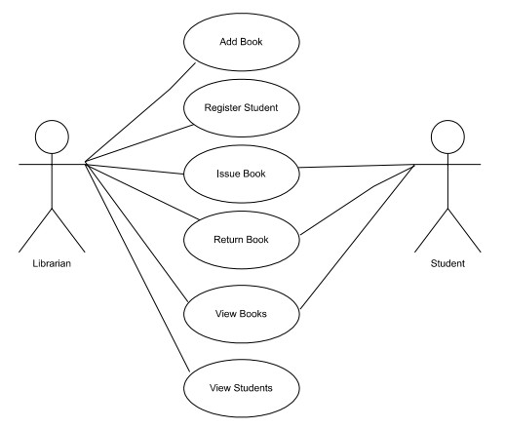

- Workflow Diagram:
Purpose: Shows the flow of operations in the system.
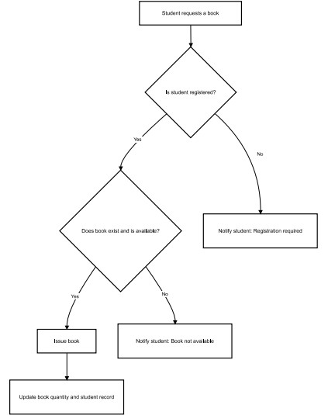

- Sequence Diagram:
Purpose: Shows the interaction between objects over time.

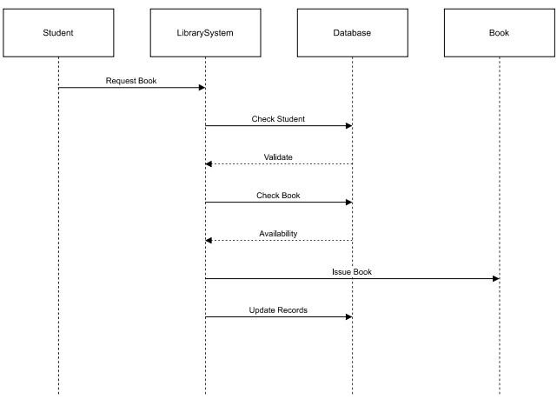

- Class/Component Diagram:
Purpose: Shows the structure of classes and relationships.
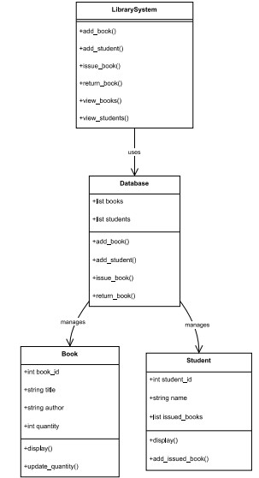

- ER Diagram:
Purpose: Shows database structure (entities, attributes, relationships).
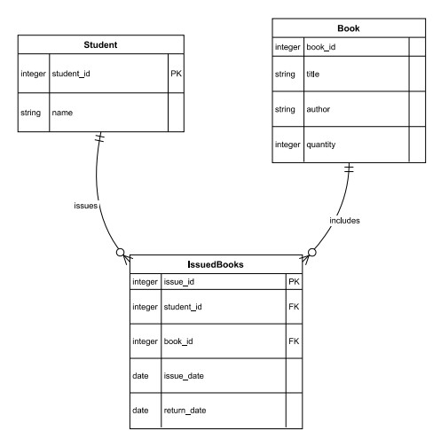

DESIGN DECISIONS AND RATIONALE

When designing the Library Management System (LMS), several important decisions were made to ensure the system is efficient, user-friendly, maintainable, and scalable. Each decision was carefully considered based on the requirements of the project and the constraints of a Python-based implementation.

- Choice of Programming Language
Decision: Java
Rationale:
- Strong OOP support
- Platform-independent
- Widely used for academic projects

- Modular Design
Decision: The system is divided into separate modules: Book.java, Student.java, LibraryDatabase.java, LibrarySystem.java
Rationale: Clean separation of UI, logic, and data layers
- Data Storage Approach
Decision: Java collections are used
Rationale:
Used Java Collections instead of external databases as they are simple for a small/medium library
- User Interface Design
Decision: A menu-driven command-line interface (CLI) was implemented.
Rationale:
Simple and easy to navigate for librarians without advanced computer skills.
Reduces complexity compared to GUI development, which is outside the current project scope.
Ensures focus on core functionalities like book issuance and student management.

- Object-Oriented Approach
Decision: Classes Book, Student, and Database were used to model system entities.
Rationale:
Encapsulates data and behavior for each entity, making the system modular and reusable.
Improves scalability, allowing additional attributes or methods to be added in the future (e.g., book categories, fine calculations).

- Transaction Handling
Decision: Book issue and return operations are handled with validation checks.
Rationale:
Ensures data integrity, preventing books from being issued to unregistered students or returned incorrectly.
Minimizes errors and ensures that book quantities are updated accurately after every transaction.

- Menu Navigation and Error Handling
Decision: Input validation and error messages are included in all operations.
Rationale:
Improves user experience by guiding the user to provide correct inputs.
Prevents program crashes due to invalid inputs, making the system robust.

- Scalability Considerations
Decision: System is designed to handle future expansions.
Rationale:
Can easily integrate additional features like search, categorization, reporting, or online notifications without major redesign.
Modular design and OOP principles ensure minimal disruption when extending functionalities.

IMPLEMENTATION DETAILS

The LMS is implemented using four Java files. The system is modular, with separate files for different components, making it easy to maintain and extend. The implementation focuses on core library functionalities such as managing books, students, and book transactions.

1. Modules and Their Functionality

1. Book.java
Represents a book with:
ID
Title
Author
Quantity
Methods:
Increment/decrement quantity
Check availability
Display info

2. Student.java
Represents a student with:
ID
Name
List of issued books
Methods:
Issue book
Return book
Display info

3. LibraryDatabase.java
Handles:
Adding books/students
Issuing/returning books
Data validation
Storage via HashMap

4. LibrarySystem.java (Main File)
Displays menu
Takes user input
Calls database methods
Runs application loop

2. Key Features Implemented
Add Book:
Librarian enters book details; system stores it in the books dictionary.

Register Student:
Student details are collected and stored in the students dictionary.

Issue Book:
Checks if the student exists and the book is available.
Updates the issued_books list for the student and decreases the book quantity.

Return Book:
Validates the student and book.
Updates the student’s issued_books list and increases book quantity.

View Records:
Displays all books and students with relevant details.

- Data Structures Used
Dictionaries: For storing books and student records (book_id or student_id as key).
Lists: To track books issued to each student.
Advantages:
  - Fast lookup and updates
  - Easy to implement and understand
  - Suitable for small-to-medium library datasets

- User Interface
Menu-Driven CLI:
- Add Book
- Register Student
- Issue Book
- Return Book
- View Books
- View Students
- Exit
User selects an option, and the system prompts for required details.
Input validation ensures correct and safe data entry.

RESULTS

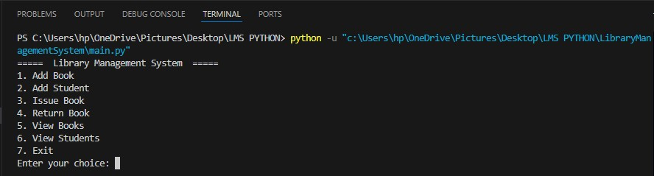
➢

Menu display

- Add book
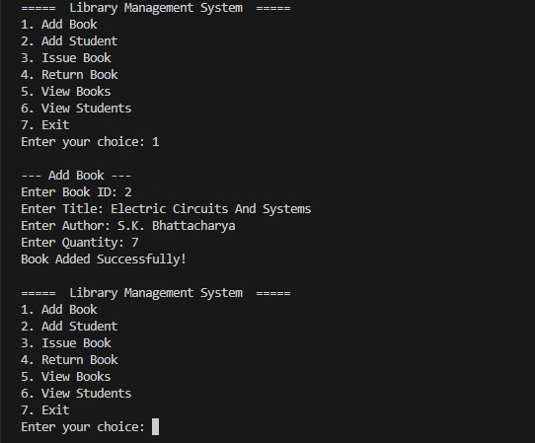

- Issue Book
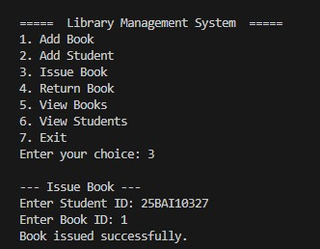

- Return Book
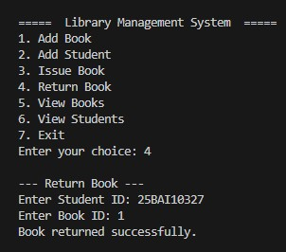

TESTING APPROACH

Testing is an essential part of software development to ensure that the system works correctly, reliably, and meets the specified requirements. For the Library Management System (LMS), a manual and systematic testing approach was adopted to verify all functionalities, validate data integrity, and ensure errorfree operation.

1. Testing Objectives
- To verify that all functionalities of the system are working as intended.
- To identify and correct any errors or bugs in the code.
- To ensure that the system is user-friendly and robust against invalid inputs.
- To validate that book and student records are stored and updated correctly.

2. Testing Types Used
- Unit Tests
- Individual class behavior
- Ensuring methods work correctly

2. Integration Tests
- Interactions between classes
- Database + UI flow

3. System Tests
- Full end-to-end scenarios

4. User Testing
- Tested with sample records to ensure ease of us
- Edge cases tested:
> Duplicate IDs
> Issuing unavailable books
> Returning unissued books
> Incorrect inputs

4. Error Handling and Validation
- Input validation ensures only valid IDs, names, and quantities are accepted.
- Attempting to issue a book that is out of stock shows an appropriate error message.
- Attempting to return a book that was not issued is prevented.
- Duplicate entries for books or students are handled gracefully.

5. Testing Outcome
- All core functionalities of the Library Management System work as intended.
- Errors and invalid inputs are handled properly.
- System is robust, user-friendly, and ready for deployment in small-scale library environments.

CHALLENGES FACED
While developing the Library Management System (LMS) in Java, several challenges were encountered and addressed during the design and implementation phases:

1. Designing an Efficient Data Structure
Challenge: Choosing the right data structure to store books and student records efficiently.
Solution: Dictionaries were used for fast lookup and easy management of records, with book IDs and student IDs as keys.

2. Handling Transactions Correctly
Challenge: Ensuring that book issuance and returns update records accurately without inconsistencies.
Solution: Implemented validation checks before issuing or returning books to confirm student registration, book availability, and previous transactions.

3. Input Validation
Challenge: Users entering incorrect or invalid inputs (e.g., letters instead of numbers for quantity).
Solution: Added input validation and exception handling to prevent crashes and guide users to enter correct data.

4. Maintaining Object-Oriented Design
Challenge: Structuring the program into classes and modules while keeping it simple for a small-scale project.
Solution: Separated concerns into Book, Student, Database, and Main modules, ensuring modularity and maintainability.

5. Managing Menu Navigation
Challenge: Designing a menu system that is intuitive and avoids errors when invalid choices are entered.
Solution: Implemented loops with clear instructions and error messages to guide the user.

6. Ensuring Scalability
Challenge: Making the system flexible enough to allow future features (like search, reporting, fines) without major changes.
Solution: Adopted modular design and object-oriented principles so new features can be added easily.

7. Testing All Scenarios
Challenge: Covering all possible edge cases, such as issuing unavailable books or returning unissued books.
Solution: Created comprehensive test cases to validate each function and handled all exceptional cases with appropriate error messages.

Summary:
Despite these challenges, the system was successfully implemented by using modular design, proper validation, and careful testing, resulting in a reliable and user-friendly Library Management System.

LEARNINGS AND KEY TAKEAWAYS

Working on the Library Management System (LMS) project provided valuable practical experience in software development, problem-solving, and programming. The following points summarize the key learnings and insights gained during the project:

1. Object-Oriented Programming (OOP) Concepts
- Gained hands-on experience in Java.
- Learned to model real-world entities like Book and Student effectively using OOP principles.
- Understood the importance of encapsulation and modular design to make code reusable and maintainable.

2. Modular Programming
- Learned to separate functionality into different modules
- Realized the benefits of modularity in debugging, testing, and extending functionality.

3. Data Structures
- Practical understanding of Java.
- Learned how to perform quick lookups, updates, and deletions using dictionary keys.

4. Input Validation and Error Handling
- Developed skills to handle invalid inputs and exceptions gracefully.
- Ensured the system is robust and user-friendly, preventing crashes due to unexpected input.

5. Menu-Driven Application Design
- Learned to design a simple, intuitive user interface for command-line applications.
- Developed skills in guiding users through multiple options while ensuring smooth navigation.

6. Testing and Debugging
- Gained experience in unit testing, integration testing, and system testing.
- Learned the importance of comprehensive test cases to cover all possible scenarios and edge cases.

7. Problem-Solving Skills
- Improved logical thinking by handling book issuance, returns, and record management.
- Learned to anticipate errors and design solutions to maintain data integrity.

8. Key Takeaways
- Building a project end-to-end enhances understanding of software development lifecycle.
- Proper planning, modular design, and testing are crucial for developing functional and maintainable software.
- Practical implementation bridges the gap between theoretical knowledge and real-world application.
•
Summary:
This project not only strengthened programming skills in Java but also provided practical experience in designing a functional, user-friendly, and efficient system. It reinforced the importance of planning, modularity, and thorough testing in software development.

FUTURE ENHANCEMENTS

Although the current Library Management System (LMS) provides basic functionalities for managing books, students, and book transactions, there are several opportunities to enhance its capabilities in the future. These enhancements can make the system more efficient, user-friendly, and scalable for larger libraries or online integration.

1. Persistent Storage
Enhancement: Integrate a database system such as SQLite, MySQL, or PostgreSQL.
Benefit: Data will be stored permanently, allowing the library to maintain records across multiple sessions. This avoids losing data when the program is closed.

2. Search and Filter Functionality
Enhancement: Implement advanced search options to filter books by title, author, category, or availability.
Benefit: Makes it faster and easier to locate books, improving user experience.

3. Fine and Penalty Management
Enhancement: Add functionality to calculate fines for late book returns.
Benefit: Helps maintain discipline in book return policies and improves accountability among students.

4. Categorization of Books
Enhancement: Introduce categories or genres for books (e.g., Science, Literature, Programming).
Benefit: Allows organized management of books and better reporting for library usage.

5. Online Access / Web Integration
Enhancement: Convert the system into a web-based LMS using frameworks like Flask or Django.
Benefit: Allows students and staff to access the system remotely, enabling online book requests, reservations, and real-time updates.

6. Automated Notifications
Enhancement: Add email or SMS notifications for book due dates, new arrivals, or overdue books.
Benefit: Keeps students informed and reduces late returns.

7. Reporting and Analytics
Enhancement: Generate reports on most issued books, active students, and library usage statistics.
Benefit: Helps librarians make data-driven decisions for improving library services.

8. Multi-User Support
Enhancement: Introduce role-based access (e.g., librarian, student, admin).
Benefit: Ensures secure operations and allows multiple users to use the system simultaneously with different permissions.

Summary:
These enhancements will transform the current Java-based LMS into a comprehensive, scalable, and modern library management system, suitable for larger libraries or institutions seeking digital solutions for library management.

REFERENCES

- Java Official Documentation

- Java Collections Framework Tutorials

- Oracle Java Tutorials

- Online LMS examples

- Stack Overflow community discussions

CONCLUSION

This Java-based Library Management System successfully automates essential library functions through a simple, reliable, and efficient console application. The project demonstrates strong object-oriented design, clean modular structure, and practical software engineering principles.

The system is fully functional and easily extendable, making it suitable for small to medium-sized libraries and an excellent foundation for future enhancements such as GUIs or web integration.

