GreenCompute AI Hackathon Submission
Autonomous Carbon Aware Batch Workload Optimization on Google Cloud
Patchamomma 2026 Touchpoint 3 Final Submission
Submitted by Aayushi Choubey
Submission date 10 September 2026

Deployed application
Open GreenCompute AI
Source repository
View the GitHub repository

GreenCompute AI accepts a natural language workload request, enforces technical and policy constraints, selects an execution plan, runs it through Google Cloud Batch, and records the result in BigQuery.

Executive Summary
GreenCompute AI helps teams place flexible batch workloads in an appropriate Google Cloud region, time window, machine type, and provisioning model. It evaluates cost, regional grid intensity, reliability, capacity, deadline, data locality, checkpointing, and business policy before dispatching work.
A user describes a workload in natural language. Gemini 2.5 Flash converts that request into a validated specification. Deterministic Python code then creates candidate plans, rejects unsafe or prohibited options, scores feasible candidates, and selects the winner. Google Cloud Workflows coordinates scheduling and Google Cloud Batch performs the real execution. BigQuery stores the decision evidence and final telemetry.
The deployed prototype demonstrates the complete control loop. It uses current public list price observations from the Google Cloud Billing API and real Workflow and Batch telemetry. Carbon, capacity, and reliability inputs are source labelled static baselines in this hackathon version.

Submission at a Glance
Item | Implementation
Primary use case | Movable compute intensive batch workloads with a deadline
User interface | Natural language dashboard hosted on Cloud Run
Google model | Gemini 2.5 Flash through Vertex AI and the Google Gen AI SDK
Decision engine | Deterministic hard constraints and weighted multi objective scoring
Execution | Google Cloud Workflows and Google Cloud Batch
Data layer | BigQuery configuration metrics events audit evidence and analytical views
Traceability | Workload optimization candidate decision Workflow Batch and execution identifiers

Project Links
Application greencompute-api-877509863043.asia-south1.run.app
Repository github.com/AayushiChoubey/greencompute-ai

Project Description
Cloud batch workloads are often submitted with a fixed region, immediate start time, oversized machine, and Standard provisioning. This is simple to operate, but it ignores differences in regional price, grid intensity, capacity, Spot interruption risk, and available deadline slack.
GreenCompute AI turns these factors into a policy controlled placement decision. The system does not assume that every workload should move. Data local jobs stay in their home region. Jobs with approved replicas may run near a replica. Portable compute heavy jobs may use another permitted region when the modeled benefit justifies it.

Project Use Case
The primary use case is a compute intensive job whose input is small, portable, or already replicated and whose deadline allows some placement flexibility. Examples include Monte Carlo risk simulations, scientific parameter sweeps, synthetic data generation, software test matrices, media rendering, model training, and batch inference.
A financial services team, for example, can request a checkpointable portfolio simulation that must finish before the next business day. GreenCompute AI evaluates allowed regions and Standard or Spot options. It can select a cheaper or lower intensity plan while preserving the required reliability and SLA buffer. If no candidate satisfies every hard constraint, the system prevents execution and shows the rejected alternatives.

Where the Product Is Most Useful
- The job consumes much more compute than data transfer.
- The input is portable or already replicated in approved regions.
- The workload can start within a window rather than immediately.
- Spot can be used safely because the workload is checkpointable.
- Cost carbon reliability and deadline tradeoffs must be recorded and explained.

Where the Product Should Not Move Work
- Data must remain in one region and no approved replica exists.
- The job is latency sensitive or stateful.
- Input transfer cost or time is larger than the placement benefit.
- A noncheckpointable workload has a tight deadline and cannot tolerate Spot interruption.

Architecture Diagram
The architecture separates language understanding from decision authority. Gemini parses and explains the request. The optimizer alone applies constraints and chooses a plan. This keeps the final decision reproducible and auditable.
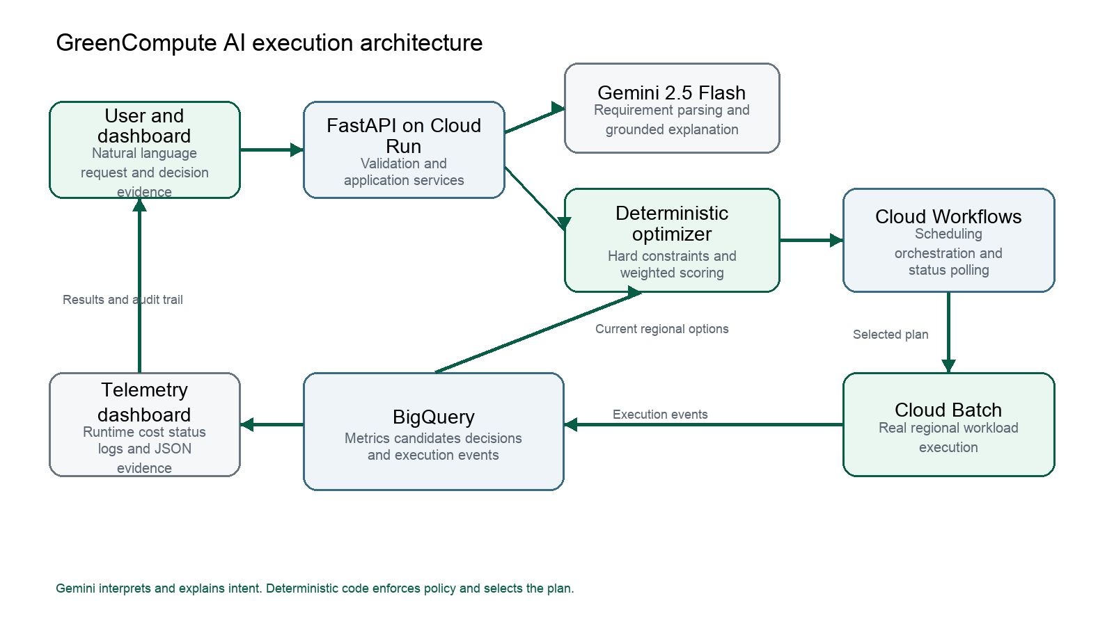
Figure 1 GreenCompute AI end to end architecture

Architecture Components
Component | Responsibility
Dashboard | Collects workload intent and displays the selected plan candidate evidence Workflow status and telemetry
FastAPI on Cloud Run | Hosts APIs validation orchestration adapters and the dashboard
Gemini 2.5 Flash | Parses natural language into structured input and explains verified decisions
Deterministic optimizer | Generates candidates enforces hard constraints applies weights and selects the winner
BigQuery | Stores metrics candidates policy evaluations decisions and execution events
Cloud Workflows | Waits for scheduled starts dispatches Batch polls status and sends the terminal callback
Cloud Batch | Runs the selected job in the chosen region machine and provisioning model
Cloud Logging | Provides detailed Workflow Cloud Run and Batch diagnostics

Solution Workflow
1. The user enters a workload request in natural language.
2. Gemini returns a structured specification containing runtime resources deadline regions locality Spot checkpointing reliability and objective weights.
3. Pydantic validates types allowed values timestamps and weight totals.
4. The API reads current compute options from a BigQuery analytical view.
5. The optimizer creates region machine provisioning and start time candidates.
6. Hard constraints reject invalid candidates before any scoring occurs.
7. Feasible candidates receive normalized cost carbon reliability and SLA scores.
8. The API stores the full candidate set policy evidence selected decision and alternatives.
9. Gemini explains the verified result using authoritative comparison facts.
10. Cloud Workflows schedules and submits the candidate to Cloud Batch.
11. The final Batch state runtime and calculated cost return to BigQuery and the dashboard.

Decision Constraints
Constraint | Decision rule
Data locality | Use only the home region approved replica regions or explicitly allowed portable regions
Resources | Reject machines with insufficient vCPU or memory
Resource fit | Reject oversized shapes when a smaller shape satisfies the request at equal or lower modeled cost
Spot safety | Permit Spot only when Spot is allowed and the workload is checkpointable
Deadline | Reject candidates whose predicted finish exceeds the deadline
SLA buffer | Preserve the minimum requested safety margin
Reliability | Reject options below the configured reliability threshold
Cost premium | Reject options above the permitted premium over the cheapest feasible candidate

Weighted Scoring
The optimizer normalizes every feasible candidate to a zero to one benefit score. Lower cost and lower grid intensity are better. Higher reliability and a larger SLA buffer are better. The final score is the weighted sum of those four values. Default weights are 0.45 for cost, 0.25 for carbon, 0.25 for reliability, and 0.05 for SLA buffer. Users can change the weights, but they must total 1.0.
$$Benefit Score = (W_{cost} · {Cost}_{norm}) + (W_{carbon} · {Carbon}_{norm}) + (W_{rel} · {Rel}_{norm}) + (W_{sla} · {SLA}_{norm})$$
Hard constraints always take precedence over scoring. A low cost option cannot win if it violates data locality, misses the deadline, lacks capacity, or falls below the reliability requirement.

Data Architecture
BigQuery is the analytical and event store. The schema separates versioned configuration, time series metric observations, immutable decision events, audit evidence, and query friendly views. This separation keeps the optimization trail reproducible and supports future reporting.
The hackathon's static carbon metrics use concrete regional comparison baselines: asia-south1 uses 650 gCO₂e/kWh, while the cleaner europe-west1 region in Belgium uses 170 gCO₂e/kWh. The relative static grid intensity reduction is (650 − 170) ÷ 650 = 73.8 percent. This calculation is the numerical basis for the 73.8 percent reduction cited in the demonstrated-results table; these values are comparative baselines, not live measured workload emissions.
Dataset | Contents
greencompute_config | Workload policy data asset region machine and pricing SKU versions
greencompute_metrics | Price carbon reliability capacity and transfer observations
greencompute_events | Optimization candidate policy decision and execution events
greencompute_audit | User action security and data quality evidence
greencompute_analytics | Current compute options candidate comparison optimization summary execution summary and daily metrics

Current Data Sources
Input | Hackathon implementation
Compute price | Google Cloud Billing API public list price snapshots
Grid intensity | Static regional comparative baselines marked synthetic
Reliability | Static Standard and Spot baselines marked synthetic
Capacity | Static availability baselines marked synthetic
Runtime | Observed Cloud Batch execution duration when available
Actual cost | Observed runtime multiplied by the selected hourly rate

Use of Gemini
Gemini 2.5 Flash performs two bounded tasks. It converts natural language into a validated workload specification, and it converts the deterministic result into a concise explanation. Gemini does not submit arbitrary jobs or override hard constraints.
The explanation receives calculated home region comparison facts. It is instructed not to invent savings, recalculate percentages, describe static grid intensity as measured workload emissions, or make legal conclusions. This design uses generative AI where language understanding helps while retaining deterministic control over cloud execution.

Implementation Details
Layer | Technology | Implemented capability
Frontend | HTML JavaScript Tailwind CSS | Prompt entry decision evidence Workflow polling telemetry and JSON details
API | Python 3.12 FastAPI Pydantic | Validation optimization execution callbacks and telemetry endpoints
AI | Gemini 2.5 Flash Vertex AI | Structured parsing and grounded explanation
Decision | Python optimizer | Candidate generation constraints normalization weighting and trace IDs
Data | BigQuery SQL | Versioned configuration time series metrics append only events and analytical views
Orchestration | Cloud Workflows | Scheduling Batch dispatch bounded status polling callback and final result
Compute | Cloud Batch | Regional machine and Standard or Spot workload execution
Delivery | Docker Cloud Build Artifact Registry Cloud Run | Container build and public application deployment
Quality | Pytest | Core locality Spot scoring cost guardrail and resource fit tests

Google Cloud Services
- Cloud Run hosts the FastAPI application and dashboard.
- Vertex AI provides Gemini 2.5 Flash through the Google Gen AI SDK.
- BigQuery stores metric observations and the complete decision and execution trail.
- Cloud Workflows coordinates delayed execution status polling and callbacks.
- Cloud Batch runs the selected workload in the chosen region and provisioning model.
- Cloud Billing API supplies public list price observations.
- Secret Manager protects the pricing API key.
- Cloud Build and Artifact Registry build and store the application container.
- Cloud Logging exposes Cloud Run Workflow and Batch diagnostics.

Implemented Features
- Natural language workload specification and strict schema validation.
- Data local replicated and portable locality modes.
- Exact and flexible start modes with hourly candidate generation.
- Standard and Spot comparison with checkpoint and reliability safety rules.
- Configurable cost carbon reliability and SLA weights.
- Cost premium and oversized resource guardrails.
- Persisted selected cheapest greenest and safest alternatives.
- Real Workflow and Batch dispatch with BigQuery terminal telemetry.
- Dashboard candidate comparison Workflow details logs and JSON evidence.
- Historical runtime estimation from successful execution telemetry.

Demonstrated Results
The following runs were observed in the deployed hackathon application on 10 September 2026. Costs depend on runtime and the stored price snapshot. Grid values are static comparative intensity baselines rather than measured workload emissions.
Scenario | Selected plan | Observed decision
Data local cost priority | asia-south1 n2-standard-4 Spot | Stayed in the home region and selected Spot after meeting the 0.80 reliability threshold
Portable cost priority | europe-west1 n2-standard-4 Spot | 30.8 percent lower modeled cost and 73.8 percent lower static grid intensity than the comparable home region Spot option
Replicated carbon priority | europe-west1 n2-standard-4 Spot | Used an approved replica region and selected the lower intensity lower cost candidate
High reliability | europe-west1 n2-standard-4 Standard | Rejected lower reliability Spot candidates and selected reliability 0.99
Impossible deadline and resources | No execution | Returned No Feasible Plan and prevented Workflow dispatch

What Makes the Implementation Distinct
The implementation combines language understanding, constrained optimization, real cloud execution, and an auditable data model. The model interprets the request, but deterministic code owns the decision. Every rejected candidate has a reason, and every selected plan is connected to its Workflow execution, Batch job, runtime, and cost.
The locality model also makes the sustainability claim practical. GreenCompute AI can move portable compute, execute near an approved replica, or keep data local. Staying in the home region is a valid optimized result when movement is prohibited or uneconomic.

Impact
Without this decision layer, teams can miss lower cost or lower intensity execution opportunities, overprovision machines, use unreliable capacity for the wrong workloads, or make regional moves that violate policy. They also lack a common record explaining why a workload ran in a specific place and whether the result matched the estimate.
GreenCompute AI gives engineering, FinOps, sustainability, and governance teams the same evidence. The immediate value is safer placement and clearer tradeoffs. The longer term value is a feedback loop in which actual runtime and cost improve future decisions.

Deployed Application Guide
The application is public and does not require a login for the hackathon demonstration.
Open the deployed GreenCompute AI application

Recommended Demo Prompt
Run a 5-minute checkpointable Monte Carlo risk simulation before tomorrow at noon UTC. The input is portable and may run in asia-south1 or europe-west1. It needs 4 vCPUs and 16 GB memory. Spot is allowed with minimum reliability 0.80. Use weights: cost 0.20, carbon 0.60, reliability 0.15, SLA buffer 0.05.

Steps to Test
1. Paste the recommended prompt into Natural Language Dispatch.
2. Select Evaluate and Explain Plan.
3. Review the selected region machine provisioning cost grid intensity and weights.
4. Inspect candidate start times SLA buffers scores and rejected alternatives.
5. Select Dispatch Live Workflow to start a real Workflow and Batch job.
6. Wait approximately one to two minutes for the demonstration job.
7. Review Empirical Telemetry for state runtime cost Workflow details logs and raw JSON.

Expected Demo Outcome
The exact candidate depends on the latest stored price observations. The application should choose only among asia-south1 and europe-west1, reject candidates that violate the request, and explain the selected tradeoff. Because the workload is checkpointable and the minimum reliability is 0.80, a Spot candidate can remain feasible. Dispatch should create a Workflow and Batch execution and later add terminal telemetry.

Infeasible Plan Demonstration
To demonstrate policy safety, request 128 vCPUs and 512 GB memory within 20 minutes, require reliability 0.999, require a 30-minute SLA buffer, make the workload data local and noncheckpointable, and request Spot. GreenCompute AI should show No Feasible Plan and must not create a Workflow execution.

Hackathon Scope and Transparency
This submission focuses on proving the end to end architecture and decision behavior. It is not presented as a production platform. The deployed application uses a demonstration Batch runnable, public application access, static carbon capacity and reliability baselines, and runtime derived cost rather than reconciled billing cost.
These limitations are visible in the data model and user explanation. The prototype does not claim that its static regional grid values are live Google data center emissions. It demonstrates how live forecasts can replace the current source without changing the decision and audit architecture.

Next Product Capabilities
- Live hourly grid intensity ingestion for meaningful temporal shifting.
- Input asset and replica references with transfer cost and transfer duration.
- Automatic Spot preemption recovery on a retained Standard fallback candidate.
- Registered workload containers with controlled commands data access and service accounts.
- Portfolio simulation for budget carbon and SLA tradeoffs across many jobs.

Submission Information
Field | Value
Idea title | GreenCompute AI Autonomous Carbon Aware Batch Workload Optimizer
Submitter | Aayushi Choubey
Registered email | aayushichoubey23@gmail.com
Team | Self
Data source category | Other Google Cloud Billing API static source labelled baselines and empirical Batch telemetry stored in BigQuery
AI category | Gemini API
Repository | https://github.com/AayushiChoubey/greencompute-ai
Application | https://greencompute-api-877509863043.asia-south1.run.app

