**ASP.NET (ASSIGNMENT-1)**

1. ONE CONTROLLER

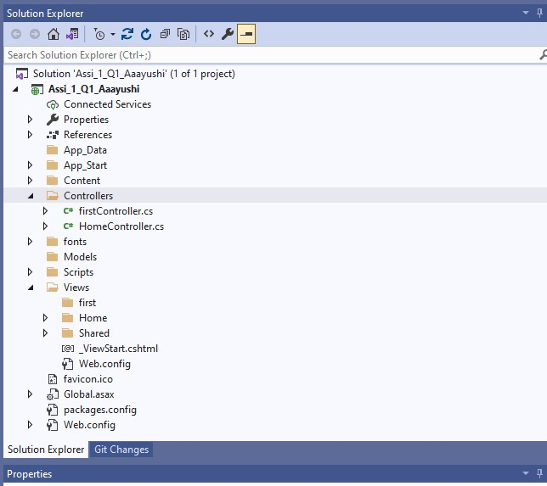

1. TWO CONTROLLER

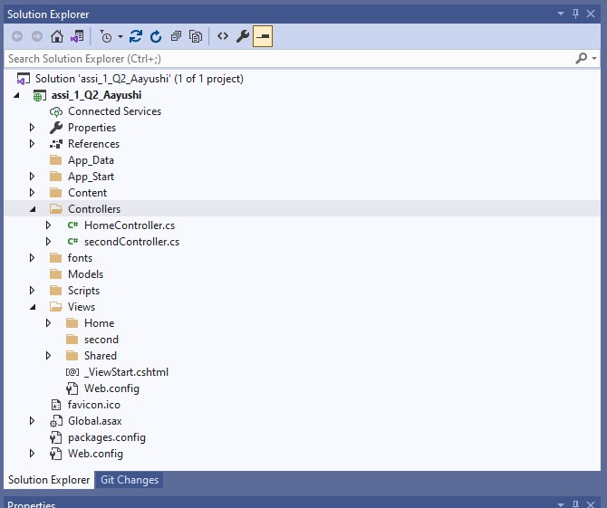

1. THREE CONTROLLER

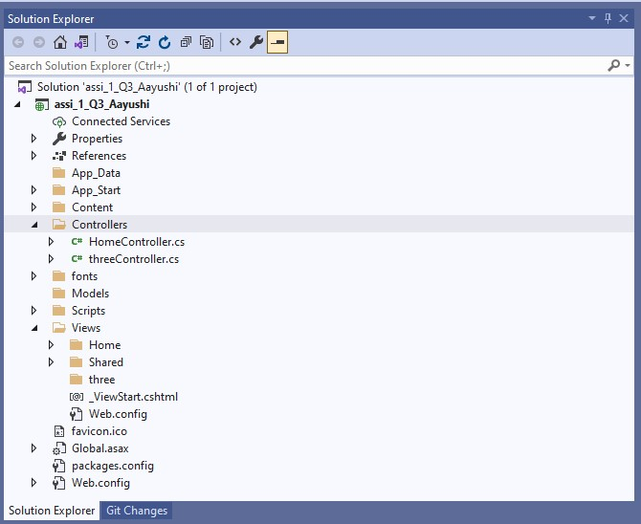

1. FOUR CONTROLLER

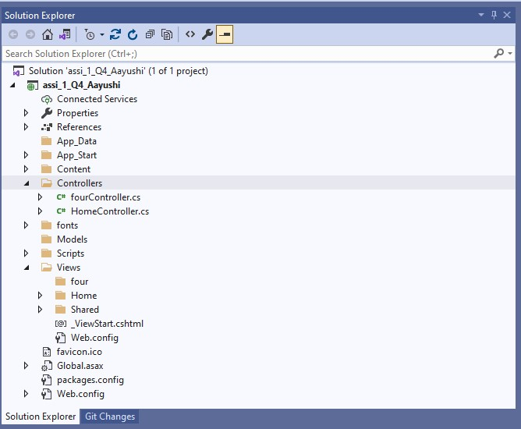

1. FIVE CONTROLLER

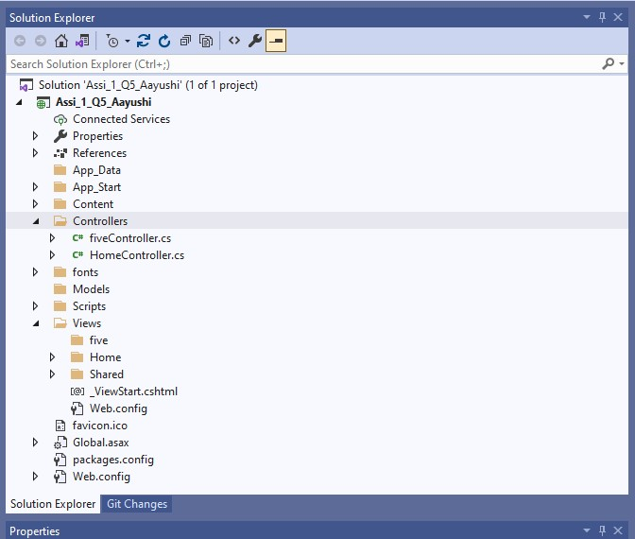

1. SIX CONTROLLER

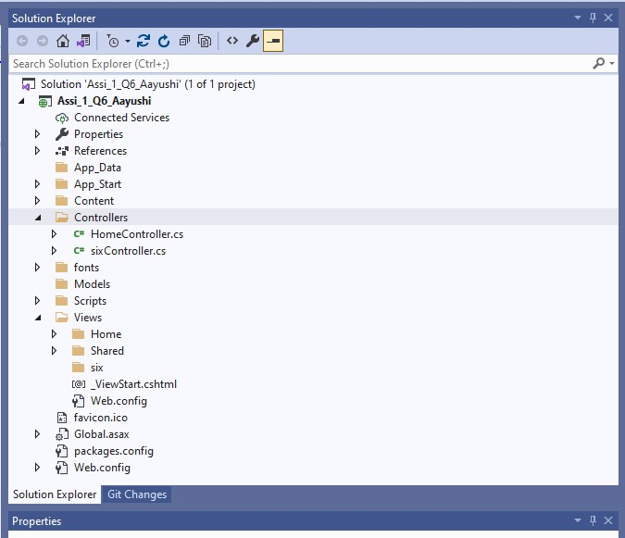

1. SEVEN CONTROLLER

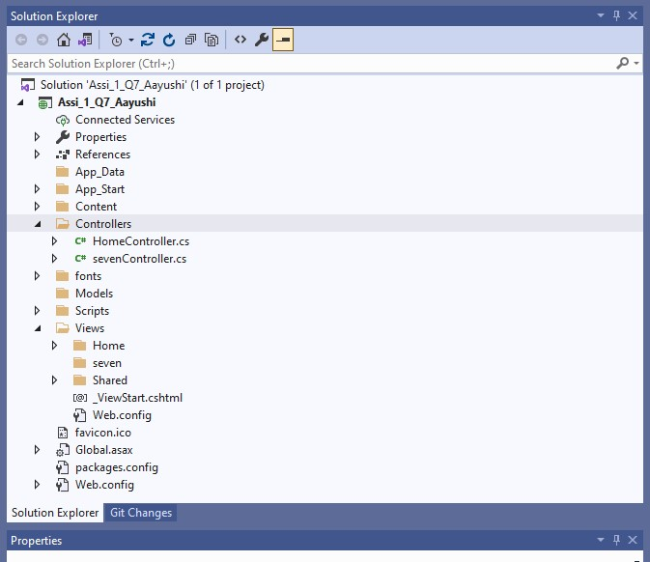

1. EIGHT CONTROLLER

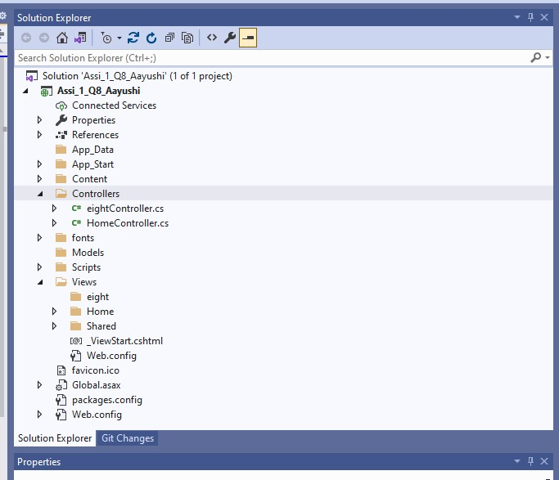

1. NINE CONTROLLER

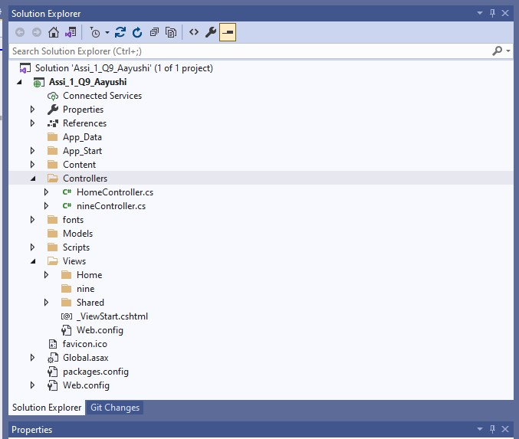

1. TEN CONTROLLER

