HTML 5
Question 1 : Demonstrate all the text formatting tags in a single HTML page.

CODE:
<!DOCTYPE html>
<html lang="en">
<head>
<meta charset="UTF-8">
<mata name="viewport" content="width=device-width, initial-scale=1.0">
<title>Text Formatting Tags Example</title>
</head>
<body>
<h1>Text Formatting Tags</h1>
<p><strong>Bold.</strong></p>
<p><em>Italicized</em></p>
<p><u>Underlined.</u></p>
<p>Here is <sub>subscript</sub> and <sup>superscript</sup></p>
<p><del>struck-through text.</del></p>
<p><ins>Inserted or underlined text.</ins></p>
<p>abbreviation <abbr title="Cascading Style Sheets">CSS</abbr></p>
<p>Here is some <mark>highlighted text</mark>.</p>
<p>This segment contains an inline <code>code snippet</code>.</p>
<p>Example of <kbd>keyboard input </kbd>notation.</p>
<p>Output from a computer program is shown using <samp>sample text</samp>.</p>
<p>Click this <a href="#">link</a> to visit a webpage.</p>
<blockquote> <p>This blockquote is used to highlight or quote a longer section of the text.</p>
</blockquote>
<pre>This is preformatted text.</pre>
<p><small>Smaller text size example.</small></p>
</body>
</html>

OUTPUT

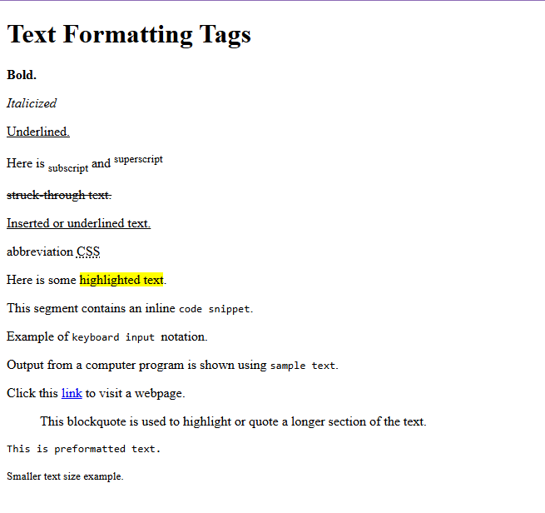

Question 2 : Write a HTML code to draw the following Figure :
*
* * *
* * * * *
* * * * * * *

CODE:
<!DOCTYPE html>
<html lang="en">
<head>
<meta charset="UTF-8">
<meta name="viewport" content="width=device-width, initial-scale=1.0">
<title>Document</title>
</head>
<body>
<pre>
*
* * *
* * * * *
* * * * * * *
</pre>
</body>
</html>

OUTPUT

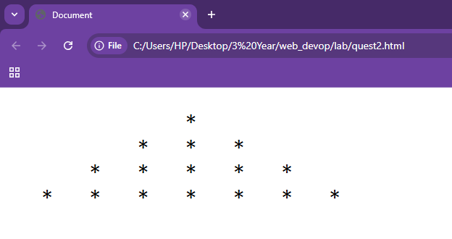

Question 3: Create a web page to print the following table:

CODE:
<!DOCTYPE html>
<html lang="en">
<head>
<meta charset="UTF-8">
<meta name="viewport" content="width=device-width, initial-scale=1.0">
<title>Document</title>
</head>
<style>
table,td,tr,th {
border: 1px solid black;
}th {
text-align: center;
}
</style>
<body>
<table>
<tr>
<th rowspan="2">Sr. No.</th>
<th rowspan="2">Course</th>
<th rowspan="2">Subject</th>
<th colspan="2">Marks</th>
<th colspan="2">Category</th>
<th rowspan="2">Pratical/Theory</th>
</tr>
<tr>
<th>Internal</th>
<th>External</th>
<th>Internal</th>
<th>External</th>
</tr>
<tr>
<td rowspan="4">1</td>
<td rowspan="4">MBA</td>
<td>Managment Accounting</td>
<td>30</td>
<td>70</td>
<td>-</td>
<td><b>✓</b></td>
<td>Theory</td>
</tr>
<tr>
<td>Information Technology</td>
<td>30</td>
<td>70</td>
<td>-</td>
<td><b>✓</b></td>
<td>T and P</td>
</tr>
<tr>
<td>Basics of Marketing</td>
<td>30</td>
<td>70</td>
<td>-</td>
<td><b>✓</b></td>
<td>Theory</td>
</tr>
<tr>
<td>E-Commerce</td>
<td>50</td>
<td>-</td>
<td><b>✓</b></td>
<td>-</td>
<td>Theory</td>
</tr>
<tr>
<td rowspan="6">2</td>
<td rowspan="6">MCM</td>
<td>Visual Basic</td>
<td>30</td>
<td>70</td>
<td>-</td>
<td><b>✓</b></td>
<td>T and P</td>
</tr>
<tr>
<td>Internet Technology</td>
<td>30</td>
<td>70</td>
<td>-</td>
<td><b>✓</b></td>
<td>T and P</td>
</tr>
<tr>
<td>Network Technology</td>
<td>30</td>
<td>-</td>
<td><b>✓</b></td>
<td>-</td>
<td>Theory</td>
</tr>
</table>
</body>
</html>

OUTPUT

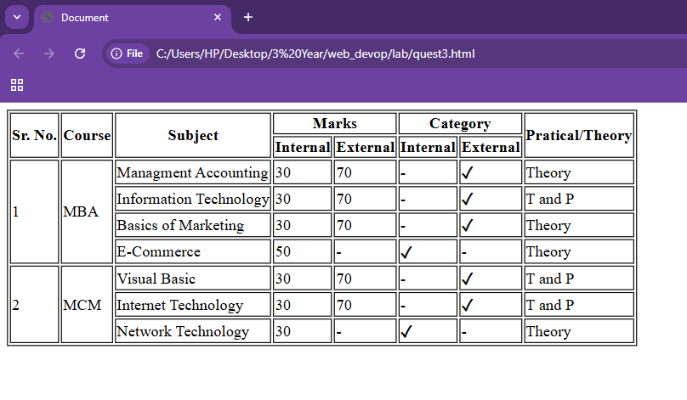

Question 4: Using table related tags align the images with hyperlinks.

CODE:
<!DOCTYPE html>
<html lang="en">
<head>
<meta charset="UTF-8">
<meta name="viewport" content="width=device-width, initial-scale=1.0">
<title>Table with Images</title>
<style>
img{
height:200px;
}
table,td,tr{
border: 5px solid rgba(0, 0, 0, 0.348);
}
</style>
</head>
<body>
<table>
<tr>
<td>
<a href="https://www.vodafone.com/">
<img src="https://images.indianexpress.com/2019/11/vodafone-759-1-1.jpg">
</a>
</td>
<td>
<a href="https://www.tata.com/business/tata-teleservices">
<img src="https://upload.wikimedia.org/wikipedia/commons/thumb/8/8e/Tata_logo.svg/1200px-Tata_logo.svg.png">
</a>
</td>
<td>
<a href="https://www.airtel.in/">
<img src="https://upload.wikimedia.org/wikipedia/commons/f/fb/Bharti_Airtel_Logo.svg">
</a>
</td>
<td>
<a href="https://www.docomo.ne.jp/english/">
<img src="https://upload.wikimedia.org/wikipedia/commons/thumb/b/b0/Tata_Docomo_Logo.svg/1200px-Tata_Docomo_Logo.svg.png">
</a>
</td>
</tr>

<tr>
<td>
<a href="https://www.vodafone.com/">
<img src="https://images.indianexpress.com/2019/11/vodafone-759-1-1.jpg">
</a>
</td>
<td colspan="2" style="text-align: center; font-size: 30px;">
Table With Images
</td>
<td>
<a href="https://www.docomo.ne.jp/english/">
<img src="https://upload.wikimedia.org/wikipedia/commons/thumb/b/b0/Tata_Docomo_Logo.svg/1200px-Tata_Docomo_Logo.svg.png">
</a>
</td>
</tr>

<tr>
<td>
<a href="https://www.vodafone.com/">
<img src="https://images.indianexpress.com/2019/11/vodafone-759-1-1.jpg">
</a>
</td>
<td>
<a href="https://www.tata.com/business/tata-teleservices">
<img src="https://upload.wikimedia.org/wikipedia/commons/thumb/8/8e/Tata_logo.svg/1200px-Tata_logo.svg.png">
</a>
</td>
<td>
<a href="https://www.airtel.in/">
<img src="https://upload.wikimedia.org/wikipedia/commons/f/fb/Bharti_Airtel_Logo.svg">
</a>
</td>
<td>
<a href="https://www.docomo.ne.jp/english/">
<img src="https://upload.wikimedia.org/wikipedia/commons/thumb/b/b0/Tata_Docomo_Logo.svg/1200px-Tata_Docomo_Logo.svg.png">
</a>
</td>
</tr>
</table>
</body>
</html>

OUTPUT

Question 5: Create a web page with the following using HTML:
I. To embed an image map in a web page
II. To fix the hot spots
III. Show all the related information when the hot spots are clicked.

CODE:
<!DOCTYPE html>
<html lang="en">
<head>
<meta charset="UTF-8">
<meta name="viewport" content="width=device-width, initial-scale=1.0">
<title>Document</title>
</head>
<body>
<img src="img1.jpg" usemap="#imagemap" height="300" width="400">
<map name="imagemap" id="imagemap">
<area shape="rect" coords="0,0,300,100" href="https://www.google.com/" alt="Google" title="Google">
<area shape="rect" coords="0,0,300,150" href="https://www.youtube.com/" alt="YouTube" title="YouTube">
<area shape="rect" coords="0,0,300,200" href="https://www.instagram.com/" alt="Instagram" title="Instagram">
<area shape="rect" coords="0,0,300,250" href="https://www.facebook.com/" alt="Facebook" title="Facebook">
</map>
</body>
</html>

OUTPUT




Question 6: Write a HTML code for the following snapshot.
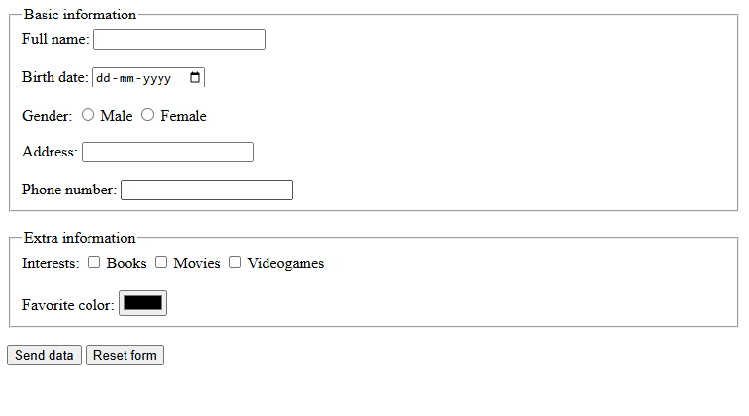

CODE:
<!DOCTYPE html>
<html lang="en">
<head>
<meta charset="UTF-8">
<meta name="viewport" content="width=device-width, initial-scale=1.0">
<title>Form</title>
</head>
<body>
<form>
<fieldset>
<legend>Basic information</legend>
Full name:
<input type="text"><br><br>
Birth date:
<input type="date"><br><br>
Gender:
<input type="radio" name="gender"> Male
<input type="radio" name="gender"> Female
<br><br>
Address:
<input type="text"><br><br>
Phone number:
<input type="text">
</fieldset>
<br>
<fieldset>
<legend>Extra information</legend>
Interests:
<input type="checkbox"> Books
<input type="checkbox"> Movies
<input type="checkbox"> Videogames
<br><br>
Favorite color:
<input type="color">
</fieldset>
<br>
<input type="submit" value="Send data">
<input type="reset" value="Reset form">
</form>
</body>
</html>

OUTPUT

