PROJECT AND TEAM INFORMATION

Project Title
Design and Implementation of a Mini Operating System with Core Functionalities.

Student / Team Information
Team Name: | EduKernel
Team member 1 (Team Lead)  Aayushi Sharma  2318130  230121926  sharmaaayushi953@gmail.com | 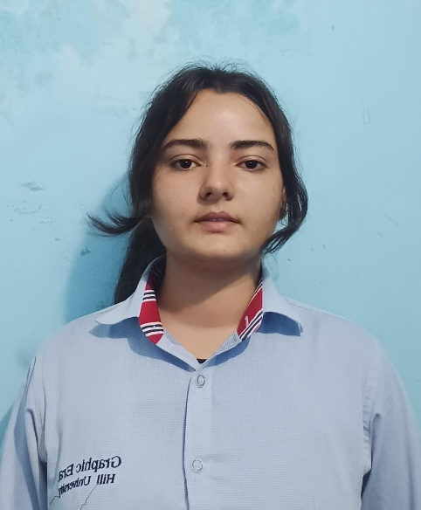
Team member 2  Deepshikha  2318706  230121796  DEEPSHIKHA.230121796@gehu.ac.in | 
Team member 3  Abhilasha  2318150  23011426  abhilashabhatt77@gmail.com | 
Team member 4  Tanuja  2319745  230124746  tanujachuphal7@gmail.com | 

PROPOSAL DESCRIPTION

Motivation
The problem this project addresses is the lack of practical understanding of how operating systems work at their core. Learners often study topics such as process management, memory handling, and file systems in theory, but rarely gain hands-on experience in implementing them. Full-scale operating systems like Windows or Linux are highly complex, making it difficult to isolate and analyze these essential mechanisms.
This gap between theory and practice results in a limited grasp of fundamental system-level concepts. Without practical exposure, learners may struggle to understand how processes are scheduled, how memory is allocated, or how files are stored and accessed, which restricts their ability to design efficient software or contribute to low-level system development.
By building a mini operating system kernel from scratch, this project provides a simplified environment where these features can be clearly implemented and tested. This hands-on approach bridges theory with application, enhances problem-solving skills, and prepares learners for advanced domains like embedded systems, systems programming, and cybersecurity.

State of the Art / Current solution
Today, the challenge of learning operating system fundamentals is addressed mainly through textbooks, simulations, and simplified teaching kernels. Academic courses often explain concepts such as process scheduling, memory allocation, and file systems theoretically, but this knowledge can remain abstract without hands-on practice. To provide practical exposure, universities and learners use educational operating systems like xv6, Minix, Nachos, or Pintos, which offer simplified environments for experimentation.
While these tools are effective for demonstrating core concepts, they also have limitations. Full-scale open-source kernels are highly complex for beginners, making it difficult to isolate specific mechanisms. On the other hand, simulators and teaching kernels often abstract away low-level details, preventing learners from fully experiencing how an operating system works internally.
Therefore, while current solutions provide partial insights, they often fail to bridge the gap between theory and practice. Building a mini OS from scratch offers a more direct and comprehensive learning experience.

Project Goals and Milestones
The primary goal of this project is to design and implement a mini operating system kernel that demonstrates the fundamental components of modern operating systems in a simplified and educational manner. The project aims to bridge the gap between theoretical concepts and practical implementation, providing a hands-on platform to understand how process management, memory handling, and basic file management work in practice.

General Goals:
- Develop a lightweight kernel capable of running in a controlled environment (e.g., emulator or virtual machine).
- Implement process management features such as process creation, scheduling, and termination.
- Introduce memory management techniques, including allocation and deallocation mechanisms.
- Create a basic file management system that supports simple storage and retrieval operations.
- Ensure modularity and simplicity so that the system can serve as an educational tool for learners.
Initial Milestones:
- Milestone 1: Set up the development environment with a bootloader and minimal kernel that boots successfully.
- Milestone 2: Implement basic process management (creating and switching between processes).
Subsequent Milestones:
- Milestone 3: Add memory management capabilities such as paging or segmentation.
- Milestone 4: Develop a basic file system for storing and accessing files.
- Milestone 5: Refine the kernel for stability, modularity, and clarity, ensuring it can be extended for future work.
- Milestone 6: Extend kernel functionality to support multilingual commands, enabling interaction in languages such as Hindi in addition to English.
By achieving these milestones, the project will not only deliver a functional mini OS but also provide a clear roadmap for understanding operating system design in a practical and approachable way.

Project Approach
The solution will be articulated and designed as a mini operating system kernel, developed from scratch with incremental implementation of core components. The focus will be on simplicity, modularity, and clarity to ensure both functionality and educational value.
The project will begin with setting up a bootloader using low-level programming in Assembly language, which initializes the system and loads the kernel into memory. The kernel itself will be developed primarily in C language, as it provides the right balance between low-level hardware access and higher-level abstraction, making it ideal for operating system development.
The kernel design will follow a modular approach:
- Process Management: Implement context switching, scheduling algorithms, and basic inter-process communication.
- Memory Management: Start with simple fixed partition allocation and extend to paging or segmentation.
- File Management: Develop a minimal file system capable of creating, storing, and retrieving files.
- Command Interface: Design a simple command-line interface to interact with the OS. As a final milestone, extend this interface to support multilingual commands (e.g., Hindi), showcasing adaptability and inclusivity.
The OS will be tested and executed in a controlled environment using platforms such as QEMU or Bochs emulators, ensuring hardware independence and safe experimentation. Development tools like GCC (GNU Compiler Collection), NASM (Netwide Assembler), and GNU Make will be employed for compiling and building the kernel.
By combining low-level languages (C and Assembly) with robust testing on emulators, the project will create a clear, functional mini operating system. This structured approach not only ensures the achievement of technical milestones but also strengthens the practical understanding of operating system fundamentals.

System Architecture (High Level Diagram)
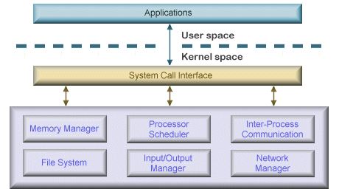
Key Components:
- Bootloader: Initializes hardware and loads the kernel into memory.
- Kernel Core:
  - Process Manager: Handles creation, scheduling (e.g., round-robin), and termination of processes.
  - Memory Manager: Manages allocation/deallocation, paging or segmentation.
  - File System Manager: Provides basic file operations (read/write/delete).
  - Command Interpreter: Parses user commands, supports multilingual input.
- System Calls Interface: Acts as a bridge between user programs and kernel services.
- User Programs: Simple applications or shell commands running in user space.
- Hardware Abstraction Layer (HAL): Interfaces with CPU, memory, and I/O devices.

Project Outcome / Deliverables
The project will deliver a functional mini operating system kernel that demonstrates the essential features of process management, memory handling, and basic file operations. The kernel will be bootable on an emulator such as QEMU or Bochs, providing a safe and controlled environment for execution and testing.
Key Outcomes:
- Bootable Kernel: A lightweight operating system kernel that initializes through a custom bootloader.Process
- Management Module: Implementation of process creation, scheduling, and switching to illustrate multitasking concepts.
- Memory Management Module: Support for allocation and deallocation techniques, with potential extension to paging or segmentation.
- File Management System: A minimal file system capable of storing, retrieving, and managing simple files.
- Command-Line Interface (CLI): A user interface for interacting with the OS, including the ability to execute basic system commands.
- Multilingual Support: Extension of the CLI to accept commands in multiple languages (e.g., Hindi), highlighting inclusivity and adaptability.
- Documentation and Architecture Diagram: Comprehensive documentation describing system design, implementation details, limitations, and possible future enhancements.
These deliverables will provide both a working educational operating system and a learning resource, enabling learners to gain hands-on experience with the inner workings of OS design.

Assumptions
- The mini OS will run in a controlled virtual environment (e.g., QEMU or Bochs) rather than on physical hardware.

- Only basic hardware components (CPU, memory, disk) need to be supported; no complex device drivers or networking.

- Focus will be on core OS concepts: process management, memory handling, and file management.

- Users will interact through a command-line interface (CLI).

- The CLI will later be extended to support multilingual commands (e.g., Hindi).

References
[1] A. Silberschatz, P. B. Galvin, and G. Gagne, Operating System Concepts, 10th ed. Hoboken, NJ: Wiley, 2018.
[2] A. S. Tanenbaum and H. Bos, Modern Operating Systems, 4th ed. Pearson, 2015.
[3] R. Love, Linux Kernel Development, 3rd ed. Addison-Wesley, 2010.
[4] “xv6: A simple Unix-like teaching OS,” MIT, [Online]. Available: https://pdos.csail.mit.edu/6.828/xv6/. [Accessed: Sep. 13, 2025].
[5] OSDev Wiki – Tutorials on OS development, [Online]. Available: https://wiki.osdev.org/Main_Page. [Accessed: Sep. 13, 2025].
[6] QEMU Emulator, [Online]. Available: https://www.qemu.org/. [Accessed: Sep. 13, 2025].

