

PROJECT AND TEAM INFORMATION

Project Title

Design and Implementation of a Mini Operating System with Core Functionalities.

Student/Team Information

Team Name: | EduKernel
Team member 1 (Team Lead)  Sharma Aayushi  230121926  sharmaaayushi953@gmail.com | 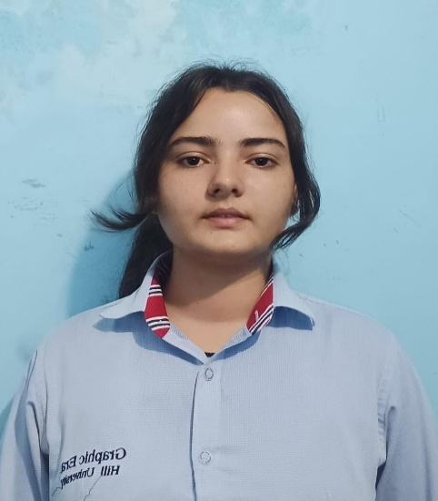
Team Member 2  Abhilasha  2318150  23011426  abhilashabhatt77@gmail.com | 
Team member 3  Tanuja  230124746  tanujachuphal7@gmail.com | 
Team member 4  Deepshikha  2318706  230121796  DEEPSHIKHA.230121796@gehu.ac.in | 

PROJECT PROGRESS DESCRIPTION (35 pts)

Project Abstract (2 pts)
(Brief restatement of your project’s main goal. Max 300 words).
This project is about creating a mini operating system that performs the basic tasks of a regular OS, like managing processes, memory, files, and input/output operations. It is designed to help users understand how an operating system works in a simple and practical way. Users can run small programs, manage system resources, and see how software interacts with hardware.
The mini OS also provides a learning platform for students to explore system-level programming and operating system concepts. By experimenting with this system, users can understand how tasks are scheduled, memory is allocated, and files are handled, which makes it a useful educational tool for both beginners and those looking to deepen their knowledge of operating systems.

Updated Project Approach and Architecture (2 pts)
The mini operating system is developed using a step-by-step approach to cover all essential OS functionalities.
How It Works:
The system follows a modular architecture, where each core function of an OS is treated as a separate module.
- Process Management Module: Handles creation, execution, and termination of processes, and schedules tasks efficiently.
- Memory Management Module: Allocates memory to programs and keeps track of used and free memory.
- Boot Loader Module – Handles system startup and loads the kernel into memory.
- Kernel Module – Core of the OS, manages processes, memory, and system calls.
- File Management Module: Allows creation, reading, writing, and deletion of files.
- Input/Output Module: Manages communication between hardware devices (like keyboard, display) and software programs.
Tools and Libraries:
- C – For kernel and system-level programming
- Assembly (ASM) – For boot loader and low-level hardware initialization
- Standard C libraries: stdlib.h, stdio.h, string.h
- Custom headers: disk.h, fs.h, io.h, kprintf.h, string.h (for modular OS functionality)
- X86 Emulator / Virtual Machine (like QEMU or Bochs) – To run and test the OS image (os_image.img)
Modules interact through a central controller, ensuring resources are allocated properly and the OS runs smoothly.

Tasks Completed (7 pts)
Task Completed | Team Member
- Kernel Development and Booting  - Command interface  - Process and memory management  - File management | - Aayushi Sharma  - Abhilasha  - Deepshikha  - Tanuja

Challenges/Roadblocks (7 pts)
(Describe the challenges that you have faced or are facing so far and how you plan to solve them. Max 300 words).
1. Bootloader Implementation : Writing assembly code for stage1.asm and stage2.asm to correctly initialize hardware and load the kernel.
2. Memory Management : Allocating and managing memory efficiently for processes in a small OS environment.
3. Process Scheduling : Designing a simple scheduler to handle multiple tasks and system calls.
4. File System Development : Implementing a working file system (fs.c, fs.h) to read, write, and organize files.
5. Input/Output Handling : Managing keyboard and display I/O using io.c and kprintf.c without standard libraries.
6. Debugging and Testing : Finding and fixing errors in low-level C and assembly code, especially during booting and kernel execution.
7. Integration of Modules : Combining bootloader, kernel, file system, I/O, and helper modules to form a working OS image.
8. Kernel Development : Designing a stable kernel to handle process management, memory, and system calls.
9. Module Integration : Combining bootloader, kernel, file system, I/O, and helper modules into a working OS image.

Tasks Pending (7 pts)
Task Pending : NIL | Team Member (to complete the task)

Project Outcome/Deliverables (2 pts)
Project Outcome / Deliverables
- Mini Operating System: A fully functional OS image (os_image.img) that can boot on an emulator or virtual machine, demonstrating core functionalities like process management, memory handling, file operations, and basic I/O.
- Modular OS Codebase: Well-structured and documented source code, including bootloader (stage1.asm, stage2.asm), kernel (kernel.c), file system (fs.c, fs.h), I/O modules (io.c, io.h), helper modules (string.c, string.h, kprintf.c, kprintf.h), and build script (build.sh) for easy understanding, testing, and future extension.
Key Deliverables:
1. Bootable OS image (os_image.img) demonstrating core functionalities like process management, memory handling, file operations, and basic I/O.
2. Modular and well-documented source code, including bootloader, kernel, file system, I/O, helper modules, and build script (build.sh).
3. Custom utilities and functions like kprintf and string handling for easier OS operations.
4. Tested system that can run on an emulator or virtual machine, ensuring smooth booting and functionality.
5. Educational tool for understanding operating system concepts and system-level programming.

Progress Overview (2 pts)
The mini operating system project has successfully implemented the bootloader, kernel core, and essential modules for file system, disk operations, and I/O. Custom utilities like kprintf and string functions are working, and the OS image (os_image.img) has been built and tested on an emulator. The system demonstrates core OS functionalities and is ready for further enhancements.
We’ve implemented:
- Bootloader implemented to initialize the system and load the kernel.
- Kernel core developed with process management, memory handling, and system calls.
- File system and disk operation modules integrated successfully.
- I/O modules and custom utilities (kprintf, string functions) working.
- OS image (os_image.img) built and tested on an emulator.
- Core OS functionalities demonstrated and stable.
Overall, the project is nearly complete, and we are confident about demonstrating it successfully.

Codebase Information (2 pts)
The codebase of this mini operating system is modular and organized for easy understanding and maintenance. It includes:
- Bootloader Files: stage1.asm, stage2.asm, jerbel boot.s – Handle system initialization and loading the kernel.
- Kernel Core: kernel.c – Manages processes, memory, and system calls.
- File System & Disk Modules: fs.c, fs.h, disk.c, disk.h – Handle file operations and disk management.
- Input/Output Modules: io.c, io.h, kprintf.c, kprintf.h – Manage keyboard, display, and printing functions.
- Utility Modules: string.c, string.h – Provide string handling and helper functions.
- Build Script: build.sh – Compiles all modules and generates the bootable OS image (os_image.img).
The code is written primarily in C and Assembly, using modular headers and source files to separate functionalities, making it easier to debug, extend, and maintain.

Testing and Validation Status (2 pts)
Test Type | Status (Pass/Fail) | Notes
- Kernel and Bootloader  - File management  - Command Interface  - Process and memory management | Pass  Pass  Pass  Pass | It has been validated by creating, reading, writing, and deleting files to ensure accurate storage and retrieval.

Deliverables Progress (2 pts)
The outcomes and deliverables of this project include the following:

- Bootloader : Successfully implemented and tested to initialize the system and load the kernel.
- Kernel Core : Developed with process management, memory handling, and system calls, and integrated with other modules.
- File System & Disk Modules : Completed and functioning for creating, reading, writing, and managing files.
- I/O Modules & Utilities : Input/output handling and custom functions (kprintf, string handling) are working correctly.
- OS Image (os_image.img) : Built using build.sh and tested on an emulator, demonstrating smooth booting and core functionality.
- Overall Progress : All key deliverables are functional, modular, and ready for further enhancements or extensions.

