**Aayushi Singla (1/16/FET/BCG/1/020)**

**EXPERIMENT 3**

1. **Given the age of different persons with their frequencies, calculate simple mean of age and plot graph between age and frequency.**
   1. **Generate a list of 100 random numbers between 10-100 representing the age of the people. Draw the bar graph of people between the age of 10-20, 21-30,31-40, 41-50,51-60,61-70,71-80,81-90,91-100.**
   2. **Calculate the following statistics of the people mean, median, mode , variance, standard deviation of complete data in scilab.**

**CODE**

a=10;

b=100;

w=100

r=[];

d=[];

e=[];

f=[];

g=[];

h=[];

i=[];

j=[];

k=[];

l=[];

aa=0;

bb=0;

cc=0;

dd=0;

ee=0;

ff=0;

gg=0;

hh=0;

ii=0;

for z=1:w

r(z)=ceil(a+(b-a)*rand());

end,

*//printf("AGE\n")*

*//disp(r);*

for z=1:w

if r(z)<=20 then

d(z)=r(z)

aa=aa+1

elseif r(z)>20&&r(z)<=30 then

e(z)=r(z)

bb=bb+1

elseif r(z)>30&&r(z)<=40 then

f(z)=r(z)

cc=cc+1

elseif r(z)>40&&r(z)<=50 then

g(z)=r(z)

dd=dd+1

elseif r(z)>50&&r(z)<=60 then

h(z)=r(z)

ee=ee+1

elseif r(z)>60&&r(z)<=70 then

i(z)=r(z)

ff=ff+1

elseif r(z)>70&&r(z)<=80 then

j(z)=r(z)

gg=gg+1

elseif r(z)>80&&r(z)<=90 then

k(z)=r(z)

hh=hh+1

elseif r(z)>90&&r(z)<=100 then

l(z)=r(z)

ii=ii+1

end,

end

printf("\nmean")

m=mean(r)

disp(m)

printf("\nmedian")

n=median(r)

disp(n)

printf("\nmode")

q= tabul(r)

[n,i]=max(q(:,2))

amode=q(i,1)

disp(amode)

printf("\nvarience")

o=variance(r)

disp(o)

printf("\nstandard deviation")

p=stdev(r)

disp(p)

x=[20;30;40;50;60;70;80;90;100]

y=[aa;bb;cc;dd;ee;ff;gg;hh;ii]

bar(x,y)

**OUTPUT**

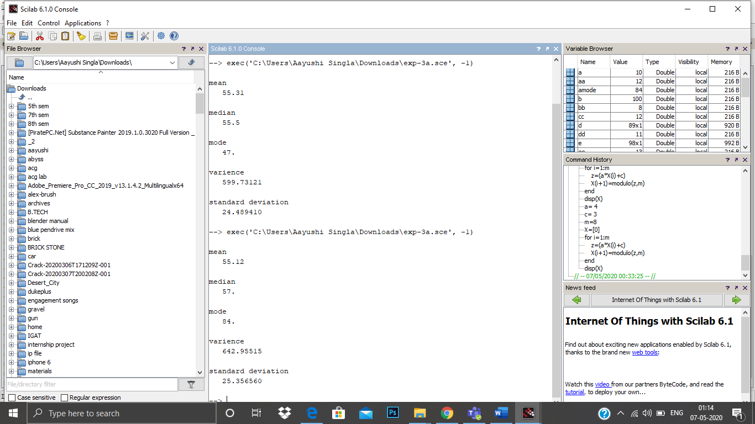

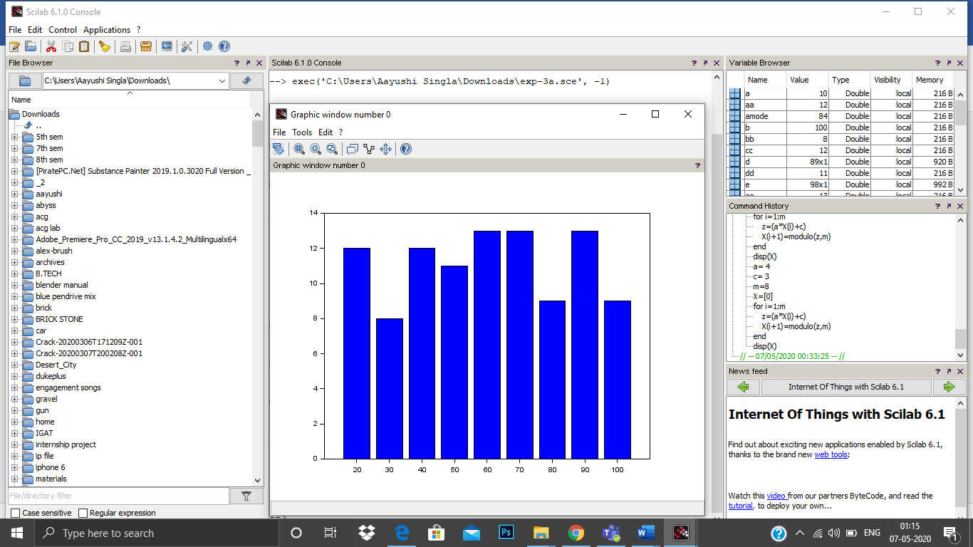

1. **To find the Covariance and Correlation For age and frequency Where** 
   1. **age==[46,53,29,61,36,39,47,49,52,38,55,32,57,54,4 4] and**
   2. **Frequency = [12,15,7,17,10,11,11,12,14,9,16,8,18,14,12];**

**CODE**

age=[46;53;29;61;36;39;47;49;52;38;55;32;57;54;44]

Frequency = [12;15;7;17;10;11;11;12;14;9;16;8;18;14;12];

c=cov(age,Frequency)

d=correl(age,Frequency)

printf("covarience\n")

disp(c)

printf("\ncorrelation\n")

disp(d)

**OUTPUT**

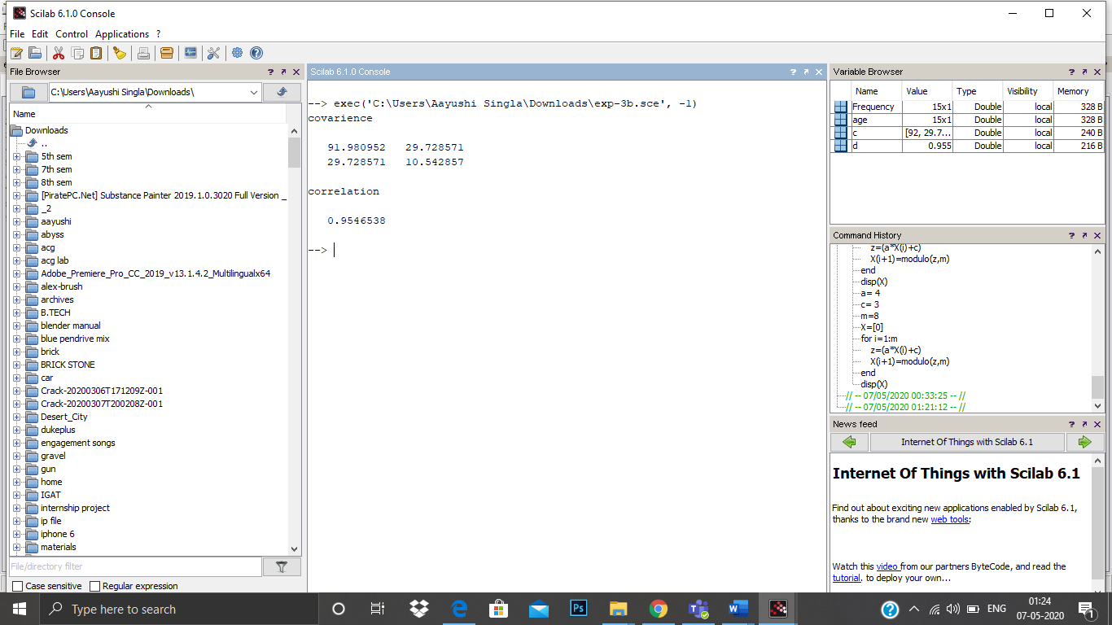

1. **We have a about vehicle performance. Miles per gallon is represented by matrix m and corresponding weight of car is represented by W matrix. Find covariance and correlation between these parameters. Plot the data set.**
   1. **Create two arrays of random numbers representing the weight array and performance array.**
   2. **The weight of the vehicle can be 1000Kg -6000Kg**
   3. **Performance of the vehicle can vary between 6-15gallons/miles**

**CODE**

n=20;

a=1000;

b=6000;

m=[];

for z=1:n

m(z)=ceil(a+(b-a)*rand());

end,

printf("performance\n")

disp(m);

c=6;

d=15;

w=[];

for y=1:n

w(y)=ceil(c+(d-c)*rand());

end,

printf("\nweight\n")

disp(w);

e=cov(m,w)

f=correl(m,w)

printf("covarience\n")

disp(e)

printf("\ncorrelation\n")

disp(f)

plot(w,m)

**OUTPUT**

