# **TASKS**

# **Objective Questions**:

1. **What is the total no. of tables present in the data?**

Ans. Originally there are two tables (Data and Country Description )

1. **What is the total no. of attributes present in the data?**

Ans. There were 21 attributers present in the data

1. **How many categorical columns are there in the data?**

Ans. There are 15 categorical columns in data .

1. **The data consists of some inconsistent and missing values so ensure that the data used for further analysis is cleaned.**

* Date format was corrected and further Year,month and Day were fetched
* Missing values in the cuisine column were handled by imputing with most frequent/ordered cuisine
* Missing values for Average_Cost_of _two column were handled by replacing with average cost

1. **Using the LookUp functions, fill up the countries in the original data using the country code.**

**Ans. Using the vlookup formula , I have fetched country name from ‘Country Description” sheet and added in my data table**

**=VLOOKUP($C2,'country description'!$A$1:$B$16,2,0)**

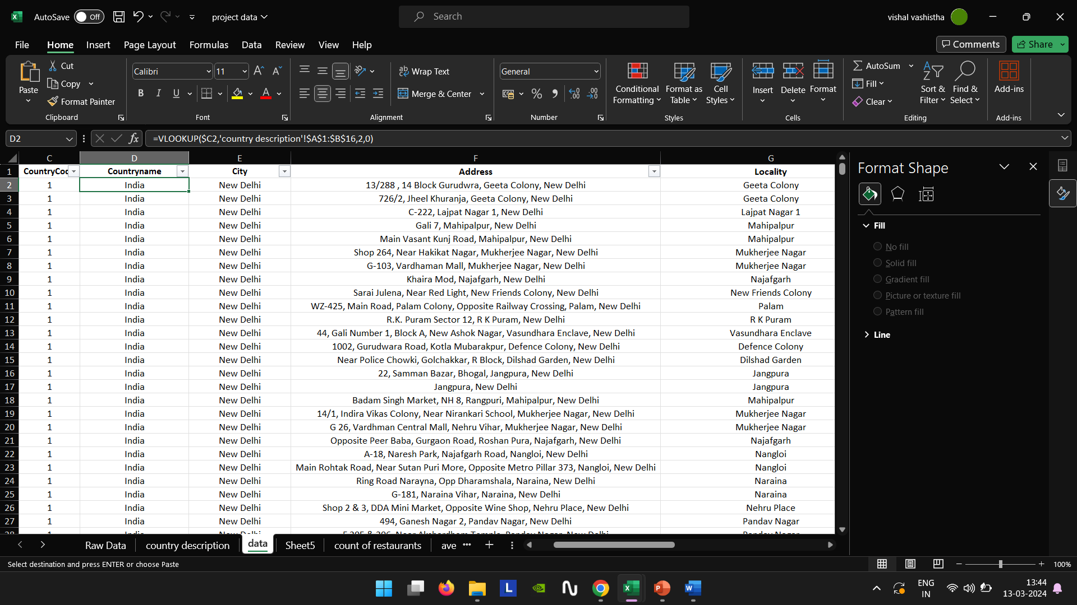

1. **Create a table to represent the number of restaurants opened in each country**.

For this I have created a pivot table having country name as Row label and Count of Restaurant ID and to visualize it a chart is added for better understanding.

1. **Also, the management wants to look at the number of restaurants opened each year, so provide them with something here.**

**For solving this purpose “Year wise slicer” is added**

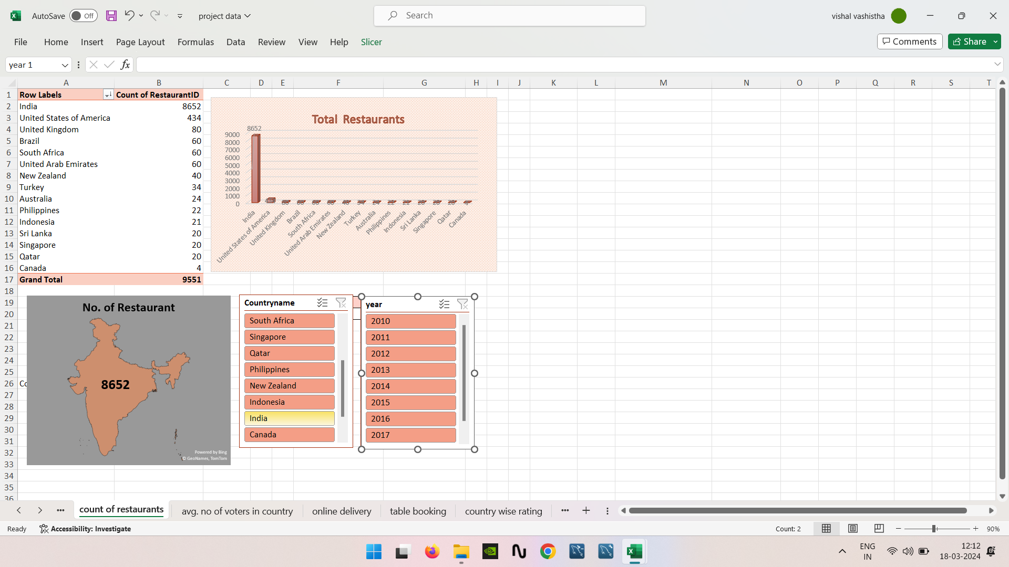

1. **What is the total number of restaurants in India in the price range of 4?**

388 restaurants are there in the given range .

For this I have used the count if function =COUNTIFS(data!C:C,"1",data!R:R,"4")



1. **What is the average no. of voters for the restaurants in each country according to the data?**

**Ans .** On an average there are 20 voters in Brazil, 103 in Canada,137 in India , 772 in Indonesia ,243 in New Zealand, 407 in Phillipines , 164 in Qatar , 32 in Singapore,315 in South Africa, 146 in Sri Lanka, 111 in Australia,431 in Turkey,494 in UAE,205 in UK ,428 in USA

**Note-** These are not exact values but rounded off till 0 decimal point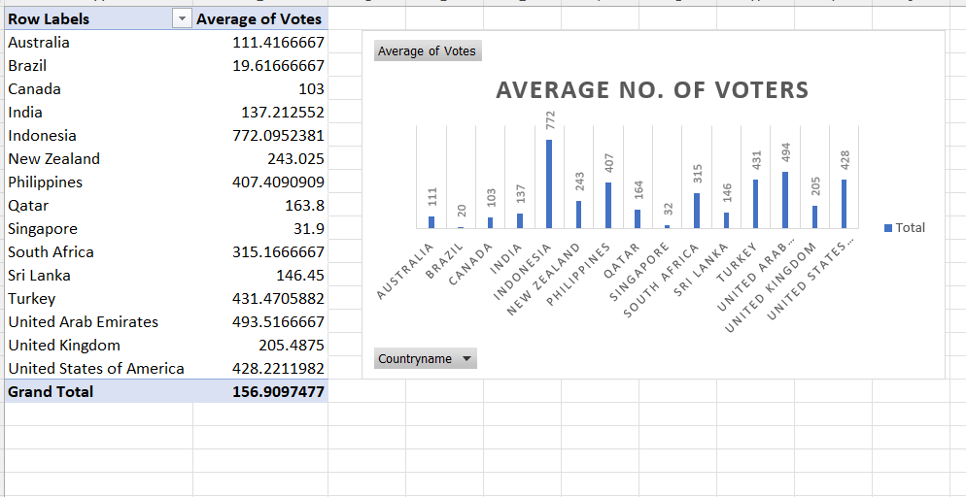

1. **Calculate the average rating for all the restaurants that have price_range < 4 and provide online delivery. Use only the “IF” function, Logical Operators, and Aggregation functions to solve this problem**

**Average rating according to the given condition is 3.2738115 which is obtained through given formula**

=AVERAGE(IF(((data!R:R<4)*(data!O:O="Yes")),(data!X:X)))



1. **Using Conditional formatting highlight the rows of restaurants that are located in the countries or cities that you’ve suggested to the management for opening new restaurants**.

**Criteria chosen**:

* Ratings >=3.5
* Count<400
* Price range 1-2
* Votes >150

For this refer to excel sheet Data , where the required fields have been highlighted

1. **Create a new customized price column that consists of the abbreviation/symbol of the currency along with the Average_cost_for_two value.**

* First I extracted the currency symbol using FIND AND MID functions : =MID(K2,FIND("(",K2)+1,FIND(")",K2)- FIND("(",K2)-1)
* Then I concatenated the currency symbol with average_cost_of_two

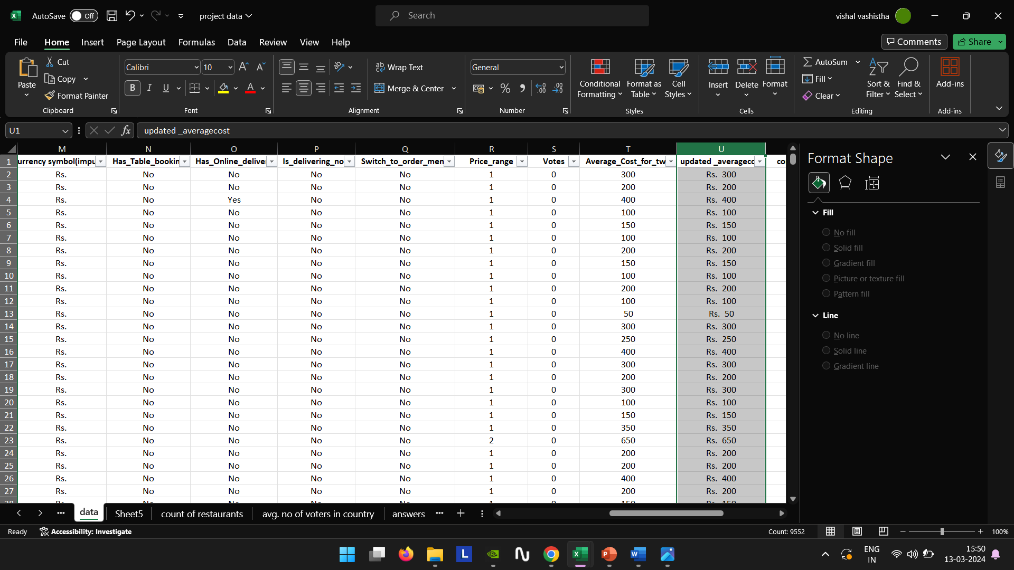

1. **How can you create an array formula in Excel or Google Sheets to count the number of restaurants listed that do not offer online delivery, are in the lowest price range, and have an average cost for two people less than or equal to 250 Indian Rupees?**

**{=COUNT(IF(((data!P:P="No")*(data!S:S=1)*(data!X:X<=250)),(data!X:X)))}**

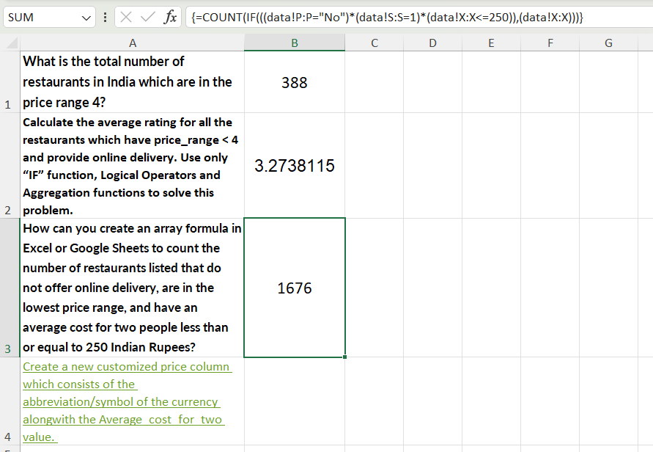

**Subjective Question:**

1. **Suggest a few countries where the team can open newer restaurants with lesser competition. Which visualization/technique will you use here to justify the suggestions?**

**APPROACH**  - I have used a pivot table to compare the countries data by their restaurant count (<400), average price range(1-2), average rating(>=3.5) and average of vote count(>150)

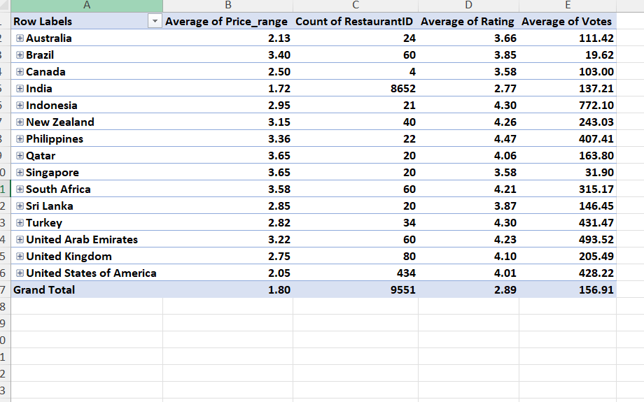

**INSIGHTS**:

* Count of restaurant suggests how the market is too clustered in a particular area
* Price range – The lower price range(1-2) here suggests the restaurants affordability for the crowd
* Rating and votes –It gives an insight of of the restaurants performance from the customer’s point of view

|  |
| --- |
| **Australia** |
| **Canada** |
| **Indonesia** |
| **New Zealand** |
| **Qatar** |
| **South Africa** |
| **Sri Lanka** |
| **Turkey** |
| **United Arab Emirates** |
| **United Kingdom** |

**Recommendations:**

1. **Come up with the names of States and cities in the suggested countries suitable for opening restaurants.**

**APPROACH**  – A pivot table is used to compare the countries and their cities data by their restaurant count (<400), average price range(1-2), average rating(>=3.5) and average of vote count(>150)

**INSIGHTS**:

* Count of restaurant in given area gives the idea if the market is too clustered or not
* Rating–It gives an insight of the restaurants performance from the customer’s point of view
* Price range – By including restaurants with price ranges of 1-2, we target restaurants that are perceived to be more affordable, which could be key competitors in the market.
* Vote - Restaurants with a higher number of votes indicate a higher level of customer engagement and satisfaction

**Recommendations : On above basis , these are the cities :**

|  |  |
| --- | --- |
| **Australia** | **3** |
| Beechworth | 1 |
| Hepburn Springs | 1 |
| Phillip Island | 1 |
| **Canada** | **1** |
| Chatham-Kent | 1 |
| **Indonesia** | **1** |
| Bogor | 1 |
| **New Zealand** | **5** |
| Auckland | 3 |
| Wellington City | 2 |
| **Qatar** | **1** |
| Doha | 1 |
| **South Africa** | **4** |
| Cape Town | 4 |
| **Sri Lanka** | **1** |
| Colombo | 1 |
| **Turkey** | **5** |
| Istanbul | 5 |
| **United Arab Emirates** | **6** |
| Abu Dhabi | 4 |
| Dubai | 2 |
| **United Kingdom** | **9** |
| Edinburgh | 1 |
| London | 6 |
| Manchester | 2 |

1. **According to the countries you suggested, what is the current quality regarding ratings for restaurants that are open there?**

**APPROACH - For this analysis I have used a pivot table showing the average rating of the restaurants of the said countries and also depicted the rating of the restaurants using line chart for better visualization**

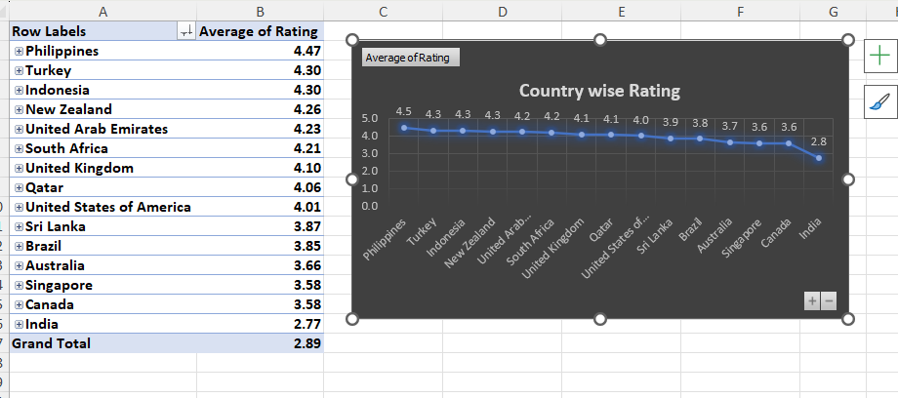

**INSIGHTS – From this analysis , we conclude that the rating of restaurants is found to be good ranging from 3.7- 4.5**

1. **Also, what is the current expenditure on food in the suggested countries, so we can keep our financial expenditure in control?**

**APPROACH –**

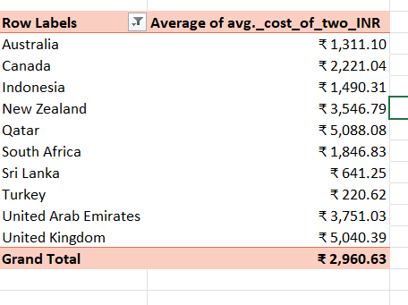

**INSIGHTS –**

* It shows how affordable dining out is in each country. Countries with lower average costs, such as Sri Lanka and Turkey, may be more affordable for dining out compared to countries with higher average costs, such as Qatar and the United Kingdom.
* For restaurants, this data can help in identifying countries where the average cost of dining out is relatively high, indicating a potentially lucrative market for upscale restaurants.

**RECOMMENDATION-**

For countries with high expenditure, strategies for managing costs, such as opting for more budget-friendly menu items or exploring alternative dining options can be

1. **Come up with the names of restaurants from the recommended states that are our biggest competitors and also those that are rated in the lower brackets, i.e. 1-2 or 2-3**

**APPROACH** – On filtering the restaurants of the suggested countries according to criteria

and also whose rating is less than or equal to three

* Count<400
* Price range 1-2
* Votes >150
* Ratings <=3

following restaurants are our biggest competitor

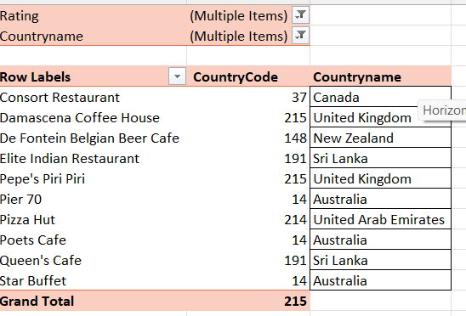

**INSIGHTS:**

Competitor Identification:

* By combining these criteria, we have identified restaurants that are not only popular (based on count and votes) but also competitively priced and rated. These restaurants are likely to be direct competitors in the market.
* The inclusion of price range and ratings provides insights into customer preferences.
* Customers may prefer affordable options (price range 1-2) but also expect a certain level of quality (ratings <=3), indicating a balance between price and perceived value .
* Here , Lower ratings indicate areas where competitors are struggling or where there is room for improvement .Hence, making these restaurants potential competitors to watch.

1. **Which cuisines should we focus on in the newer restaurants to get better feedback? Does the choice of cuisines affect the restaurant ratings?**

**APPROACH –** to show this I have used a pivot table and chart showing top 10 cuisines according to customer rating

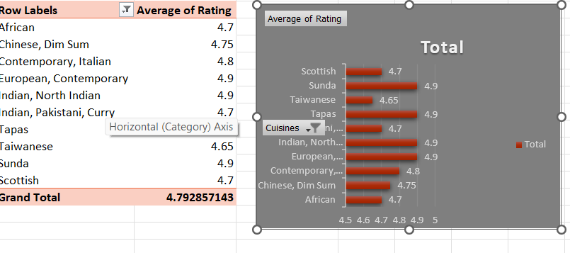

**INSIGHTS - On comparing the choice of cuisines against Rating , it is found these are some of the most rated cuisines**

**RECOMMENDATIONS – Following cuisines are the most loved and rated dishes by the restaurants , so they can be added in newer restaurant to improve their ratings**

1. **According to our current data, should we go for online delivery and table booking? Does that affect the customer’s ratings?**

**APPROACH –to decide this we have compared them with ratings using pivot table and chart**

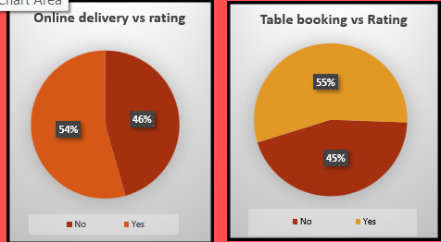

**Recommendations – Comparison clearly states that restaurant providing Online delivery and Table booking has better rating , so Yes we should we go for online delivery and table booking**

1. **Should the team keep the rate of cuisines higher? Will that affect the feedback? According to our data are the rates of cuisines and ratings, correlated?**

**APPROACH – using “Corelation analysis” and pivot table , I have visualized the distribution of cuisines ratings and average cost of two for each cuisine using a scatter plot along with trendline**

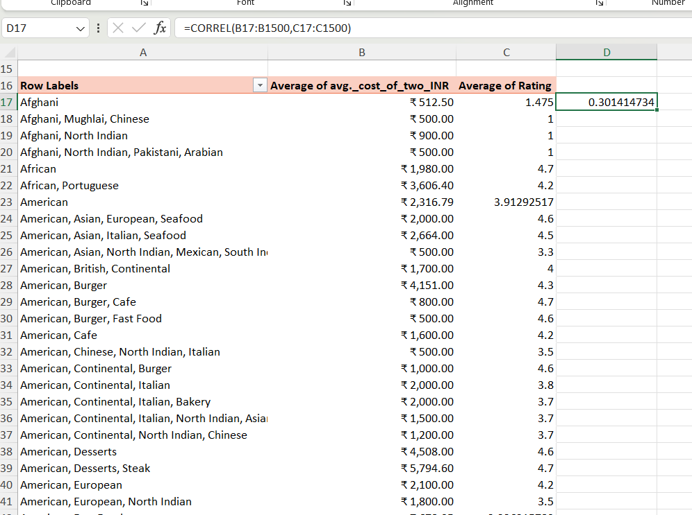

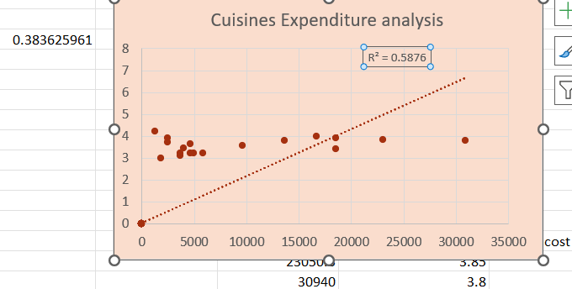

**INSIGHT & RECOMMENDATION –**

**There is a weak correlation between price of cuisine and customer rating.**

**So based on this corelation factor alone , it may not be advisable for the team to solely focus on keeping higher rates of cuisines to get better ratings.**

1. **What is the distribution of the number of restaurants of different price ranges in all the countries?**

**APPROACH – Using a pivot taking Price range as row label and Count of Restaurant ID in values , this distribution of the number of restaurants of different price ranges in all the countries is found**

|  |  |
| --- | --- |
| **Row Labels** | **Count of RestaurantID** |
| 1 | 4444 |
| 2 | 3113 |
| 3 | 1408 |
| 4 | 586 |
| **Grand Total** | **9551** |

1. **Explain your approach in brief for suggesting countries/cities in order to open new restaurants, if the objective and subjective questions would have not been given to assist you. [you have to give bullet pointers in order to answer this question]**

* **Area with less count : Look for areas with a growing population but relatively few restaurants, indicating a potential gap in the market.**
* **Demand: Analyze data to identify countries or cities with a high demand for restaurants. This could include population size and consumer spending on dining out.**
* **Considerations for cuisines: cultural factors such as dietary preferences, dining habits, and local food culture may impact the success of a restaurant so cuisine choice to be considered**
* **Cost Analysis: Conduct a cost analysis to compare the cost of operating a restaurant in different countries or cities, including rent, labor costs, and supply chain expenses.**
* **Technology Adoption: Consider the level of technology adoption in the target country or city. Ensure that Zomato's digital platform and services are well-received and can be effectively utilized.**