STUDENT PLACEMENT MANAGEMENT SYSTEM (SPMS)
UML ACTIVITY DIAGRAM MODELING
Task: Model the major scenarios of the project using activity diagrams for workflow representation.

1. Introduction
An activity diagram represents a workflow as a sequence of actions, decisions and hand-offs. Unlike a use case diagram, which says what the system offers, or a class diagram, which says what it is made of, an activity diagram shows how work actually flows from the first step to the last, who performs each step and what happens at every decision.
This document models six major scenarios of the Student Placement Management System (SPMS). Each scenario is drawn with swimlanes, one per actor or system, so that responsibility for every step is visible. The scenarios were chosen to cover the complete placement lifecycle of the SRS: account activation, company verification, drive publication, application, recruitment and final placement.
Notation used
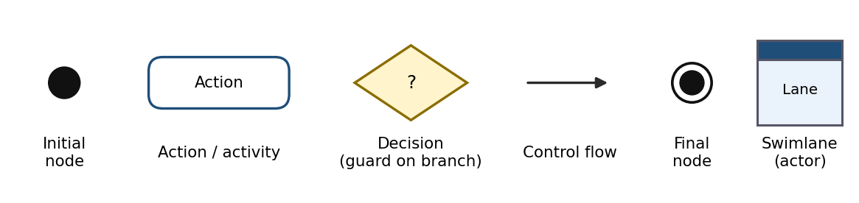
- Swimlanes separate the actors (Student, Recruiter, Placement Officer) and the SPMS System, so each action sits in the lane of whoever performs it.
- Decision nodes are diamonds; every outgoing branch carries a guard such as Yes or No.
- Loops show retries, for example correcting a form after validation errors or scheduling the next stage.
- Several final nodes are used where a scenario can end in different outcomes (success, rejection, blocked).

2. Scenario Overview
The table links every activity diagram to the use cases and SRS requirements it realises.
ID | Scenario | Swimlanes | Use cases | SRS requirements
AD-1 | Student Registration and Account Activation | Student, SPMS System, Email Service | UC-01, UC-02, UC-03 | REQ-1, REQ-2, REQ-3
AD-2 | Company Registration and Verification | Recruiter, SPMS System, Placement Officer | UC-12, UC-13, UC-26 | REQ-13, REQ-14, REQ-15
AD-3 | Placement Drive Creation, Approval and Publication | Recruiter, Placement Officer, SPMS System, Student | UC-14, UC-15, UC-16, UC-26 | REQ-15 to REQ-20
AD-4 | Eligibility Evaluation and Application to a Drive | Student, SPMS System | UC-07, UC-08, UC-09, UC-11 | REQ-21, REQ-22, REQ-23
AD-5 | Shortlisting and Recruitment Stage Evaluation | Recruiter / Placement Officer, SPMS System | UC-17, UC-18, UC-19 | REQ-25, REQ-26, REQ-27
AD-6 | Final Selection and Placement Recording | Recruiter, SPMS System, Placement Officer, Student | UC-19, UC-20, UC-21 | REQ-28, REQ-29, REQ-30, REQ-31

Business rules captured in the diagrams
- A new account stays Pending Verification until the emailed link is confirmed (REQ-1).
- The official company domain must be unique, and only a Verified company can create drives (REQ-13, REQ-15).
- A drive needs officer approval before publication and closes automatically at its deadline (REQ-16, REQ-20).
- All unmet eligibility criteria are reported at once, and a student cannot apply twice to the same drive (REQ-21, REQ-23).
- A final decision is allowed only after all mandatory stages are passed (REQ-27, REQ-28).
- One active placement per student per cycle unless a multi-offer policy is configured (REQ-30).

3. Activity Diagrams
Each diagram is presented with a short description of the scenario.

3.1 AD-1: Student Registration and Account Activation
A new student registers with the institutional email, the system validates the data and creates a Pending Verification account, and the Email Service delivers a verification link. The account becomes Active only when the link is opened before it expires; an expired link triggers a resend.
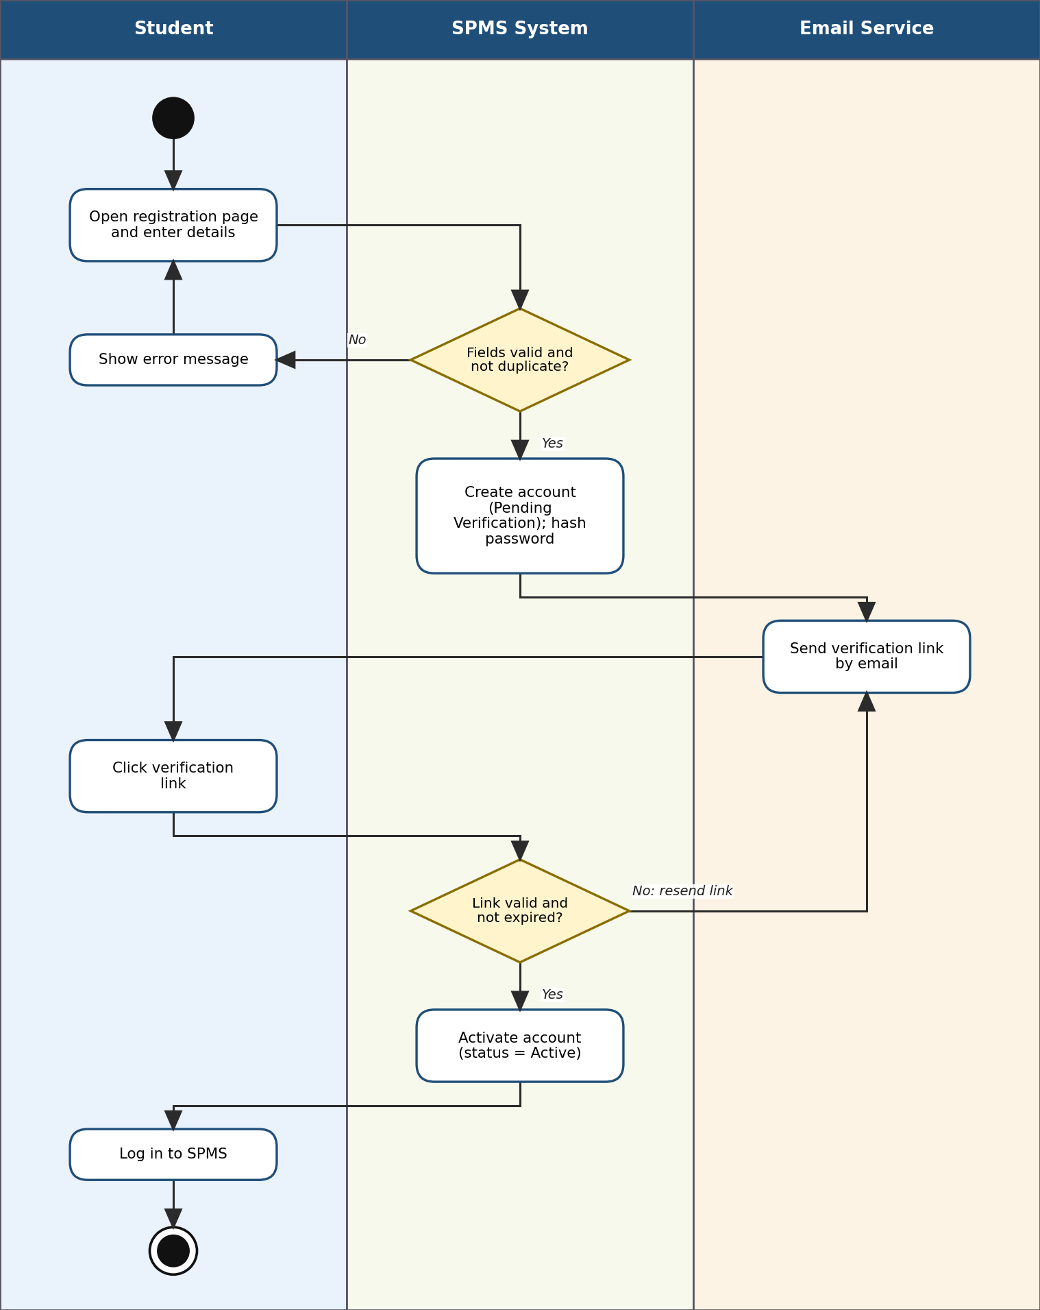
Figure 1. Student Registration and Account Activation

3.2 AD-2: Company Registration and Verification
A recruiter registers a company; the system checks the details and the unique official domain, and the company is held as Pending Verification until a placement officer reviews it. The officer verifies or rejects it (with a reason), and only a Verified company may create drives.
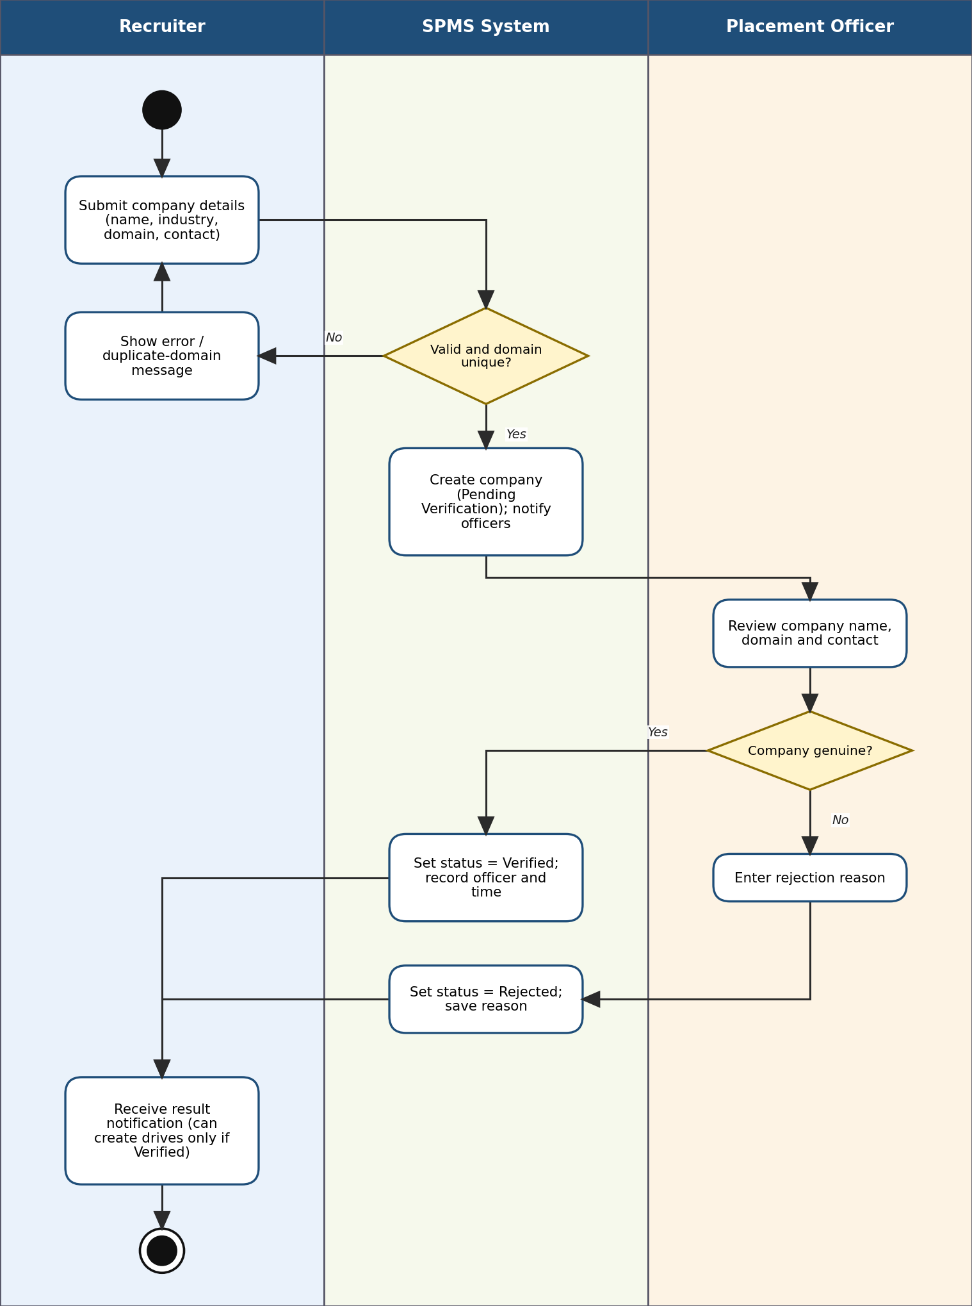
Figure 2. Company Registration and Verification

3.3 AD-3: Placement Drive Creation, Approval and Publication
A recruiter of a verified company enters the drive details, eligibility criteria and stages. The drive is saved as Pending Approval, reviewed by a placement officer and, when approved, published and announced to eligible students. Published drives close automatically at their deadline.
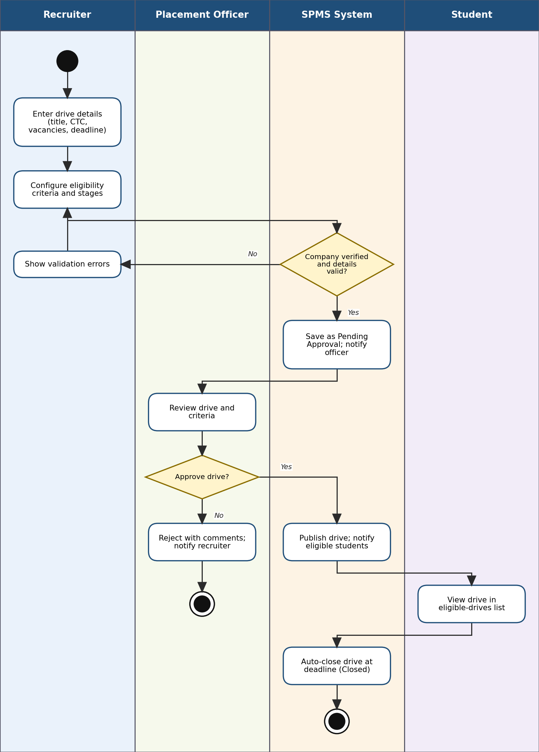
Figure 3. Placement Drive Creation, Approval and Publication

3.4 AD-4: Eligibility Evaluation and Application to a Drive
A student selects a published drive and applies. The system checks the profile, duplicate or late applications, and every eligibility criterion; all unmet criteria are reported together. Only an eligible student with no earlier application gets an Application with status Applied and a confirmation.
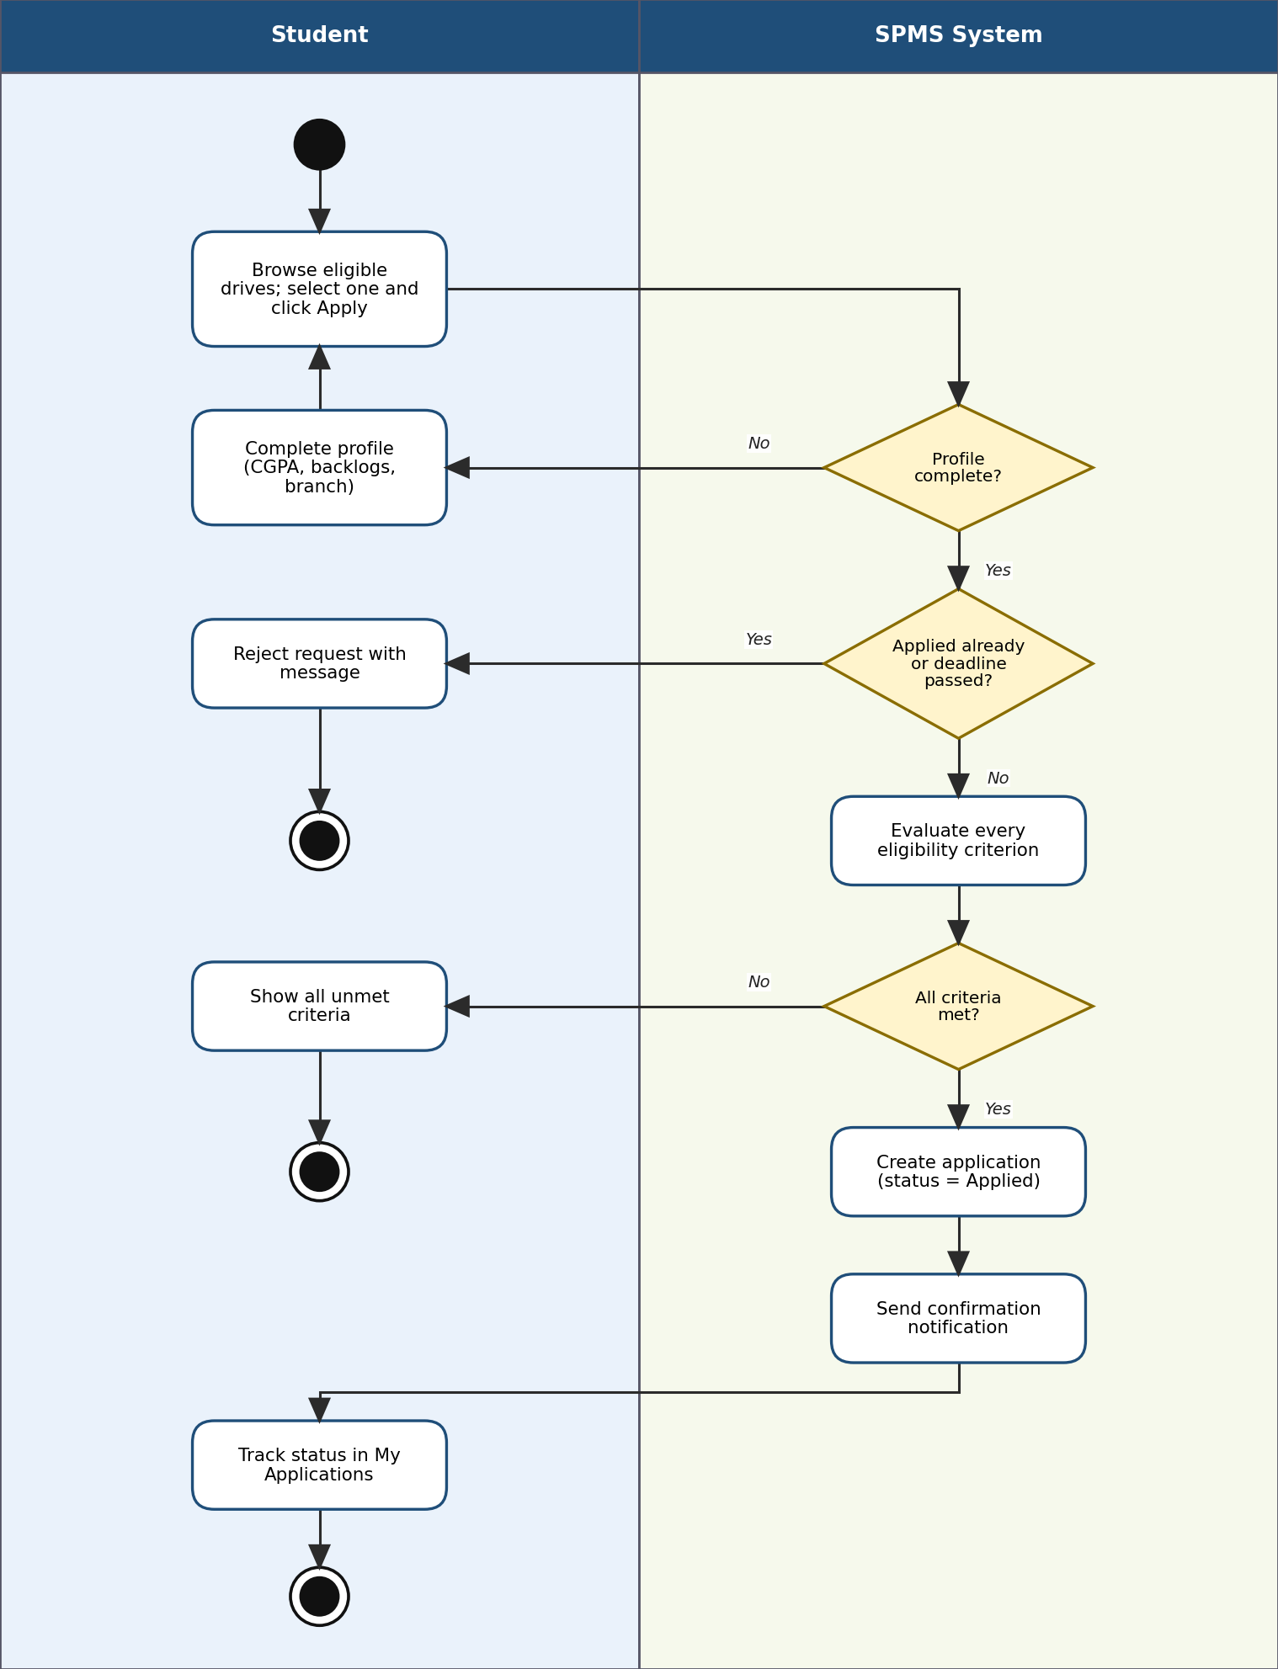
Figure 4. Eligibility Evaluation and Application to a Drive

3.5 AD-5: Shortlisting and Recruitment Stage Evaluation
Applicants are shortlisted, stages are scheduled (with clash detection) and outcomes are recorded stage by stage. A failed stage rejects the candidate; a candidate who passes all mandatory stages becomes ready for the final decision.
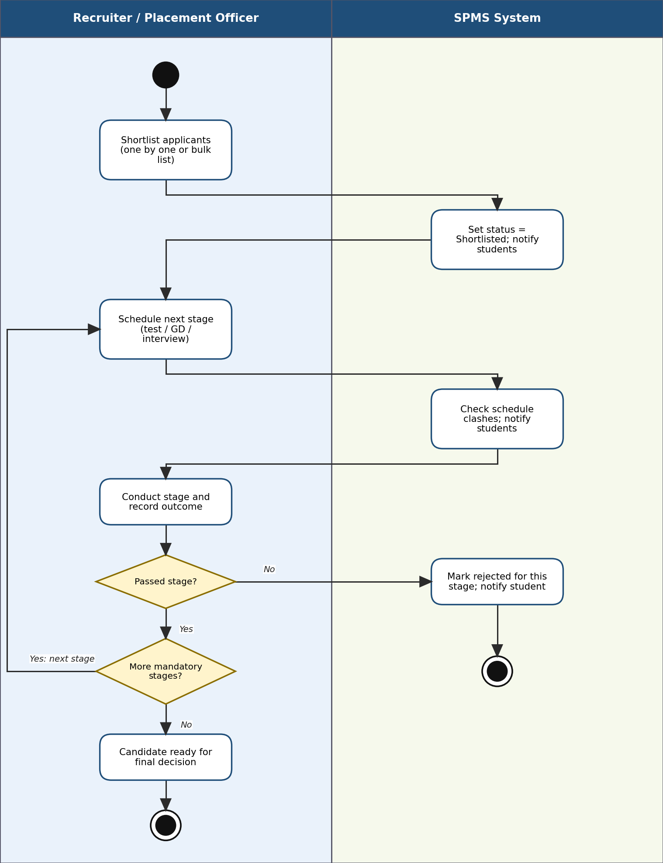
Figure 5. Shortlisting and Recruitment Stage Evaluation

3.6 AD-6: Final Selection and Placement Recording
After the final Selected decision the system checks that all mandatory stages were passed. The officer then confirms the placement; the system blocks a second placement for the same student in the cycle unless the multi-offer policy is enabled, otherwise it creates the PlacementRecord, logs the change, notifies the student and feeds the reports.
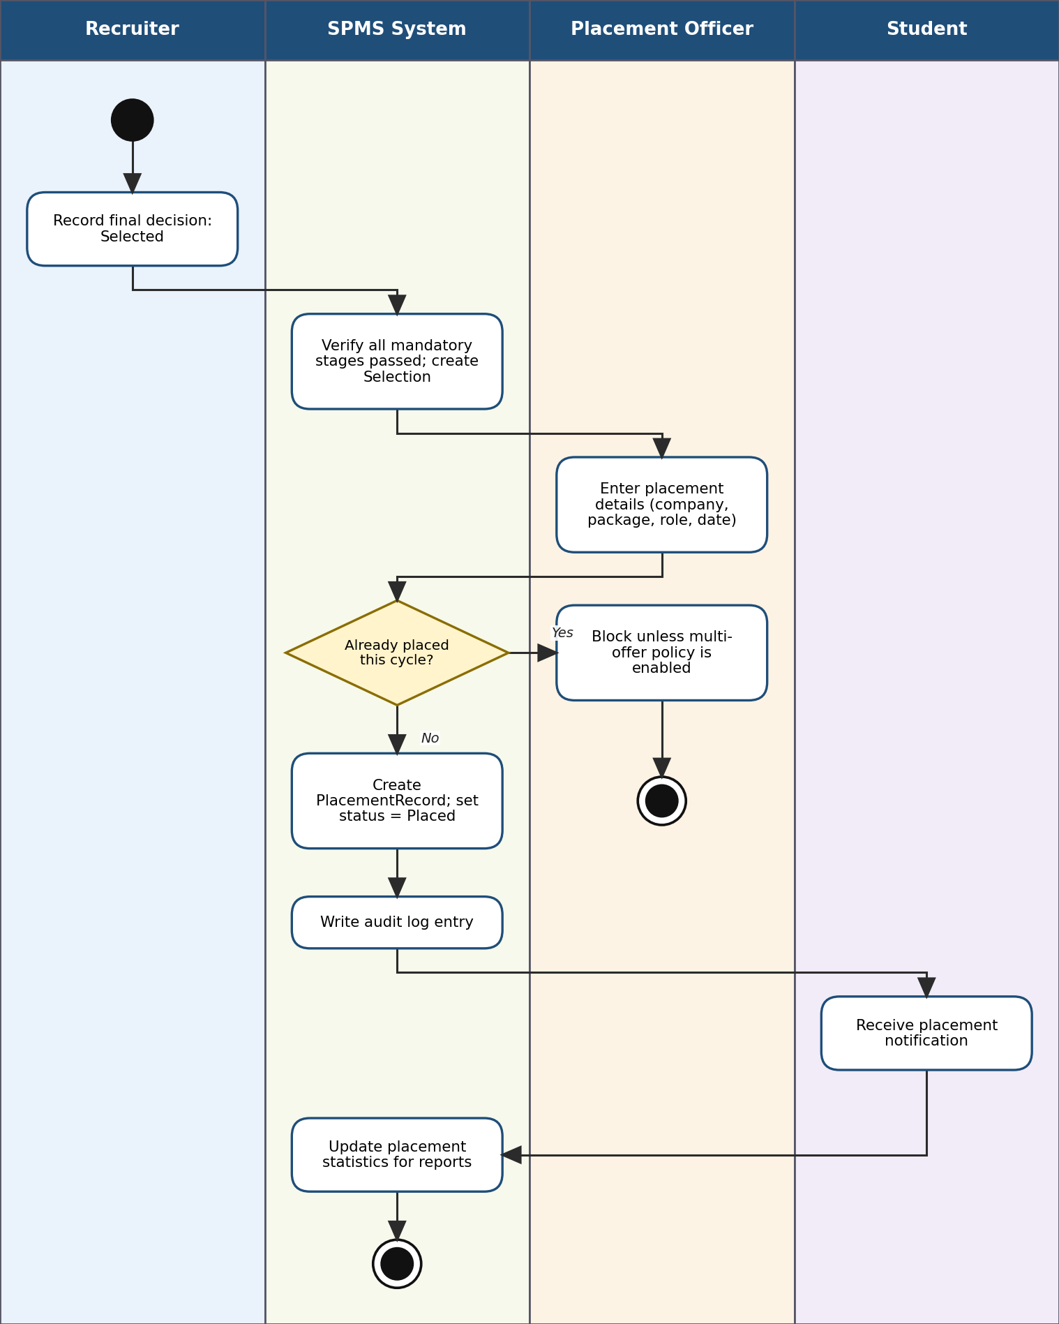
Figure 6. Final Selection and Placement Recording

4. Conclusion
The six activity diagrams describe the end-to-end placement workflow of SPMS: a student registers and activates an account, a recruiter's company is verified, a drive is approved and published, an eligible student applies, candidates move through the recruitment stages, and a confirmed placement is recorded. Swimlanes make the hand-offs between actors and the system explicit, and every decision corresponds to a business rule in the SRS. Together with the use case and class diagrams, they form the basis for the sequence diagrams, test cases and implementation that follow.

