STUDENT PLACEMENT MANAGEMENT SYSTEM (SPMS)
UML SEQUENCE DIAGRAM MODELING
Task: Model the major scenarios of the project using sequence diagrams for message flow.

1. Introduction
A sequence diagram shows how objects collaborate to carry out one scenario: which object sends which message to which other object, and in what order. It complements the activity diagrams, which describe the workflow, by showing the exact calls between the user interface, the controllers and the domain objects.
This document models seven major scenarios of the Student Placement Management System (SPMS). The participants come from the class diagram (Student, Company, PlacementDrive, EligibilityCriteria, Application, StageOutcome, Selection, PlacementRecord, Notification, Report, AuditLog) together with the supporting objects that every web request passes through: a WebUI (boundary) and a controller (control) for each feature. The scenarios follow the placement lifecycle of the SRS.
Notation used
Element | Meaning
Actor lifeline | A human user (stick figure) who starts the scenario, such as Student, Recruiter or Placement Officer.
Object lifeline | A box with the name object:Class; the dashed line below it shows the time the object is alive. Dashed orange boxes are external systems (Email Service).
Synchronous message | A solid arrow with a filled head: the sender calls an operation and waits, for example 2: register(details).
Return message | A dashed arrow with an open head: the value or result returned to the caller, drawn in italics.
Self message | A loop on one lifeline: an object calls its own operation, such as validate(details).
alt frame | A frame with alternatives separated by a dashed line; each branch has a guard in square brackets, for example [token valid]. Frames can be nested.
Phase divider | A dotted line with a title that separates the stages of a longer scenario.

Messages are numbered in order. When an alt frame has several branches, each branch restarts at the same number because only one of them runs.

2. Scenario Overview
Every sequence diagram is linked to the use cases and SRS requirements it realises.
ID | Scenario | Alternatives modelled | Use cases | SRS requirements
SD-1 | Student Registration | Invalid data / valid data | UC-01, UC-02 | REQ-1, REQ-2
SD-2 | Email Verification and Account Activation | Token valid / expired | UC-02, UC-03 | REQ-1, REQ-3
SD-3 | Apply for a Placement Drive | Drive closed / ineligible or duplicate / success | UC-08, UC-09, UC-26 | REQ-21, 22, 23
SD-4 | Company Verification | Verify / reject | UC-13, UC-25, UC-26 | REQ-14, 15
SD-5 | Shortlisting and Stage Evaluation | Stage passed / failed | UC-17, UC-18, UC-19 | REQ-25, 26, 27
SD-6 | Final Selection Decision | Mandatory stages passed / pending | UC-19 | REQ-27, 28
SD-7 | Placement Recording and Report Generation | Not placed / already placed | UC-20, UC-21 | REQ-29 to 32

Design approach
- Layered interaction. Each request flows WebUI to controller to domain objects, so business rules stay in the domain classes and not in the interface.
- Rules enforced by the owner of the data. EligibilityCriteria evaluates eligibility, StageOutcome answers whether all mandatory stages are passed, and Student reports whether it already has a placement.
- Cross-cutting services. Notification and AuditLog are called by controllers whenever a status changes, as the SRS requires.

3. Sequence Diagrams

3.1 SD-1: Student Registration
The student submits the registration form. The AuthController validates the data, including the institutional email domain and uniqueness of email and roll number. Invalid data is returned to the student as errors. Valid data creates a Student object with status PENDING and triggers a verification email through the Email Service.
Participants: Student, :WebUI, :AuthController, stu:Student, :EmailService
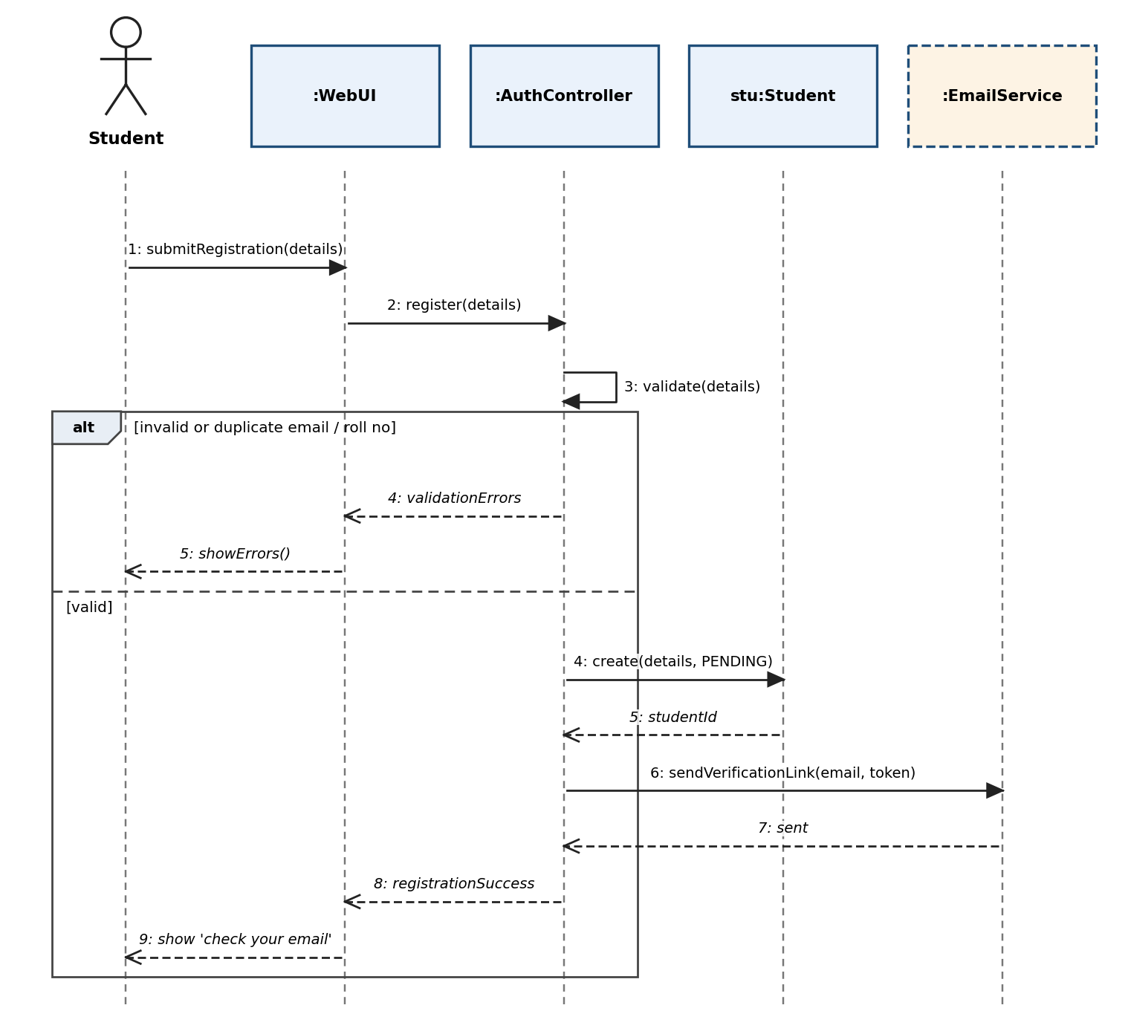
Figure 1. Student Registration

3.2 SD-2: Email Verification and Account Activation
The student opens the verification link. The AuthController checks the token; if it is valid and not expired the Student object is activated and the student can log in. An expired or invalid token produces a new link and the student is offered a resend.
Participants: Student, :WebUI, :AuthController, stu:Student, :EmailService
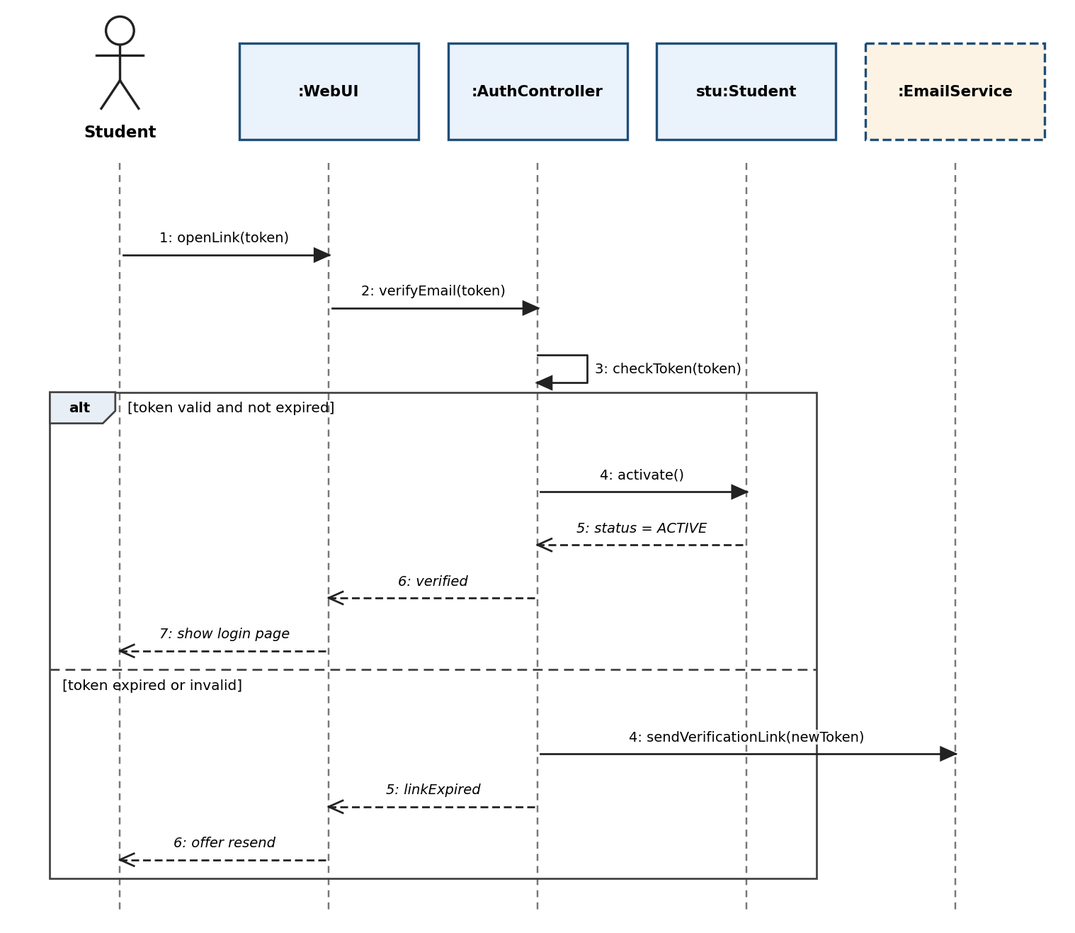
Figure 2. Email Verification and Account Activation

3.3 SD-3: Apply for a Placement Drive
The ApplyController first asks the drive for its status and deadline. For an open drive it asks the EligibilityCriteria object to evaluate the student and checks for a duplicate application. Only an eligible, non-duplicate application is submitted and confirmed; otherwise all reasons are returned. A closed drive refuses the request at once.
Participants: Student, :WebUI, :ApplyController, d:PlacementDrive, :EligibilityCriteria, a:Application, :Notification
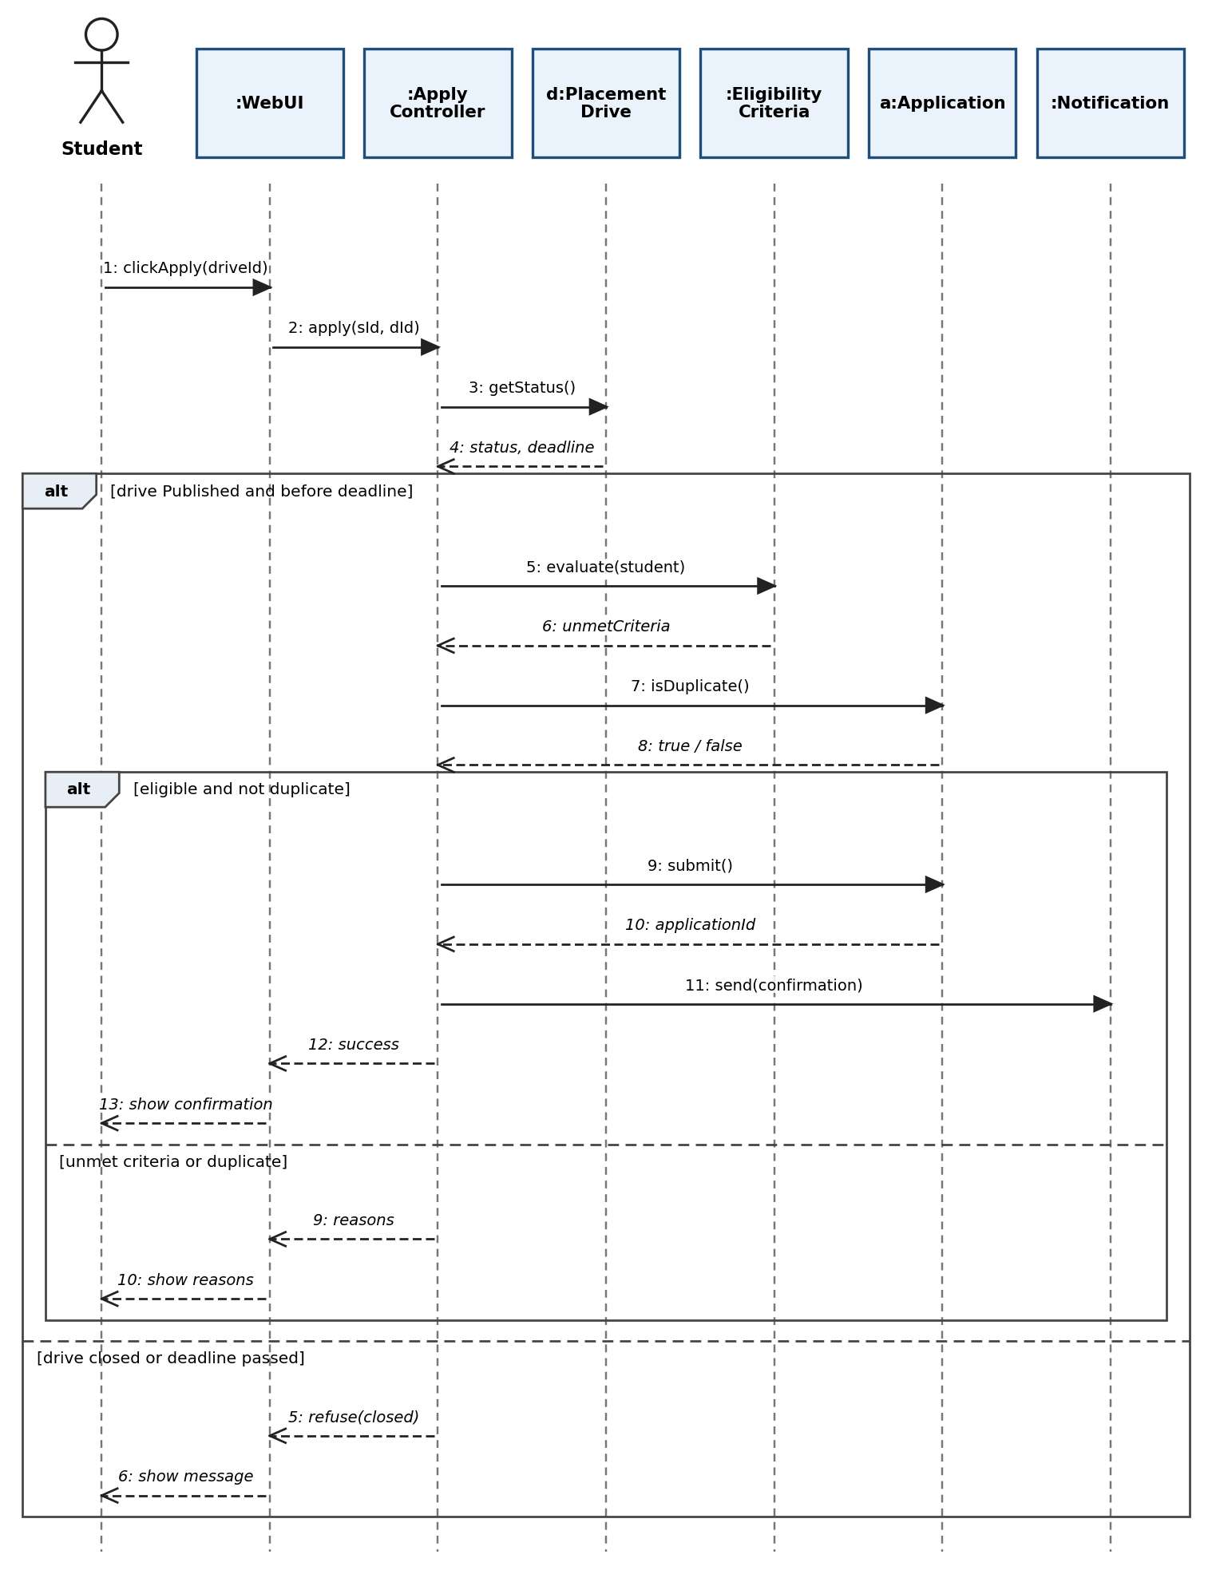
Figure 3. Apply for a Placement Drive

3.4 SD-4: Company Verification by the Placement Officer
The officer opens the list of companies awaiting verification and submits a verdict. The Company object is marked VERIFIED or REJECTED (with a reason), the recruiter is notified and the decision is written to the audit log.
Participants: Placement Officer, :WebUI, :CompanyController, c:Company, :Notification, :AuditLog
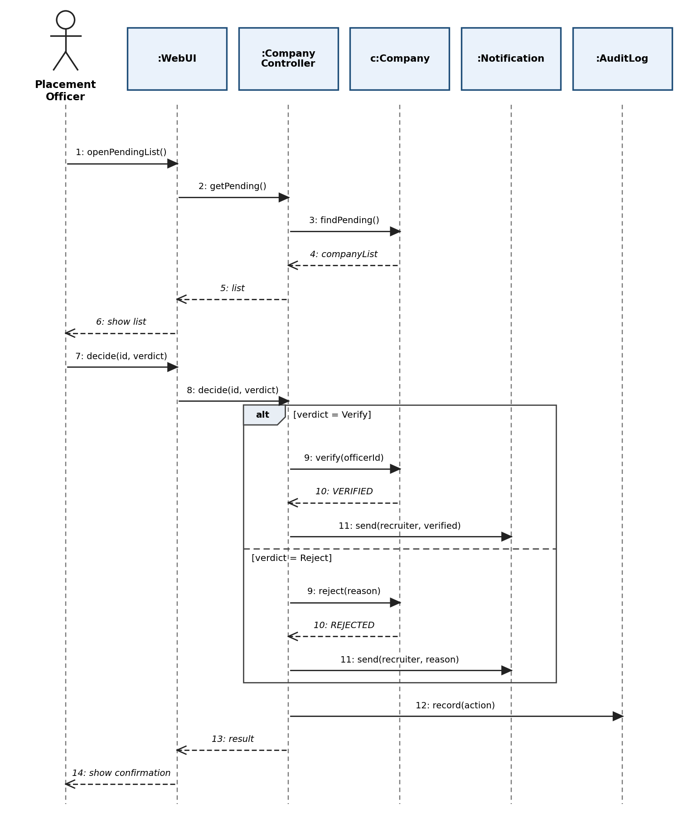
Figure 4. Company Verification by the Placement Officer

3.5 SD-5: Shortlisting and Stage Evaluation
Applicants are first shortlisted and the students are notified. For each stage the recruiter records an outcome in a StageOutcome object. A PASSED result advances the candidate; a FAILED result rejects the application and notifies the student.
Participants: Recruiter, :WebUI, :RecruitmentController, a:Application, so:StageOutcome, :Notification
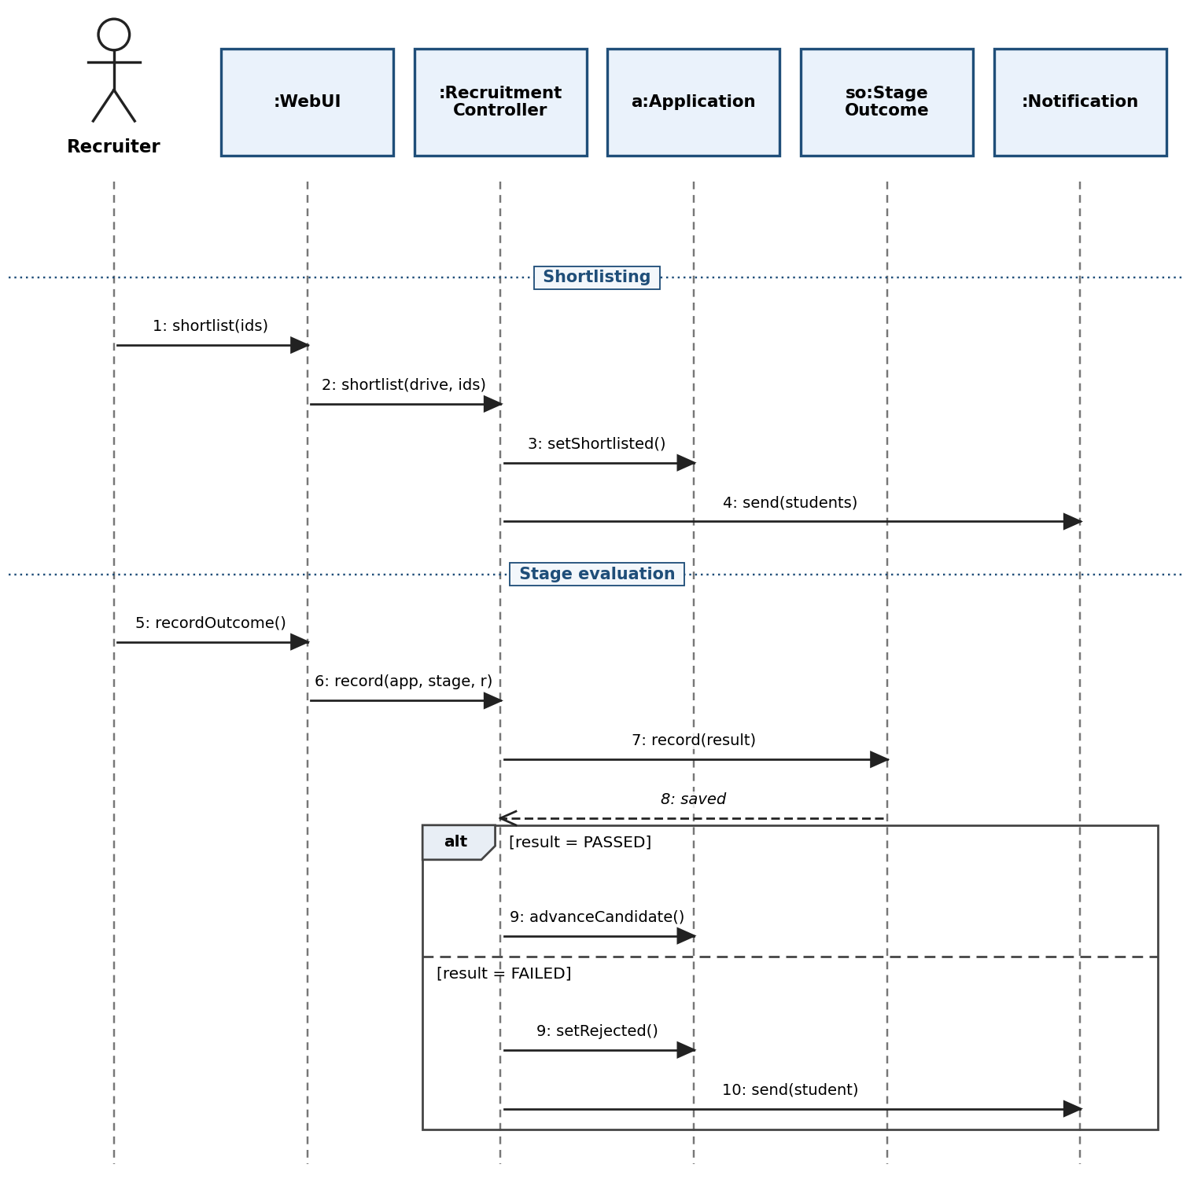
Figure 5. Shortlisting and Stage Evaluation

3.6 SD-6: Final Selection Decision
Before a Selected decision is stored, the controller asks the StageOutcome objects whether every mandatory stage was passed. If so, a Selection is created, the application status becomes SELECTED and the student is notified; otherwise the decision is refused.
Participants: Recruiter, :WebUI, :RecruitmentController, so:StageOutcome, a:Application, sel:Selection, :Notification
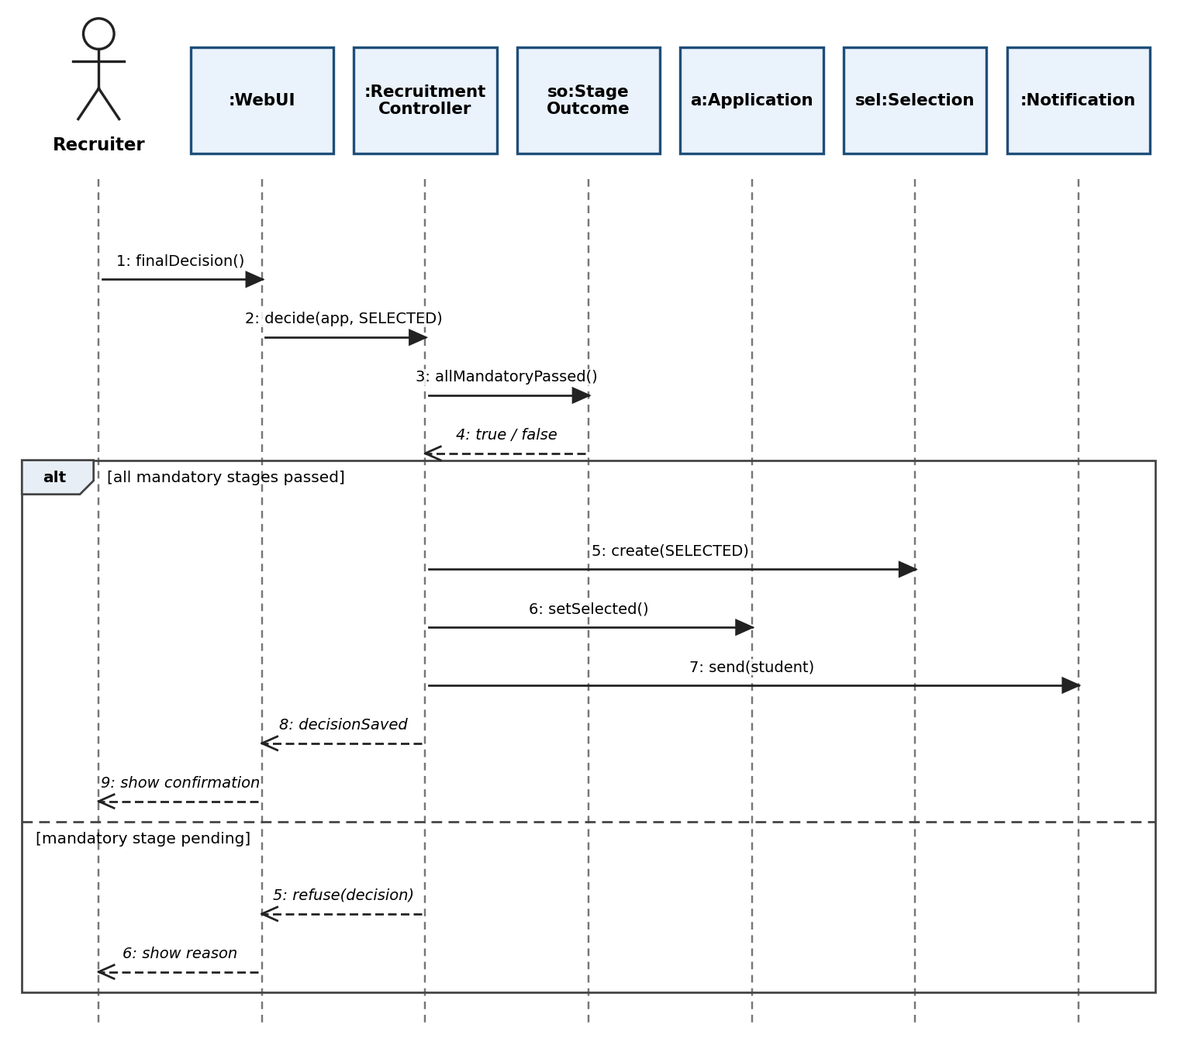
Figure 6. Final Selection Decision

3.7 SD-7: Placement Recording and Report Generation
The PlacementController checks that the student has no active placement. If none exists, or a multi-offer policy allows it, a PlacementRecord is created, the student is set to PLACED and the change is logged. The officer can then request a report, which the Report object builds from the stored placement records.
Participants: Placement Officer, :WebUI, :Report, :PlacementController, stu:Student, pr:PlacementRecord, :AuditLog
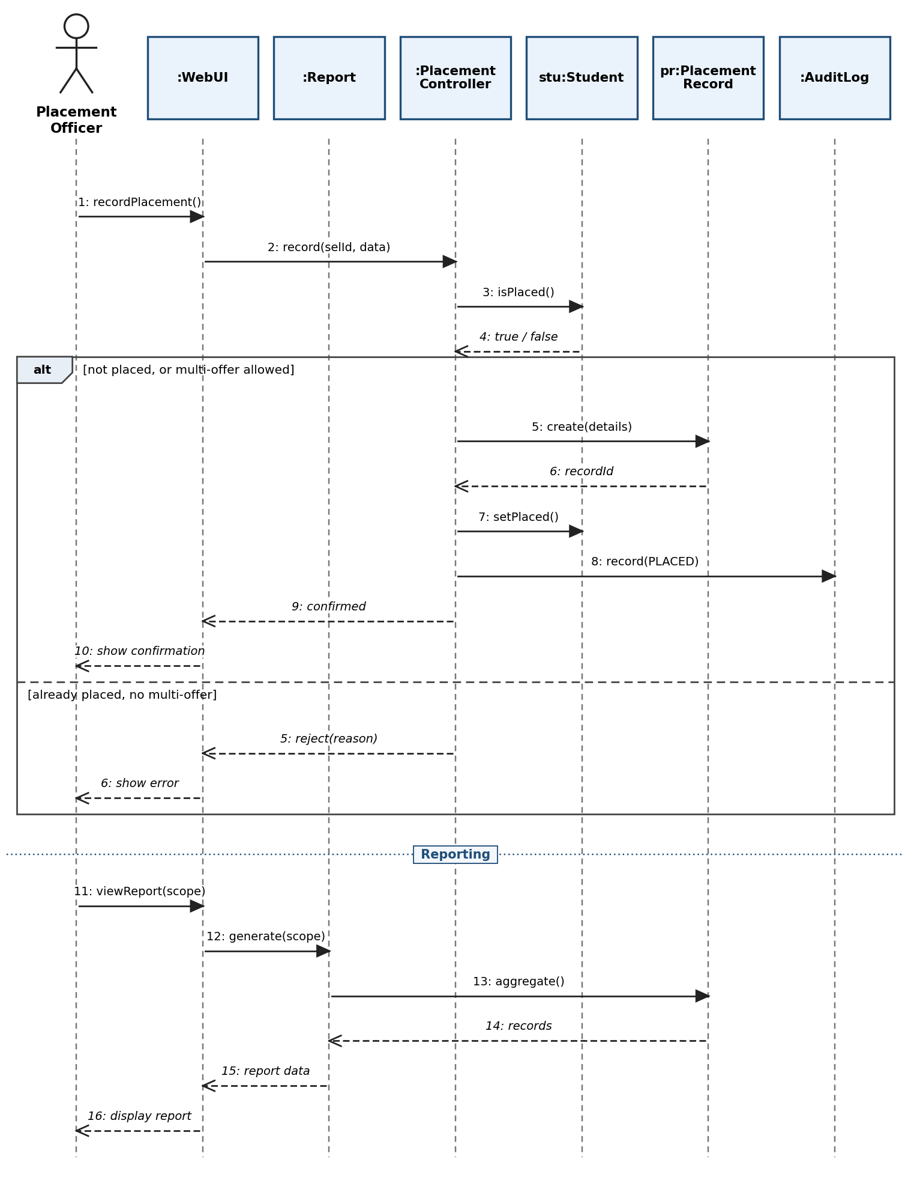
Figure 7. Placement Recording and Report Generation

4. Conclusion
The seven sequence diagrams show the message flow of the main SPMS scenarios: registration and activation, application with eligibility evaluation, company verification, shortlisting, stage evaluation, final selection and placement recording with reporting. Each diagram uses the classes of the class diagram, covers the success path and its alternatives, and traces back to use cases and SRS requirements. Together with the activity diagrams they give a complete behavioural model that can be used directly for implementation and for writing test cases.

