STUDENT PLACEMENT MANAGEMENT SYSTEM (SPMS)
DESIGN ANALYSIS REPORT

1. Introduction
1.1 Purpose and scope
This report analyses the design of the Student Placement Management System (SPMS) before implementation. It checks whether the design models produced so far are sound, consistent and traceable to the SRS, and it lists the weaknesses that should be corrected while changes are still cheap.
The analysis covers the architecture, the class model (responsibilities, cohesion and coupling), the application of design principles (SOLID and others) and design patterns, the support for the non-functional requirements, traceability from requirements to design, and a prioritised list of design issues with recommendations.
1.2 Inputs and method
The inputs are the approved SRS and the four UML models already prepared: the use case diagram (26 use cases), the class diagram (17 classes), six activity diagrams and seven sequence diagrams. Coupling figures in Section 3 are counted directly from the class diagram (20 relationships, including generalisations). Judgements on principles and patterns are qualitative and are supported by evidence taken from the models. No code exists yet, so run-time measurements are out of scope.
1.3 Summary of findings
Criterion | Rating | Finding
Architecture and modularity | Strong | Four layers plus cross-cutting services; modules match the SRS (authentication, student, company, drive, reporting).
Cohesion of domain classes | Strong | Most domain classes have one clear purpose (EligibilityCriteria, AuditLog, Notification, StageOutcome).
Coupling | Good | Average of 2.35 relationships per class, no cyclic dependencies, dependencies point from volatile role classes to stable domain classes.
SOLID principles | Adequate | Good use of Open/Closed, Liskov and Dependency Inversion in places; Single Responsibility is weak in RecruitmentController and the role classes.
Design patterns | Good | Layered/MVC, Facade, Composition and Generalisation are used; State, Observer and Strategy would fit naturally.
Requirements traceability | Strong | All 33 requirements trace to classes, use cases and at least one behavioural diagram.
Consistency between models | Needs work | Operations sit on role classes in the class diagram but on controllers in the sequence diagrams; some status data is duplicated.
Completeness against the SRS | Adequate | Offer acceptance, waitlist handling and recruiter or administrator requirements are not yet modelled (SRS gaps).

The three actions with the greatest effect are: align the class and sequence models and remove duplicated operations (issues 1 to 3 in Section 8), split RecruitmentController by responsibility, and close the SRS gaps by modelling offer acceptance and waitlist handling.

2. Architecture Analysis
2.1 Architectural style
SPMS is a web application and the models imply a layered architecture with a request flow of user interface, controller, domain object and repository. Section 6.1 of the SRS also asks for a modular structure with separate authentication, student, company, drive and reporting modules. Figure 1 shows how the design maps onto these layers.
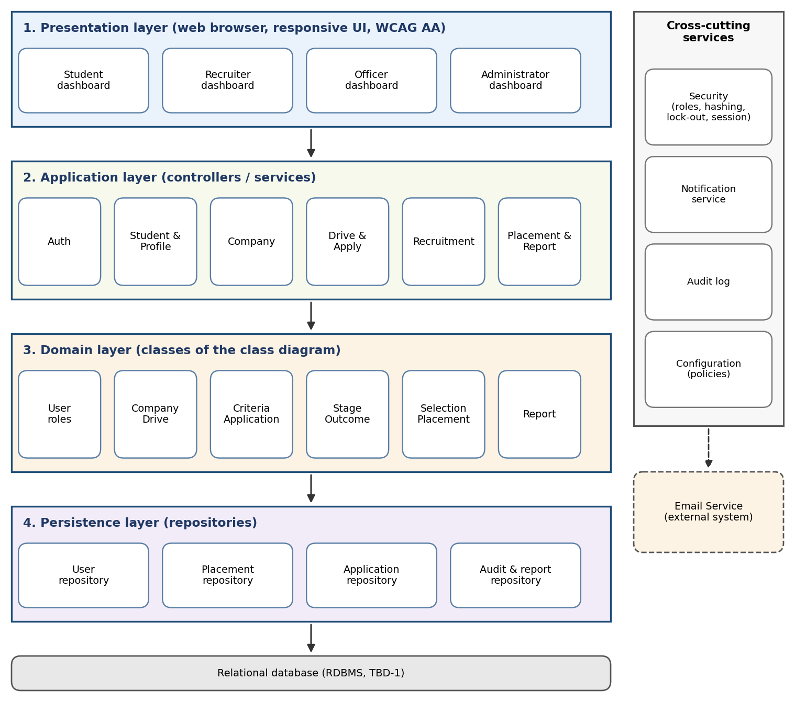
Figure 1. Layered architecture of SPMS
2.2 Key design decisions
Decision | Rationale | Alternative considered
Layered architecture | Separates screens, workflow and business rules; each layer can be tested and changed on its own. | Single page-script style, rejected because rules would spread over screens.
Abstract User with four role subclasses | Credentials, status and login logic are shared once (REQ-3 to 7). | Separate unrelated classes, rejected because of duplicated authentication code.
EligibilityCriteria as its own class owned by each drive | Placement policy is configurable data, not code (REQ-18, SRS 5.5). | Criteria as fields of PlacementDrive, rejected because it mixes two responsibilities.
StageOutcome and Selection kept apart | Per-stage results and the final decision are different facts; the rule 'all mandatory stages passed' is enforced between them (REQ-27, 28). | A single status on Application, rejected because it loses history.
Notification and AuditLog as cross-cutting services | Both are needed by almost every use case (REQ-19, 25, 26 and SRS 5.3). | Calls written inside every feature, rejected because of duplication.
External email behind an interface | The email provider and hosting are open (TBD-1), so the design should not depend on one vendor. | Direct vendor calls from controllers.

3. Class Model Analysis
3.1 Responsibilities and cohesion
Cohesion measures how closely the attributes and operations of a class belong together. The table summarises the responsibility of each class and a cohesion judgement based on whether the class has a single purpose.
Class | Responsibility | Attrs | Methods | Cohesion
User | Identity, credentials, account status, login and logout | 9 | 5 | High
Student | Academic profile, resume, applying and withdrawing | 12 | 7 | High
PlacementOfficer | Verification, approval, shortlisting, placement, reports | 2 | 7 | Medium (7 duties)
Recruiter | Company registration, drives, shortlisting, outcomes | 2 | 7 | Medium (overlaps officer)
Administrator | Users, configuration, audit review | 2 | 5 | High
Company | Registration data and verification status | 10 | 5 | High
PlacementDrive | Drive data and lifecycle (create, approve, close) | 9 | 6 | High
EligibilityCriteria | Rules and their evaluation for one drive | 6 | 3 | High
Application | One student's application and its status | 3 | 4 | High
RecruitmentStage | One scheduled step of the selection process | 6 | 3 | High
StageOutcome | Result of one application in one stage | 4 | 2 | High
Selection | Final decision with offered CTC and role | 5 | 4 | High
PlacementRecord | Authoritative record of a confirmed placement | 6 | 3 | High
Notification | A message to one user | 6 | 2 | High
Report | A generated statistics report and its export | 5 | 2 | High
AuditLog | One entry of the audit trail | 6 | 1 | High
ProfileItem | A skill, certification or project of a student | 4 | 2 | High

Student has the most attributes (12) and PlacementOfficer and Recruiter the most operations (7 each). The two role classes score lower on cohesion because they carry workflow operations that belong to the drive and recruitment process, and they duplicate three of those operations between them (issue 1, Section 8).
3.2 Coupling
Coupling was counted for each class as outgoing dependencies Ce (classes it depends on), incoming dependencies Ca (classes that depend on it) and instability I = Ce / (Ca + Ce). A value of 0 means a stable class that others depend on; 1 means a class that depends on others and nobody depends on it.
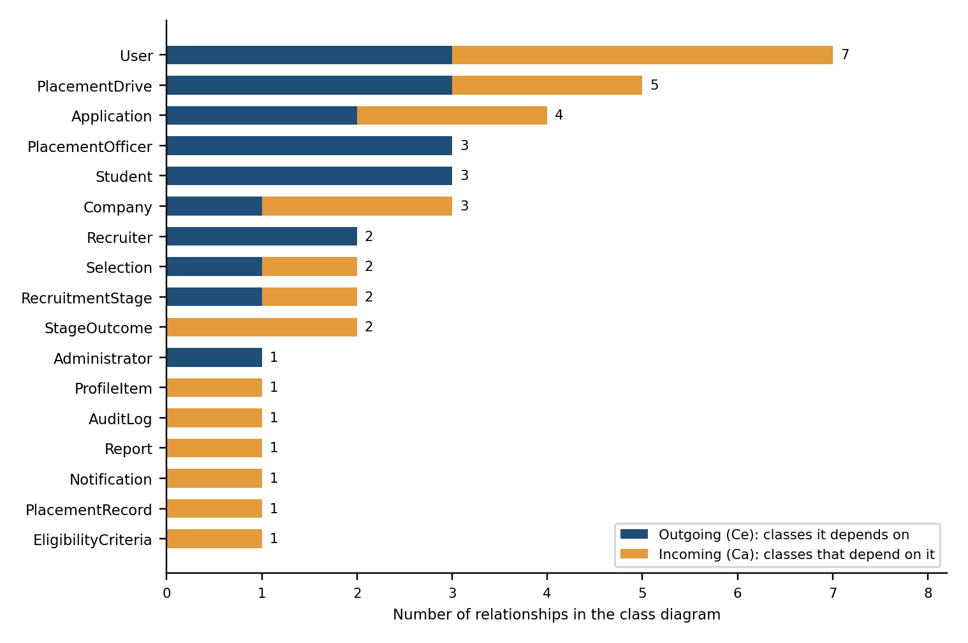
Figure 2. Relationships per class (outgoing and incoming)
Class | Ce | Ca | Total | Instability I | Reading
User | 3 | 4 | 7 | 0.43 | Intermediate
PlacementDrive | 3 | 2 | 5 | 0.60 | Intermediate
Application | 2 | 2 | 4 | 0.50 | Intermediate
Company | 1 | 2 | 3 | 0.33 | Intermediate
PlacementOfficer | 3 | 0 | 3 | 1.00 | Volatile; free to change
Student | 3 | 0 | 3 | 1.00 | Volatile; free to change
Recruiter | 2 | 0 | 2 | 1.00 | Volatile; free to change
RecruitmentStage | 1 | 1 | 2 | 0.50 | Intermediate
Selection | 1 | 1 | 2 | 0.50 | Intermediate
StageOutcome | 0 | 2 | 2 | 0.00 | Stable; leaf of the model
Administrator | 1 | 0 | 1 | 1.00 | Volatile; free to change
AuditLog | 0 | 1 | 1 | 0.00 | Stable; leaf of the model
EligibilityCriteria | 0 | 1 | 1 | 0.00 | Stable; leaf of the model
Notification | 0 | 1 | 1 | 0.00 | Stable; leaf of the model
PlacementRecord | 0 | 1 | 1 | 0.00 | Stable; leaf of the model
ProfileItem | 0 | 1 | 1 | 0.00 | Stable; leaf of the model
Report | 0 | 1 | 1 | 0.00 | Stable; leaf of the model

Observations
- Low overall coupling. 20 relationships over 17 classes give an average of 2.35 relationships per class, and the busiest class (User, 7) is an intended hub because every role extends it.
- No cyclic dependencies. Following the arrows never returns to the starting class, which satisfies the Acyclic Dependencies Principle and allows classes to be built and tested in order.
- Stable Dependencies Principle satisfied. The role classes (I = 1) depend on stable domain classes (I = 0 for StageOutcome, EligibilityCriteria, PlacementRecord, Notification, Report, AuditLog and ProfileItem), not the other way round.
- One hidden dependency. Report summarises PlacementRecord data but no relationship is drawn, and EligibilityCriteria uses a student's skills (ProfileItem) without one. Both should be added as dependencies.

4. Design Principles Analysis
4.1 SOLID principles
Principle | Evidence in SPMS | Finding | Recommendation
Single Responsibility | EligibilityCriteria, AuditLog, Notification and StageOutcome each do one thing. RecruitmentController (SD-5, SD-6) handles shortlisting, stage outcomes and final decisions. | Partly met | Split RecruitmentController into shortlisting, stage and selection services. Move workflow operations out of Recruiter and PlacementOfficer.
Open / Closed | New role, report type or notification type can be added without changing existing classes. Eligibility rules are fixed fields (minCgpa, maxBacklogs, ...). | Partly met | Model each eligibility rule as an object (Strategy) so a new rule is an added class, not a change to EligibilityCriteria.
Liskov Substitution | Student, PlacementOfficer, Recruiter and Administrator can all be used wherever a User is expected (login, logout, notifications, audit). | Met | Keep role-specific restrictions (for example an administrator cannot deactivate self) in the role checks, not as overridden User behaviour.
Interface Segregation | Each role has its own dashboard and controllers; clients do not depend on operations they never call. | Largely met | Expose small interfaces such as Notifiable and Auditable instead of one large service.
Dependency Inversion | Controllers depend on repositories and on an email service. The class diagram does not yet show these abstractions. | Partly met | Define repository interfaces and an EmailGateway interface; implementations are chosen when hosting is decided (TBD-1).
4.2 Other design principles
Principle | How the design applies it | Gap
Separation of concerns | Layers keep screens, workflow, rules and storage apart; eligibility, notification and audit are separate classes. | Controllers still call Notification and AuditLog directly.
Encapsulation and information hiding | Attributes are private in the class diagram and only the operations are public; the password is stored as passwordHash only. | Public operations on role classes expose internal workflow.
High cohesion, low coupling | Section 3: 14 of 17 classes have high cohesion; no cycles; average 2.35 relationships. | Role classes overlap.
DRY (do not repeat yourself) | Common account data is in User; one EligibilityCriteria type serves all drives. | shortlistApplicants(), configureCriteria() and manageStages() appear in two classes; final outcome appears in both Application and Selection.
Information expert | Rules sit with the data owner: EligibilityCriteria evaluates, StageOutcome knows if mandatory stages passed, Student knows if already placed (SD-3, SD-6, SD-7). | None found.
KISS / YAGNI | No speculative classes; multi-offer behaviour is configuration, not a new class. | The role attribute in User duplicates the subclass type.
Design for change | Policies (multi-offer, limits, thresholds) are configuration; the email provider can be swapped. | Lifecycle rules for Drive, Company and Application are not yet isolated.

5. Design Pattern Analysis
The table separates patterns that the models already use from patterns that would solve a problem identified in this review.
Pattern | Status | Where in SPMS | Benefit
Layered / MVC | Applied | WebUI (view), controllers (control), domain classes (model) in every sequence diagram. | Separates screens from business rules.
Facade | Applied | Each controller gives the UI one entry point to several domain objects, for example apply() in SD-3. | Hides internal collaboration from the UI.
Generalisation / Composition | Applied | User with four role subclasses; PlacementDrive owns EligibilityCriteria and RecruitmentStages; Student owns ProfileItems. | Reuse, and a clear lifetime of parts.
State | Recommended | Lifecycles of Drive (Pending Approval, Published, Closed), Company (Pending, Verified, Rejected) and Application (Applied to Selected). | Replaces scattered status checks with one transition table or state classes; blocks illegal changes such as editing a closed drive.
Observer | Recommended | Notification and AuditLog are triggered after status changes in SD-3 to SD-7. | Controllers publish an event; listeners notify and log, so new listeners need no controller change.
Strategy | Recommended | Eligibility rules (CGPA, backlogs, branch, skills) and report exporters (PDF, spreadsheet). | A new rule or format is a new class (Open/Closed).
Repository | Recommended | Persistence layer in Figure 1, including the unique (student, drive) check. | Hides storage details and makes classes testable.
Factory Method | Recommended | Creating Student, Recruiter and officer accounts with the right defaults and status. | Keeps role and subclass consistent.
Singleton | Use sparingly | System configuration (policies). | A single configuration source; implement as an injected service so it stays testable.

6. Quality Attribute Analysis
This section checks how the design supports the non-functional requirements of the SRS.
Attribute | SRS target | Design support | Risk and mitigation
Performance | Pages within 3 s; 200 users normal, 500 sessions (TBD-4) | Eligibility is evaluated in memory per request; unique key on (student, drive) avoids scans; controllers hold no session state. | Reports over all placement records are heavy: paginate, index by year and department, and generate large exports in the background.
Security | TLS 1.2+, salted hashes, lock-out after 5 failures, 30-minute session timeout, role-based access | User holds passwordHash, failedAttempts and lockedUntil; each role has its own controllers; every status change is audited. | Server-side check of resume type and size (5 MB); enforce role checks in controllers, not only in the UI.
Reliability and availability | 99% uptime, restore within 4 hours | Multi-step actions (record placement, final decision) are single transactions, as in SD-6 and SD-7. | Single database is a point of failure: scheduled backups and a tested restore plan.
Data integrity | No duplicate applications, one placement per cycle, unique company domain | Unique constraints and the rules owned by Application, Student and Company. | Duplicated status fields can drift apart: keep a single source of truth (issue 5).
Usability and accessibility | WCAG AA, role dashboards | A dashboard per role; notifications for each state change; all unmet criteria shown at once (AD-4). | Test colour contrast and keyboard navigation in the diagrams' screens.
Maintainability and extensibility | Modular, configurable policies | Layers, small classes, policy as configuration, replaceable email service. | Apply the State and Strategy patterns before more rules are added.

7. Requirements Traceability
Every requirement group of the SRS maps to design classes, use cases and behavioural diagrams, so no requirement is left without a design element.
Requirements | Design classes | Use cases | Behavioural diagrams
REQ-1 to 7 Authentication | User, Student, AuditLog | UC-01 to UC-04 | AD-1; SD-1, SD-2
REQ-8 to 12 Student profile | Student, ProfileItem | UC-05, UC-06 | Covered by class model
REQ-13 to 15 Company | Company, Recruiter, PlacementOfficer | UC-12, UC-13 | AD-2; SD-4
REQ-16 to 20 Drives | PlacementDrive, EligibilityCriteria, RecruitmentStage | UC-14 to UC-16 | AD-3
REQ-21 to 24 Eligibility and application | EligibilityCriteria, Application | UC-07 to UC-11 | AD-4; SD-3
REQ-25 to 28 Recruitment | RecruitmentStage, StageOutcome, Selection | UC-17 to UC-19 | AD-5, AD-6; SD-5, SD-6
REQ-29 to 33 Placement and reports | PlacementRecord, Report | UC-20 to UC-22 | AD-6; SD-7
Cross-cutting (notifications, audit, administration) | Notification, AuditLog, Administrator | UC-23 to UC-26 | Used in SD-3 to SD-7

Coverage gap: REQ-8 to 12 has no activity or sequence diagram. A profile update is a simple create-read-update flow, but a short sequence diagram for resume upload with validation would complete the set.

8. Design Issues and Recommendations
Issues are listed by priority. High means the issue could cause wrong behaviour or an incomplete system; Medium affects maintainability; Low is an improvement.
# | Issue | Evidence | Recommendation | Priority
1 | Duplicated operations in role classes | shortlistApplicants(), configureCriteria() and manageStages() exist in both Recruiter and PlacementOfficer. | Move them to one RecruitmentService used by both roles. | Medium
2 | Class and sequence models disagree | Class diagram: applyForDrive() on Student. Sequence diagram SD-3: ApplyController does the work. | Decide one rule: workflow in services and controllers, rules in domain objects; update the class diagram accordingly. | High
3 | Low cohesion of RecruitmentController | It handles shortlisting, stage outcomes, final decisions and notifications (SD-5, SD-6). | Split into ShortlistingService, StageService and SelectionService. | Medium
4 | Direct calls to Notification and AuditLog | Repeated in SD-3 to SD-7. | Publish domain events; Notification and AuditLog subscribe (Observer). | Medium
5 | Duplicated status data | Application.status and Selection.decision both hold the final outcome; Student.placementStatus is derived from PlacementRecord. | Keep one source of truth, or update all copies in one transaction and add a consistency check. | High
6 | Role stored twice | User.role and the subclass type. | Create users through a factory that sets both, or derive the role from the subclass. | Low
7 | Lifecycle rules scattered | Status enums for Drive, Company, Application are checked in many places. | State pattern or a transition table that rejects illegal changes. | Medium
8 | Eligibility rules are fixed fields | minCgpa, maxBacklogs, eligibleBranches in EligibilityCriteria. | Rule objects with a common evaluate() (Strategy). | Low
9 | SRS gaps not modelled | No offer acceptance, no waitlist handling, no recruiter registration or administrator requirement numbers. | Add an Offer response (accept or decline) to Selection and a waitlist rule to Application; raise the gaps with the SRS owner. | High
10 | Missing dependencies | Report to PlacementRecord and EligibilityCriteria to ProfileItem are not drawn. | Add dependency arrows to the class diagram. | Low
11 | Vendor dependence | Email and database choices are open (TBD-1). | Define EmailGateway and repository interfaces now. | Medium

9. Conclusion
The SPMS design is structurally sound: it is layered, modular, free of dependency cycles and traceable to every SRS requirement. The domain classes are cohesive and the dependencies point in the right direction. The main weaknesses are in the role and controller classes, where responsibilities overlap, and in a few places where the class and sequence models disagree or the same status is stored twice.
Correcting the eleven issues in Section 8, and in particular issues 2, 5 and 9, will make the design consistent and complete before coding starts. The recommended State, Observer and Strategy patterns can then be applied with little rework, because the domain classes they affect are already small and stable.

