STUDENT PLACEMENT MANAGEMENT SYSTEM (SPMS)
UML USE CASE DIAGRAM
Software Engineering and Design Principles | Assignment 2

1. Introduction
A use case diagram describes what a system does from the point of view of the people and systems that use it. It shows the actors, the functions (use cases) each actor can perform, and the relationships between those functions, without describing how they are implemented.
This document presents the UML use case model of the Student Placement Management System (SPMS). SPMS is a web-based platform that centralises registration, company verification, placement drives, eligibility evaluation, applications, multi-stage recruitment, final placement recording and reporting for a college Training & Placement Cell. The model is derived directly from the approved Software Requirements Specification (SRS), and every use case is traced to the SRS requirement (REQ-n) it realises.
The document contains an overall diagram, three module-level diagrams that show the include and extend relationships in detail, a description of every actor and use case, and detailed specifications of four key use cases.

2. Actors
1. Student
A registered student of the college. Students maintain their academic profile and resume, view the drives they are eligible for, apply to drives, withdraw applications and track the status of each application.
2. Placement Officer
A member of the Training & Placement Cell. Officers verify companies, approve drives, configure eligibility, shortlist applicants, manage recruitment stages, record final placements and generate reports. Officer accounts are provisioned by the Administrator and cannot be self-registered.
3. Recruiter
A representative of a company. A recruiter is linked to exactly one company, registers it for verification and, once it is verified, creates drives and manages shortlisting, stages and selection decisions for those drives.
4. Administrator
The system administrator. Administrators manage user accounts, maintain system configuration and policies, review the audit log and have access to placement reports.
5. Email Service (secondary actor)
An external outbound email service used by the system to deliver verification links, password-reset links and lifecycle notifications. It does not initiate any use case.

3. Overall Use Case Diagram
Figure 1 gives the high-level view of SPMS. Related functions are grouped into twelve main use cases, which keeps the diagram readable. Every role must log in before using the system, so Login is shown connected to all four actors. The detailed breakdown of each group follows in Section 4.
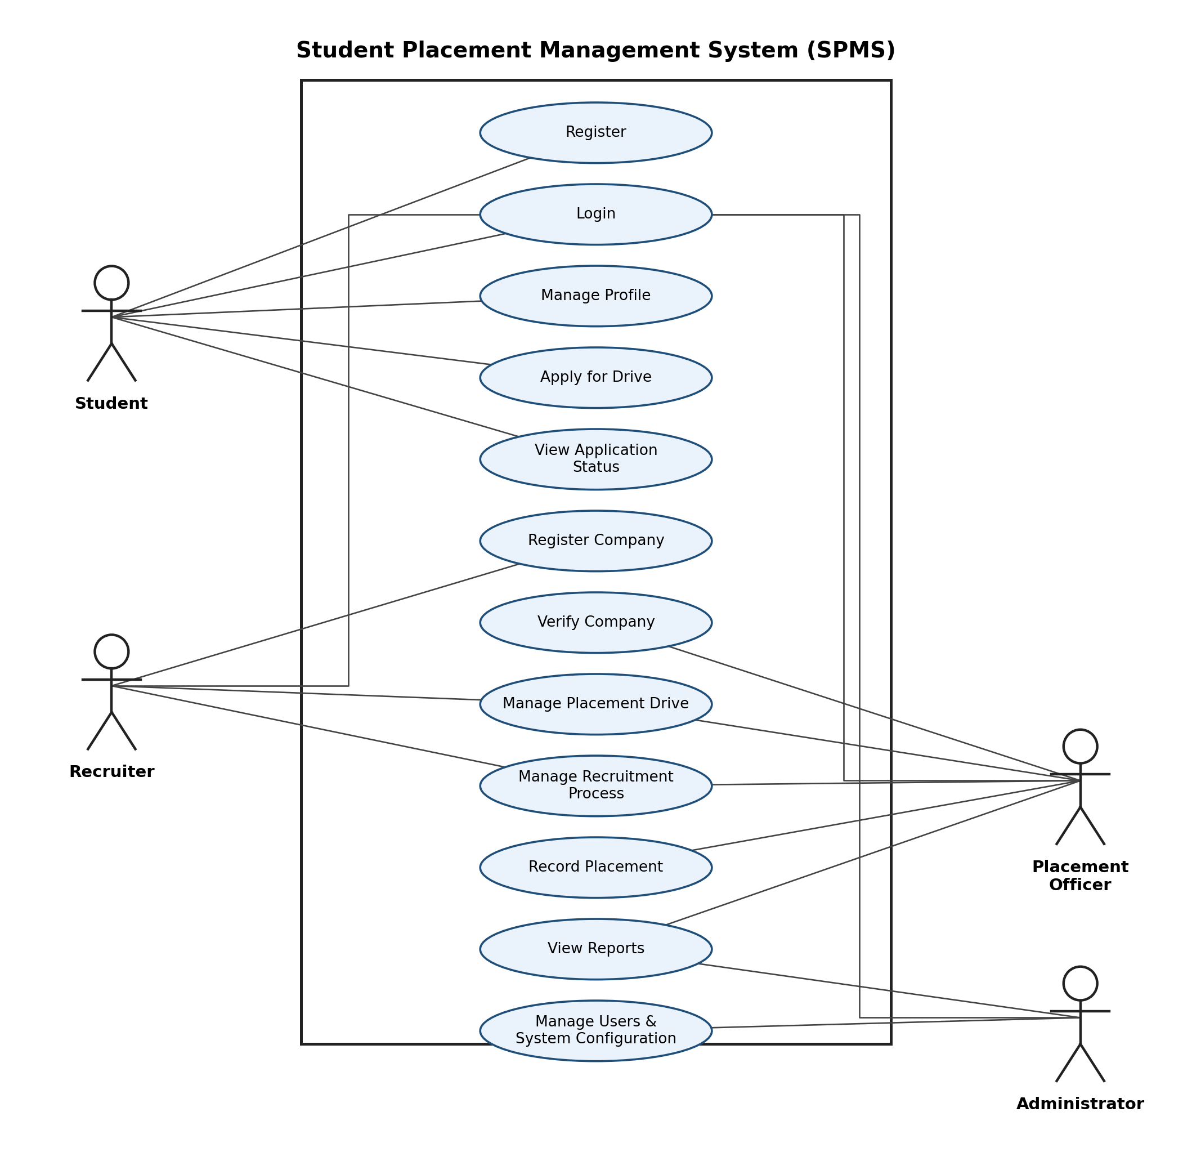
Figure 1. Overall use case diagram of SPMS

4. Module-wise Use Case Diagrams
The overall use cases are expanded into individual functions below. Dashed arrows labelled «include» mean the base use case always performs the included one; arrows labelled «extend» mean the extending use case adds optional behaviour to the base use case. All use cases except Register, Login and Reset Password require an authenticated session.

4.1 Authentication and Student Module
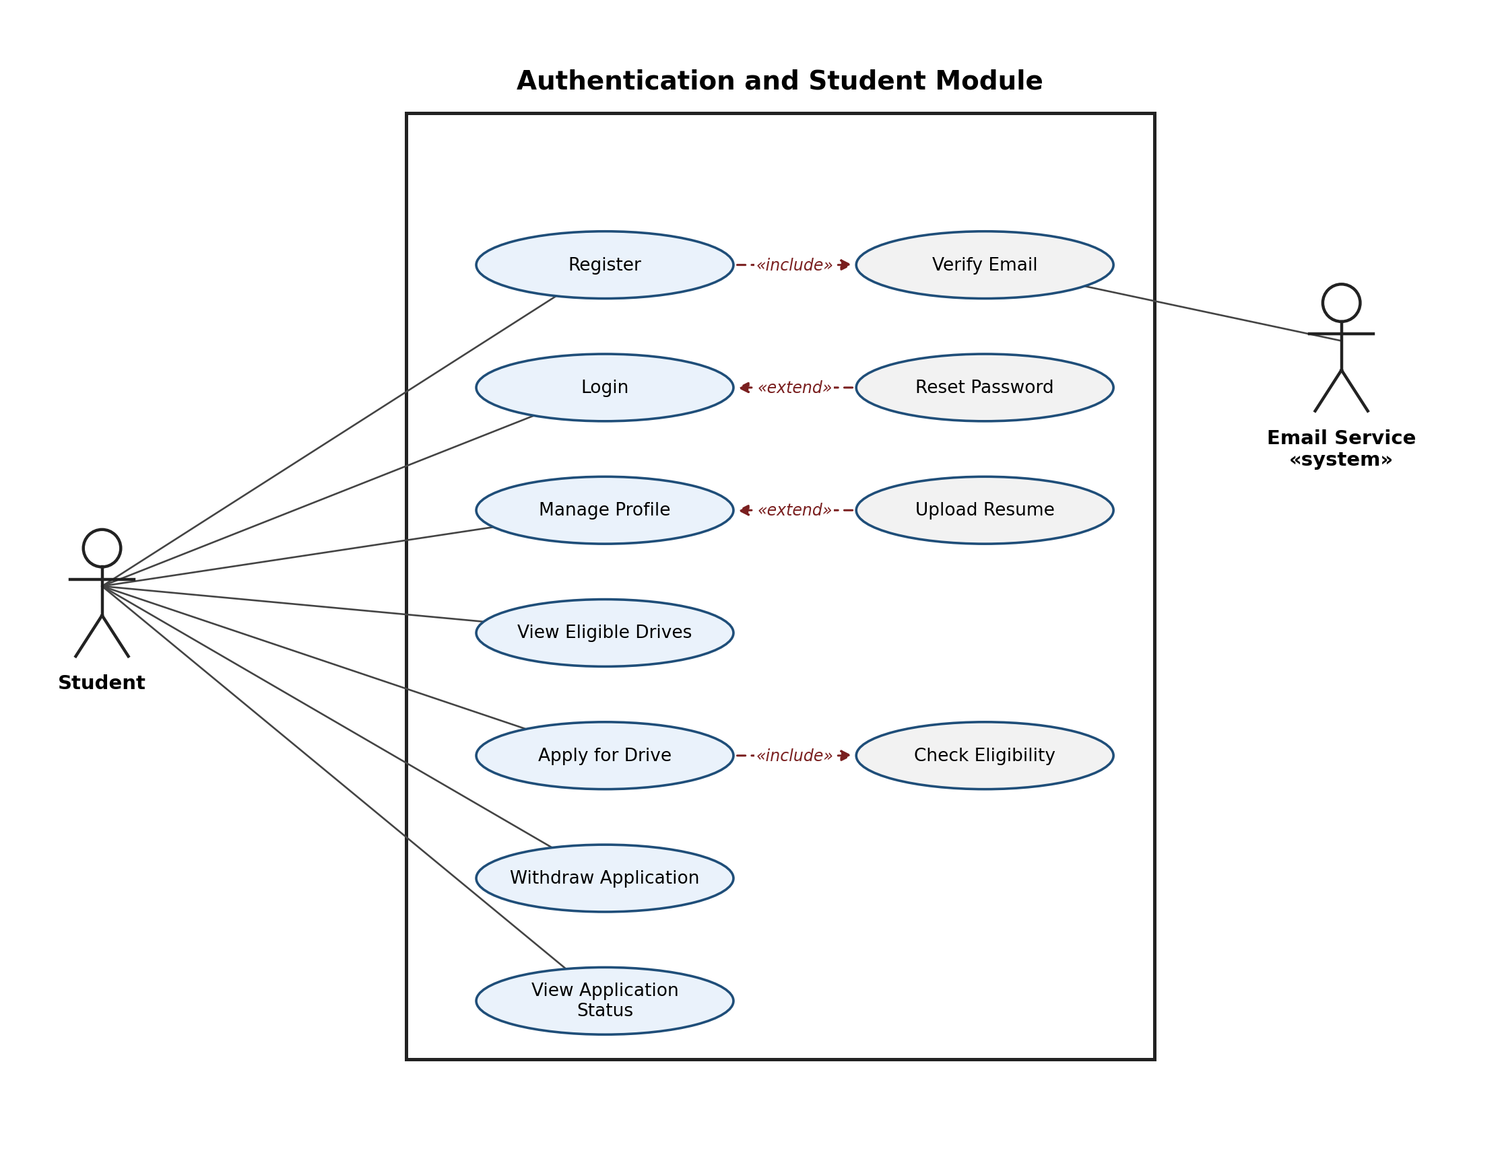
Figure 2. Authentication and student use cases
Login and Reset Password are common to every role; they are drawn with the Student here for clarity. Register includes Verify Email, which involves the Email Service. Apply for Drive includes Check Eligibility so that no application can be created without an eligibility evaluation.

4.2 Company Verification and Placement Drive Module
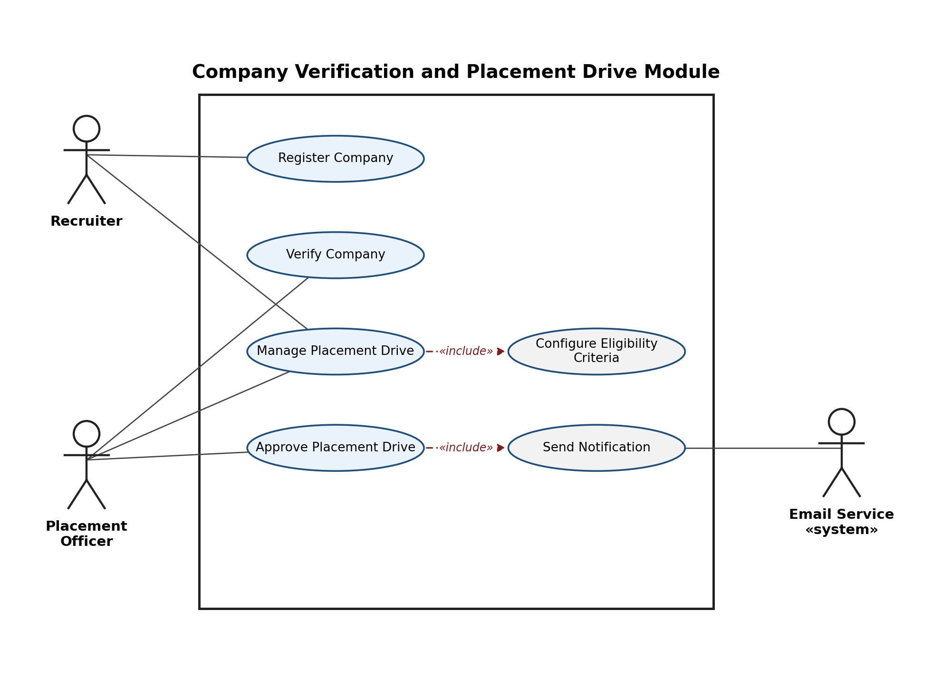
Figure 3. Company verification and placement drive use cases
A recruiter registers a company, and the Placement Officer verifies it. Only a verified company can create drives (REQ-15). Each drive includes the configuration of its eligibility criteria and must be approved by an officer, which triggers a notification through the Email Service.

4.3 Recruitment, Placement, Reporting and Administration Module
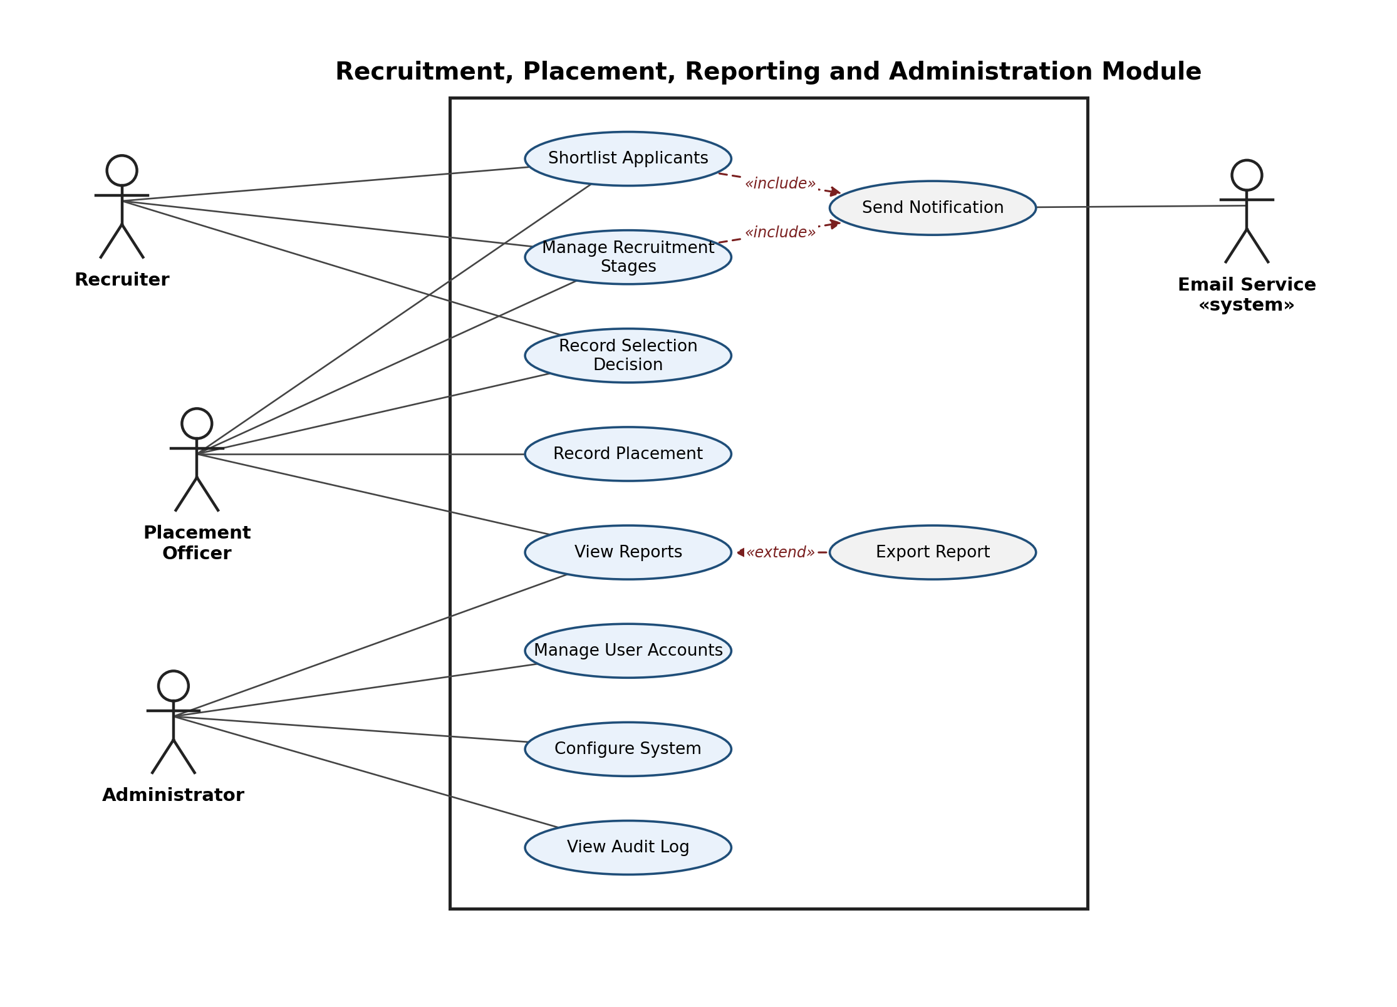
Figure 4. Recruitment, placement, reporting and administration use cases
Shortlisting and stage management both notify students. Recruiters and officers share the recruitment use cases, while only officers record the final placement. Reports can optionally be exported, and administrator-only functions cover user accounts, system configuration and the audit log.

