STUDENT PLACEMENT MANAGEMENT SYSTEM (SPMS)
SYSTEM ARCHITECTURE DIAGRAM

1. Introduction
This document describes the system architecture of the Student Placement Management System (SPMS): its context, the logical layers, the component structure, the deployment and the way a request travels through the system. It turns the requirements of the SRS and the models already prepared (use case, class, activity and sequence diagrams and the design analysis) into one architectural view that guides implementation.
Five architectural views are given, each answering one question:
- System context: who and what interacts with SPMS from outside.
- Logical architecture: how the software is organised in layers.
- Component architecture: which modules exist and how they depend on each other.
- Deployment architecture: where the parts run and how they are connected.
- Request flow: how one user action passes through the layers, including security checks.
Assumption: the SRS leaves the hosting environment and the database product open (TBD-1). The architecture is therefore described independently of any vendor, and the technology table in Section 8 gives example choices only.

2. Architectural Drivers
The requirements below shape the architecture most. Each one is matched with the decision it leads to.
Driver | Requirement (SRS) | Architectural decision
Performance | Pages load within 3 s; 200 users normal load, 500 sessions peak (TBD-4) | Stateless application tier that can be duplicated behind the reverse proxy; indexed queries; paging for lists; slow exports run in the background.
Security | TLS 1.2+, salted password hashes, lock-out after 5 failed logins, 30-minute session timeout, role-based access | TLS ends at the reverse proxy; one security filter checks session and role before every controller; hashing and lock-out in the Auth service.
Availability and recovery | 99% uptime, restore within 4 hours | Daily backups of database and files, automatic restart of the application, a documented restore procedure.
Data integrity | No duplicate applications, one placement per cycle, unique company domain | Business rules in the service layer, run inside database transactions with unique constraints as a safety net.
Auditability | Audit log of every status-changing action | Audit log service called through the same event mechanism as notifications.
Configurability | Policies such as multi-offer must be changeable without code | Configuration service read by the services at run time.
Usability | WCAG AA, responsive web interface | Browser-based role portals; no software to install on the user's device.
Maintainability | Modular structure (authentication, student, company, drive, reporting) | Layers and components of Sections 4 and 5; one module per SRS area.

3. System Context
Figure 1 shows SPMS as one system with its four user roles and one external system. Users work through a web browser; the only outbound integration is the Email Service.
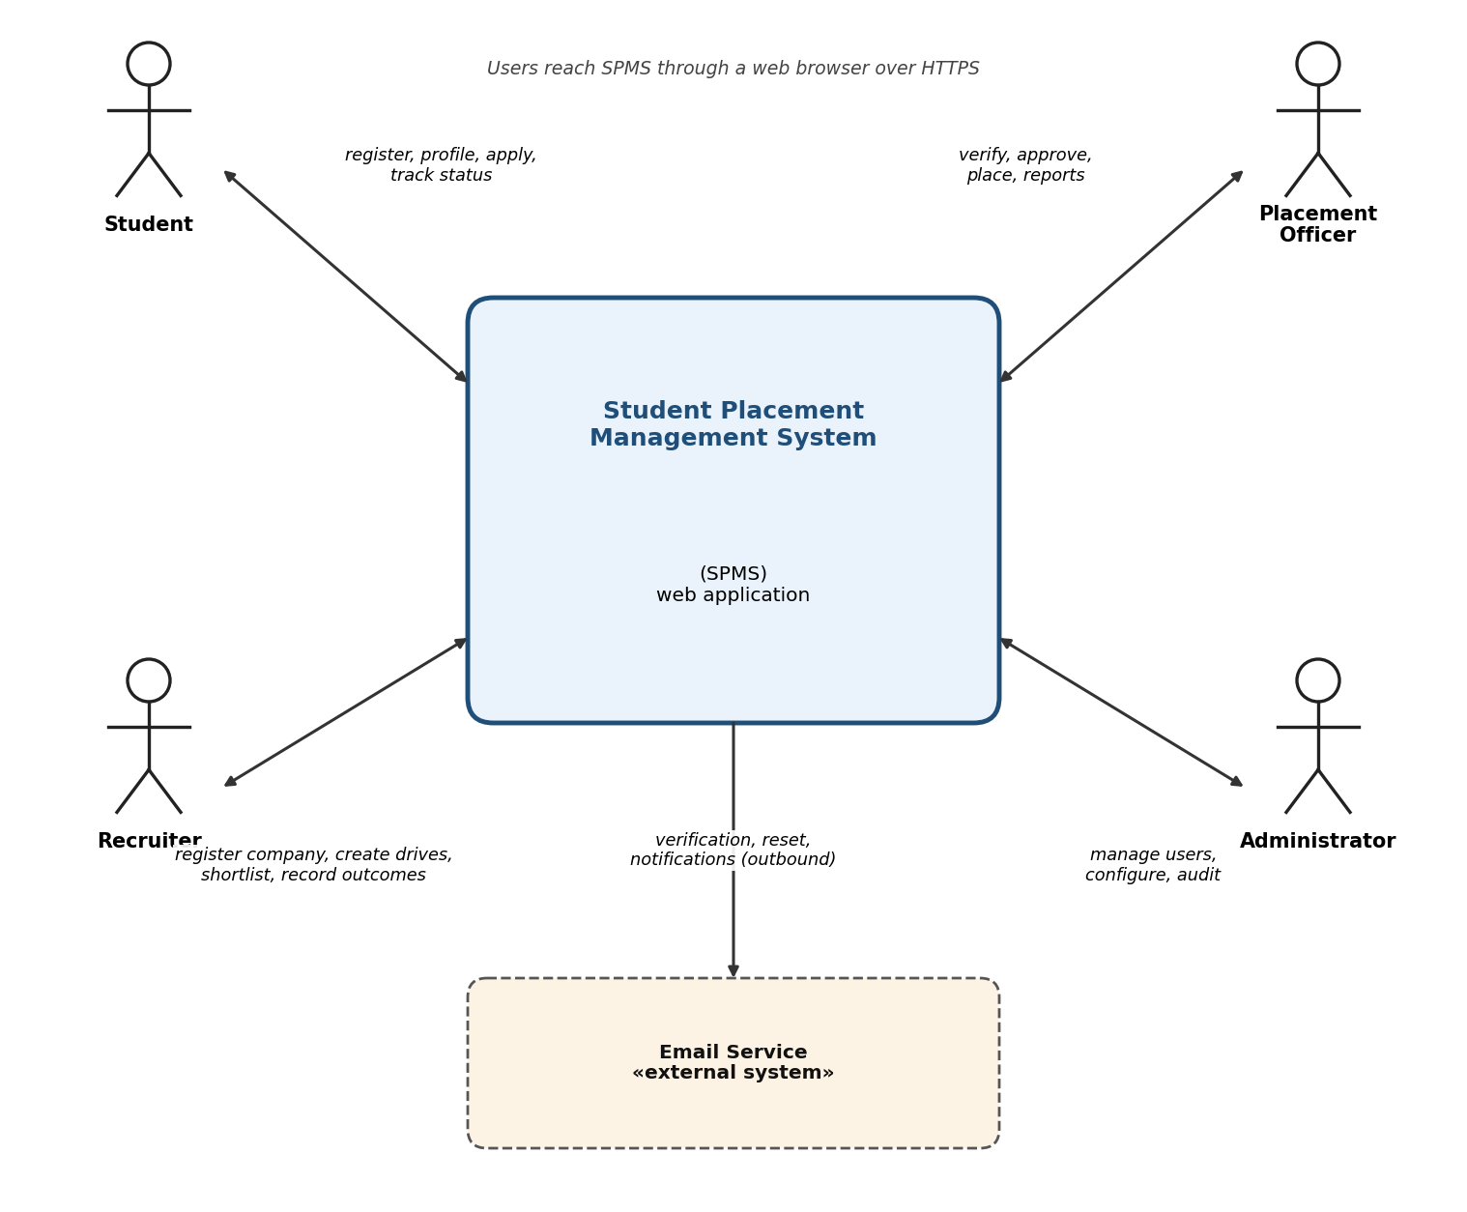
Figure 1. System context diagram
External party | Type | Direction | Purpose
Student | Human actor | In and out | Registers, maintains the profile, applies to drives and tracks status.
Recruiter | Human actor | In and out | Registers the company, creates drives, shortlists and records outcomes.
Placement Officer | Human actor | In and out | Verifies companies, approves drives, records placements and reads reports.
Administrator | Human actor | In and out | Manages accounts, configuration and the audit log.
Email Service | External system | Outbound only | Delivers verification links, password-reset links and notifications.

4. Logical Architecture
Figure 2 shows the layered structure. A request enters at the presentation layer and moves downwards; each layer calls only the layer below it. Security, event handling, notification, auditing and configuration are shared services used by the controller and service layers.
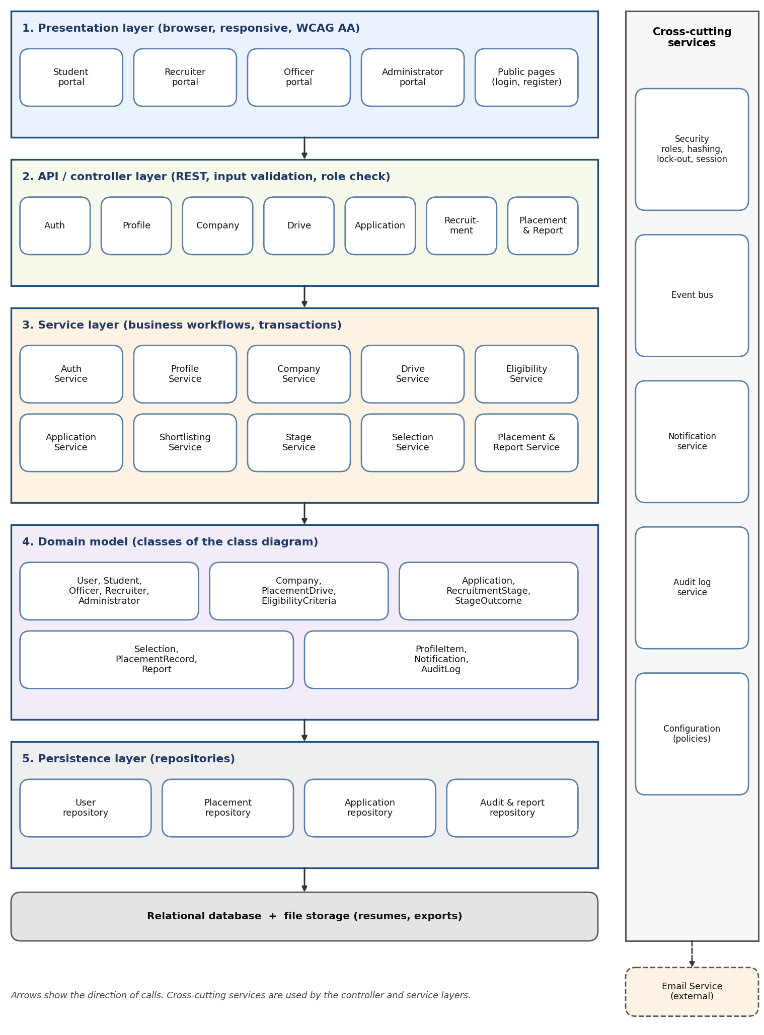
Figure 2. Logical (layered) architecture

