STUDENT PLACEMENT MANAGEMENT SYSTEM (SPMS)
UML CLASS DIAGRAM

1. Introduction
A class diagram shows the static structure of a system: its classes, their attributes and operations, and the relationships between them. It is the main bridge between the requirements (SRS) and the implementation.
The classes of SPMS were identified from the approved SRS by noun analysis: the actors (Student, Placement Officer, Recruiter, Administrator), the business entities named in the requirements (Company, Placement Drive, Application, Recruitment Stage, Placement Record, Report, Notification) and the supporting concepts that the requirements imply (Eligibility Criteria, Stage Outcome, Selection, Audit Log, Profile Item). Verbs in the requirements, such as verify, approve, shortlist and apply, became the operations of those classes.
Design decisions followed from the SRS:
- Inheritance for roles. The four roles share account data, so they inherit from an abstract User class.
- Separate EligibilityCriteria. Institution rules must be configurable, not hard-coded (SRS 2.5, 5.5), so they are data owned by each drive.
- StageOutcome and Selection. Outcomes per stage and the final decision are stored separately to enforce the rule that a candidate advances only after passing every earlier mandatory stage (REQ-27, 28).
- AuditLog. The SRS requires an audit trail of every status-changing action (SRS 5.3).
- Composition. Criteria, stages and profile items cannot exist without their owner, so they are drawn as compositions.
Figure 1 on the next page shows the complete diagram with the key attributes and operations. Complete member lists are given in Section 3.

2. Class Diagram
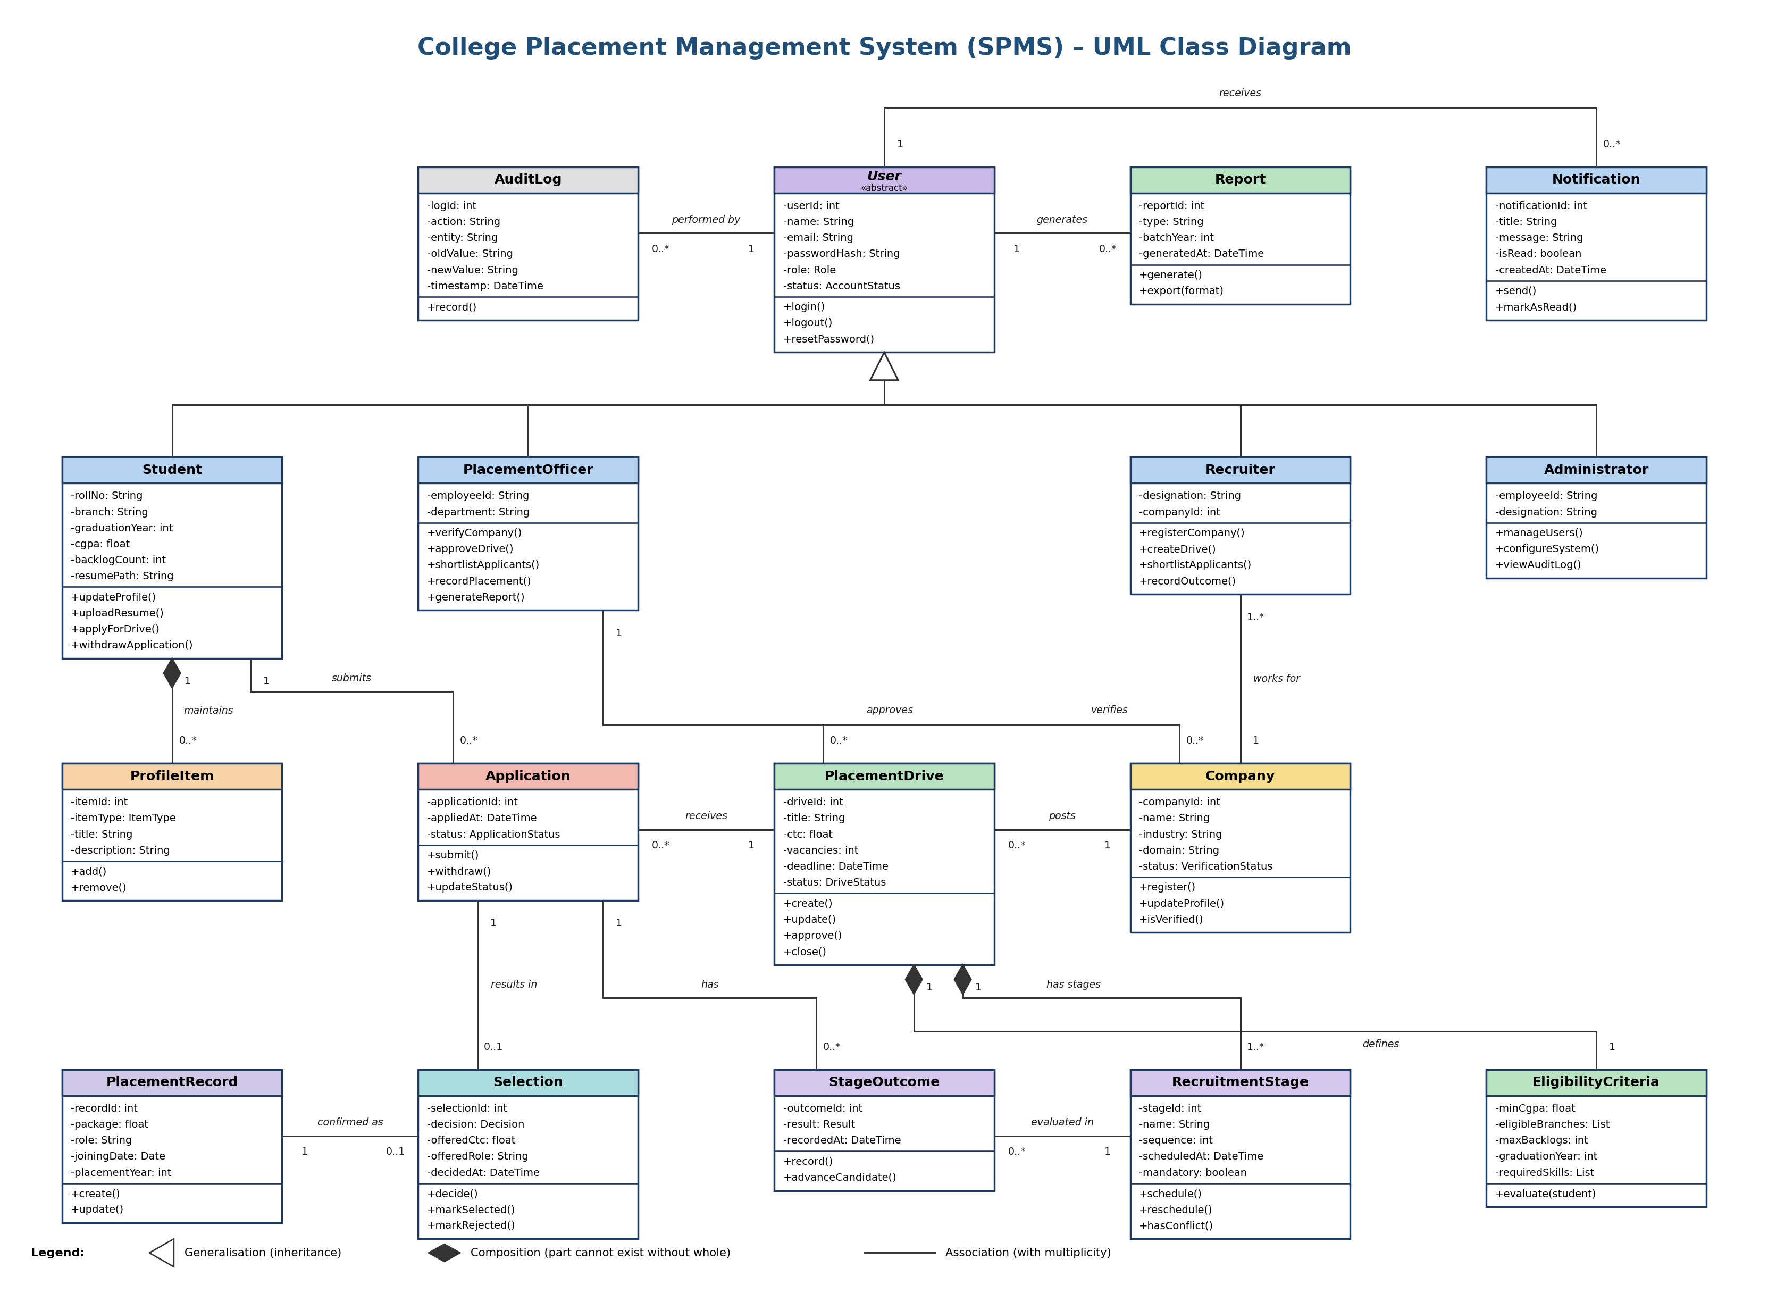
Figure 1. UML class diagram of the Student Placement Management System

3. Description of Classes
1. User (abstract)
The User class is the parent class for every account in SPMS. It holds the data and behaviour common to all roles: identity, credentials, role and account state. Passwords are stored only as salted hashes, and the failed-attempt counter and lock time support the account lock-out rule (REQ-3, REQ-4).
Attributes: userId, name, email, passwordHash, role, status, failedAttempts, lockedUntil, createdAt
Methods: login(), logout(), changePassword(), resetPassword(), updateProfile()
User is inherited by Student, PlacementOfficer, Recruiter and Administrator. A user receives many Notifications, generates Reports and is the actor recorded in AuditLog entries.
2. Student
The Student class represents a student of the college. It stores the academic data used by the eligibility engine (CGPA, backlogs, branch, graduation year) together with contact details, resume and placement status (REQ-8, 9, 11, 12).
Attributes: rollNo, branch, degree, graduationYear, cgpa, backlogCount, category, phone, address, resumePath, profileCompleteness, placementStatus
Methods: updateProfile(), uploadResume(), calculateCompleteness(), viewEligibleDrives(), applyForDrive(), withdrawApplication(), viewApplications()
A student owns many ProfileItems (skills, certifications, projects) and submits many Applications.
3. PlacementOfficer
The PlacementOfficer class represents a member of the Training & Placement Cell. Officers control the quality of placement data: they verify companies, approve drives, shortlist, manage stages, confirm placements and produce reports. Officer accounts are provisioned by an administrator.
Attributes: employeeId, department
Methods: verifyCompany(), approveDrive(), configureCriteria(), shortlistApplicants(), manageStages(), recordPlacement(), generateReport()
An officer verifies companies and approves placement drives.
4. Recruiter
The Recruiter class represents a company representative. A recruiter belongs to exactly one company and, once the company is verified, creates drives and handles shortlisting, stages and outcomes for them.
Attributes: designation, companyId
Methods: registerCompany(), createDrive(), configureCriteria(), shortlistApplicants(), manageStages(), recordOutcome(), viewApplicants()
Many recruiters can work for one Company; each recruiter is linked to exactly one Company.
5. Administrator
The Administrator class represents the system administrator. It manages accounts, system configuration and institution-specific policies, and reviews the audit log. An administrator cannot deactivate their own account.
Attributes: employeeId, designation
Methods: manageUsers(), provisionOfficer(), configureSystem(), viewAuditLog(), generateReport()
The administrator reads AuditLog entries and generates Reports.
6. Company
The Company class represents a recruiting company. It stores registration details and the verification status that decides whether the company may publish drives (REQ-13, 14, 15). The official domain is unique.
Attributes: companyId, name, industry, domain, contactName, contactEmail, status, reviewedBy, reviewedAt, rejectionReason
Methods: register(), updateProfile(), verify(), reject(reason), isVerified()
A company has one or more Recruiters, posts many PlacementDrives and is verified by a PlacementOfficer.
7. PlacementDrive
The PlacementDrive class represents one recruitment process started by a company for a role. It follows the lifecycle Pending Approval, Published and Closed, and closes automatically at its deadline (REQ-16, 17, 19, 20).
Attributes: driveId, title, description, ctc, location, vacancies, deadline, status, createdBy
Methods: create(), update(), approve(), close(), autoCloseAtDeadline(), notifyApplicants()
A drive belongs to one Company, owns one EligibilityCriteria and one or more RecruitmentStages, and receives many Applications.
8. EligibilityCriteria
The EligibilityCriteria class holds the rule set attached to a drive. Keeping the rules in their own class means placement policy is configured as data, not hard-coded (REQ-18, REQ-21). evaluate() checks every rule and reports all unmet criteria instead of stopping at the first one.
Attributes: criteriaId, minCgpa, eligibleBranches, maxBacklogs, graduationYear, requiredSkills
Methods: validate(), evaluate(student), update()
Each PlacementDrive owns exactly one EligibilityCriteria (composition).
9. Application
The Application class represents a student's application to a drive. The (student, drive) pair is unique, so a student cannot apply twice (REQ-23, 24).
Attributes: applicationId, appliedAt, status
Methods: submit(), withdraw(), updateStatus(), isDuplicate()
An application belongs to one Student and one PlacementDrive, has many StageOutcomes and results in at most one Selection.
10. RecruitmentStage
The RecruitmentStage class represents one step of a drive's selection process, such as a written test, group discussion or interview. Stages have a sequence, a schedule and a mandatory flag (REQ-26, 27).
Attributes: stageId, name, sequence, scheduledAt, venueOrLink, mandatory
Methods: schedule(), reschedule(), hasConflict()
A stage is part of one PlacementDrive and is evaluated through many StageOutcomes.
11. StageOutcome
The StageOutcome class records the result of one application in one stage. It links Application and RecruitmentStage and enforces that a candidate advances only after passing all earlier mandatory stages (REQ-27).
Attributes: outcomeId, result, recordedAt, remarks
Methods: record(), advanceCandidate()
Many StageOutcomes belong to an Application and to a RecruitmentStage.
12. Selection
The Selection class stores the final decision (Selected, Rejected or Waitlisted) for an application, with the offered CTC and role. It is allowed only after every mandatory stage has a Passed outcome (REQ-28).
Attributes: selectionId, decision, offeredCtc, offeredRole, decidedAt
Methods: decide(), markSelected(), markRejected(), markWaitlisted()
An Application has zero or one Selection; a Selected candidate may be confirmed as a PlacementRecord.
13. PlacementRecord
The PlacementRecord class is the authoritative record of a confirmed placement. It is created by a placement officer and marks the student as Placed. Only one active record per student per cycle is allowed unless a multi-offer policy is configured (REQ-29, 30).
Attributes: recordId, package, role, joiningDate, placementYear, recordedBy
Methods: create(), update(), markStudentPlaced()
A PlacementRecord confirms one Selection.
14. Notification
The Notification class represents an in-application or email message sent to a user for events such as drive approval, shortlisting or stage scheduling (REQ-19, 25, 26).
Attributes: notificationId, title, message, type, isRead, createdAt
Methods: send(), markAsRead()
Each Notification is addressed to one User; a user receives many Notifications.
15. Report
The Report class represents a generated statistics report such as placement percentage, department-wise and company-wise figures and average and highest package. Reports can be exported as PDF or spreadsheet (REQ-31, 32, 33).
Attributes: reportId, type, batchYear, generatedAt, filePath
Methods: generate(), export(format)
A Report is generated by a User (placement officer or administrator).
16. AuditLog
The AuditLog class records every status-changing action on applications, placement records and eligibility criteria, which gives the system an auditable history (security requirement, SRS 5.3).
Attributes: logId, action, entity, oldValue, newValue, timestamp
Methods: record()
Each entry is performed by one User; a user can perform many logged actions.
17. ProfileItem
The ProfileItem class represents one skill, certification or project in a student's profile. Duplicate skill names for the same student are rejected (REQ-10).
Attributes: itemId, itemType, title, description
Methods: add(), remove()
ProfileItems are part of a Student (composition) and cannot exist without it.

