Name: Aayushi Gupta
Roll No: 202401100200007
CSE 5-A
STUDENT PLACEMENT MANAGEMENT SYSTEM (SPMS)
SOFTWARE METRICS AND COMPLEXITY ANALYSIS

1. Introduction
1.1 Purpose
Software metrics turn properties of a product or project into numbers, so that size, effort, complexity and quality can be estimated, compared with limits and tracked. This report measures the Student Placement Management System (SPMS) at the design stage, before any code exists, so that cost, schedule and design risks are known early.
1.2 Approach
Because there is no source code yet, all measures are predictive. They are computed from the approved SRS and the UML models (use case diagram, class diagram, six activity diagrams and seven sequence diagrams). Four groups of metrics are used:
Group | Metrics | Taken from
Size and effort | Function Points, Use Case Points, KLOC, COCOMO effort and schedule | SRS requirements and use case model
Control-flow complexity | McCabe cyclomatic complexity V(G), basis paths, predicted complexity of key operations | Activity and sequence diagrams
Object-oriented design | Chidamber-Kemerer metrics (WMC, DIT, NOC, CBO), component instability | Class diagram and component diagram
Requirements and design inventory | Counts, traceability coverage, open issues | SRS, all UML models and the design analysis report

Judgements about the cost drivers and complexity weights are explained next to each table, so that every figure can be checked and changed. Predicted values should be re-measured on the real code, as planned in Section 8.

2. Size Estimation
2.1 Function Point Analysis
Function Points (FP) measure the functionality delivered to the user, independent of language. Each data function and transaction found in the SRS is classified and given a weight by complexity (low, average or high) using the standard IFPUG weights. The complexity class was assigned by judgement from the number of fields and files involved.
Internal logical files (ILF), weights 7 / 10 / 15
# | File | Complexity | FP
1 | User account (all roles) | Average | 10
2 | Student profile (with profile items) | High | 15
3 | Company | Average | 10
4 | Placement drive (criteria, stages) | High | 15
5 | Application | Average | 10
6 | Stage outcome and selection | Average | 10
7 | Placement record | Low | 7
8 | Notification | Low | 7
9 | Audit log | Low | 7
10 | System configuration | Low | 7
No external interface files (EIF) are counted: the Email Service is outbound only and SPMS reads no data maintained by another system.
External inputs (EI), weights 3 / 4 / 6
# | Input | Complexity | FP
1 | Register | Average | 4
2 | Verify email | Low | 3
3 | Login | Low | 3
4 | Reset password | Low | 3
5 | Manage profile | High | 6
6 | Upload resume | Low | 3
7 | Apply for drive | High | 6
8 | Withdraw application | Low | 3
9 | Register company | Average | 4
10 | Verify company | Average | 4
11 | Create / update drive | High | 6
12 | Configure eligibility criteria | Average | 4
13 | Approve drive | Low | 3
14 | Shortlist applicants | Average | 4
15 | Schedule stage | Average | 4
16 | Record stage outcome | Average | 4
17 | Record final decision | Average | 4
18 | Record placement | High | 6
19 | Manage user accounts | Average | 4
20 | Configure system | Average | 4

External outputs (EO), weights 4 / 5 / 7
# | Output | Complexity | FP
1 | Placement statistics report | High | 7
2 | Department and company-wise report | High | 7
3 | Report export (PDF / spreadsheet) | Average | 5
4 | Eligibility result with unmet criteria | Average | 5
5 | Email notifications | Average | 5
6 | Verification and reset emails | Low | 4

External inquiries (EQ), weights 3 / 4 / 6
# | Inquiry | Complexity | FP
1 | View eligible drives | Average | 4
2 | View application status | Low | 3
3 | View profile | Low | 3
4 | View pending companies | Low | 3
5 | View applicants of a drive | Average | 4
6 | View notifications | Low | 3
7 | View audit log | Average | 4
8 | View placement records | Low | 3
9 | Role dashboard | Average | 4
2.2 Unadjusted and adjusted Function Points
Function type | Count | Weighted FP | Share
Internal logical files (ILF) | 10 | 98 | 40%
External interface files (EIF) | 0 | 0 | 0%
External inputs (EI) | 20 | 82 | 34%
External outputs (EO) | 6 | 33 | 14%
External inquiries (EQ) | 9 | 31 | 13%
Unadjusted FP (UFP) | 45 | 244 | 100%

The 14 general system characteristics are rated from 0 (no influence) to 5 (strong influence).
# | Characteristic | Rating
1 | Data communications | 4
2 | Distributed data processing | 1
3 | Performance | 3
4 | Heavily used configuration | 2
5 | Transaction rate | 3
6 | Online data entry | 5
7 | End-user efficiency | 4
8 | Online update | 4
9 | Complex processing | 3
10 | Reusability | 2
11 | Installation ease | 2
12 | Operational ease | 3
13 | Multiple sites | 1
14 | Facilitate change | 4

Value adjustment factor: total degree of influence TDI = 41; VAF = 0.65 + 0.01 x 41 = 1.06. Adjusted size: FP = 244 x 1.06 = 258.6, about 259 FP.
Using the industry average of 53 lines of code per Function Point for Java, the expected size is 259 x 53 = about 13.7 KLOC (a similar figure results for other mainstream web languages). This is a medium-sized web application. Online data entry (5) and data communications (4) raise the VAF; the single-site, non-distributed design keeps it close to 1.

3. Effort and Schedule Estimation
3.1 COCOMO
COCOMO estimates effort E in person-months and development time D in months from the size in KLOC (13.7). The project is a web information system built by a small, familiar-domain team, so it is classed as organic; semi-detached is shown as a pessimistic case.
Model | Equation | Effort (PM) | Time (months) | Average staff
Basic COCOMO, organic | E = 2.4 x KLOC^1.05; D = 2.5 x E^0.38 | 37.5 | 9.9 | 3.8
Basic COCOMO, semi-detached | E = 3.0 x KLOC^1.12; D = 2.5 x E^0.35 | 56.3 | 10.2 | 5.5
Intermediate COCOMO, organic | E = 3.2 x KLOC^1.05 x EAF (EAF = 1.07) | 53.5 | 11.3 | 4.7

Cost drivers used for the intermediate model
Cost driver | Rating | Multiplier
Applications experience (AEXP) | Low | 1.10
Programmer capability (PCAP) | Nominal | 1.00
Virtual machine experience (VEXP) | Low | 1.10
Language experience (LEXP) | Low | 1.07
Modern programming practices (MODP) | High | 0.91
Use of software tools (TOOL) | High | 0.91
Required reliability (RELY) | Nominal | 1.00
Product complexity (CPLX) | Nominal | 1.00
Required schedule (SCED) | Nominal | 1.00
Effort adjustment factor (EAF) = product |  | 1.07
The team is rated low on experience with this application type and language, offset by high use of modern practices and tools. Reliability and complexity are nominal because the system holds important but not safety-critical data.
3.2 Use Case Points
Use Case Points (UCP) estimate effort directly from the use case model of Document 1.
Step | Calculation
Unadjusted actor weight (UAW) | 4 human actors with a graphical interface (weight 3) + Email Service with an interface to another system (weight 2) = 14
Unadjusted use case weight (UUCW) | 2 complex use cases x 15 (Manage Placement Drive, Record Placement) + 14 average x 10 + 10 simple x 5 = 220
Unadjusted use case points | UUCP = 14 + 220 = 234
Technical complexity factor | 13 factors give a weighted sum of 39.5; TCF = 0.6 + 0.01 x 39.5 = 0.995
Environmental complexity factor | 8 factors give a weighted sum of 16; ECF = 1.4 - 0.03 x 16 = 0.92
Adjusted use case points | UCP = 234 x 0.995 x 0.92 = 214.2
Effort | 214.2 x 20 hours per UCP = 4284 hours; at 152 working hours per person-month, about 28.2 person-months

The 26 use cases were classed as simple (3 or fewer transactions), average (4 to 7) or complex (more than 7). The environmental factors are weakest for stable requirements, because the SRS still has open TBD items.
3.3 Comparison and interpretation
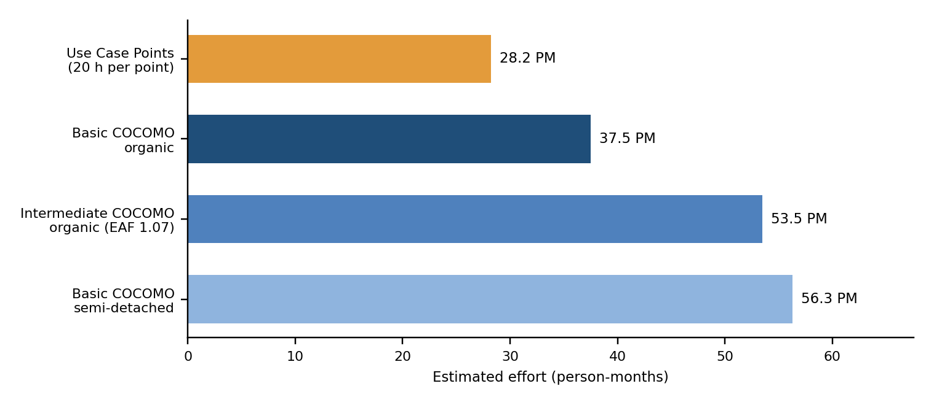
Figure 1. Effort estimates from the four models

- Range. The models give 28.2 to 56.3 person-months. The central estimate is 37.5 person-months (basic organic), which agrees with the 4-person team the project already has: about 9.9 months of full-time work for about 3.8 people.
- Why the models differ. UCP counts only the use case functionality; intermediate COCOMO adds a penalty for the team's limited experience with the application and language.
- Scope for a course project. A semester allows far fewer person-hours than the full-scope estimate. The practical plan is to build the core flow (registration, company verification, drive publication, application with eligibility, shortlisting and placement) as a working prototype and leave reporting extras and administration for a later release.

4. Cyclomatic Complexity
McCabe's cyclomatic complexity V(G) counts the independent paths through a flow. It is computed on the control-flow graph as V(G) = E - N + 2 (with one virtual exit when several end nodes exist), which equals the number of decision points plus one. It is also the minimum number of test cases needed to cover every path. The usual limit is 10; values above 10 mean the flow should be simplified.
4.1 Activity diagrams
ID | Scenario | Nodes N | Edges E | Exits | Decisions | V(G) | Risk
AD-1 | Registration and activation | 11 | 12 | 1 | 2 | 3 | Low
AD-2 | Company verification | 12 | 13 | 1 | 2 | 3 | Low
AD-3 | Drive creation and publication | 14 | 14 | 2 | 2 | 3 | Low
AD-4 | Apply for a drive | 15 | 15 | 3 | 3 | 4 | Low
AD-5 | Shortlisting and stages | 12 | 12 | 2 | 2 | 3 | Low
AD-6 | Selection and placement | 12 | 11 | 2 | 1 | 2 | Low

Mean V(G) = 3.0, maximum 4 (AD-4, which has three guard decisions: profile complete, already applied or late, all criteria met). Both formulas gave the same value for all six diagrams.
4.2 Sequence diagrams
In a sequence diagram every alt frame branch adds one path, so V(G) = 1 + the number of alternative branches beyond the first.
ID | Scenario | Lifelines | Messages | alt frames | V(G) | Risk
SD-1 | Student registration | 5 | 11 | 1 | 2 | Low
SD-2 | Email verification | 5 | 10 | 1 | 2 | Low
SD-3 | Apply for a drive | 7 | 17 | 2 | 3 | Low
SD-4 | Company verification | 6 | 17 | 1 | 2 | Low
SD-5 | Shortlisting and stages | 6 | 11 | 1 | 2 | Low
SD-6 | Final selection | 7 | 11 | 1 | 2 | Low
SD-7 | Placement and report | 7 | 18 | 1 | 2 | Low

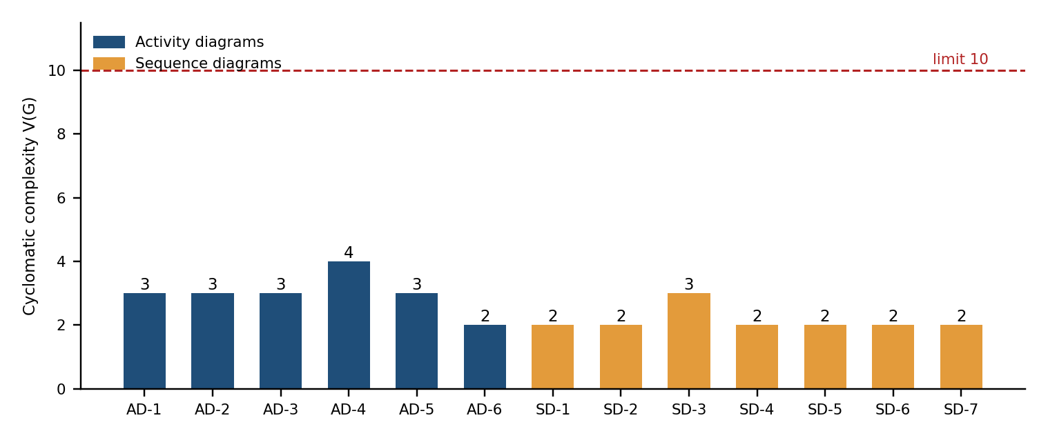
Figure 2. Cyclomatic complexity of the behavioural diagrams against the limit of 10

All thirteen flows are far below the limit (mean 3.0 for activity and 2.1 for sequence diagrams). The workflows are therefore simple enough to test and maintain. Testing every workflow path needs at least 18 test cases from the activity diagrams and 15 from the sequence diagrams.
4.3 Predicted complexity of key operations
The activity diagrams merge several checks into one decision. Written as code, each condition becomes a separate decision, so the complexity of the main operations was predicted by counting every condition (a loop counts as one decision, and each case of a multi-way branch counts as one).
Operation | Decisions counted | Predicted V(G) | Risk
AuthService.register() | required fields, email domain, duplicate email, duplicate roll number | 5 | Low
AuthService.login() | account exists, status active, not locked, password matches, failed-attempt limit | 6 | Low
EligibilityCriteria.evaluate() | CGPA, backlogs, branch, graduation year, skills loop with test | 7 | Low to moderate
ApplicationService.apply() | drive published, before deadline, profile complete, duplicate, eligible | 6 | Low
StageService.recordOutcome() | stage exists, passed or failed, more mandatory stages | 4 | Low
SelectionService.decide() | three decision types, all mandatory stages passed | 5 | Low
PlacementService.record() | selection exists, mandatory passed, already placed, multi-offer policy | 5 | Low
ReportService.generate() | scope (3 kinds), export format (2 kinds); each case counts as one | 6 | Low

EligibilityCriteria.evaluate() is the most complex operation and the one most likely to grow, because each new placement rule adds a condition. Turning each rule into its own object (Strategy pattern, issue 8 of the design analysis) keeps V(G) of evaluate() constant at about 2 however many rules exist.

5. Object-Oriented Design Metrics
5.1 Chidamber-Kemerer metrics
The CK suite is measured on the class diagram. WMC is the number of methods per class (each method weighted 1, since real complexity is not yet known), DIT the depth in the inheritance tree, NOC the number of direct subclasses and CBO the number of other classes a class is coupled to (associations, dependencies and generalisations in either direction).
Class | WMC | DIT | NOC | CBO | Attributes | Assessment
User | 5 | 0 | 4 | 7 | 9 | CBO > 5: hub class
PlacementDrive | 6 | 0 | 0 | 5 | 9 | At limit
Application | 4 | 0 | 0 | 4 | 3 | Within limits
Student | 7 | 1 | 0 | 3 | 12 | Within limits
PlacementOfficer | 7 | 1 | 0 | 3 | 2 | Within limits
Company | 5 | 0 | 0 | 3 | 10 | Within limits
Recruiter | 7 | 1 | 0 | 2 | 2 | Within limits
Selection | 4 | 0 | 0 | 2 | 5 | Within limits
RecruitmentStage | 3 | 0 | 0 | 2 | 6 | Within limits
StageOutcome | 2 | 0 | 0 | 2 | 4 | Within limits
Administrator | 5 | 1 | 0 | 1 | 2 | Within limits
EligibilityCriteria | 3 | 0 | 0 | 1 | 6 | Within limits
PlacementRecord | 3 | 0 | 0 | 1 | 6 | Within limits
Notification | 2 | 0 | 0 | 1 | 6 | Within limits
Report | 2 | 0 | 0 | 1 | 5 | Within limits
ProfileItem | 2 | 0 | 0 | 1 | 4 | Within limits
AuditLog | 1 | 0 | 0 | 1 | 6 | Within limits

Suggested limits: WMC up to 20, DIT up to 5, CBO up to 5 in the design. Figure 3 plots WMC against CBO.
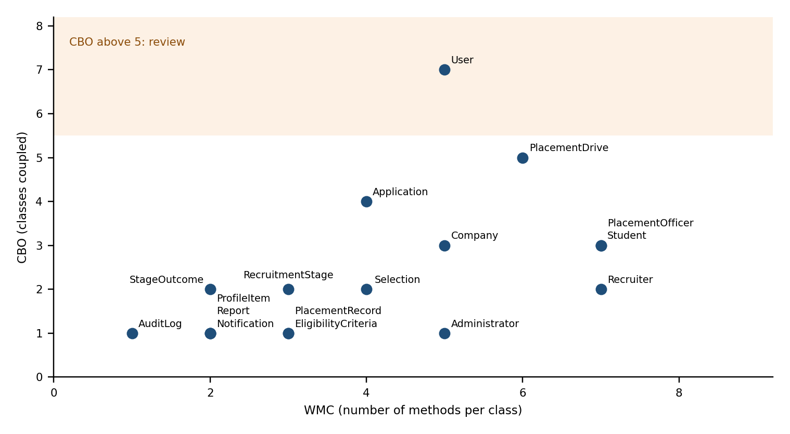
Figure 3. Methods per class (WMC) against coupling (CBO)

Metric | Value | Reading
WMC | mean 4.0, max 7, total 68 | Small classes; far below the limit of 20. Student, PlacementOfficer and Recruiter have the most methods (7).
DIT | max 1 | Shallow hierarchy: one abstract parent and four role subclasses. No fragile deep inheritance.
NOC | User = 4, all others 0 | User is the only parent. Four children is healthy; changes to User affect only the role classes.
CBO | mean 2.4, max 7 | Low overall. User (7) is the only class above 5, which is expected for the common parent; PlacementDrive (5) is at the limit.
LCOM (cohesion) | qualitative | 14 of 17 classes are highly cohesive; PlacementOfficer and Recruiter are medium because they mix workflow duties (see design analysis).
5.2 Component coupling and stability
At component level the instability I = Ce / (Ca + Ce) was computed from the dependencies of the component diagram. The Stable Dependencies Principle requires a component to depend only on components that are at least as stable as itself.
Component | Ce | Ca | Instability I | Reading
Authentication | 2 | 3 | 0.40 | Intermediate
Student Profile | 1 | 1 | 0.50 | Intermediate
Company | 2 | 1 | 0.67 | Intermediate
Drive | 2 | 1 | 0.67 | Intermediate
Application | 2 | 1 | 0.67 | Intermediate
Recruitment | 2 | 1 | 0.67 | Intermediate
Placement & Reporting | 2 | 0 | 1.00 | Top-level, free to change
Administration | 2 | 0 | 1.00 | Top-level, free to change
Notification | 0 | 4 | 0.00 | Stable service
Audit log | 0 | 2 | 0.00 | Stable service
Security | 0 | 1 | 0.00 | Stable service

Every dependency in the component diagram points from a component to one with equal or lower instability, so there are no violations. Notification, Audit log and Security are the most stable (I = 0), which is correct because many modules depend on them; their interfaces must therefore be kept stable. Placement & Reporting and Administration are the most volatile (I = 1) and can change without affecting other modules.

6. Requirements and Design Inventory Metrics
Measure | Value | Note
Functional requirements (REQ) | 33 | In seven feature areas.
Use cases / actors | 26 / 5 | Four human actors and the Email Service.
Classes / relationships | 17 / 20 | Including 4 generalisations and 3 compositions.
Activity diagrams / sequence diagrams | 6 / 7 | Covering the whole placement lifecycle.
Requirement traceability coverage | 100% | Every REQ maps to classes, use cases and a behavioural diagram except REQ-8 to 12, which are covered by the class model only.
Open TBD items in the SRS | 4 | Hosting and DBMS (TBD-1), user-documentation artifacts (TBD-2), vacancy-multiplier threshold (TBD-3) and the 500-session target (TBD-4); each is a requirements-stability risk.
Design issues found | 11 | 3 high priority: model mismatch, duplicated status, SRS gaps (design analysis report).
Average requirements per use case | 1.3 | Several use cases realise more than one requirement.

TBD count is a stability indicator: each unresolved item can change the design. Closing TBD-1 and TBD-4 early removes most of the uncertainty in the effort estimate.

7. Metrics Summary
The table collects the main results with the limit used and a verdict.
Metric | Result | Limit or reference | Verdict
Function Points (adjusted) | 258.6 FP (UFP 244, VAF 1.06) | Small below 100, large above 1000 | Medium size
Estimated size | 13.7 KLOC | 53 LOC per FP (Java) | Medium
Effort (central / range) | 37.5 PM / 28.2 to 56.3 PM | Three independent models | Wide range: prototype scope advised
Schedule and staffing | 9.9 months, 3.8 people | Team of 4 | Consistent with team
V(G) of activity diagrams | mean 3.0, max 4 | At most 10 | Pass
V(G) of sequence diagrams | mean 2.1, max 3 | At most 10 | Pass
V(G) of key operations (predicted) | 4 to 7, max 7 | At most 10 | Pass; watch evaluate()
WMC | mean 4.0, max 7 | At most 20 | Pass
DIT / NOC | max 1 / max 4 | DIT at most 5 | Pass
CBO | mean 2.4, max 7 | At most 5 | User exceeds (hub)
Component stability | No SDP violations | Depend towards stability | Pass
Requirement traceability | 100% | 100% | Pass
Basis paths to test | 18 (activity) + 15 (sequence) | One test per path | Defined

Conclusions drawn from the metrics
- Complexity is low. All workflows and predicted operations are well below V(G) = 10, and classes are small and shallow, so the design should be easy to test and maintain.
- Hot spots are few. User (CBO 7), PlacementDrive (CBO 5) and EligibilityCriteria.evaluate() (V 7) deserve attention because they will change most often.
- Effort is the main risk, not complexity. The full scope is about 28 to 56 person-months, so the plan must define a prototype scope for the available time.
- Uncertainty is traceable. The wide effort range comes from the open TBD items and the team's limited experience, both of which can be reduced.

8. Measurement Plan for the Implementation
The predictive figures above should be replaced by measured ones during development. The plan follows the Goal-Question-Metric approach.
Metric | Question it answers | Target | How to collect
Cyclomatic complexity per method | Is each method easy to test? | At most 10 | Static analysis (for example SonarQube, PMD, radon) in each build
WMC, CBO, DIT, LCOM | Is the class design still small and loosely coupled? | WMC at most 20, CBO at most 10, DIT at most 5 | CK metrics plug-in or SonarQube
Code size and FP check | Does actual size match the estimate? | Within 20% of 13.7 KLOC | Line counter at each milestone
Effort and schedule variance | Are we on the estimate? | Within 20% of plan | Weekly time log against the task plan
Code duplication | Is there copy-paste? | Below 3% | SonarQube
Test coverage | Is the code exercised by tests? | Line 80%, branch 70% | JaCoCo, coverage.py or equivalent
Requirement coverage by tests | Is every requirement tested? | 33 of 33 REQ | Traceability matrix
Defect density | How many defects per KLOC? | Tracked; no critical open defect at release | Issue tracker, per module
Response time | Do pages load fast enough? | 3 s at 200 users (SRS) | Load test

Re-estimate effort after the first two milestones using actual size and productivity; if actual size grows beyond 20% of the estimate, review the scope.

9. Conclusion
SPMS is a medium-sized web application of about 258.6 Function Points (roughly 13.7 KLOC). Its estimated full-scope effort is 28.2 to 56.3 person-months with a central value of 37.5, which suits a four-person team over about 9.9 months. The design is structurally simple: every workflow has cyclomatic complexity of at most 4, the most complex predicted operation is 7, classes average 4 methods and the inheritance tree is one level deep. The only metric above its design limit is the coupling of the hub class User, which is expected.
The recommended actions are to set a prototype scope that fits the available time, resolve the open TBD items, apply the Strategy pattern to the eligibility rules to keep complexity flat, and start collecting the measured values of Section 8 from the first build.

