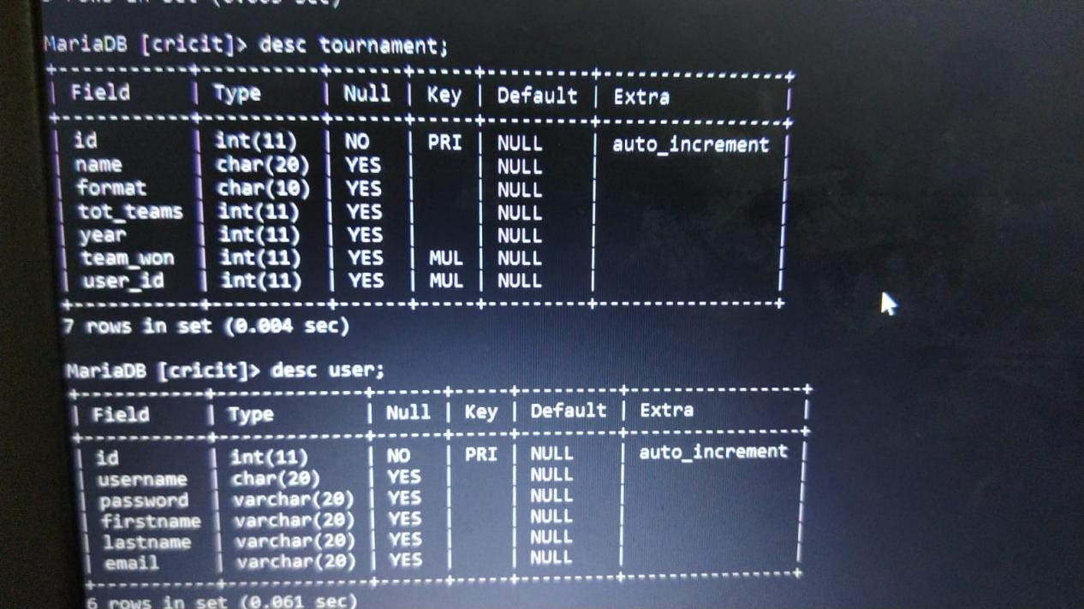

tournament

Good as it is.

User

Username:primary key

Password.

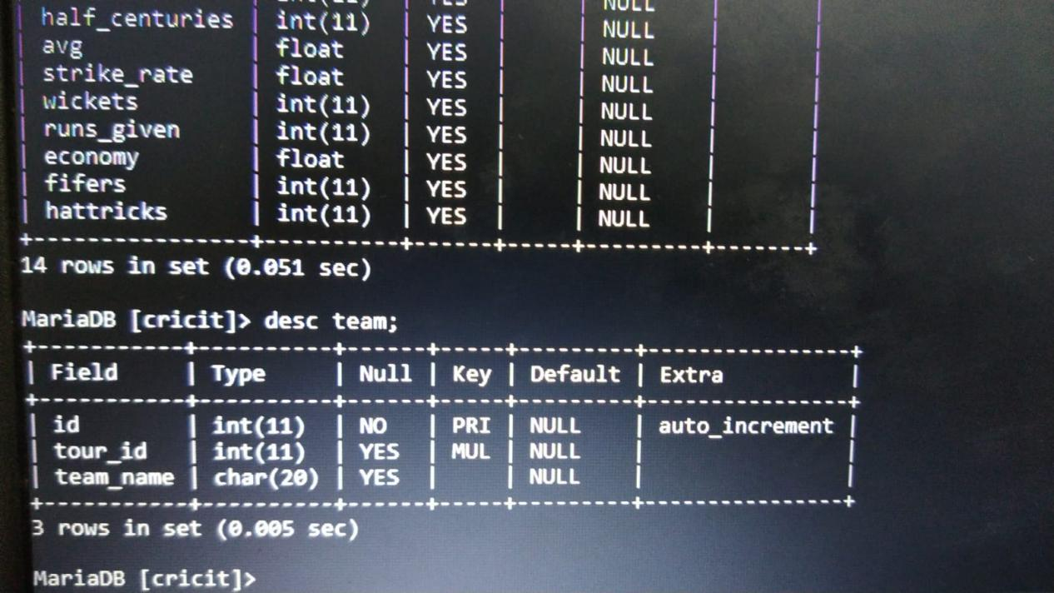

Team

As it is

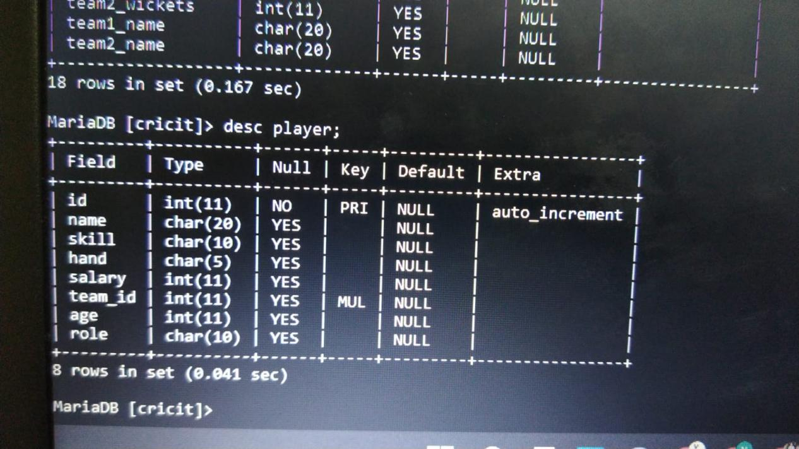

Player

Salary -- role:captain,player.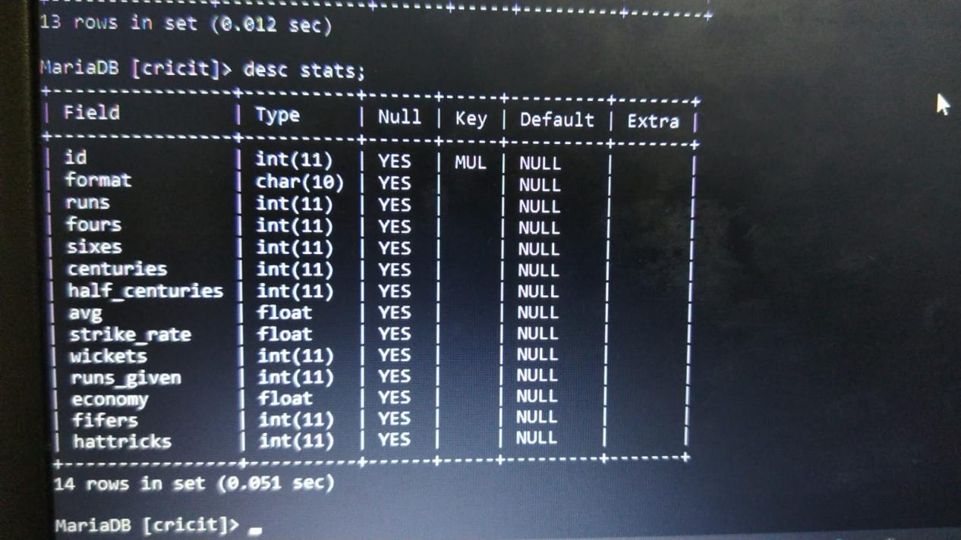

PlayerStats.

Format --.

For dislay of stats we can use order by and limit.

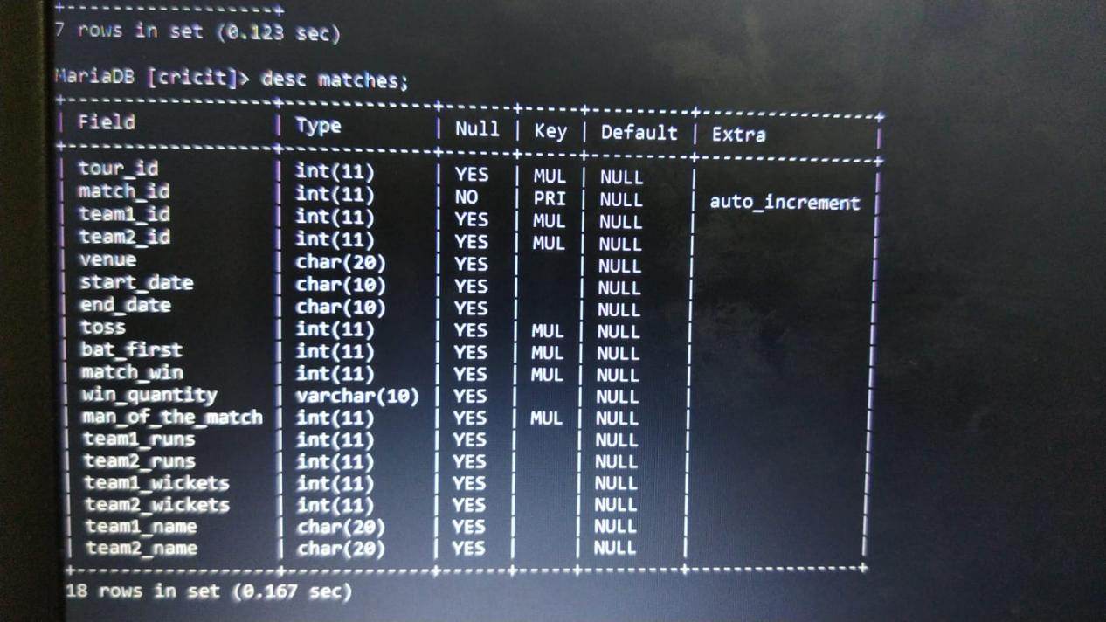

Matches.

Match_Type : final,groupStage,eliminator.

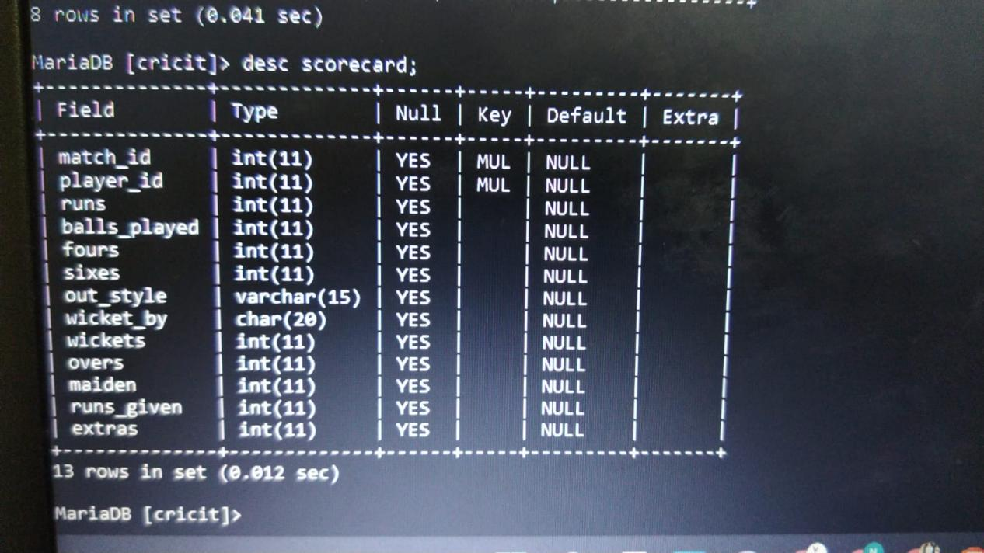

Sorecard for each match.

Divide into two parts.

Batting bowling.

To display scorecard:inAt in batting.

tourId , matchID => primary key

currentBatsMen1 =>id,name,currentMatch Score,Four,Six,BallsPlayed,

ScoreCard for each team per match

Batting ScoreCard.

BatsmenName(id will also be required) runs ballsplayed four six.Extras

DidnotBat:

Bowling Scorecard.

BowlerName(id reqd) oversbowled,maiden,runsGiven,Wicket.

Search Key in home(viewTournament Page)

Ongoing matches

Matches done playing

Home Page view matches.

3 parts . ongoing matches , matches played , schedule.

Add matches

Add teams

Add players

Edit players

Statistics

Playerwise

Most runs

In use mysql

Alter table extras for primary key.

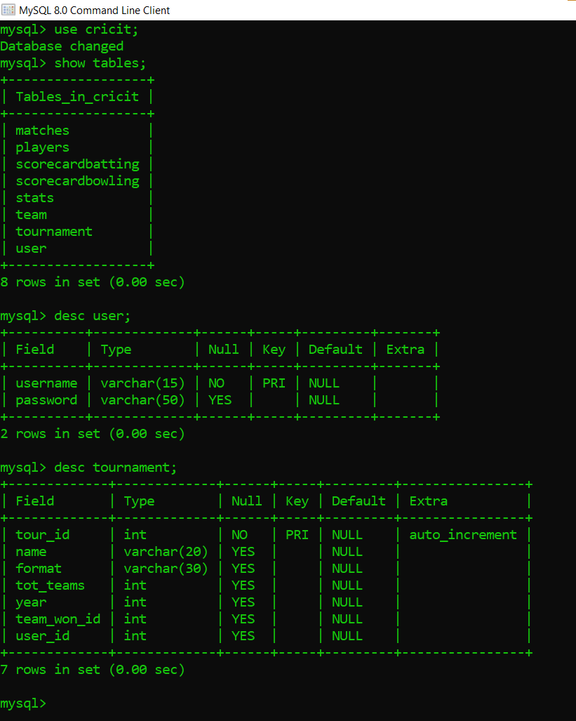

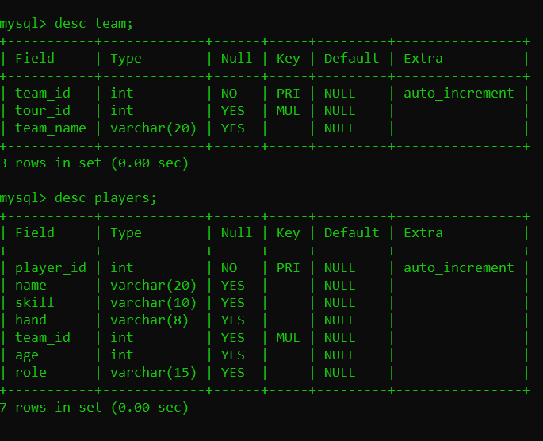

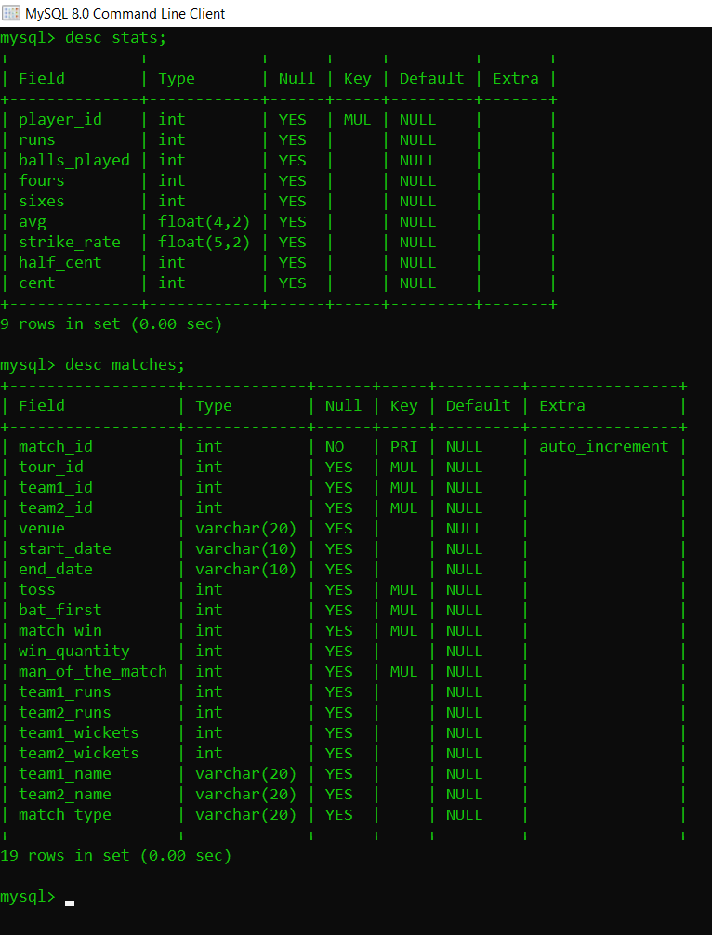

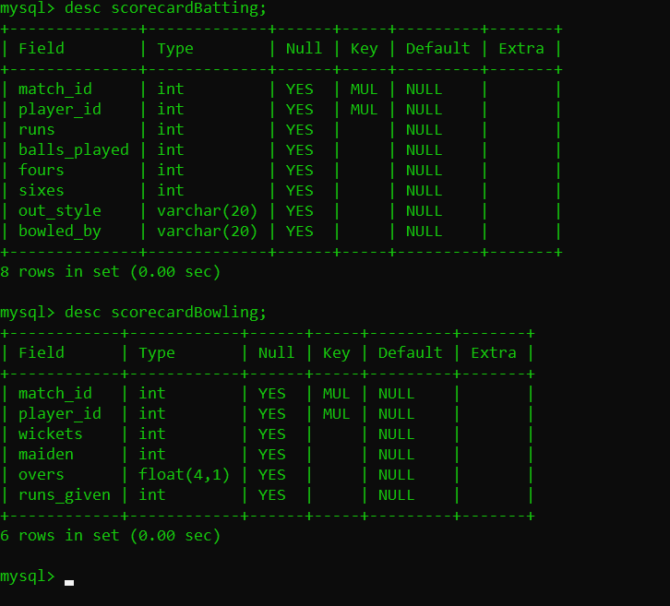

Extras table : match id,teamID . noBall,lb,byes,wide

Home page:

Followed Tournaments

In a particular tournament

3 parts (horizontal top nav) ongoing matches , pastResults,scheduled ahead.,stats page,teams,points table

Matches:

ScoreCard(mini)

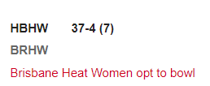

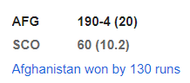

Same for matches done.

For particular match whole scorecard.

Create a new tournament straight forward.

A form .Labels same as values required.

Once it is created it returns a info stating the id of the pfrmed tournament.

Then after create tournment . Render to Add teams.

Team

Add Team.

Add players. Basic info to the players table .ALso set stats as 0 for everything I.e. default values.

Then schedule matches.

match_id ,tour_id,team1_id ,team1_name,venue,startDate,EndDate.MatchType.Time? Ongoing?

DataEntry for a match.

BattingTeamId:

BowlingTeamId:

Enter twoOpening Batsmen.

JDropDown With player names(try to remove the ones who are out.)

Same for bowler. JDropDown.

Have a count for 6balls.

Batsmen Onstrike : (swap button)inCaseOf caught or runout

Bowler :Increment MaidenOver for bowler.

RunsScoredAtBall: buttons 0,1,2,3,4,6, (wideBall,noball,lb) => extraRuns -> 0,1,2,3,4,6

Out,RunOut,RetdHurt,ChangeBolwer(Will continue from where match was halted)

If odd number clicked add runs

NewBatsmen :insert into scorecard batting.

End Innings.

EndMatch.=> ask for result

Cases:

Init:

1)Start Match Button.

1. Toss:Team1ID;

Update into match tossId,BatFirstteam.

1. BattingTeamId:Will be passed

Set BattingTeamId and BowlongTeamID at backend.

1. Take 2batsmen input. Note Batsmen 1 will be onstrike.Set batsmenOnStrike.

How will we display onStrike batsmen to others.(Batsmen onStrike in matches is good)

1. Select BOwler.
2. Set batting team score as 0 and wickets as 0 in matches.And player 1and 2 as 0 runs,fours,sixes,etc in scoreCardBatting.OuStyle NotOut.
3. Set Bowler balls faced etc as 0

RunScored

3 runs

1. Update scorecardBatting where payerID=onstrikeBatsmen. Add Balls Faced.
2. if(runs%2==1)swapFunction to be called.
3. Update scorecardBatting where playerId = bolwing . Add player.

Out

1. changewicketBy BowedBy wicketType .
2. Add Bowler way. Add wicket
3. Add new Batsmen.Same as above.

Innings end.

Swap batting team and bowlingteam. Repeat initial steps of init match.

End match.

1. Ask for result.
2. Append it to the results.

Delete tournament .

must delete everything where it is a multiple key.

On delete cascade on every foreignKey.

WorkFlow>>

CreateTorunament

Create Team,CreateMatch,Create player/add player , score a match

RightNow constructing in all admin mode.

Creating user. 15mins. Done Ariund 1hr (git included)

Now Create tournament .

In AddPlayer. Players plus init stats.

View above.

Modify above.

Delete above.

Mtch scheduler

To be added in matches table

Team1/2 id,

Status: future,match_typestart_date,end_date

Display all matches tille now

Add match.

Team1 name,id,venue,start_date,match_type

WE need to display using schedule

To display in scheduler

MatchType Team1 vs team 2 venue date match_id srNo