LAB-1: OLAP Operation: Roll Up and Roll Down

#Import libraries and create data set
import pandas as pd

# Sample Data Warehouse Dataset
data = {
'Region': ['East', 'East', 'West', 'West', 'North', 'South', 'North', 'South'],
'Product': ['A', 'B', 'A', 'B', 'A', 'B', 'B', 'A'],
'Year': [2022, 2022, 2022, 2022, 2023, 2023, 2023, 2023],
'Sales': [100, 150, 200, 250, 300, 350, 400, 450]
}

df = pd.DataFrame(data)

print("Original Data:")
print(df)

#Roll Up Operation

rollup = df.groupby('Region')['Sales'].sum()
print("\nRoll-Up (Total Sales by Region):")
print(rollup)

#Roll Down Operation

drilldown = df.groupby(['Region', 'Product'])['Sales'].sum()
print("\nDrill-Down (Region + Product):")
print(drilldown)

Output:

Original Data:
Region Product Year Sales
0 East A 2022 100
1 East B 2022 150
2 West A 2022 200
3 West B 2022 250
4 North A 2023 300
5 South B 2023 350
6 North B 2023 400
7 South A 2023 450

Roll-Up (Total Sales by Region):
Region
East 250
North 700
South 800
West 450
Name: Sales, dtype: int64

Drill-Down (Region + Product):
Region Product
East A 100
B 150
North A 300
B 400
South A 450
B 350
West A 200
B 250
Name: Sales, dtype: int64

LAB-2: OLAP Operation: Slice, Dice and Pivot Operation

slice_data = df[df['Year'] == 2022]
print("\nSlice (Year = 2022):")
print(slice_data)

#Dice Operation

dice_data = df[(df['Region'] == 'East') & (df['Product'] == 'A')]
print("\nDice (Region = East AND Product = A):")
print(dice_data)

#Pivot Operation

pivot = pd.pivot_table(df, values='Sales', index='Region', columns='Product', aggfunc='sum')
print("\nPivot Table:")
print(pivot)

Output:

Slice (Year = 2022):
Region Product Year Sales
0 East A 2022 100
1 East B 2022 150
2 West A 2022 200
3 West B 2022 250

Dice (Region = East AND Product = A):
Region Product Year Sales
0 East A 2022 100

Pivot Table:
Product A B
Region
East 100 150
North 300 400
South 450 350
West 200 250

LAB-3: Simple Linear Regression

# Simple Linear Regression Example

import numpy as np
import matplotlib.pyplot as plt
from sklearn.linear_model import LinearRegression

# Sample dataset
# X = Independent variable
# y = Dependent variable
X = np.array([1, 2, 3, 4, 5]).reshape(-1, 1)
y = np.array([2, 4, 5, 4, 5])

# Create regression model
model = LinearRegression()

# Train the model
model.fit(X, y)

# Predict values
y_pred = model.predict(X)

# Print results
print("Slope (Coefficient):", model.coef_[0])
print("Intercept:", model.intercept_)

# Plot original data and regression line
plt.scatter(X, y, label="Actual Data")
plt.plot(X, y_pred, label="Regression Line")
plt.xlabel("X")
plt.ylabel("Y")
plt.legend()
plt.show()
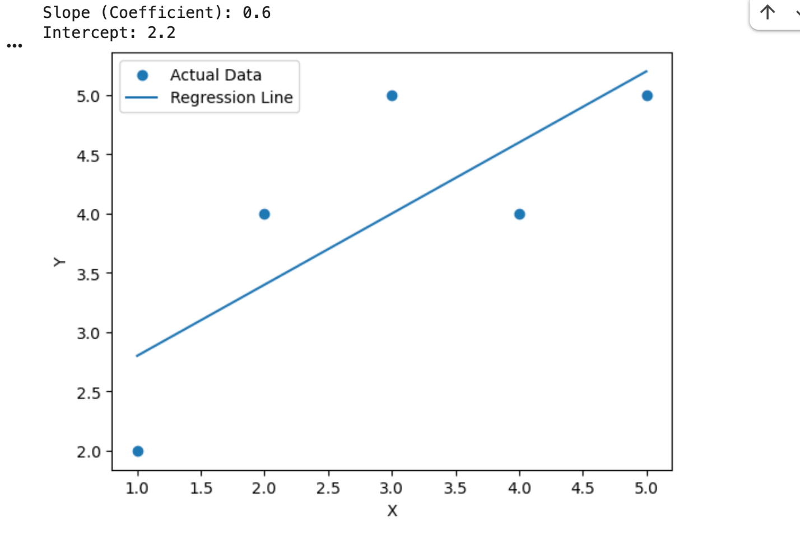

LAB-4: Multiple Linear Regression with Plot

# Multiple Linear Regression with Plot

import numpy as np
import matplotlib.pyplot as plt
from sklearn.linear_model import LinearRegression
from mpl_toolkits.mplot3d import Axes3D

# Dataset (X1, X2 → Y)
X = np.array([
[1, 2],
[2, 1],
[3, 3],
[4, 5],
[5, 4]
])

y = np.array([5, 6, 9, 12, 13])

# Model
model = LinearRegression()
model.fit(X, y)

# Coefficients
print("Intercept:", model.intercept_)
print("Coefficients:", model.coef_)

# Create grid for plane
x1 = np.linspace(1, 5, 10)
x2 = np.linspace(1, 5, 10)
x1, x2 = np.meshgrid(x1, x2)

y_plane = model.intercept_ + model.coef_[0]*x1 + model.coef_[1]*x2

# Plot
fig = plt.figure()
ax = fig.add_subplot(111, projection='3d')

# Scatter points
ax.scatter(X[:,0], X[:,1], y)

# Regression plane
ax.plot_surface(x1, x2, y_plane, alpha=0.5)

ax.set_xlabel("X1")
ax.set_ylabel("X2")
ax.set_zlabel("Y")

plt.show()

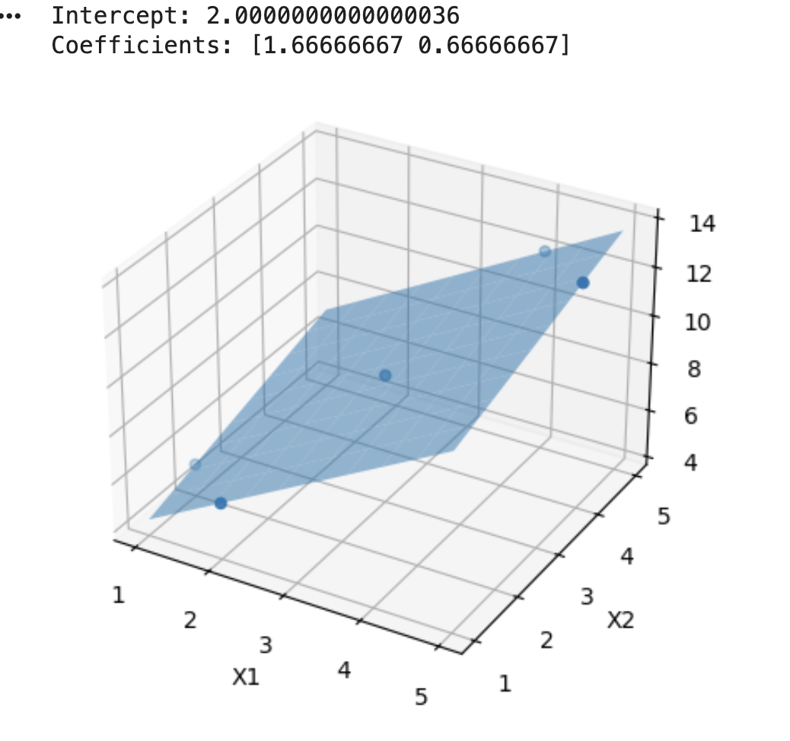
LAB-5: Polynomial Regression with Plot

# Polynomial Regression with Plot

import numpy as np
import matplotlib.pyplot as plt
from sklearn.preprocessing import PolynomialFeatures
from sklearn.linear_model import LinearRegression

# Dataset
X = np.array([1, 2, 3, 4, 5]).reshape(-1, 1)
y = np.array([2, 6, 7, 10, 15])

# Convert to polynomial features (degree = 2)
poly = PolynomialFeatures(degree=2)
X_poly = poly.fit_transform(X)

# Model
model = LinearRegression()
model.fit(X_poly, y)

# Predictions for smooth curve
X_range = np.linspace(1, 5, 100).reshape(-1, 1)
X_range_poly = poly.transform(X_range)
y_pred = model.predict(X_range_poly)

# Plot
plt.scatter(X, y, label="Actual Data")
plt.plot(X_range, y_pred, label="Polynomial Curve")
plt.xlabel("X")
plt.ylabel("Y")
plt.legend()
plt.show()

# Coefficients
print("Intercept:", model.intercept_)
print("Coefficients:", model.coef_)

LAB-6: Implementation of Clustering

# Step 1: Import Libraries
import numpy as np
import matplotlib.pyplot as plt
from sklearn.cluster import KMeans

# Step 2: Generate 3 Different Scattered Datasets
np.random.seed(42)

data1 = np.random.randn(100, 2) + np.array([5, 5])
data2 = np.random.randn(100, 2) + np.array([-5, -5])
data3 = np.random.randn(100, 2) + np.array([5, -5])

# Combine all datasets
data = np.vstack((data1, data2, data3))

# Step 3: Plot Original Scattered Data
plt.figure(figsize=(6,6))
plt.scatter(data[:, 0], data[:, 1])
plt.title("Original Scattered Data (3 Datasets)")
plt.xlabel("X")
plt.ylabel("Y")
plt.show()

# Step 4: Apply Clustering (Force into ONE cluster)
kmeans = KMeans(n_clusters=1, random_state=42)
kmeans.fit(data)

labels = kmeans.labels_
center = kmeans.cluster_centers_

# Step 5: Plot Clustered Data
plt.figure(figsize=(6,6))
plt.scatter(data[:, 0], data[:, 1], c=labels)
plt.scatter(center[:, 0], center[:, 1], color='red', s=200, marker='X', label='Cluster Center')
plt.title("All Data Grouped into One Cluster")
plt.legend()
plt.show()

LAB-7: Implementation of Classification

# Classification
#Step 1: Import Libraries
import pandas as pd
from sklearn.model_selection import train_test_split
from sklearn.linear_model import LogisticRegression
from sklearn.metrics import accuracy_score

# Step 2: Create Dataset
data = {
'Marks': [35, 40, 45, 50, 55, 60, 65, 70, 75, 80],
'Pass': [0, 0, 0, 1, 1, 1, 1, 1, 1, 1]
}

df = pd.DataFrame(data)

print("Dataset:\n", df)

# Step 3: Define Features and Target
X = df[['Marks']] # Input
y = df['Pass'] # Output

# Step 4: Split Data (Training & Testing)
X_train, X_test, y_train, y_test = train_test_split(X, y, test_size=0.2)

# Step 5: Apply Classification Model
model = LogisticRegression()
model.fit(X_train, y_train)

# Step 6: Prediction
y_pred = model.predict(X_test)

print("\nPredicted:", y_pred)
print("Actual:", y_test.values)

# Step 7: Accuracy
accuracy = accuracy_score(y_test, y_pred)
print("\nAccuracy:", accuracy)

LAB-8: Data Pre-processing
#Data Preprocessing
#Sample Dataset

import pandas as pd

data = {
'Name': ['Ram', 'Shyam', 'Hari', 'Sita', 'Gita', 'Ram', None],
'Age': [20, 21, None, 19, 22, 20, 21],
'Gender': ['Male', 'Male', 'Male', 'Female', 'Female', 'Male', 'Female'],
'Marks': [80, 75, 90, None, 85, 80, 70]
}

df = pd.DataFrame(data)
print(df)

#Fill Missing Values

df['Age'].fillna(df['Age'].mean(), inplace=True)
df['Marks'].fillna(df['Marks'].mean(), inplace=True)

#Remove Missing Name rows
df = df.dropna(subset=['Name'])

#Remove Duplicate Data

df = df.drop_duplicates()

#Encode Gender
df['Gender'] = df['Gender'].map({'Male': 0, 'Female': 1})

#Filter Data

filtered = df[df['Marks'] > 75]
print(filtered)

#Normalization

from sklearn.preprocessing import MinMaxScaler

scaler = MinMaxScaler()
df[['Marks']] = scaler.fit_transform(df[['Marks']])

LAB-9: Student Project on data pre-processing (by collecting dataset)

LAB-10: Familiar with the different Data Mining Tools (KNIME, RapidMiner), Python (with libraries like scikit-learn)

