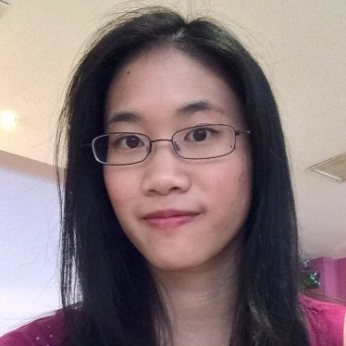Macintosh HD:Users:le:Downloads:03bd2f0.png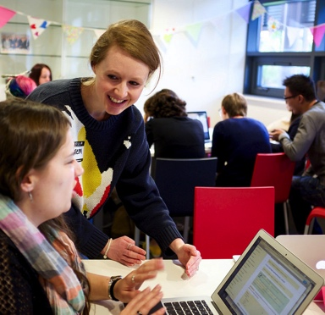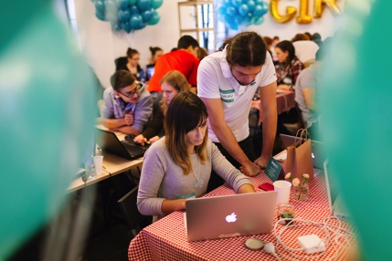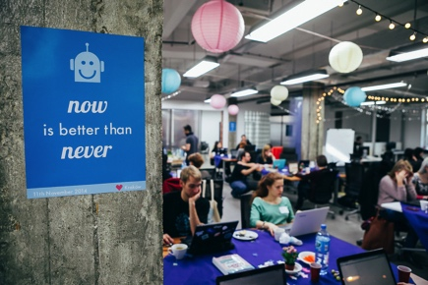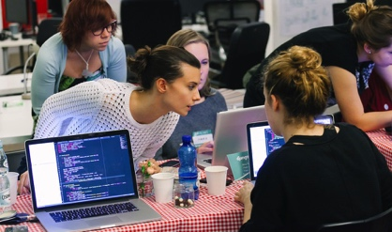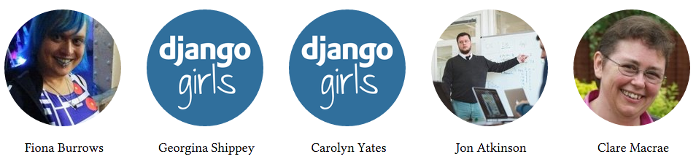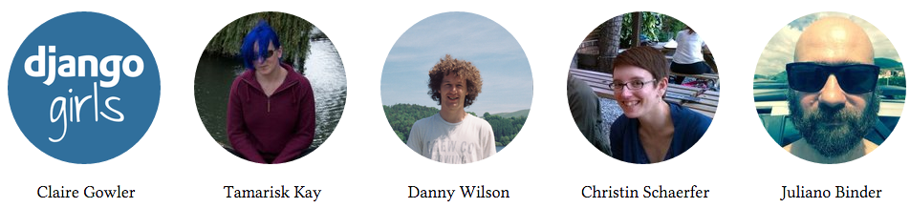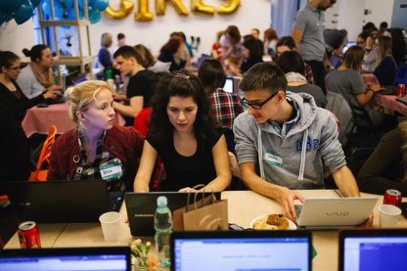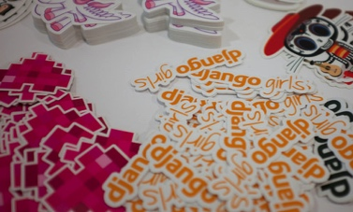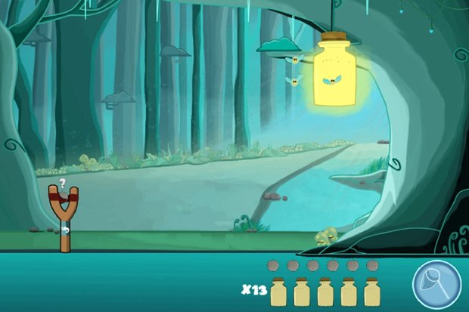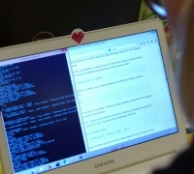

## We must thank our mentors who are willing to give up a day of their free time mentoring our participants. In no particular order: Fiona Burrows, Georgina Shippey, Carolyn Yates, Jon Atkinson, Clare Macrae, Claire Gowler, Tamarisk Kay, Danny Wilson, Christin Schaerfer and Juliano Binder.

Leona So

## Leona was inspired to bring Django Girls to Manchester after attending Django Girls Coventry. She is an A-level Maths tutor and an ILT champion at a college. She is also the chair of IET Manchester Young Professionals Section as she organises regular events for the IET.

Meet the organisers

## **Best Wishes,**

## We hope you would enjoy Django Girls Manchester and this will be the first step to help you learn programming further, whether in Python, Django or extending to other programming languages. We hope this will also be your first step to enter the workforce of the IT community, and become a successful programmer or related role! Never give up!

# Hope for the future…

## “Django Girls is a non-profit organisation that empowers and helps women to organise free, one-day programming workshops by providing tools, resources and support. It was born in July 2014 in Berlin and started by Olas Sitarska and Olas Sendecka. Today, Django Girls is a volunteer run organisation with hundreds of people contributing to bring more women to Python & Django community. Our goal is to bring more amazing women into the world of technology and increase the diversity in the Django community.”

## **Leona So**

Claire Dodd

## Claire is an organiser of BarCamp and CodeUp Manchester, STEM Ambassador and Community Group Manager at MadLab. She also ran a number of programming workshops for the community in Manchester.

Django Girls Coventry, PyConUK Sep 2015

# What is ?

# Thank you mentors!

February 2016

Manchester Newsletter #1

# Want to contribute?

# IET Manchester Young Professionals Network

# FARM Digital

@wearefarm

FARM is a digital agency who provides services to companies by building, maintaining and supporting websites and applications. And the best thing about FARM? They use Django (among other technologies) to do it! “Whatever the digital production piece be, our philosophy is simple: create real, unique, beautiful and compelling work that delivers return on investment.”

# GitHub

GitHub provides source code hosting service, it hosts web-based Git repository. Many people use GitHub to build software, where you can contribute, fork or discover projects from users around the world. The use of GitHub forms one of the important parts of Django Girls tutorial!

There are many meet up groups in the area:

**Python Northwest:** A user group for the Python programming language meeting on 3rd Thursday monthly at MabLab Manchester.

**CodeUp Manchester:** Mentoring Program to support Adults who want to learn how to code at Building Blocks Manchester.

IET Manchester Network is one of the IET (Institution of Engineering and Technology) Manchester communities. They are a network of engineering and technology students and young professionals, all of which are volunteers. They organise regular events for their members and non-members in a wide range of areas, aiming to promote engineering and technology in local areas.

Arctic Shores is a start up company based in Manchester. They design and develop innovative games-based psychometric assessments, to be used as part of a recruitment process. They also use Python and Django! “Our mission is to enable organisations to attract and identify the best candidates from all background in a fun and fair way.” They have recently won Design in Innovation Award from Innovate UK in November 2015.

@github

# Arctic Shores

@IETMcrYP

Firefly Freedom game

@arctic_shores

Sponsors focus

There are many ways to contribute to Django Girls: you can organise an event, coach, work on the tutorial and help on Gitter. Visit *djangogirls.org/contribute/* to find out more!

# A step further…

@pythonnw

Django Girls provides an extension section to extend your project to the next level. There are also suggestion of other resources at the end of the tutorial, be sure to check them out! Let us know if you would like to share your completed project or story after the event.

# What’s next?

@CodeUpMcr