Topology.py results:
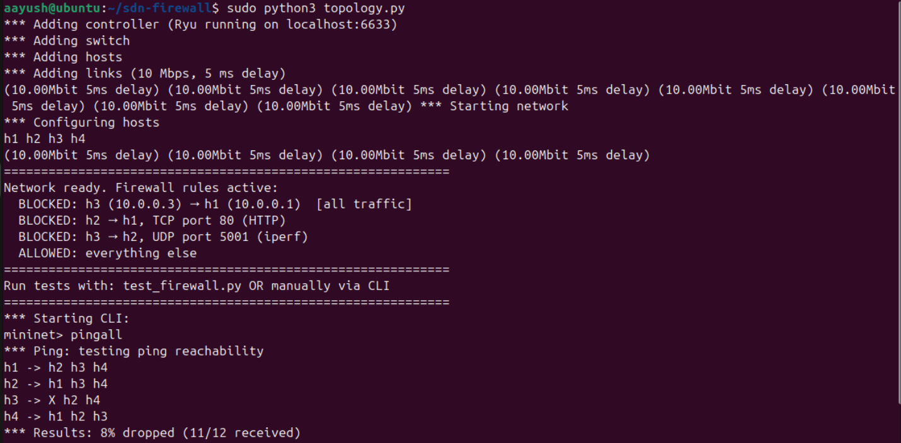

Sudo ovs-ofctl dump-flows s1
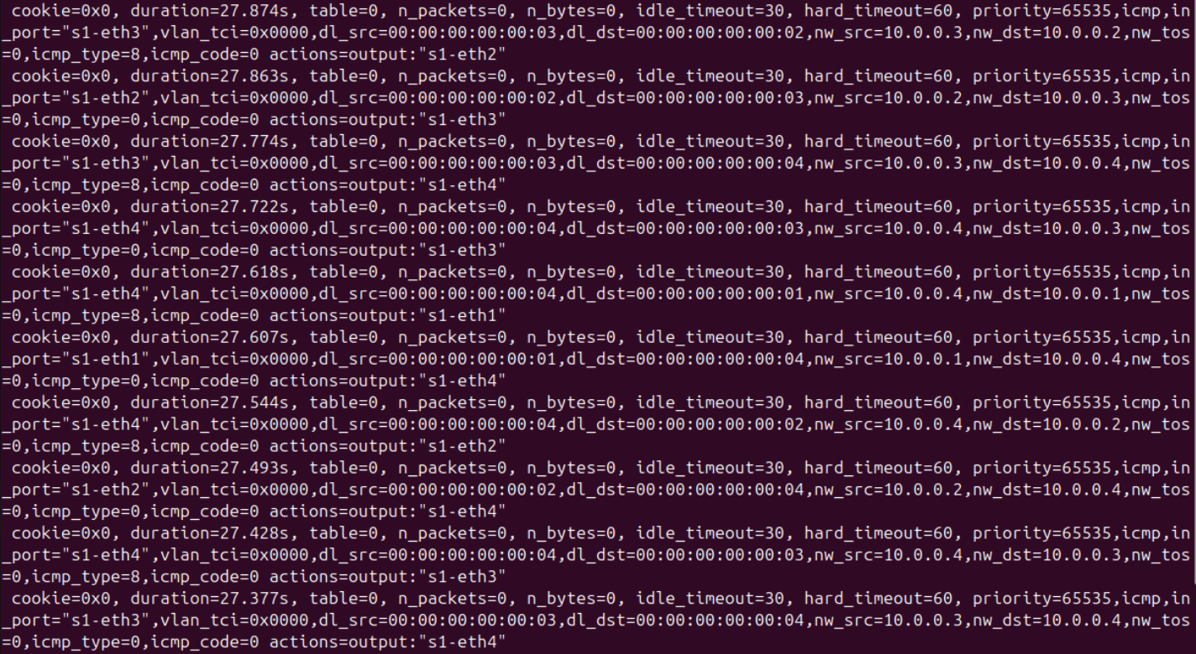

icmp on: h1 ping h2
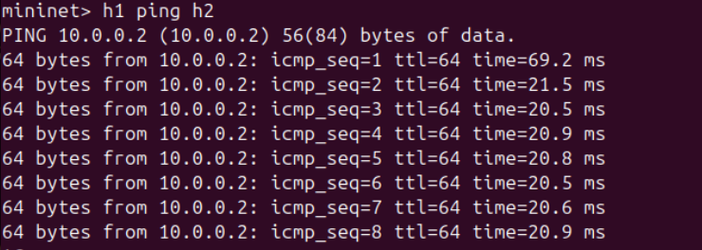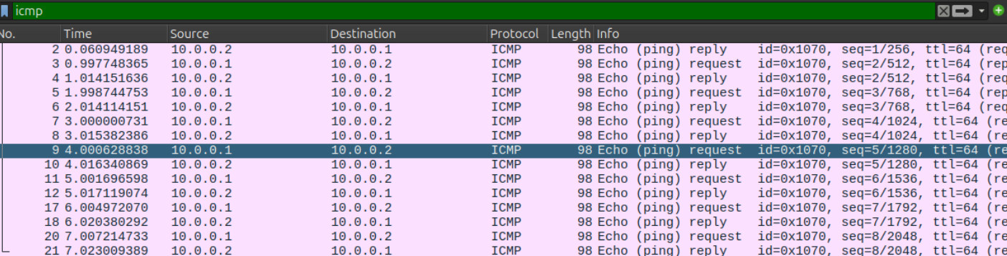

icmp: h3 ping h1:
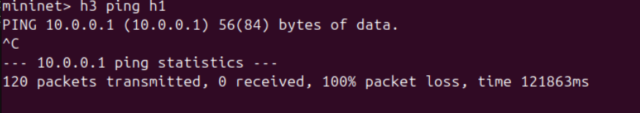

Without icmp filter:
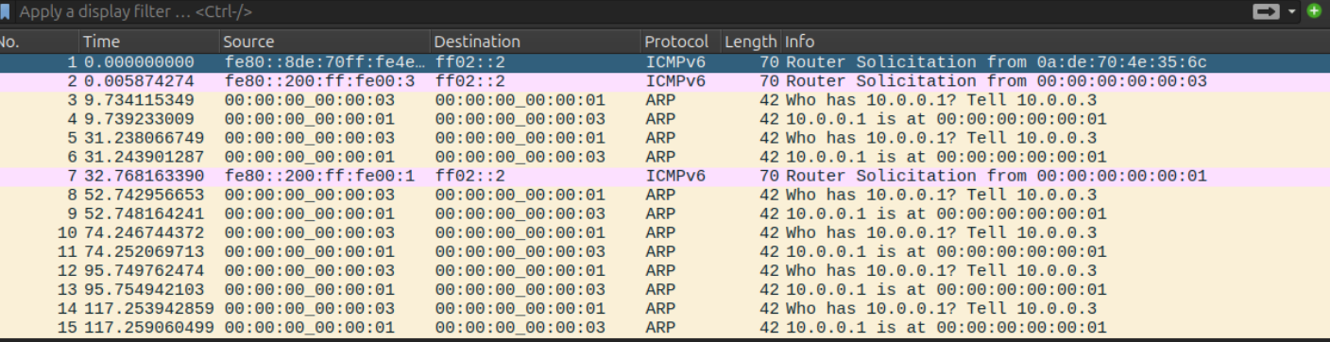

TCP:
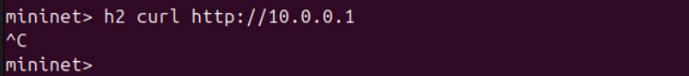
Without any filter:
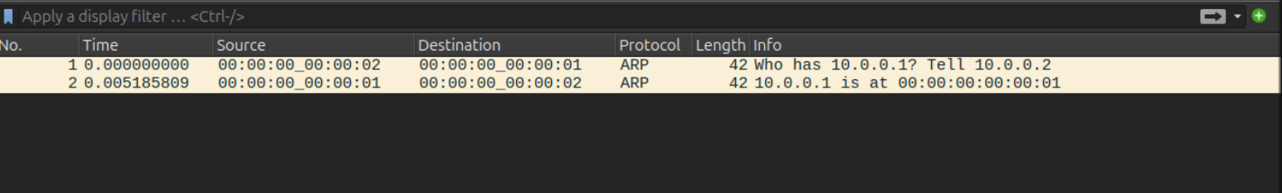
Tcp filter:
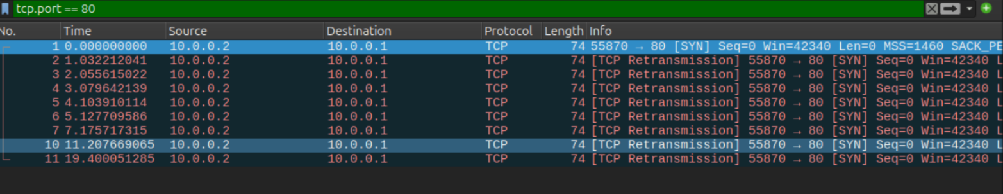

UDP:
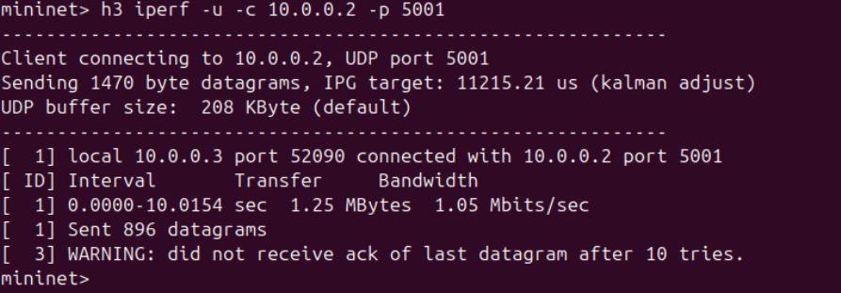
Without filters:
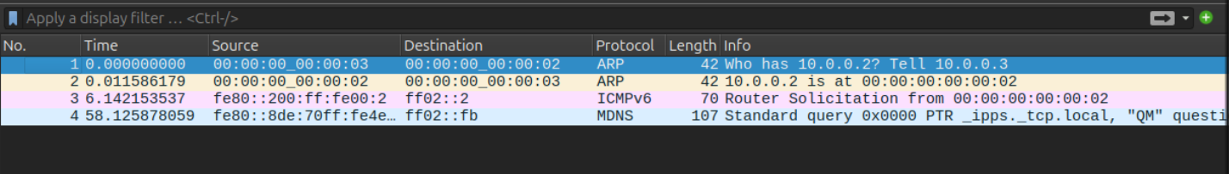
UDP filter:
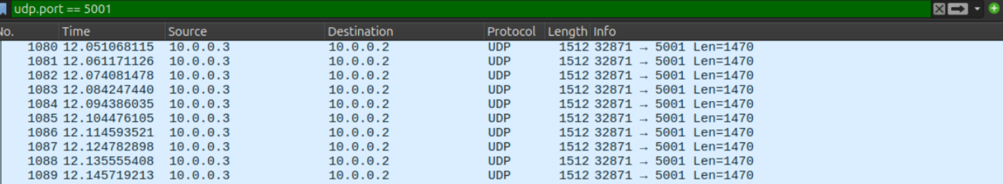
Flow table for all blocked requests: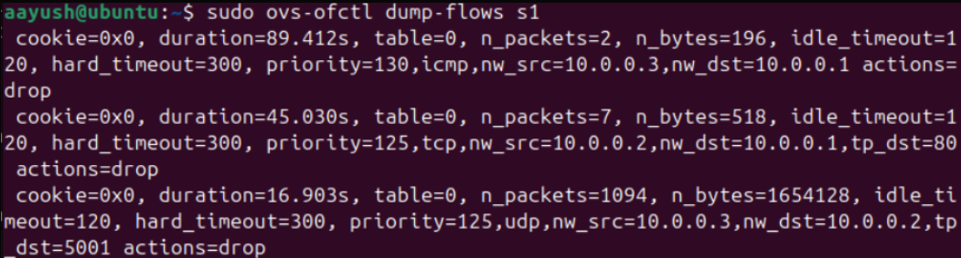
Ping latency: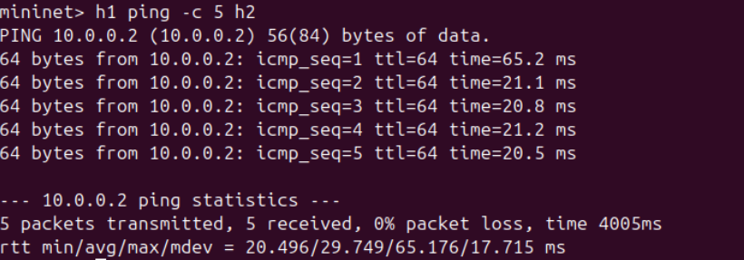

Blocked ping:
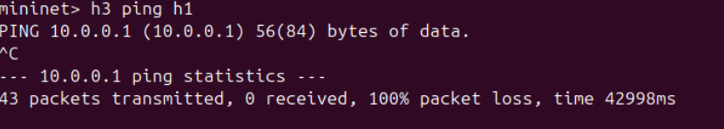
TCP throughput:
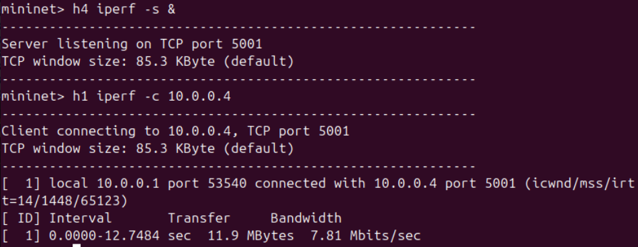
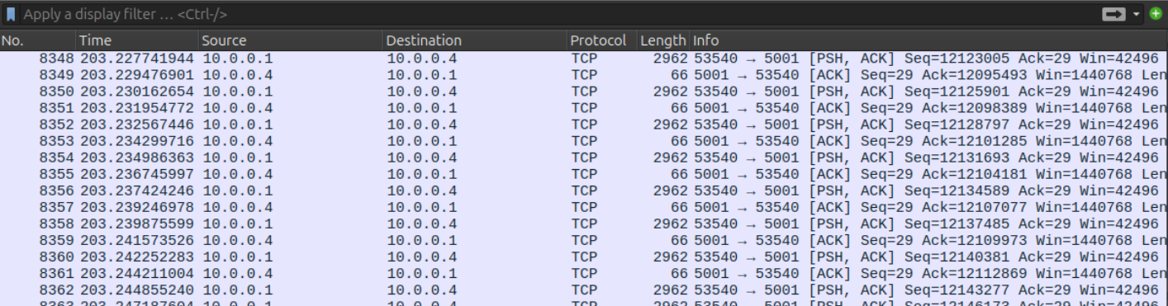

UDP blocked:

