Canny Edge Detection: Concept, Development, Use and Application, with a Case Study of Coastline Detection in Sentinel-2 Images
Term paper, CE671 Introduction to Remote Sensing (2026-27-I), Department of Civil Engineering, IIT Kanpur
Group 15: Aayushman Kumar (Group Leader, Roll No. [__]), Shivakshi (Member 2, Roll No. [__]), Rajendra Singh (Member 3, Roll No. 261230610).
Instructor: Dr. Salil Goel

1. Introduction

1.1 Edges
In an image of a beach, the brightness changes suddenly where the dark sea meets the bright sand; this boundary is an edge. An edge is a place in an image where the brightness changes quickly over a short distance (Gonzalez & Woods, 2018). Edges usually show where one thing ends and another begins: a road and a field, a roof and the ground, the sea and the land.
Figure 1 shows the ideal shapes of edges: a step edge, a ramp edge and a roof edge, each with its appearance in an image and its brightness profile (Gonzalez & Woods, 2018). A fourth type, the line edge, is a roof edge whose base is only about one pixel wide (Gonzalez & Woods, 2018; Jain et al., 1995).
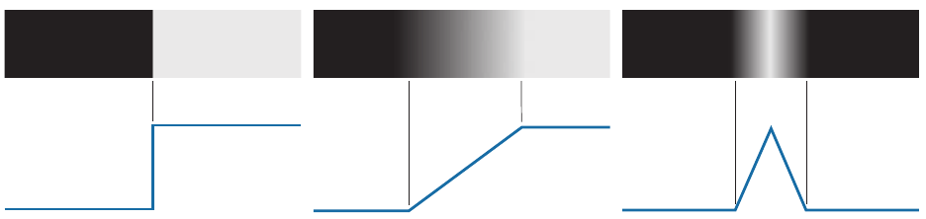
Figure 1. Models of a step, a ramp and a roof edge (top) and their brightness profiles (bottom). (Source: Gonzalez and Woods, 2018, Fig. 10.8.)
- Step edge: the brightness jumps from dark to bright in one pixel. Example: the sharp shadow of a tall building on a bright road, or black text on white paper. In satellite images true step edges are rare, because each pixel covers a large patch of ground and averages what is inside it.
- Ramp edge: the brightness rises slowly over a few pixels. Example: a coastline, or the edge of a forest.
- Roof edge: the brightness rises slowly to a peak and then falls again. Example: a mountain ridge in an elevation image, or a wide road that is brightest in its middle.
- Line edge: a thin bright (or dark) line on a plain background. Example: a narrow road, a canal or a railway line only a few metres wide, seen in a 10 m satellite image.

In real images, step and line edges are rare, while ramp and roof edges are common. Real edges are also never perfect. Figure 2 shows a CT image of the head in which an actual ramp edge spans 9 pixels, a step edge 2 pixels, and the base of a roof edge 3 pixels (Gonzalez & Woods, 2018).
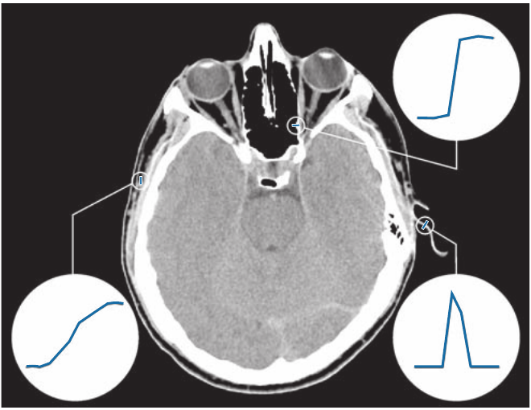
Figure 2. Actual ramp (bottom left), step (top right) and roof (bottom right) edge profiles in a CT image of the head. (Source: Gonzalez and Woods, 2018, Fig. 10.9.)
The coastline is a ramp edge. A Sentinel-2 pixel covers 10 m × 10 m of ground. A pixel that sits right on the shore is partly water and partly land, so its brightness is somewhere in between. As a result, the brightness does not jump from sea to land; it climbs over two or three pixels, like a ramp.
However, on the ground, the shore is a single line: water on one side, land on the other. The ramp is not a real feature of the ground; it appears only because the sensor mixes water and land inside the pixels at the shore. The middle of the ramp, where a pixel is about half water and half land, is the best estimate of where the real shore lies. If the whole ramp were kept, the edge would be a band two or three pixels wide, which is 20 to 30 m on the ground, with no way to tell where inside that band the shore is. A map needs one line. A good edge detector should therefore mark only the middle of the ramp, as a line one pixel wide (Canny, 1986). Making the edge thin brings the result closer to reality, not further from it. Section 3.4 explains how Canny does this.

1.2 The Relation between edges and human eye
The eye and brain are built to find edges. In the retina, at the back of the eye, some nerve cells look at a small round patch of the scene. Each cell compares the light falling on a small centre spot with the light falling on a ring around it (Kuffler, 1953). On a flat, even area, the centre and the ring receive the same light, the two cancel out, and the cell stays quiet. When an edge passes through, the centre receives more (or less) light than part of the ring. Now there is a difference, and the cell fires. In other words, these cells ignore flat areas and react only to changes in brightness, which is exactly what an edge is.
Marr and Hildreth (1980) showed that a filter called the Laplacian of Gaussian (LoG) behaves like these cells. Deeper in the brain, Hubel and Wiesel (1959, 1962) recorded the signals of single cells in the visual cortex of a cat while bars of light at different angles were shown on a screen (Figure 3). Each cell fired strongly only for a bar at one particular angle, such as a vertical or a horizontal line. This discovery won them the Nobel Prize in 1981.
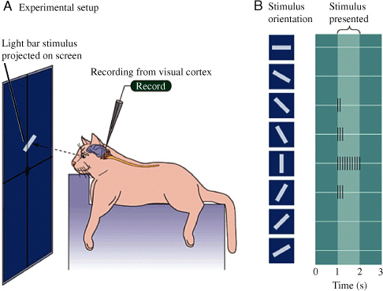
Figure 3. The experiment of Hubel and Wiesel: (A) a bar of light is shown to a cat while a cell in the visual cortex is recorded; (B) the cell fires only for one orientation of the bar. (Source: Konz et al., 2017, Stanford CS131 Lecture 5 notes, after Hubel & Wiesel, 1959.)
Edge filters used by computers copy this behaviour of the eye: they ignore flat areas and respond only where the brightness changes.

1.3 Edges in remote sensing
In satellite images, edges show the outlines of coastlines, rivers, lakes, roads, buildings and fields. Finding these outlines is a basic step in reading an image (Lillesand et al., 2015; Campbell & Wynne, 2011). Coastlines are a good example of edges. Knowing where the coastline lies is the basis for measuring land and water areas and for navigation, coastal erosion studies and coastal management. In the past, cartographers traced coastlines by hand with a pencil on aerial photographs, which was slow and depended on the person, so an automatic method has long been wanted (Liu & Jezek, 2004). Edge filters have two practical advantages:
- Edge Filters need no training data. Methods based on machine learning, such as the deep-learning model of Seale et al. (2022), must first be trained: they are shown thousands of images in which a person has already marked the answer, and they learn from these examples. An edge filter is a fixed formula. It needs no examples and works on any new image straight away.
- Edge Filters are fast. An edge filter does only a few multiplications and additions for each pixel, so even a large satellite image is processed in seconds on an ordinary computer (Gonzalez & Woods, 2018).

1.4 Aim of this paper
After a review of earlier work (Section 2), this paper has the following parts:
- Development and concept: how edge filters improved over time, and how the Canny filter works, step by step.
- Use : where Canny is used today.
- Application : testing Canny against classical filters, and using it to find coastlines in Sentinel-2 satellite images.

2. Literature review
Earlier work on edge detection and coastline mapping falls into four strands: the development of edge detectors, water indices that make water stand out, edge-based coastline extraction, and the way edge detectors are evaluated. This section reviews each strand and the gap this study addresses; the detectors themselves are explained in Section 3.

2.1 Development of edge detectors
The first detectors estimated the brightness gradient with small kernels: Roberts (1963) used a 2 × 2 kernel, Sobel and Feldman (1968) a 3 × 3 kernel with 1-2-1 smoothing, and Prewitt (1970) a 3 × 3 kernel with equal weights. These kernels only highlight edges; thresholding their output gives thick lines that break where the edge weakens (Jain et al., 1995).
Marr and Hildreth (1980) blurred the image with a Gaussian before taking the Laplacian and marked edges at zero crossings, which reduced noise but rounded corners. Canny (1986) instead derived a detector from three criteria, good detection, good localization and a single response to each edge, and showed that the best filter is close to the first derivative of a Gaussian. Non-maximum suppression and hysteresis thresholding, which earlier detectors lacked, give thin and connected edges, and Canny remains the standard baseline (Gonzalez & Woods, 2018).

2.2 Water indices
Water absorbs most near-infrared and short-wave infrared light, so spectral indices can make water bright and land dark before edges are detected (Lillesand et al., 2015). McFeeters (1996) defined the Normalized Difference Water Index (NDWI) from the green and near-infrared bands. Xu (2006) replaced the near-infrared band with short-wave infrared (MNDWI), which suppresses built-up land better. For Sentinel-2, NDWI uses two 10 m bands, while MNDWI uses the 20 m band B11.

2.3 Edge detection for coastline extraction
- Liu and Jezek (2004) combined Canny with locally adaptive thresholding. Canny located the mixed shore pixels, which were left out of each block’s histogram so that a water/land threshold could be found reliably. On Radarsat images of Antarctica and a Landsat 7 image near Galveston, Texas, the coastline was accurate to about one pixel.
- O’Sullivan et al. (2024) compared Canny, Sobel, Scharr and Prewitt for coastline extraction. Canny gave the edges closest to the reference (average SSIM about 0.8) but also marked edges of coastal development; histogram equalization and Gaussian blur improved results by up to 1.5 and 1.6 times.
- Seale et al. (2022) released the Sentinel-2 Water Edges Dataset (SWED) with hand-drawn water masks and used it to train a deep-learning model. Such models need large labelled training sets, whereas edge filters need no training (Section 1.3).

2.4 Evaluating edge detectors
Edge detectors are scored by comparing their edges with hand-drawn boundaries. Precision is the share of detected edges that lie on the true boundary, and recall is the share of the boundary that was found; van Rijsbergen (1979) combined the two into the F-measure, now called the F1 score. Martin et al. (2004) applied these measures to boundary detection with a small distance tolerance for imprecise labels, which is now standard practice. In remote-sensing terms, precision and recall correspond to user’s and producer’s accuracy.

2.5 Summary and research gap
Table 1 summarises the studies reviewed.
Table 1. Key studies reviewed.
Study | Year | Contribution | Relevance to this study
Roberts | 1963 | 2 × 2 gradient kernel | Classical filter compared
Sobel & Feldman | 1968 | 3 × 3 gradient with 1-2-1 smoothing | Classical filter compared
Prewitt | 1970 | 3 × 3 gradient, equal weights | Classical filter compared
Marr & Hildreth | 1980 | Laplacian of Gaussian | LoG filter compared
Canny | 1986 | Optimal detector from three criteria | Main filter studied
McFeeters | 1996 | NDWI (green and near-infrared) | Input image tested
Liu & Jezek | 2004 | Canny with adaptive thresholding for coastlines | Role of Canny in coastline mapping
Martin et al. | 2004 | Precision, recall and F1 with a distance tolerance | Scoring method used
Xu | 2006 | MNDWI (green and short-wave infrared) | Input image tested
Seale et al. | 2022 | SWED dataset and deep-learning model | Data and ground truth
O’Sullivan et al. | 2024 | Canny vs Sobel, Scharr and Prewitt for coastlines | Similar comparison, different measure (SSIM)
Most of these studies either develop a single method or compare detectors with a measure other than F1. Few compare Canny with the classical filters taught in remote-sensing courses on the same Sentinel-2 scene, scored against hand-drawn ground truth, while also testing which input image suits each filter. This study does so for the SWED image of Ashdod port, using precision, recall and F1 with a 2-pixel tolerance (Section 4).

3. Background: development and concept of the Canny filter

3.1 How an edge filter works
A computer finds edges by sliding a small grid of numbers, called a kernel, over the image. At each pixel it multiplies each number in the kernel by the pixel below it and adds up the results (Gonzalez & Woods, 2018). Edge filters are zero-sum filters: the numbers in the kernel add up to zero. For example, the Sobel kernel that measures change from left to right is:
$$G_{x}\text{ kernel}=\left[\begin{matrix}-1 & 0 & 1 \\ -2 & 0 & 2 \\ -1 & 0 & 1\end{matrix}\right]$$
Its numbers add up to zero (−1 + 0 + 1 − 2 + 0 + 2 − 1 + 0 + 1 = 0). This is why it finds edges:
- On a flat area, all nine pixels have the same value, say 50. The answer is 50 × 0 = 0: no edge.
- On an edge, say water (20) on the left and land (100) on the right, the answer is (−1 − 2 − 1) × 20 + (1 + 2 + 1) × 100 = −80 + 400 = 320: a large number, so there is an edge.
So a sudden change in pixel values gives a large answer, and a flat area gives an answer close to zero. In terms of calculus, an edge filter measures the first derivative of the brightness, and edges lie where this derivative is large. Figure 4 shows a ramp edge with its first and second derivatives: the first derivative is non-zero only on the ramp and zero in flat areas, and the second derivative crosses zero in the middle of the ramp (Gonzalez & Woods, 2018).
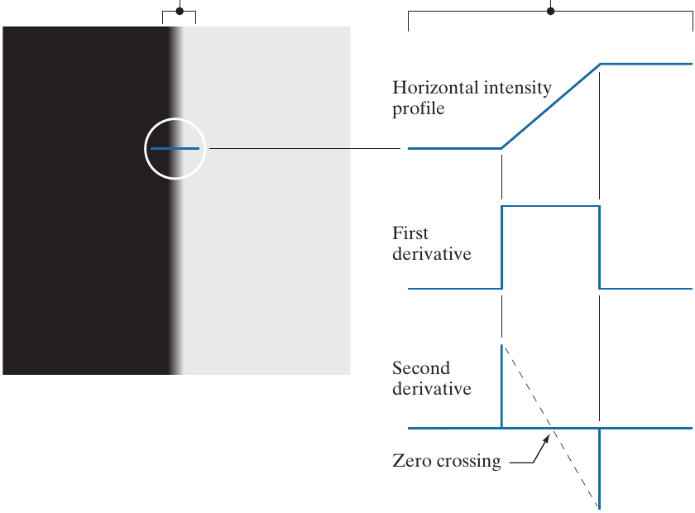
Figure 4. (a) Two regions of constant brightness separated by an ideal ramp edge. (b) Brightness profile across the edge, and its first and second derivatives. (Source: Gonzalez and Woods, 2018, Fig. 10.10.)
Two directions: Gx and Gy. The Sobel filter uses two kernels (Sobel & Feldman, 1968):
$$G_{x}\text{ kernel}=\left[\begin{matrix}-1 & 0 & 1 \\ -2 & 0 & 2 \\ -1 & 0 & 1\end{matrix}\right] G_{y}\text{ kernel}=\left[\begin{matrix}-1 & -2 & -1 \\ 0 & 0 & 0 \\ 1 & 2 & 1\end{matrix}\right]$$
- Gx measures the change from left to right. It responds to edges that run up and down (vertical edges), such as a coastline running north–south.
- Gy measures the change from top to bottom. It responds to edges that run left to right (horizontal edges), such as a coastline running east–west.
A real coastline curves in every direction, so both are needed. Together they give the edge strength $G=\sqrt{G_{x}^{2}+G_{y}^{2}}$ (how strong the change is) and the edge direction $θ=\tan^{-1}\left(G_{y}/G_{x}\right)$ (which way the change points) (Gonzalez & Woods, 2018). The gradient points across the edge, in the direction in which the brightness increases fastest, and the edge itself runs at right angles to the gradient (Figure 5).
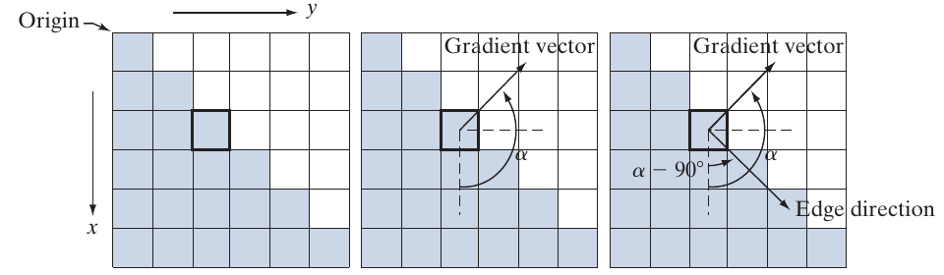
Figure 5. Using the gradient to find the strength and direction of an edge at a pixel. Each square is one pixel. The edge direction is at right angles to the gradient vector. (Source: Gonzalez and Woods, 2018, Fig. 10.12.)

3.2 Edge filters before Canny
Edge filters improved step by step over about twenty years (Table 2).
Table 2. Early edge filters.
Filter | Year | Main idea | Main problem
Roberts | 1963 | Very small 2 × 2 kernel | Easily disturbed by noise
Sobel | 1968 | 3 × 3 kernel, extra weight on the centre row | Thick edges
Prewitt | 1970 | 3 × 3 kernel, equal weights | Noise and thick edges
Laplacian | – | Looks for a change in all directions at once | Very sensitive to noise
LoG (Marr–Hildreth) | 1980 | Blur first, then Laplacian | Less noise, but corners get rounded
The kernels of the Roberts, Prewitt and Sobel filters are shown in Figure 6, and Figure 7 shows the Sobel filter applied to a photograph of a building (Gonzalez & Woods, 2018). In Gonzalez and Woods (2018) the x-axis runs down the rows of the image, so their $g_{x}$ responds to horizontal edges and their $g_{y}$ to vertical edges. Figure 8 compares the Roberts, Sobel and Prewitt filters on a noisy image of a connecting rod (Jain et al., 1995): all three mark many false edge points caused by the noise.
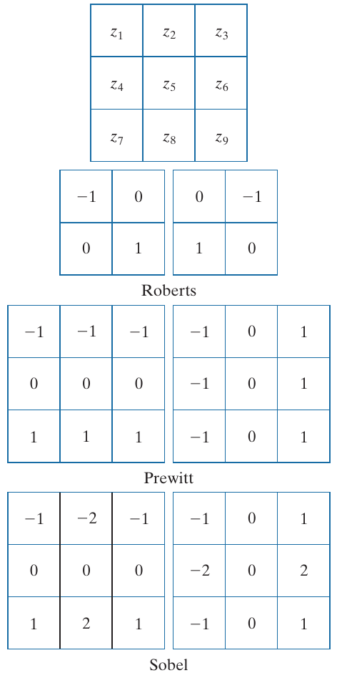
Figure 6. A 3 × 3 region of an image (the z’s are brightness values) and the kernels of the Roberts, Prewitt and Sobel filters. (Source: Gonzalez and Woods, 2018, Fig. 10.14.)
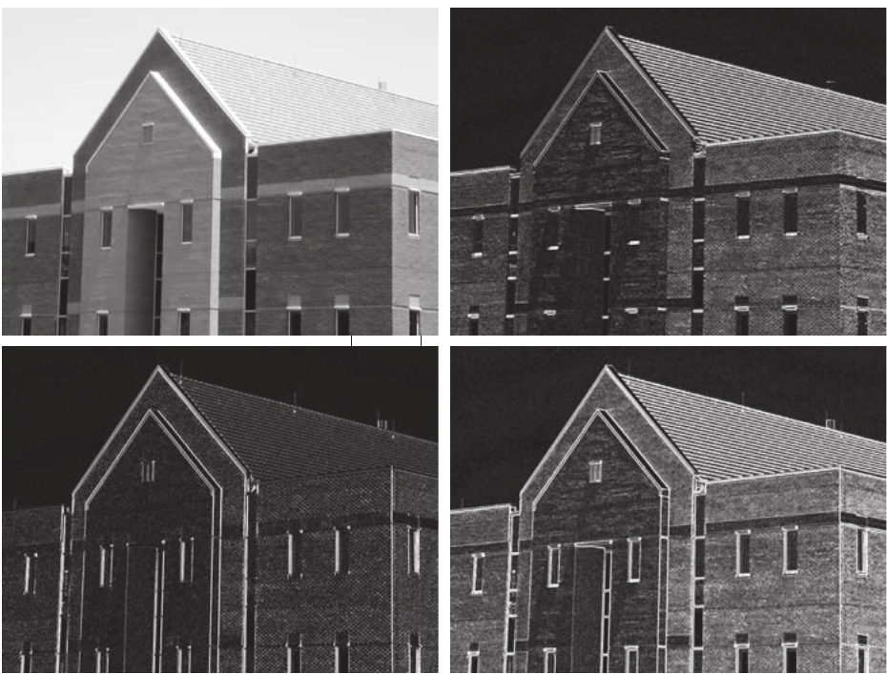
Figure 7. (a) Image of a building. (b) |gx| and (c) |gy| obtained with the Sobel kernels. (d) The gradient image |gx| + |gy|. (Source: Gonzalez and Woods, 2018, Fig. 10.16.)
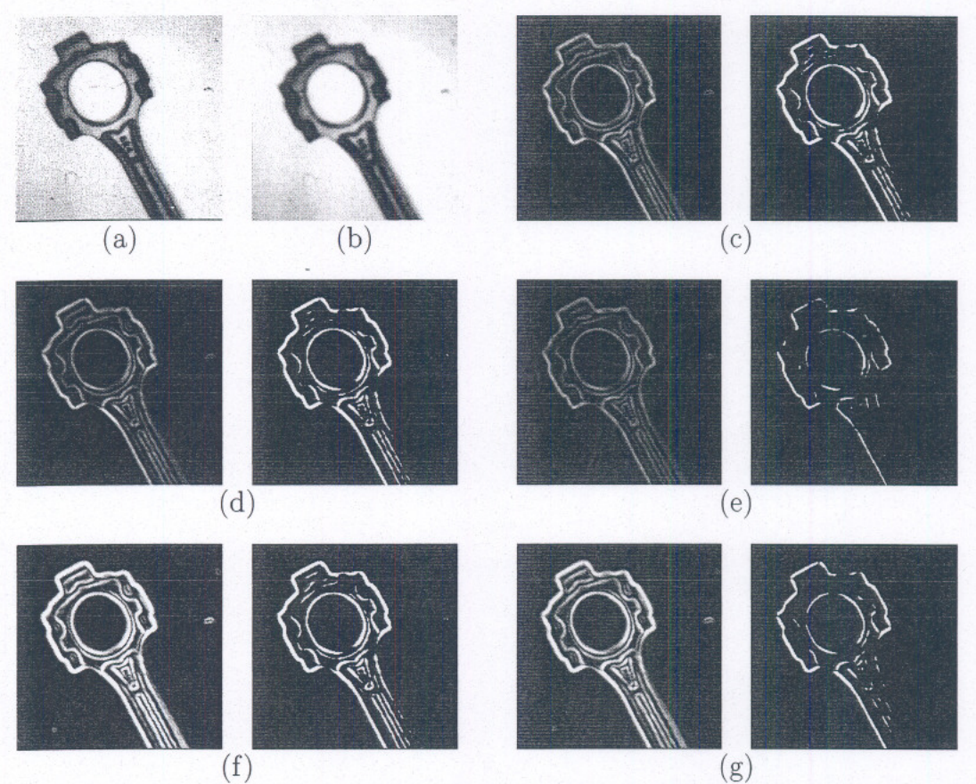
Figure 8. Comparison of edge detectors on a noisy image. (a) Noisy image. (b) Filtered image. (c) Simple gradient using 1 × 2 and 2 × 1 masks. (d) Gradient using 2 × 2 masks. (e) Roberts cross operator. (f) Sobel operator. (g) Prewitt operator. (Source: Jain et al., 1995, Fig. 5.6.)
All these filters only highlight edges. They do not decide where an edge really is, their lines are thick and noisy, and a line that fades in one place breaks into pieces (Gonzalez & Woods, 2018).

3.3 Canny’s idea (1986)
In 1986, John Canny at MIT asked a new question. Instead of “which kernel should be used?”, he asked “what should a perfect edge detector do?” He set three goals (Canny, 1986):
- Find the real edges and ignore noise.
- Put each edge in the right place.
- Mark each edge only once, as a line one pixel wide.
In Canny’s words, these are “good detection”, “good localization” and “only one response to a single edge” (Canny, 1986). He wrote each goal as a mathematical formula and then searched for the filter shape that scores best on all three together.
Figure 9, taken from Canny’s paper, shows why the shape of the filter matters. Panel (a) is a step edge buried in noise, much like a coastline in a noisy satellite image. Panel (b) is a simple filter that subtracts the average of the pixels on the left from the average of the pixels on the right (a “difference of boxes”). Its output (c) is rough and has several small peaks near the edge, so it is not clear where the edge is. Panel (d) is the first derivative of a Gaussian, a smooth bell-shaped curve that has been differentiated. Its output (e) has one clear, smooth peak at the edge (Canny, 1986).
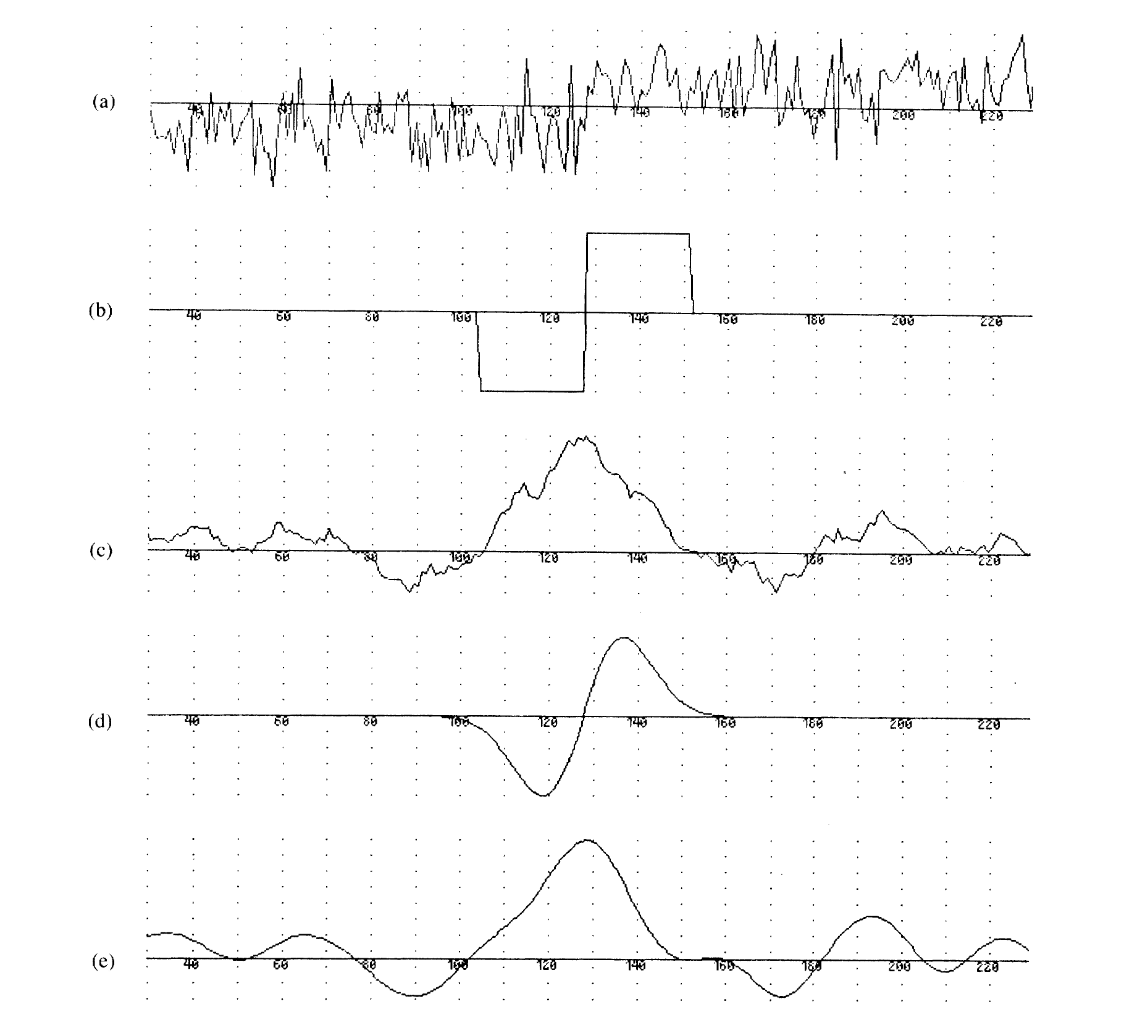
Figure 9. (a) A noisy step edge. (b) Difference of boxes operator. (c) Difference of boxes operator applied to the edge. (d) First derivative of Gaussian operator. (e) First derivative of Gaussian applied to the edge. (Source: Canny, 1986, Fig. 1.)
Canny found that the best filter for a step edge has almost the same shape as the first derivative of a Gaussian. The Gaussian derivative scores only about 20% lower than the exact best filter, but it is much easier and faster to compute in two dimensions, so Canny used it in all his experiments (Canny, 1986). This is why the Canny filter is, in practice, “blur with a Gaussian, then measure the change”. He also found a trade-off: a wider filter finds edges more reliably in noise, but places them less exactly. No single filter width is best for every image, which is why the user of Canny must choose the amount of blur (Canny, 1986).
Forty years later, Canny’s paper is one of the most cited papers in image processing, and his filter is built into common software such as OpenCV and MATLAB (OpenCV, n.d.).

3.4 The five steps of the Canny filter
The Canny filter works in five steps (Canny, 1986; Gonzalez & Woods, 2018). The result of each step on a test image is shown in Section 5.1.2.
Step 1 — Blur the image. Noise makes false edges, so Canny first smooths the image with a Gaussian blur. The amount of blur is called σ (sigma). For example, one bright wave pixel of 90 among water pixels of 20 drops to about 28 after blurring, so it no longer looks like an edge. Figure 10 shows why this is needed: noise that is hardly visible in the image makes the first and second derivatives so noisy that the edge is lost (Gonzalez & Woods, 2018). More blur removes more noise, but it also rounds off small details. Figure 11 shows this trade-off for Canny’s method: with a small (7 × 7) Gaussian, fine detail is kept but some false edge pieces appear; with a large (31 × 31) Gaussian, the false pieces are gone but the corners are rounded (Jain et al., 1995).
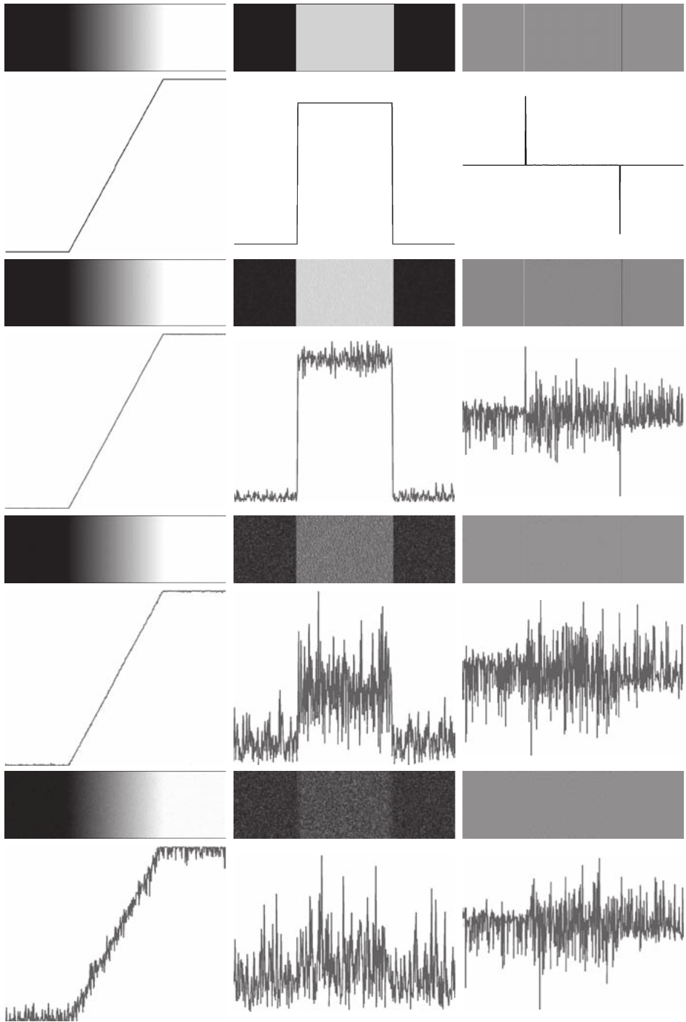
Figure 10. First column: a ramp edge with Gaussian noise of standard deviation 0, 0.1, 1.0 and 10.0 brightness levels, and its brightness profile. Second column: first derivative. Third column: second derivative. (Source: Gonzalez and Woods, 2018, Fig. 10.11.)
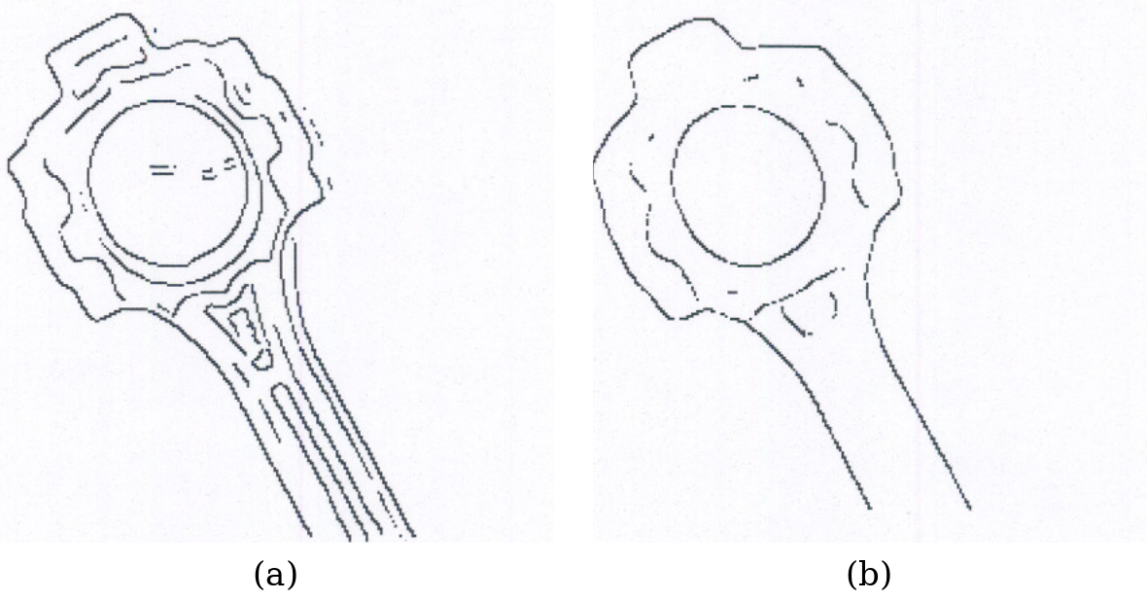
Figure 11. Canny edges of a connecting rod after smoothing with (a) a 7 × 7 and (b) a 31 × 31 Gaussian filter. (Source: Jain et al., 1995, Figs. 5.23(b) and 5.24(b).)
Step 2 — Find how fast brightness changes. The Sobel kernels of Section 3.1 are applied to the blurred image. This gives the edge strength $G$ and the edge direction $θ$ at every pixel:
$$G=\sqrt{G_{x}^{2}+G_{y}^{2}} θ=\tan^{-1}\left(\frac{G_{y}}{G_{x}}\right)$$
Because a coastline is a ramp edge, the edge strength is high over a band several pixels wide, not on a single line.
Step 3 — Thin the edges. Each pixel is compared with its two neighbours across the edge, using the direction $θ$ from Step 2. If it is the strongest of the three, it stays; if not, it is set to zero. This step is called non-maximum suppression (Canny, 1986). In a grid of pixels only four directions are possible across an edge: horizontal, vertical and the two diagonals. The gradient direction is therefore rounded to one of four sectors (Figure 12), and the pixel is compared with its two neighbours in that direction (Jain et al., 1995).
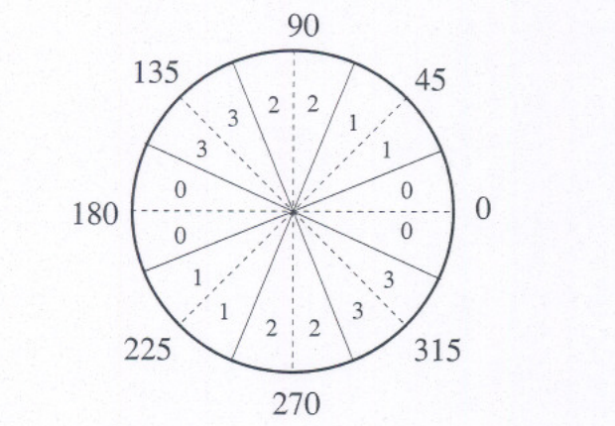
Figure 12. The four sectors (numbered 0 to 3) into which the gradient direction is rounded for non-maximum suppression; angles in degrees. (Source: Jain et al., 1995, Fig. 5.21.)
Why does this keep the middle of the ramp? Table 3 gives the brightness of nine pixels across a shore, going from water (20) to land (100). The edge strength is not the brightness. It is how fast the brightness changes: for each pixel, the brightness of the next pixel minus the brightness of the previous one. For pixel 4 this is 84 − 36 = 48.
Table 3. Brightness and edge strength of nine pixels across a ramp edge.
Pixel | Brightness | Edge strength
0 | 20 | –
1 | 20 | 4
2 | 24 | 16
3 | 36 | 36
4 | 60 | 48
5 | 84 | 36
6 | 96 | 16
7 | 100 | 4
8 | 100 | –
The brightness is highest at the land end (100), but there the brightness has stopped changing, so the edge strength is small. The change is fastest in the middle of the ramp, so the edge strength is largest there (48) (Gonzalez & Woods, 2018). Its neighbours have 36 and 36, so thinning turns 36, 48, 36 into 0, 48, 0. The pixel that stays has brightness 60, exactly halfway between water (20) and land (100). That is the middle of the ramp, and the best estimate of where the real shore is.
Step 4 — Use two thresholds. A high threshold and a low threshold are set. Pixels above the high threshold are strong edges. Pixels between the two are weak edges. Pixels below the low threshold are removed. For example, with a high threshold of 200 and a low threshold of 80, a pixel of 320 is strong, a pixel of 120 is weak, and a pixel of 50 is removed.
Step 5 — Follow the line. A weak pixel is kept only if it is connected to a strong edge. This step is called hysteresis (Canny, 1986). A faint part of a coastline is kept because it is joined to the clear part, while small spots of noise, which are joined to nothing strong, are removed. This is the main reason Canny suits coastlines: a coast is one long connected line, while noise comes in small separate spots.
The Need of two thresholds: Canny (1986) explained this with the image in Figure 13. With a single threshold, the edge strength along a real contour goes up and down a little because of noise. If the threshold is low (panel b), many noise edges appear. If it is high (panel c), the noise goes, but real contours break into dashes wherever their strength dips below the threshold; Canny called this “streaking”. With two thresholds and hysteresis (panel d), the contours are continuous and the noise is gone. Canny suggested that the high threshold should be two to three times the low threshold (Canny, 1986), that is, a low threshold of about 0.3 to 0.5 times the high one.
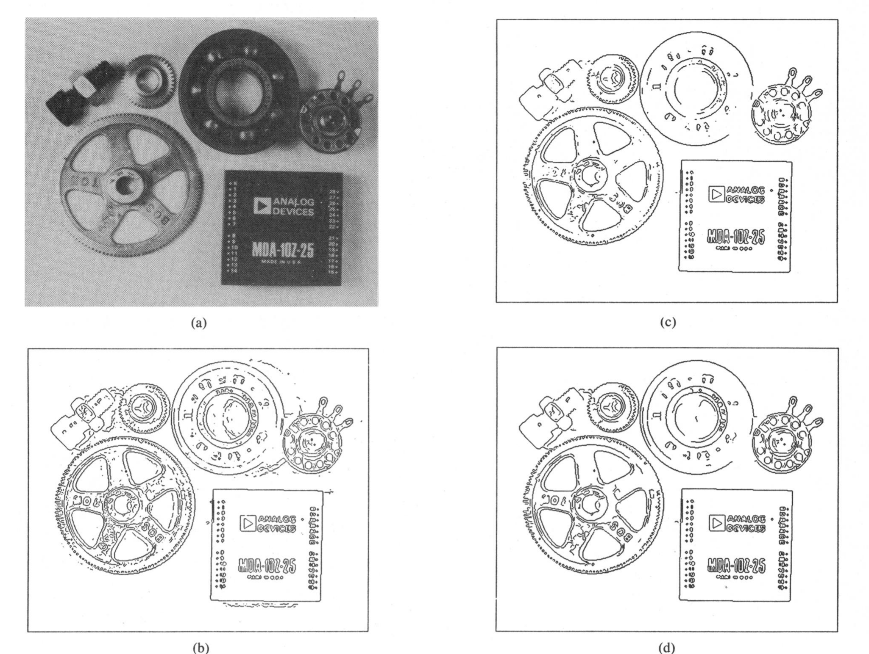
Figure 13. (a) Parts image, 576 by 454 pixels. (b) Image thresholded at T1. (c) Image thresholded at 2 T1. (d) Image thresholded with hysteresis using both the thresholds in (b) and (c). (Source: Canny, 1986, Fig. 7.)
Figure 14 compares the three main approaches on the building image (Gonzalez & Woods, 2018): a thresholded gradient, the Marr–Hildreth (LoG) detector and Canny. Canny gives the cleanest and most continuous lines, with the fewest unwanted edges.
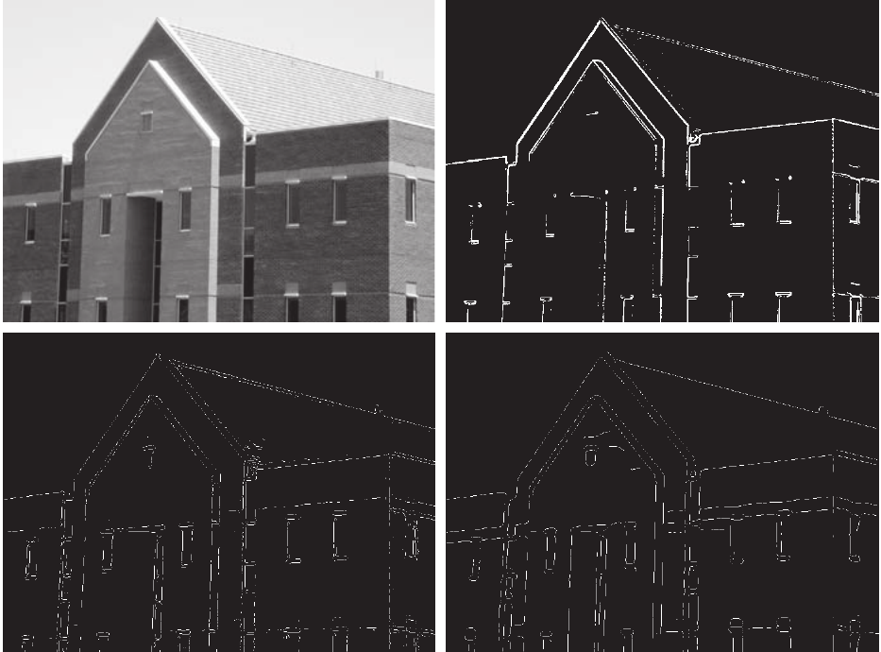
Figure 14. (a) Original image. (b) Thresholded gradient of the smoothed image. (c) Marr–Hildreth (LoG) detector. (d) Canny detector. (Source: Gonzalez and Woods, 2018, Fig. 10.25.)
Canny finds edges, not coastlines. Canny only looks at changes in brightness. It does not know what the objects in the image are. To Canny, the side of a road looks just like the edge of the sea: both are long lines where brightness changes. So Canny’s output always contains the coastline plus other edges, such as roads and buildings. To find out how many of Canny’s edges really are coastline, an answer key showing the true coastline is needed. In this study the SWED water masks provide this answer key (Section 4).

3.5 Uses of the Canny filter
Because it is simple, fast and reliable, Canny is used in many fields (Gonzalez & Woods, 2018):
- Medicine: outlining bones, organs and tumours in X-ray, CT and MRI scans.
- Cars and robots: finding lane markings on roads and the outlines of obstacles.
- Factories: checking products for cracks or wrong shapes.
- Phones and scanners: finding the edges of a page or a number plate before reading the text.
- Remote sensing: outlining buildings, roads, field boundaries, lakes, rivers and coastlines in satellite and aerial images (Lillesand et al., 2015). Figure 15 shows Canny applied to an aerial image of an airport: Canny finds the edges, and the long straight runway edges are then picked out with the Hough transform (Gonzalez & Woods, 2018).
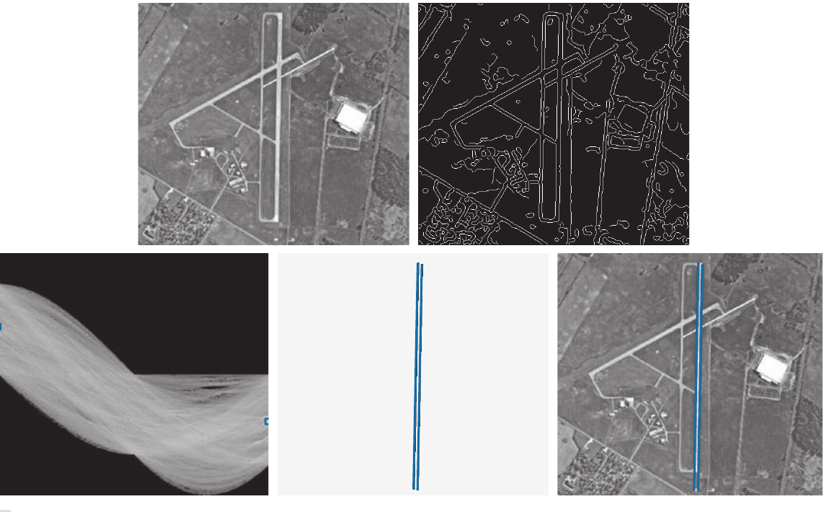
Figure 15. (a) Aerial image of an airport. (b) Edge map obtained with Canny’s algorithm. (c) Hough parameter space. (d) Lines found by the Hough transform. (e) Lines laid on the original image. (Source: Gonzalez and Woods, 2018, Fig. 10.31.)
Canny in coastline mapping: an example. Liu and Jezek (2004) built an automatic method to draw coastlines from satellite images, and Canny is one of its key parts. They first point out a problem with simple edge filters: earlier work had used the Sobel filter on radar images of the coast, but the edge pixels it gave were broken and seldom traced the whole coastline (Liu & Jezek, 2004). Their method therefore divides the image into small blocks and, in each block, chooses a brightness value that separates water from land (a threshold).
Here the ramp edge of Section 1.1 becomes a practical problem. The pixels along the shore are mixed pixels, partly water and partly land, so their brightness lies between the two. In a histogram of the block (a count of how many pixels have each brightness value), water forms one peak and land another, but the mixed pixels fill the valley between them, and the best threshold becomes hard to find. Liu and Jezek (2004) used Canny to find the shore pixels, widened them by one pixel on each side, and left out this narrow band when making the histogram. Figure 16 shows the result: after the mixed pixels are removed, the valley between the water peak and the land peak becomes clean and deep (panel d), and the threshold can be found much more reliably.
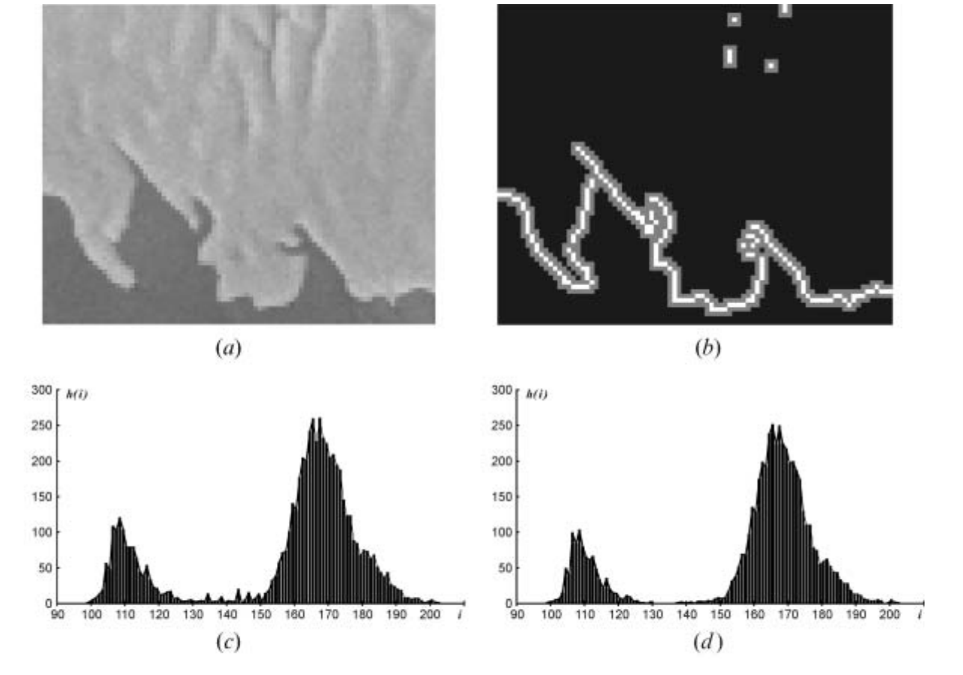
Figure 16. Sharpen observed histogram by removing mixed edge pixels: (a) a sample image region; (b) edge pixels (white) and their immediate neighbours (grey) identified by the Canny edge detector; (c) image histogram of the original image region with spikes in the valley between two lobes; and (d) sharpened image histogram after removing the pixels in the transitional buffer zone in (b). (Source: Liu and Jezek, 2004, Fig. 4.)
They applied the method to Radarsat radar images of Antarctica (100 m pixels) and to a Landsat 7 image of the Gulf of Mexico near Galveston, Texas (band 5, 30 m pixels). Figure 17 shows the Landsat result: the extracted coastline (blue) follows peninsulas, small inlets, islands, reservoirs and rivers, and the authors report that its position is correct to about one pixel (Liu & Jezek, 2004).
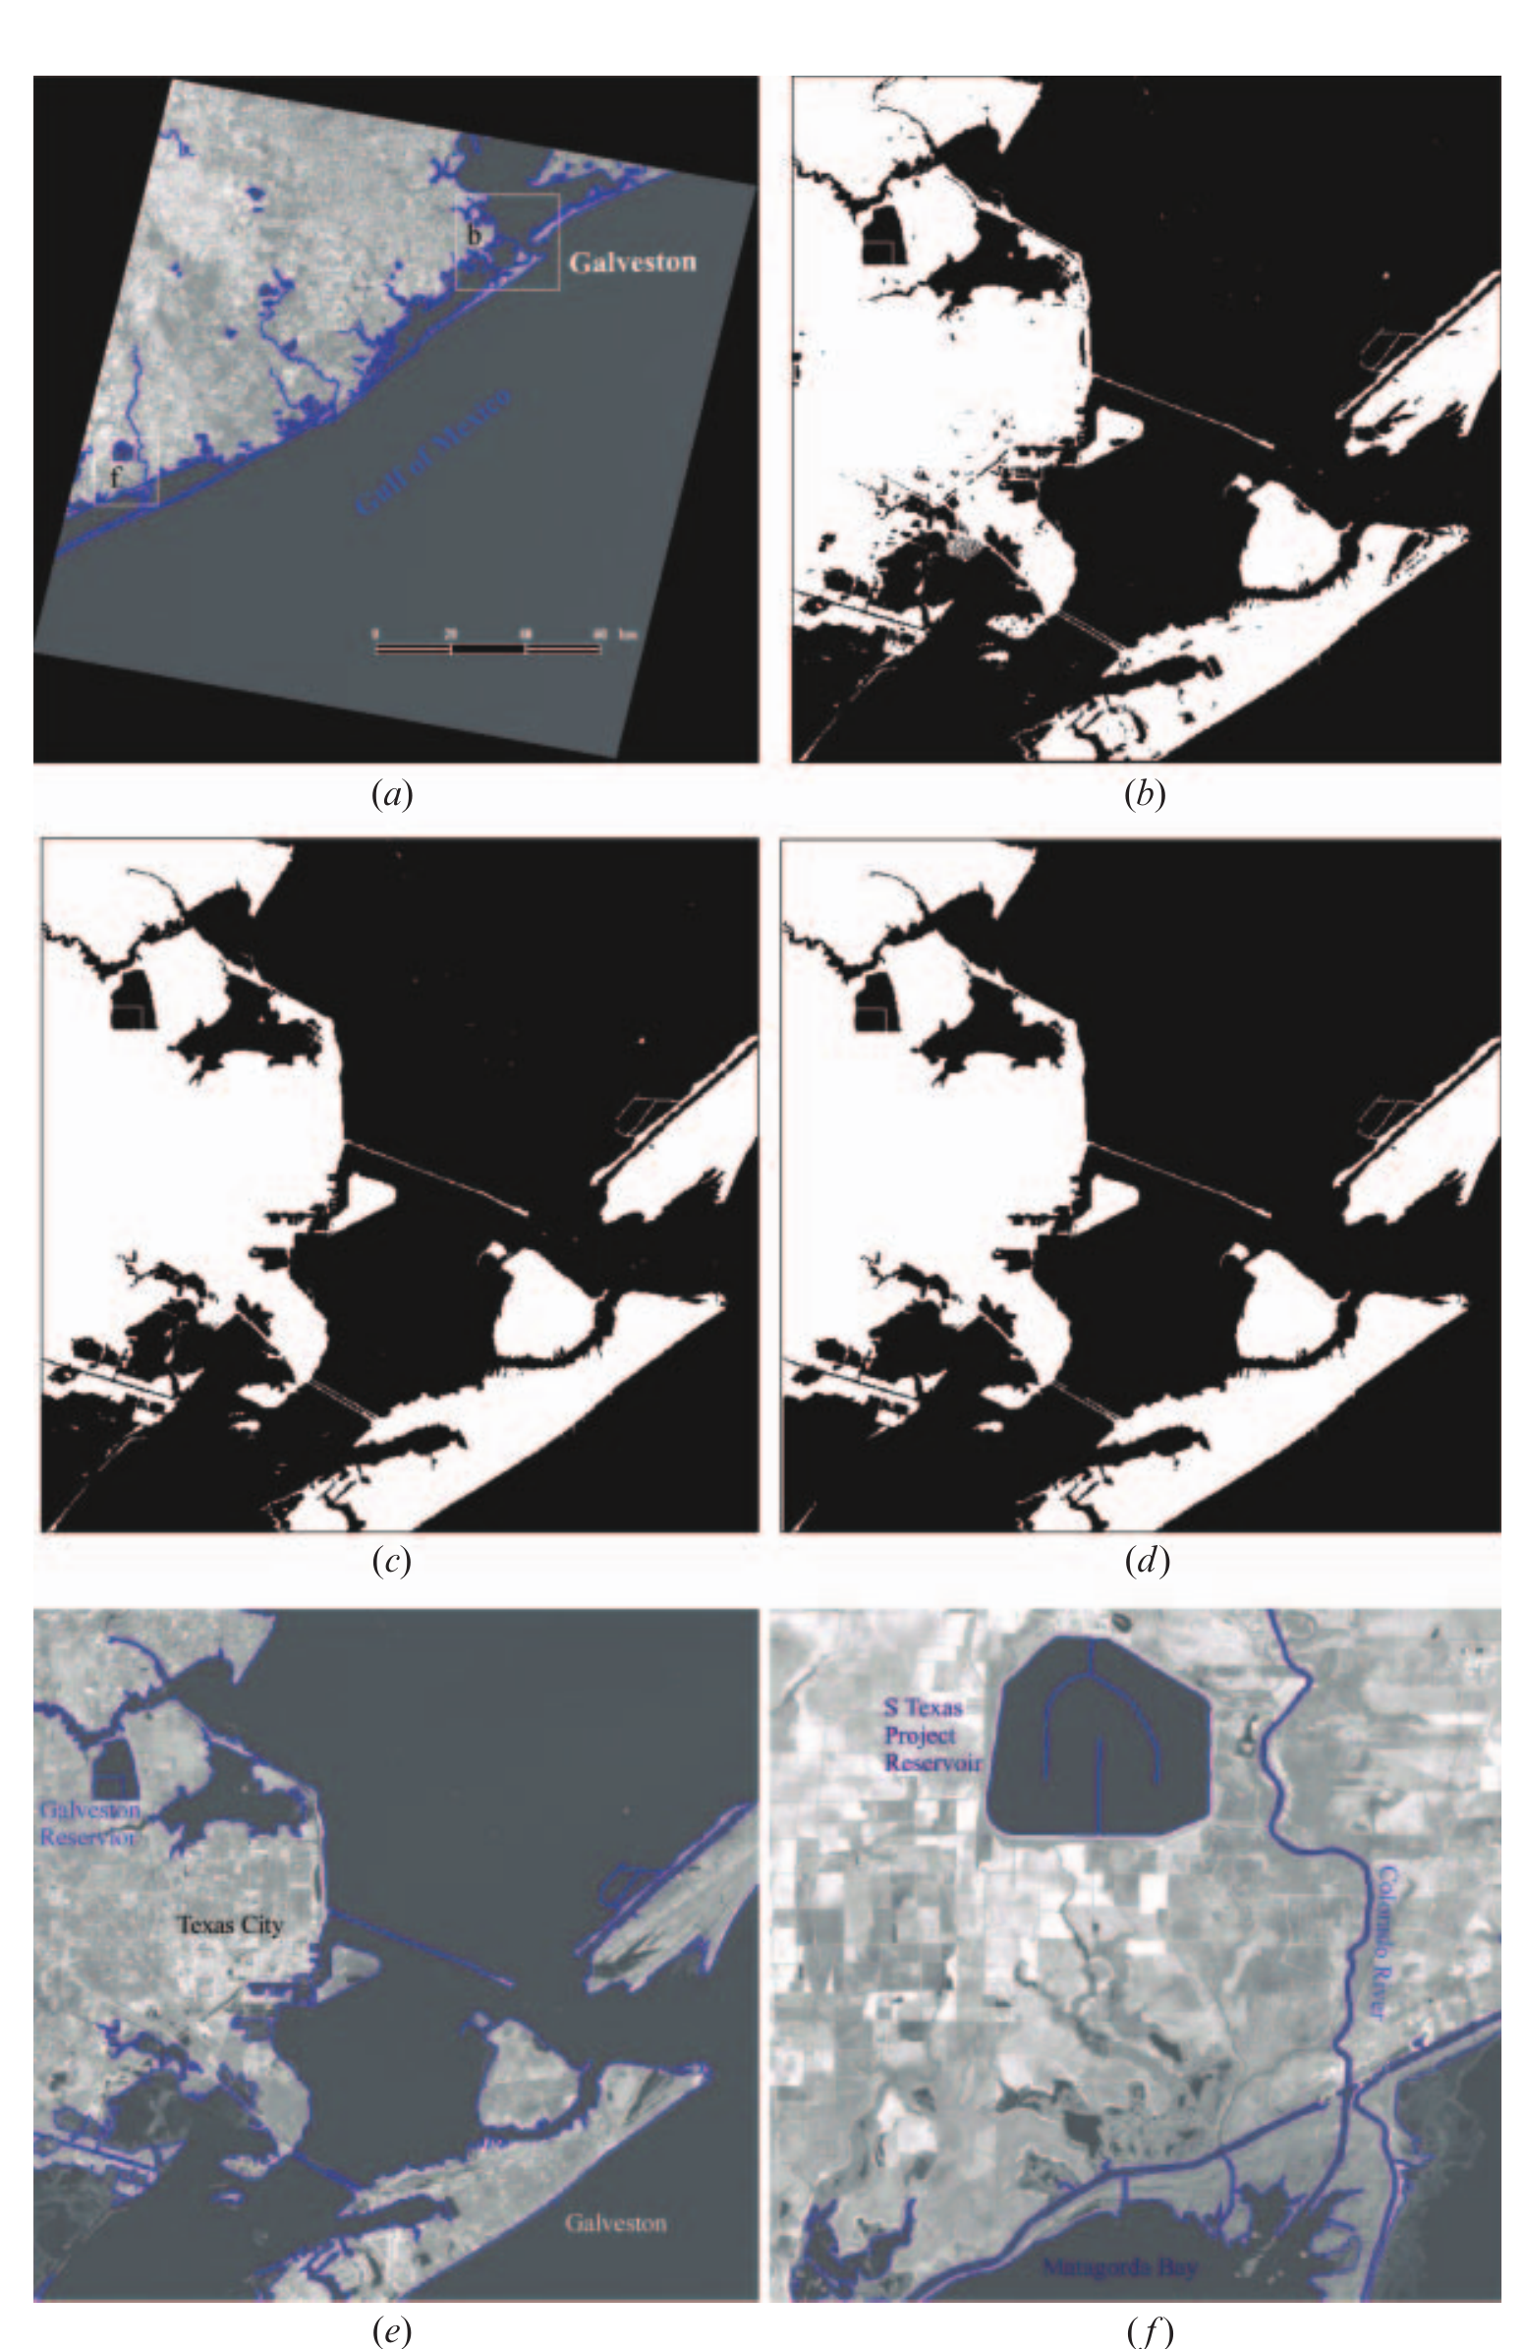
Figure 17. Automated coastline extraction from Landsat 7 ETM+ image (band 5, 30 m): (a) extracted coastline draped on the entire original Landsat image; (b) segmented image for the enlarged area b using locally adaptive thresholding method; (c) after applying image region grouping and removing small objects that are classified as water objects; (d) after applying image region grouping and removing small objects that are classified as land objects; (e) coastline draped on the enlarged area b; and (f) coastline draped on the enlarged area f. (Source: Liu and Jezek, 2004, Fig. 9.)
This example shows two points that matter for the present study. First, Canny is useful for coastlines because it marks the shore as a thin line in the middle of the band of mixed pixels. Second, Canny alone is not the whole answer: Liu and Jezek also had to remove small water and land patches and keep only the large sea and land areas, because Canny marks every edge, not only the coast.
How to use it. In Python with OpenCV, Canny is a single line: edges = cv2.Canny(image, low, high) (OpenCV, n.d.). MATLAB has edge(image, 'canny'). The user only has to choose three numbers: the blur σ and the two thresholds. Following Canny’s advice that the high threshold should be two to three times the low one (Canny, 1986), a common choice is to set the low threshold at about 0.4 times the high threshold. Noisy images need more blur; images with fine details need less.

4. Methodology
The study has three parts, all based on the SWED dataset (Section 4.1). Part A compares Canny with five classical edge filters on one Sentinel-2 scene. Part B extends the comparison to further scenes and spectral bands and maps the results in QGIS. Part C implements Canny as a scalable, adaptive pipeline (GeoEdge).

4.1 Data
Sentinel-2. Sentinel-2 is a pair of satellites run by the European Space Agency under the European Union’s Copernicus programme. They photograph all land and coastal areas of the Earth every few days, in 13 colour bands, with pixels of 10 m, 20 m or 60 m. The images are free for everyone.
The SWED dataset. The Sentinel-2 Water Edges Dataset (SWED) was made by Catherine Seale, Thomas Redfern and Paul Chatfield at the UK Hydrographic Office and is described by Seale et al. (2022). Its details are given in Table 4.
Table 4. Details of the SWED dataset.
Item | Details
Provider | UK Hydrographic Office (UKHO), Taunton, UK
Website | https://openmldata.ukho.gov.uk/
Published | October 2021 (sample download added January 2022)
Reference paper | Seale et al. (2022), Remote Sensing of Environment, 278, 113044
Places | Coastlines from around the world
Image | 256 × 256 pixels, 12 Sentinel-2 bands, all on a 10 m grid, GeoTIFF (.tif) files
Label (mask) | 256 × 256 pixels, one band: water = 1, land (non-water) = 0, drawn by hand for the test set
Parts | Training images, and a separate test set of 98 images with a file giving the tide state of each
Size | About 18 GB for the full dataset; about 1.36 GB for the sample
Licence | Geospatial Commission Data Exploration Licence: free for research and evaluation; images shown must carry the note “Not to be used for Navigation”

4.2 Part A: Comparison of Canny with classical filters
Canny and five classical edge filters were applied to the Ashdod image. The edges found by each filter were checked against the hand-drawn coastline, and each filter was given a score.

4.2.1 Test image and inputs
Part A used only the test data of the free SWED sample download (about 1.36 GB). In SWED, each image and its mask have the same file name, except that one ends in “image” and the other in “label”. The sample’s training part holds many images for teaching machine-learning models; edge filters need no training, so only the test part was used. The test part contains one image with a hand-drawn mask: the port of Ashdod, Israel, taken on 15 February 2020 (Figure 18a). The scene has a long, thin breakwater in the sea on the left, and the docks and buildings of the port on the right.
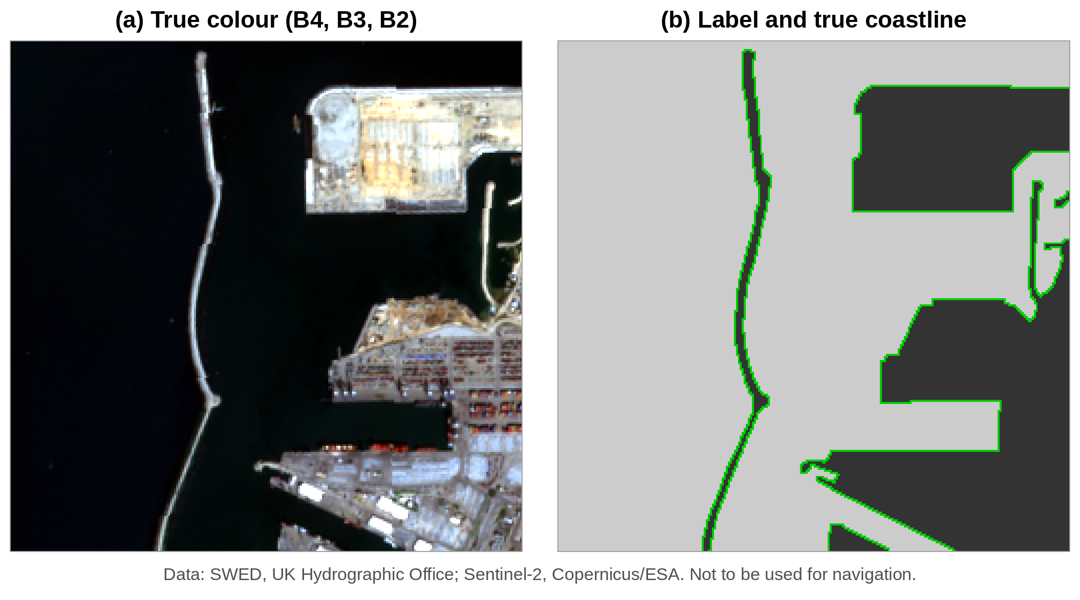
Figure 18. The Ashdod test image of SWED: (a) true colour (B4, B3, B2); (b) the hand-drawn label (light = water, dark = land) with the true coastline in green. Data: SWED, UK Hydrographic Office (Seale et al., 2022); Sentinel-2, Copernicus/ESA. Not to be used for navigation.
Inputs. The filters need a single-band image. Three inputs were made from the Sentinel-2 bands (Figure 19):
- Grayscale: made from the red, green and blue bands (B4, B3, B2), so it looks the way the eye sees the scene. Each band was first stretched between its 2nd and 98th percentile.
- NDWI (McFeeters, 1996): a water index, (Green − NIR) / (Green + NIR), using bands B3 and B8. Water reflects almost no near-infrared light, so water becomes bright and land dark, which makes the coastline stand out.
- MNDWI (Xu, 2006): like NDWI, but with the short-wave infrared band B11 in place of NIR. B11 has 20 m pixels, so this input is coarser than the other two.
NDWI and MNDWI run from −1 to +1, so they were rescaled to the range 0 to 1 before the filters were applied.
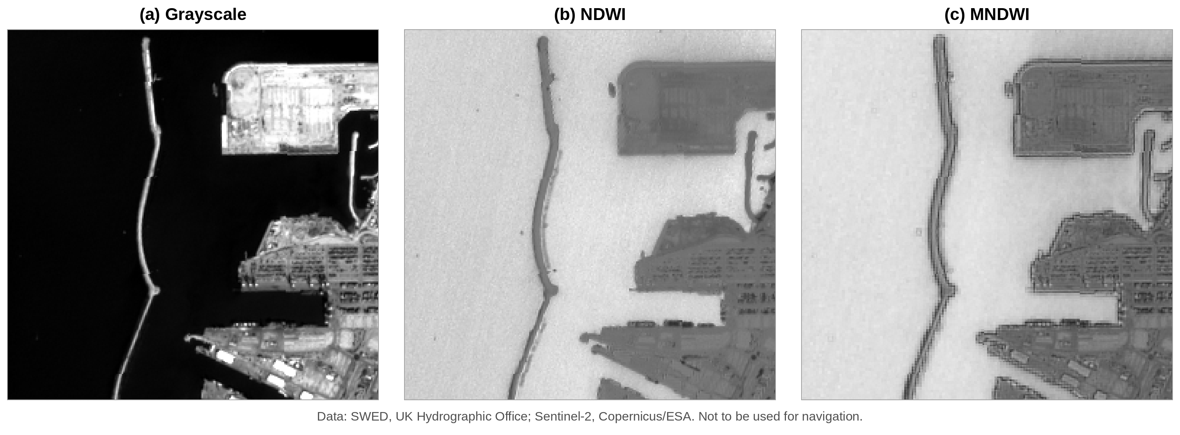
Figure 19. The three inputs made from the Ashdod image: (a) Grayscale; (b) NDWI; (c) MNDWI. Data: SWED, UK Hydrographic Office (Seale et al., 2022); Sentinel-2, Copernicus/ESA. Not to be used for navigation.

4.2.2 Filters and settings
All work was done in MATLAB Online with the Image Processing Toolbox, using one script for every step. Six filters were applied to each of the three inputs: Roberts, Sobel, Prewitt, Laplacian, LoG and Canny, all with MATLAB’s edge function.
Every filter needs at least one setting, and the result depends on it. To make the comparison fair, a range of settings was tried for every filter, and the setting with the best F1 score (Section 4.2.4) was kept for each filter and each input:
- Roberts, Sobel and Prewitt: MATLAB first picks a threshold on its own; nine thresholds from 0.25 to 3 times this value were tried.
- Laplacian: edges were taken where the output of the 3 × 3 Laplacian kernel changes sign (zero crossings), with nine thresholds as above.
- LoG: four values of the blur σ (1, 1.5, 2 and 3), each with nine thresholds.
- Canny: five values of the blur σ (1, 1.5, 2, 3 and 4) and fourteen values of the high threshold (0.05 to 0.70), giving 70 combinations for each input. Following Canny’s advice that the high threshold should be two to three times the low one (Canny, 1986), the low threshold was kept at 0.4 times the high threshold.
To show what each step of Canny does, the five steps were also written out one by one in the same script (Gaussian blur, Sobel gradient, non-maximum suppression with four direction sectors, two thresholds, and hysteresis), and the output of each step was saved.

4.2.3 Checking the edges against the true coastline
The edges found by each filter were checked against the hand-drawn mask of SWED, in four steps.
Step 1: the true coastline from the mask. The mask has one value for each pixel: 1 for water and 0 for land. In the Ashdod image, 48,394 pixels are water and 17,142 are land. The true coastline is the line where these two areas meet. It was taken as every water pixel that has at least one land pixel among its eight neighbours. This gave a coastline one pixel wide and 1,730 pixels long, shown in green in Figure 18b. It includes both sides of the breakwater and the outline of the docks.
Step 2: laying the edges on the coastline. Each filter gives an edge map of the same size as the mask, in which every pixel is either an edge (1) or not (0). For every pixel of the image, two distances were measured: the distance to the nearest true coastline pixel, and the distance to the nearest edge pixel found by the filter.
Step 3: sorting the pixels into three groups. A tolerance of 2 pixels (20 m on the ground) was allowed, because a mask drawn by hand is never exact to the last pixel, and because the shore itself is a ramp two or three pixels wide.
- Correct edge (green): an edge pixel that lies within 2 pixels of the true coastline.
- Extra edge (red): an edge pixel that lies more than 2 pixels away from the true coastline, such as the edge of a building, a road or a ship.
- Missed coastline (blue): a true coastline pixel with no edge pixel within 2 pixels of it.
Step 4: counting. The pixels in each group were counted, and these counts gave the precision, recall and F1 score described below. For example, the best Canny result on the Grayscale input marked 1,018 edge pixels. Of these, 952 lay on the coastline (correct) and 66 did not (extra). Of the 1,730 coastline pixels, Canny found 1,571 and missed 159.
The same mask, the same coastline, the same tolerance and the same counting were used for all six filters and all three inputs, so their scores can be compared directly. The coloured result figures in Section 5.1 show the three groups in green, red and blue.

4.2.4 The F1 score
From these groups, two simple numbers were worked out:
- Precision: the fraction of the edges found by the filter that lie on the coastline. Precision = correct ÷ (correct + extra).
- Recall: the fraction of the whole coastline that the filter found. Recall = coastline found ÷ whole coastline.
Each number alone can be fooled. A filter that marks every pixel in the image finds the whole coastline (recall = 1) but is almost always wrong (precision close to 0). A filter that marks only a few very sure pixels is almost always right (high precision) but misses most of the coastline (low recall). The F1 score joins the two, and it is high only when both are high:
$$F_{1}=\frac{2×\text{Precision}×\text{Recall}}{\text{Precision}+\text{Recall}}$$
F1 runs from 0 (useless) to 1 (perfect). For the Canny example above, precision = 952 ÷ 1,018 = 0.94, recall = 1,571 ÷ 1,730 = 0.91, and F1 = 2 × 0.94 × 0.91 ÷ (0.94 + 0.91) = 0.92.
Origin of the F1 score. Precision and recall were first used to judge search systems, such as library catalogues and search engines: precision is the share of the documents found that are useful, and recall is the share of the useful documents that were found. Van Rijsbergen (1979) joined the two into one score, the F-measure, now called the F1 score. Martin et al. (2004) used precision, recall and F1, with a small distance allowed between the detected edge and the hand-drawn one, to compare edge detectors on the Berkeley image dataset. This has since become the standard way to score edge detectors, and it is the method followed here.

4.3 Part B: Multi-scene and spectral evaluation
[To be written by Shivakshi.] Describe: (1) the additional SWED test scenes chosen (e.g. a clean sandy beach and a turbid estuary), with their tile IDs, dates and tide state; (2) the raw bands tested (B02, B03, B08) against NDWI and MNDWI; (3) whether the Part A settings were kept fixed or re-tuned; (4) how the edge maps were exported and compared in QGIS.

4.4 Part C: GeoEdge scalable pipeline
[To be written by Aayushman.] Describe: (1) tiled processing with halo padding to bound memory; (2) the C++20 Canny core (separable Gaussian, Sobel, non-maximum suppression, 8-connected hysteresis) and its SIMD vectorisation; (3) Otsu-based automatic thresholds, including how the low threshold is set; (4) the pybind11 interface and GDAL/Rasterio input/output; (5) the hardware and data used for benchmarking.

5. Results

5.1 Part A: Classical filters on Ashdod

5.1.1 Choosing the Canny settings
Canny needs two choices from the user: the amount of blur (σ) and the thresholds. Before the five steps and the comparison with other filters are shown, the effect of these choices is examined. On each of the three inputs, Canny was run with every combination of five values of σ and fourteen values of the high threshold (70 runs per input, 210 in all), and every result was scored against the SWED mask. Figure 20 plots the F1 score of every run, and Table 5 gives the best high threshold for each σ.
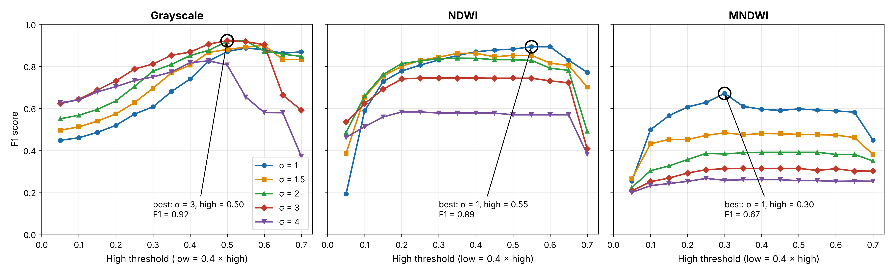
Figure 20. F1 score of Canny for every setting tried on the three inputs of the Ashdod image. Each line is one value of the blur σ; the x-axis is the high threshold (the low threshold is 0.4 times the high one). The circle marks the best setting for each input.
Table 5. Best high threshold for each value of σ, and the resulting scores (Ashdod image).
Input | σ | Best high threshold | Precision | Recall | F1 score
Grayscale | 1 | 0.55 | 0.83 | 0.95 | 0.89
Grayscale | 1.5 | 0.60 | 0.89 | 0.91 | 0.90
Grayscale | 2 | 0.55 | 0.91 | 0.93 | 0.92
Grayscale | 3 | 0.50 | 0.94 | 0.91 | 0.92
Grayscale | 4 | 0.45 | 0.88 | 0.78 | 0.83
NDWI | 1 | 0.55 | 0.85 | 0.94 | 0.89
NDWI | 1.5 | 0.35 | 0.81 | 0.91 | 0.86
NDWI | 2 | 0.35 | 0.82 | 0.85 | 0.84
NDWI | 3 | 0.25 | 0.76 | 0.73 | 0.74
NDWI | 4 | 0.25 | 0.61 | 0.56 | 0.58
MNDWI | 1 | 0.30 | 0.56 | 0.83 | 0.67
MNDWI | 1.5 | 0.30 | 0.45 | 0.52 | 0.48
MNDWI | 2 | 0.45 | 0.41 | 0.37 | 0.39
MNDWI | 3 | 0.35 | 0.34 | 0.29 | 0.31
MNDWI | 4 | 0.25 | 0.29 | 0.25 | 0.27
Three points stand out.
- The threshold matters most at the low end. With a very low high threshold (0.05 to 0.15), many weak edges in the sea and the town are kept, precision is low, and F1 falls to 0.2 to 0.6. As the threshold rises, these weak edges are removed and F1 climbs. On Grayscale and NDWI, F1 then stays high and nearly flat over a wide range (about 0.30 to 0.60), so Canny is not very sensitive to the exact threshold once it is in this range. Only at very high thresholds (0.65 to 0.70) does F1 fall again, because parts of the real coastline are lost.
- The best blur depends on the input. On Grayscale, a medium blur (σ = 2 or 3) gave the best F1 (0.92). On NDWI and MNDWI, the smallest blur (σ = 1) was best, and F1 fell steadily as σ grew. NDWI and MNDWI already make the water smooth, so they need little extra blur, and more blur only spreads the narrow breakwater and the docks.
- The best setting overall was σ = 3 with a high threshold of 0.50 (low threshold 0.20) on the Grayscale input (F1 = 0.92). This setting is used for the five steps shown next.
Figure 21 shows why too little or too much blur is worse, on the Grayscale input. With σ = 1 (panel a), Canny found almost the whole coastline (recall 0.95), but it also marked the outlines of buildings and parked ships inside the port (red), so precision fell to 0.83. With σ = 3 (panel b), most of these small edges were smoothed away (precision 0.94) while the coastline was still found (recall 0.91). With σ = 4 (panel c), the blur was so strong that the two sides of the narrow breakwater, only a few pixels apart, ran into each other: parts of the breakwater were missed (blue) or marked in the wrong place (red), and recall fell to 0.78. This is the trade-off between detection and localization described by Canny (1986) and shown in Figure 11.
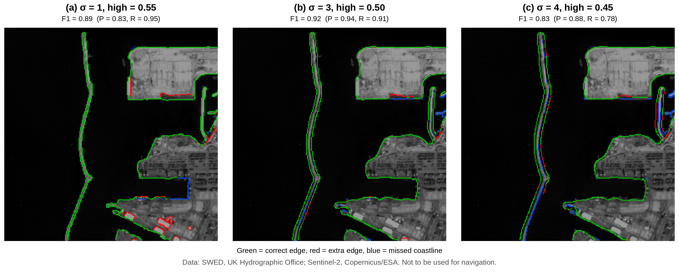
Figure 21. Canny on the Grayscale input with three amounts of blur, each with its best high threshold: (a) σ = 1; (b) σ = 3 (the best); (c) σ = 4. Green = correct edge, red = extra edge, blue = missed coastline. Data: SWED, UK Hydrographic Office (Seale et al., 2022); Sentinel-2, Copernicus/ESA. Not to be used for navigation.

5.1.2 Canny step by step on the Ashdod image
The five steps are shown on the Grayscale input with the best setting found above (σ = 3, high threshold = 0.50, low threshold = 0.20).
Sobel response. Figure 22 shows the Sobel gradient of the blurred image. |Gx| was strongest on edges that run up and down, such as the long breakwater on the left. |Gy| was strongest on edges that run left to right, such as the edges of the docks. G, which combines both, showed edges in every direction.
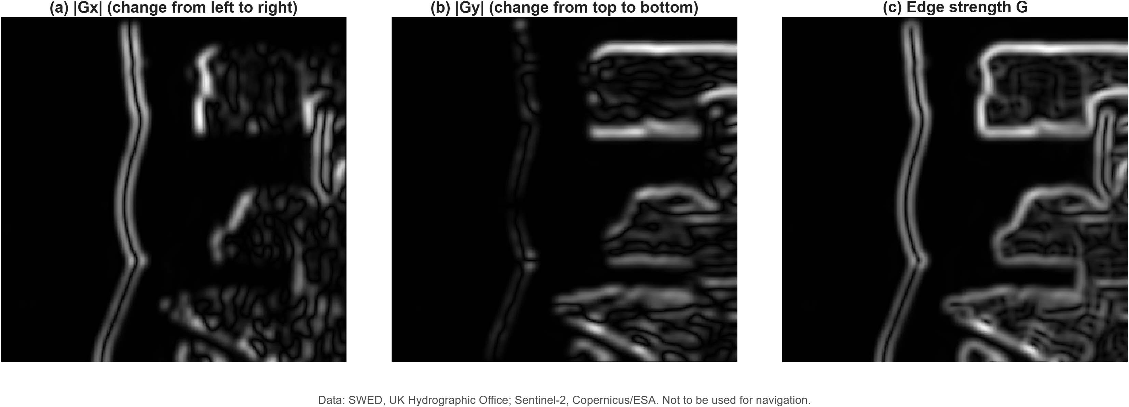
Figure 22. Sobel gradient of the blurred Grayscale input: (a) |Gx|, change from left to right; (b) |Gy|, change from top to bottom; (c) edge strength G. Data: SWED, UK Hydrographic Office (Seale et al., 2022); Sentinel-2, Copernicus/ESA. Not to be used for navigation.
Figures 23 to 25 show the five steps of Canny, two panels at a time.
Step 1 (blur). The fine texture of the sea and of the buildings was smoothed away, while the breakwater and the outline of the port stayed clear (Figure 23b).
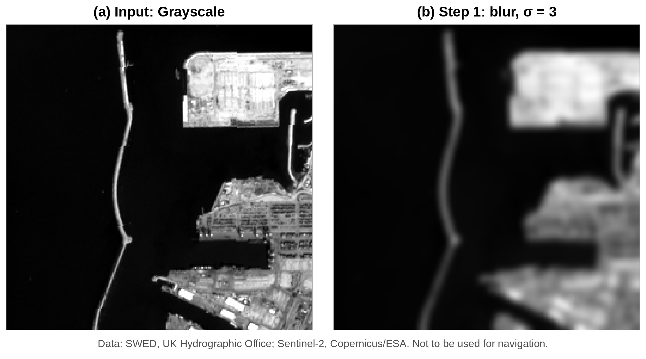
Figure 23. Canny on the Grayscale input: (a) the input image; (b) Step 1, Gaussian blur with σ = 3. Data: SWED, UK Hydrographic Office (Seale et al., 2022); Sentinel-2, Copernicus/ESA. Not to be used for navigation.
Step 2 (edge strength). The shore lit up as bright bands several pixels wide (Figure 24a). Each side of the breakwater gave its own band, because the breakwater is a thin strip of land with water on both sides. The docks and buildings inside the port also gave many weaker bands.
Step 3 (thinning). Non-maximum suppression turned every band into a line one pixel wide (Figure 24b). But it also kept the small peaks caused by the sea surface and by buildings, so the sea and the town became full of short, thin lines.
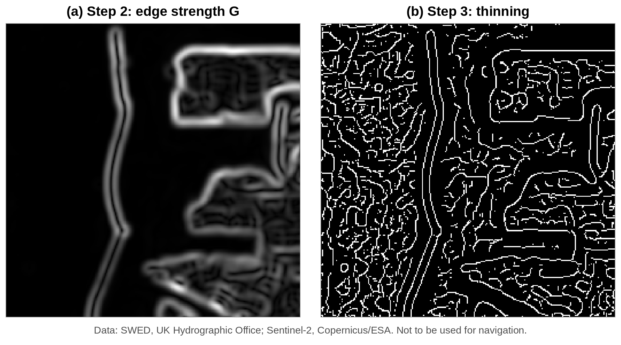
Figure 24. Canny on the Grayscale input: (a) Step 2, edge strength G; (b) Step 3, thinning (non-maximum suppression). Data: SWED, UK Hydrographic Office (Seale et al., 2022); Sentinel-2, Copernicus/ESA. Not to be used for navigation.
Step 4 (two thresholds). The outline of the port and parts of the breakwater were strong (red in Figure 25a, edge strength ≥ 0.50). Much of the breakwater, and many lines inside the town, were only weak (yellow, edge strength between 0.20 and 0.50). The short lines in the sea fell below the low threshold and were removed.
Step 5 (hysteresis). The weak parts of the breakwater touched strong parts, so they were kept, and both sides of the breakwater stayed unbroken from end to end (Figure 25b). Most weak lines inside the town touched nothing strong, so they were removed. The final map shows clean, connected outlines of the breakwater and the port.
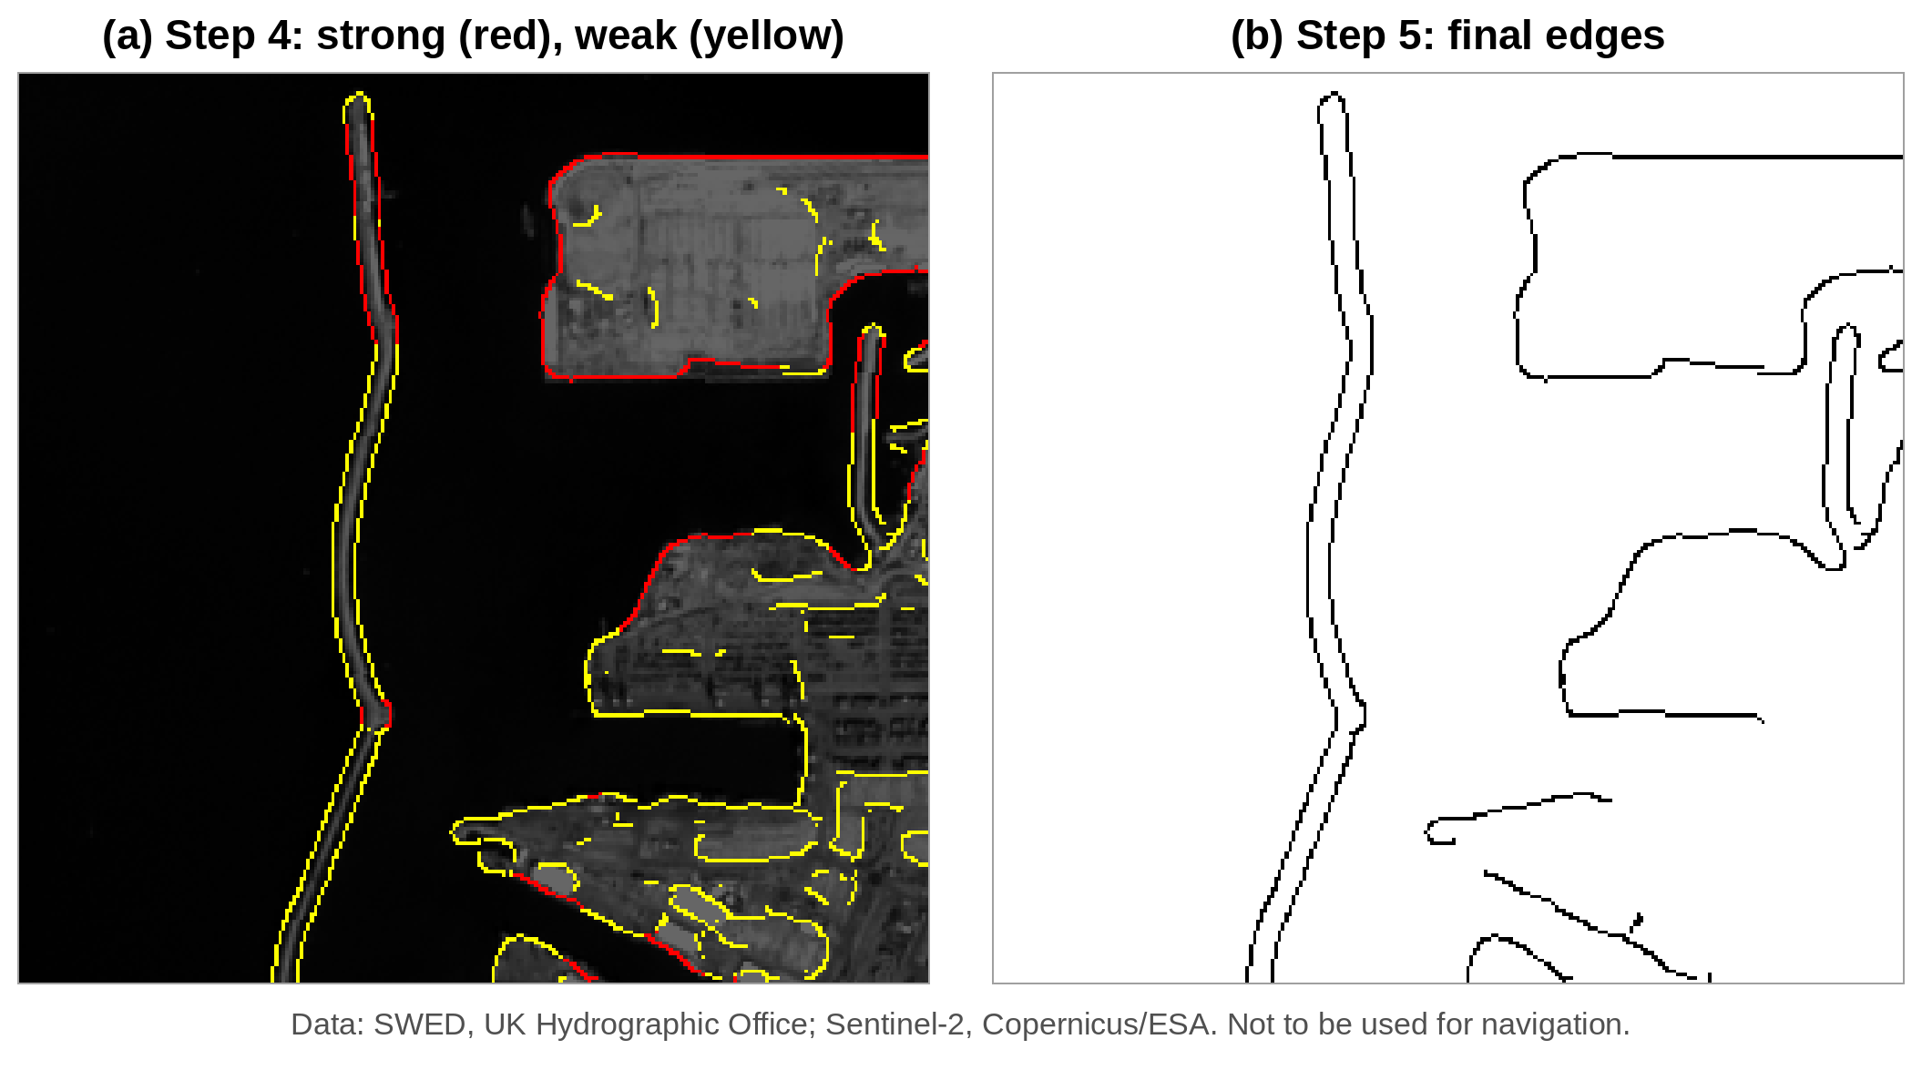
Figure 25. Canny on the Grayscale input: (a) Step 4, strong edges (red, ≥ 0.50) and weak edges (yellow, ≥ 0.20); (b) Step 5, final edges after hysteresis. Data: SWED, UK Hydrographic Office (Seale et al., 2022); Sentinel-2, Copernicus/ESA. Not to be used for navigation.
Figure 26 compares the final Canny edges with the true coastline from the mask. Almost the whole coastline is green. A few short red pieces are dock edges and buildings close to the water, and a few short blue pieces are places where the two sides of the breakwater come so close that the mask and the edges do not quite agree. Precision was 0.94 and recall 0.91: 94% of Canny’s edge pixels lie on the coastline, and Canny found 91% of the coastline.
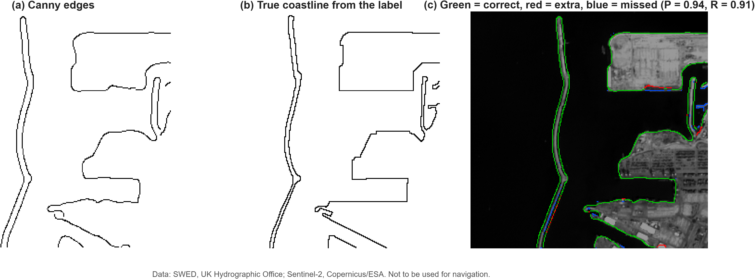
Figure 26. Checking Canny’s edges against the true coastline: (a) Canny edges; (b) true coastline from the label; (c) the two laid on top of each other, green = correct, red = extra, blue = missed (P = 0.94, R = 0.91). Data: SWED, UK Hydrographic Office (Seale et al., 2022); Sentinel-2, Copernicus/ESA. Not to be used for navigation.

5.1.3 Six filters on the Ashdod image
Figures 27 and 28 show the edges found by each filter on the Grayscale input, each with its best setting, and Table 6 gives their scores.
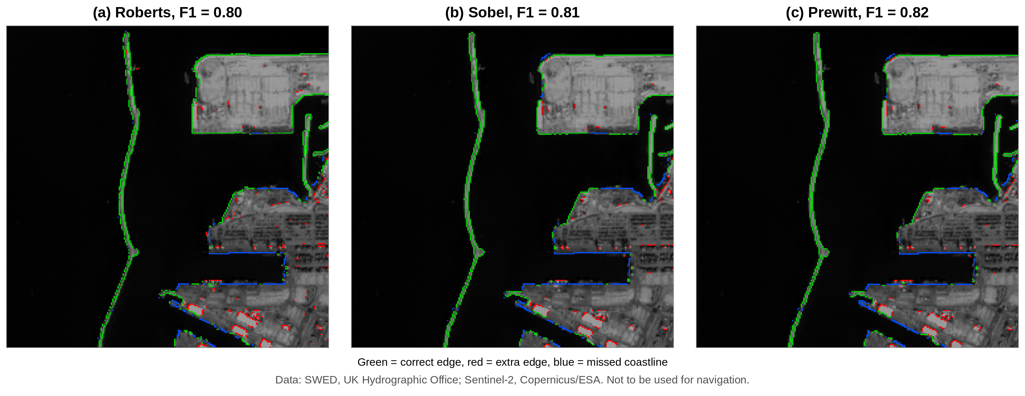
Figure 27. Edges of the Roberts, Sobel and Prewitt filters on the Grayscale input, each with its best setting. Green = correct edge, red = extra edge, blue = missed coastline. Data: SWED, UK Hydrographic Office (Seale et al., 2022); Sentinel-2, Copernicus/ESA. Not to be used for navigation.
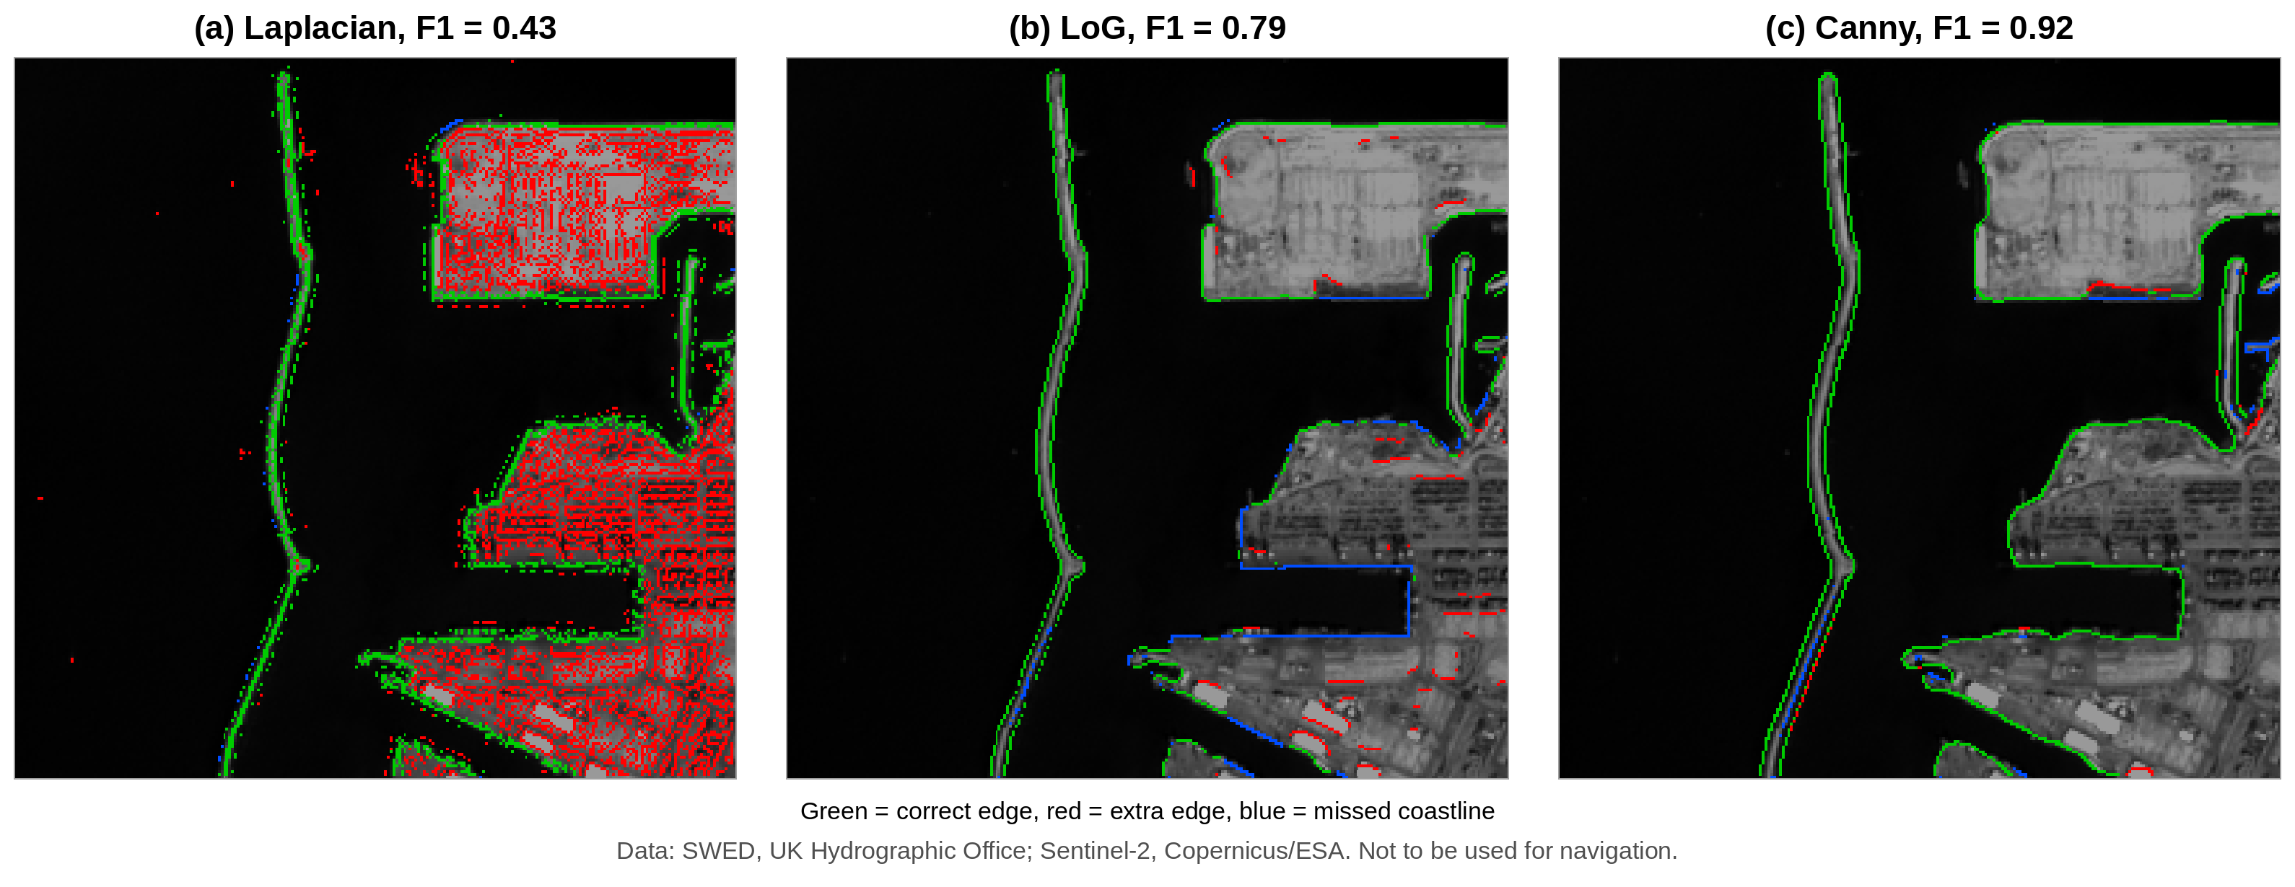
Figure 28. Edges of the Laplacian, LoG and Canny filters on the Grayscale input, each with its best setting. Green = correct edge, red = extra edge, blue = missed coastline. Data: SWED, UK Hydrographic Office (Seale et al., 2022); Sentinel-2, Copernicus/ESA. Not to be used for navigation.
Table 6. Scores of the six filters on the Grayscale input of the Ashdod image (2-pixel tolerance, best setting of each filter).
Filter | Best setting | Precision | Recall | F1 score
Roberts | threshold 0.199 | 0.78 | 0.83 | 0.80
Sobel | threshold 0.215 | 0.83 | 0.80 | 0.81
Prewitt | threshold 0.211 | 0.83 | 0.80 | 0.82
Laplacian | threshold 0.133 | 0.28 | 0.98 | 0.43
LoG | σ = 3, threshold 0.0054 | 0.79 | 0.79 | 0.79
Canny | σ = 3, high threshold 0.50 | 0.94 | 0.91 | 0.92
Canny gave the highest F1 score (0.92), and it was best in both precision and recall. The other filters behaved as their history suggests:
- Roberts, Sobel and Prewitt (F1 0.80 to 0.82) found most of the coastline, but their lines are broken in places (blue gaps along the docks), and they marked small extra pieces on buildings and roofs inside the port (red).
- The Laplacian (F1 0.43) found almost the whole coastline (recall 0.98), but it also marked nearly every building in the town, so only 28% of its edge pixels were coastline. This is the noise sensitivity expected from a second-derivative filter with no blurring.
- LoG (F1 0.79), which blurs first, removed most of this clutter, but it missed long parts of the dock edges (blue), where its zero crossings were too weak to pass the threshold.
- Canny gave clean, connected outlines with the fewest red and blue pixels. Thinning kept each edge one pixel wide, and hysteresis kept the long weak parts of the shore because they were joined to strong parts.

5.1.4 Effect of the input image
Table 7 gives the F1 score of every filter on every input, and Figure 29 shows Canny on the three inputs.
Table 7. F1 score of the six filters on the three inputs of the Ashdod image (best setting of each filter for each input).
Filter | Grayscale | NDWI | MNDWI
Roberts | 0.80 | 0.82 | 0.78
Sobel | 0.81 | 0.85 | 0.74
Prewitt | 0.82 | 0.85 | 0.73
Laplacian | 0.43 | 0.28 | 0.56
LoG | 0.79 | 0.76 | 0.62
Canny | 0.92 | 0.89 | 0.67
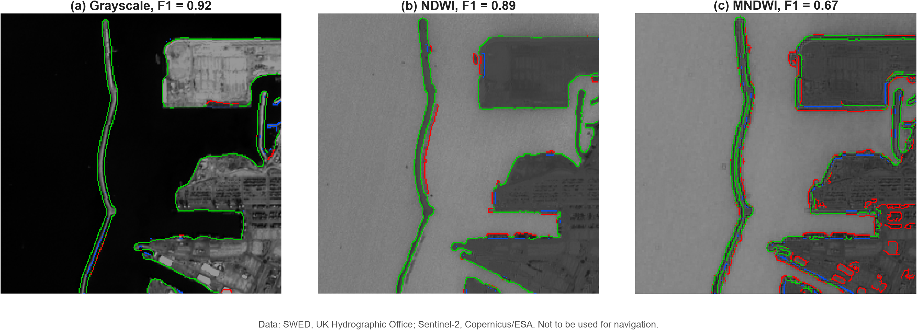
Figure 29. Canny edges on the three inputs of the Ashdod image, each with its best setting: (a) Grayscale (σ = 3, high threshold 0.50); (b) NDWI (σ = 1, high threshold 0.55); (c) MNDWI (σ = 1, high threshold 0.30). Green = correct edge, red = extra edge, blue = missed coastline. Data: SWED, UK Hydrographic Office (Seale et al., 2022); Sentinel-2, Copernicus/ESA. Not to be used for navigation.
- Canny was the best filter on Grayscale and NDWI. On MNDWI, Roberts (0.78) did better than Canny (0.67).
- Grayscale gave Canny its best score. The sea at Ashdod is clear and dark and the port is bright, so the contrast between water and land is already strong in the visible bands.
- NDWI helped the simple filters. Roberts, Sobel and Prewitt scored a little higher on NDWI than on Grayscale, because NDWI makes all water bright and all land dark, so there is less texture inside the town. For Canny, NDWI was slightly worse (0.89), mainly because of a few extra edges along the breakwater (Figure 29b).
- MNDWI was the weakest input for most filters. Its 20 m band makes the shore blocky, and Canny marked many extra edges around the buildings (Figure 29c). Only the Laplacian improved on MNDWI, because the coarser band has less fine texture for it to react to.

5.2 Part B: Additional scenes and spectral bands
[To be written by Shivakshi.] Report F1 (and precision, recall) of each filter on each new scene and input, a table comparing raw bands with NDWI/MNDWI, and the QGIS maps. State which input works best on turbid or vegetated coasts.

5.3 Part C: GeoEdge performance
[To be written by Aayushman.] Report measured runtime, throughput (Mpixels/s), peak memory and speed-up against a Python/OpenCV baseline, and the F1 of Otsu-adaptive Canny on Ashdod compared with the hand-tuned value (0.92). Report measured values only.

6. Discussion

6.1 Part A: Canny versus classical filters
Reasons for Canny’s success. The results match Canny’s three goals. Blurring removed the texture of the sea and the town (goal 1), thinning put each edge at the middle of the ramp (goal 2), and every edge was marked once as a thin line (goal 3). Hysteresis helped most: it kept the long, partly weak edges of the breakwater whole, and it removed short, isolated lines inside the town. This is the behaviour Canny (1986) designed hysteresis for (Figure 13): continuous contours without streaking, and no isolated noise.
Choice of input. No single input is best everywhere. Where the sea is clear and dark, as at Ashdod, a grayscale image already has strong contrast. NDWI should help more where the water is muddy or the land is green, because it uses the near-infrared band, where water is always dark. MNDWI is limited by its 20 m band at this scale.
Limitations.
- Canny finds docks and buildings as well as the coastline, so its output must be checked or cleaned. Liu and Jezek (2004) met the same problem and solved it by keeping only the large connected areas of sea and land; a similar step could be added to the present method.
- Only one Sentinel-2 image was tested, and the settings were chosen and scored on that same image, so the scores are likely to be higher than they would be on new images.
- Ashdod is a clear-water port with strong contrast. Coasts with muddy water, wet sand or vegetation may give different results and a different best input.

6.2 Part B: Scenes and spectral inputs
[To be written by Shivakshi.] Discuss whether Canny stays the best filter on the new coasts, which input (raw band, NDWI or MNDWI) works best on turbid or vegetated coasts and why, whether the Part A settings transfer to new scenes, and what the QGIS maps show about typical errors (docks, ships, wet sand, surf).

6.3 Part C: Scalability and adaptive thresholds
[To be written by Aayushman.] Discuss how tiling and the C++ core affect runtime and memory, whether Otsu-adaptive thresholds match the hand-tuned result without manual tuning, and the remaining limitations of the pipeline.

6.4 Overall discussion
[To be written by the group.] Bring the three parts together: what they show about Canny for coastline mapping, and the main limitations and next steps.

7. Conclusion
Edges are the lines where brightness changes suddenly, and the human eye is built to find them. Edge filters developed from simple kernels such as Roberts, Sobel and Prewitt, which give thick and noisy edges, to the Canny filter of 1986. Canny blurs the image, measures the change, thins the edges to one pixel at the middle of the ramp, and uses two thresholds to keep connected lines and remove noise. This makes it one of the most widely used edge detectors, from medicine to remote sensing, where it has been used, for example, to find the mixed shore pixels in automatic coastline mapping (Liu & Jezek, 2004). In this study, six edge filters were applied to a Sentinel-2 image of Ashdod port from the SWED dataset and checked against its hand-drawn coastline. Canny gave the highest F1 score (0.92 on the Grayscale input, against 0.79 to 0.82 for Roberts, Sobel, Prewitt and LoG, and 0.43 for the Laplacian). Its main weakness is that it finds every edge, including docks and buildings, so its output must be checked against the real coastline.

8. Contribution of the authors
- Study design: the topic, the choice of the SWED dataset and the plan to compare Canny with the filters taught in class were decided by the group after discussion with the instructor.
- Data preparation: the SWED sample was downloaded, and the Ashdod test image, its label and the NDWI and MNDWI values were checked in QGIS.
- Experiment: the six filters were run on the three inputs of the Ashdod image in MATLAB Online, with a range of settings for each filter, and the edges were scored against the SWED label. Figures 18 to 29 and Tables 5 to 7 are results of this experiment.
- Writing: the paper was written and checked by all three members.
- Individual roles: Aayushman Kumar: [to be filled]. Shivakshi: [to be filled]. Rajendra Singh: [to be filled].

References
- Campbell, J. B., & Wynne, R. H. (2011). Introduction to Remote Sensing (5th ed.). Guilford Press.
- Canny, J. (1986). A computational approach to edge detection. IEEE Transactions on Pattern Analysis and Machine Intelligence, PAMI-8(6), 679–698. https://doi.org/10.1109/TPAMI.1986.4767851
- Gonzalez, R. C., & Woods, R. E. (2018). Digital Image Processing (4th ed.). Pearson.
- Hubel, D. H., & Wiesel, T. N. (1959). Receptive fields of single neurones in the cat’s striate cortex. Journal of Physiology, 148, 574–591.
- Hubel, D. H., & Wiesel, T. N. (1962). Receptive fields, binocular interaction and functional architecture in the cat’s visual cortex. Journal of Physiology, 160, 106–154.
- Jain, R., Kasturi, R., & Schunck, B. G. (1995). Machine Vision. McGraw-Hill. Chapter 5: Edge Detection. https://cse.usf.edu/~r1k/MachineVisionBook/MachineVision.htm
- Kuffler, S. W. (1953). Discharge patterns and functional organization of mammalian retina. Journal of Neurophysiology, 16(1), 37–68.
- Lillesand, T. M., Kiefer, R. W., & Chipman, J. W. (2015). Remote Sensing and Image Interpretation (7th ed.). Wiley.
- Liu, H., & Jezek, K. C. (2004). Automated extraction of coastline from satellite imagery by integrating Canny edge detection and locally adaptive thresholding methods. International Journal of Remote Sensing, 25(5), 937–958. https://doi.org/10.1080/0143116031000139890
- Marr, D., & Hildreth, E. (1980). Theory of edge detection. Proceedings of the Royal Society of London B, 207, 187–217.
- Martin, D. R., Fowlkes, C. C., & Malik, J. (2004). Learning to detect natural image boundaries using local brightness, color, and texture cues. IEEE Transactions on Pattern Analysis and Machine Intelligence, 26(5), 530–549.
- McFeeters, S. K. (1996). The use of the Normalized Difference Water Index (NDWI) in the delineation of open water features. International Journal of Remote Sensing, 17(7), 1425–1432.
- O’Sullivan, C., Coveney, S., Monteys, X., & Dev, S. (2024). Automated coastline extraction using edge detection algorithms. arXiv:2405.11494. https://arxiv.org/abs/2405.11494
- Prewitt, J. M. S. (1970). Object enhancement and extraction. In Picture Processing and Psychopictorics. Academic Press.
- Roberts, L. G. (1963). Machine perception of three-dimensional solids. PhD thesis, Massachusetts Institute of Technology.
- Seale, C., Redfern, T., Chatfield, P., Luo, C., & Dempsey, K. (2022). Coastline detection in satellite imagery: A deep learning approach on new benchmark data. Remote Sensing of Environment, 278, 113044. https://doi.org/10.1016/j.rse.2022.113044
- Sobel, I., & Feldman, G. (1968). A 3×3 isotropic gradient operator for image processing. Stanford Artificial Intelligence Project.
- van Rijsbergen, C. J. (1979). Information Retrieval (2nd ed.). Butterworths.
- Xu, H. (2006). Modification of normalised difference water index (NDWI) to enhance open water features in remotely sensed imagery. International Journal of Remote Sensing, 27(14), 3025–3033.
Class notes and online resources
- Konz, S., Roy, S., Munger, C., Ramsey, C., & Iyabor, A. (2017). Lecture 5: Edge detection. CS131 Computer Vision: Foundations and Applications, class notes, Stanford University. https://github.com/StanfordVL/cs131_notes
- OpenCV. (n.d.). Canny Edge Detection. OpenCV documentation. https://docs.opencv.org/4.x/da/d22/tutorial_py_canny.html
- LearnOpenCV. Edge Detection Using OpenCV. https://learnopencv.com/edge-detection-using-opencv/
- UK Hydrographic Office. Sentinel-2 Water Edges Dataset (SWED). https://openmldata.ukho.gov.uk/

