import java.util.\*;

import java.lang.\*;

public class Main

{

public static void main(String[] args) {

System.out.println("Welcome to Online IDE!! Happy Coding :");

Scanner in=new Scanner(System.in);

System.out.println("Enter the no :");

int n=in.nextInt();

int fact=1;

for(int i=1;i<=n;i++)

fact=fact\*i;

System.out.println("Result is :" + fact);

}

}

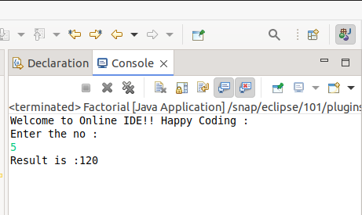

public class PrimeExample{

public static void main(String args[]){

int i,m=0,flag=0;

int n=3;//it is the number to be checked

m=n/2;

if(n==0||n==1){

System.out.println(n+" is not prime number");

}else{

for(i=2;i<=m;i++){

if(n%i==0){

System.out.println(n+" is not prime number");

flag=1;

break;

}

}

if(flag==0) { System.out.println(n+" is prime number"); }

}//end of else

}

}

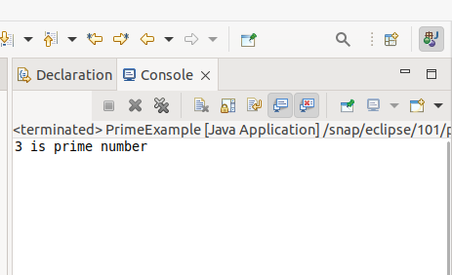

import java.util.Scanner;

public class Main

{

public static void main(String[] args) {

System.out.println("Welcome to Online IDE!! Happy Coding :)");

// TODO Auto-generated method stub

Scanner in = new Scanner(System.in);

double no,sum =0, avg;

int n;

System.out.print("How many numbers you want to enter");

n = in.nextInt();

for( int i = 1; i<= n; ++i)

{

System.out.print("Enter the No: ");

no = in.nextDouble();

sum += no;

}

avg = sum/n;

System.out.println("Avg of " + n + "number is "+ avg);

}

}

