Function calls:

main()

0 { 300 f( ) stack

. { 200 g( ) - 100 100 100 -

. . { 320

. . .

.

100 f( ) 320 g( ) .

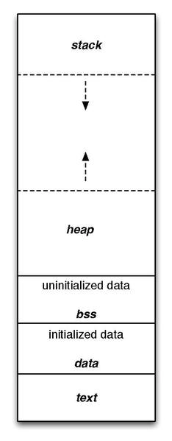 . . 240 }

. .

. .

380 }

150 }

f(0) = 0 f(1) = 1

f(n) = f(n-1) + f(n-2)

int f(int n)

{

    if (n <= 1)

        return n;

    return f(n-1) + f(n-2);

}

f(n)

f(n-1) f(n-2)

f(n-2) f(n-3) f(n-3) f(n-4)

f(n-3) f(n-4) f(n-4) f(n-5) f(n-4) f(n-5) f(n-5) f(n-6)

void printOut( int n )

{

if( n >= 10 )

printOut( n / 10 );

printDigit( n % 10 );

} printOut(6543) → printOut(654) → printOut(65) → printOut(6)

printDigit(3) ← printDigit(4) ← printDigit(5) ← printDigit(6)

6543