**Weather UML Diagram**

**Name=Aayush Rai**

**ID=2329780**

1. UML Sequence Diagram

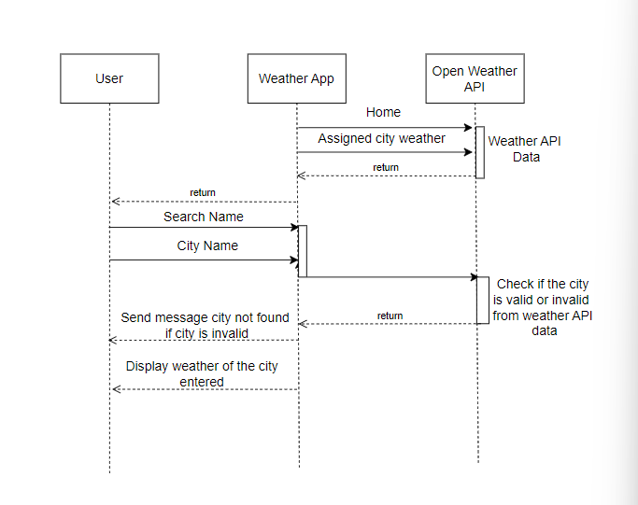

Figure 1Sequence Diagram

1. UML Activity Diagram

Figure 2 Activity Diagram

1. UML Deployment Diagram

Figure 3 Deployment Diagram