**––Hands – On Lab**

**Workshop 2**

*Note: It is mandatory for all students to draw the diagram in drawing tools as well as in a A4 paper describing the flow of each diagram in a paragraph.*

# Activity Diagram

1. Using an activity diagram, describe the process of student enrollment in an

University

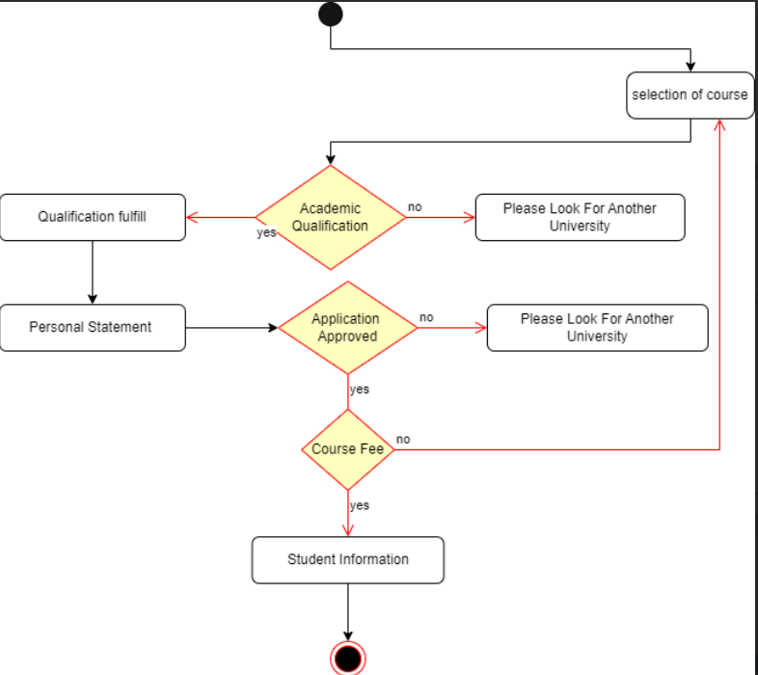

At first section of course is done. After that academic qualification is checked. If the academic qualification is fulfilled that the process goes onward and if the qualification is not fulfill that it get rejected. After the fulfillment of the qualification, personal statement (SOP) is required to be given. After that application approval process take place and if there application is approved the process get continue if not they get rejected and they have to look for other university. After the approval, course fee is mention and if the fee is suitable by the candidate than the process goes in the next step and if the fee is not suitable they have to look for another course. In the next step student required information is taken and process comes to end.

1. Consider the scenario of Order Processing. Once the order is received, the activities split into two parallel sets of activities. One side fills and sends the order while the other side handles the billing. On the Fill Order side, the method of delivery is decided conditionally. Depending on the condition either the

Overnight Delivery activity or the Regular Delivery activity is performed. Finally, the parallel activities combine to close the order. With activity diagram, describes the processing of ordering

At first order is received and after that required resources available is checked. If the resources are not available than it is informed to customer. And ask for new order to the costumer and if they say no than order is cancel and if yes than received the order. If the resources are available than preparation of order and bill of the order and later both are package together and order is delivered according to deliver option chosen by customer.

1. Show the flow of word processing application software with the help of activity diagram

At first, Word Processing App is open. After that there is two option to create new document or open exiting document. After that work is done after that there comes decision section if decision is no, we just have to continue on working on document if yes document is saved. After that there is three options to directly close document or print document and close document or export document and close document and its end.

# Sequence Diagram

1. Consider a Library Management System. Using sequence diagram, show the interaction of objects in the system to perform the function ‘Create new library user account’

At first there are user and library for interaction. As user enter username and password in the library and it is send to the database and store in database for temporarily. Library send confirmation message to the user and user confirm and it is returned to library and database which store data permanently and send message of account created by library to user. In this way the diagram work.

1. In which sequence does the Online Exam System flow? Describes using sequence diagram

In the above diagram, student enter student id, name, subject in the online exam system. System sends the details of the student in database for checking. In database it checks the given detail available in the database. If the database has available details, it sends question of the related subject exam to the student. After completion of the question and students submit it and it got saved in database. After that system send message of completion.

1. Represent the School Management System with sequence diagram

In the above diagram, students request for view other student details and request for authentication by entering authentication data in the system and by confirming it school system send authenticate user. After that student enter student id, name, class, and course of the student they want to view details in the school system. After that details are send to database of school and self-call if the details are correct and it return the student details to the user.

# Deployment Diagram

1. Show the necessary nodes, artifacts, associations and components required for

Hospital Management System

In the above deployment diagram shows the flow of hospital management system. At first patient fills form and it is send to the reception which is store in the database of the hospital database system. The patient is send for operation which is performed by doctor according to the information from database store in the database system. Patient test is done by lab assistant and result of the test is also store in the hospital database. After that patient is taken to ward and ward staff looks in the system and goes to pharmacist and brings required medicine and is given to the patient.

1. Draw a deployment diagram for Hotel Management System

This deplyment diagram shows the hotel management system, at first client goes to the receotion of the hotel and they get checkin through hotel sysytem and enter the client details in the hotel database and received room details of the client which is provided to the client by the reception. After that client goes to the room according to details provided. And room servies are also provided according to the hotel database system.