Q. Implement a Random Forest classifier to predict customer churn in a telecom dataset and evaluate its performance using accuracy, confusion matrix, and classification report metrics.
Ans:
MODEL EVALUATION RESULTS
Accuracy Score: 0.7963 (79.63%)
Confusion Matrix: [ [945 91],
[196 177] ]
Interpretation:
True Negatives (Correctly predicted Retained): 945
False Positives (Incorrectly predicted Churned): 91
False Negatives (Incorrectly predicted Retained): 196
True Positives (Correctly predicted Churned): 177
Classification Report:
precision recall f1-score support
Retained (0) 0.83 0.91 0.87 1036
Churned (1) 0.66 0.47 0.55 373
accuracy 0.80 1409
macro avg 0.74 0.69 0.71 1409
weighted avg 0.78 0.80 0.78 1409
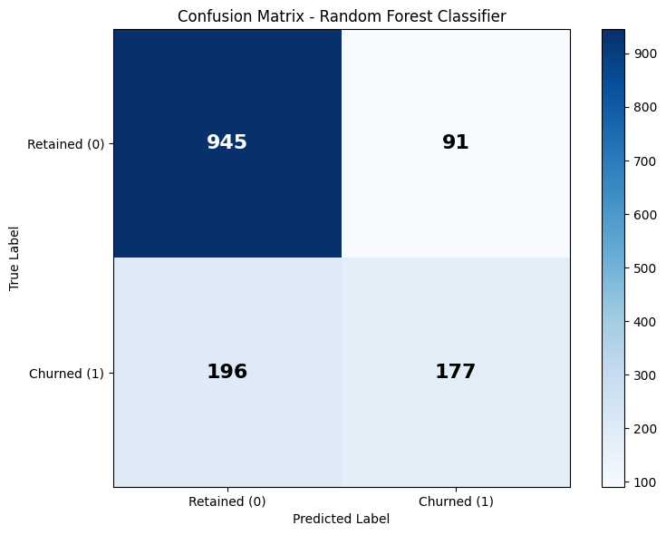
Fig: Confusion Matrix

