Q. Develop a decision tree model to classify species in the Iris dataset. Evaluate the model using accuracy and a detailed classification report with precision, recall, and F1-score for each species. Use plot_tree() to visualize the decision tree.
Ans:
Model Accuracy Score: 0.9800 (98.00%)
CLASSIFICATION REPORT
Detailed Performance Metrics for Each Species:
precision recall f1-score support
Setosa 1.00 1.00 1.00 37
Versicolor 0.96 0.98 0.97 51
Virginica 0.98 0.97 0.98 62
accuracy 0.98 150
macro avg 0.98 0.98 0.98 150
weighted avg 0.98 0.98 0.98 150
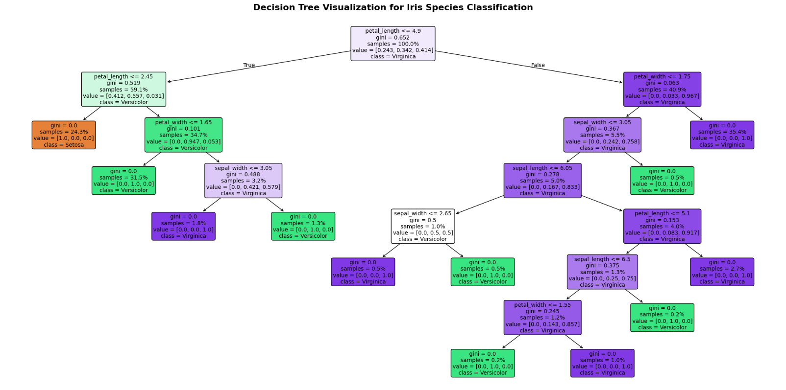
Fig: Decision Tree Visualization
Tree Depth: 7
Number of Leaves: 12

