Q. Apply K-Means clustering on the Mall Customers dataset to segment customers based on purchasing behavior and visualize the clusters with centroids.
ANS:

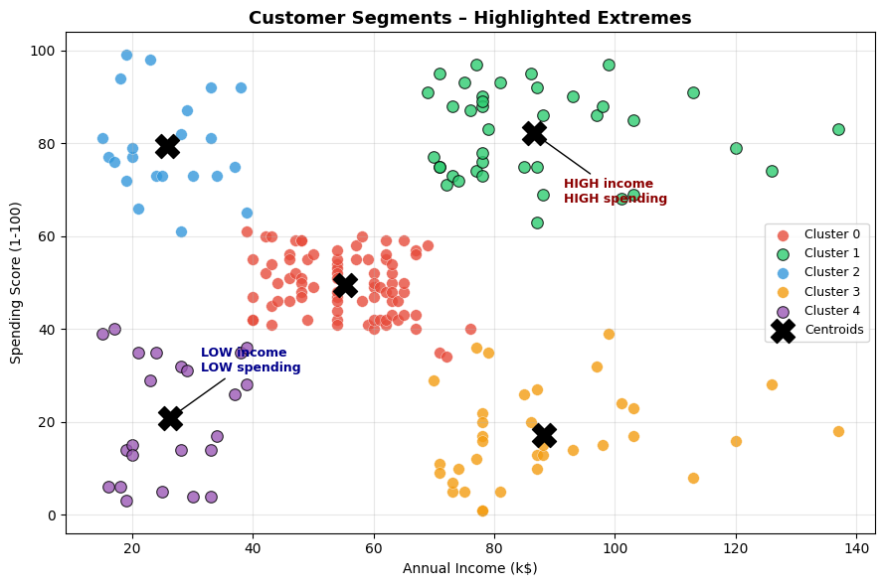
Customer segments:

Cluster | Avg Income (k$) | Avg Spending Score | Segment Description
0 | ~55 | ~50 | Moderate income, moderate spending – average customers
1 | ~26 | ~79 | Low income, high spending – impulsive / lifestyle spenders
2 | ~86 | ~82 | High income, high spending – prime / premium customers
3 | ~88 | ~17 | High income, low spending – conservative savers
4 | ~26 | ~21 | Low income, low spending – budget-conscious customers

