Q. Build a logistic regression model to classify emails as spam or not spam.

(venv) PS C:\Users\aayus\Desktop\Study Materials\AD\Lab4> python .\pre-processing.py
Dataset shape: (4601, 57)

First 5 rows:
word_freq_make word_freq_address ... capital_run_length_total spam
0.00 0.64 0.64 ... 278 1
0.21 0.28 0.50 ... 1028 1
0.06 0.00 0.71 ... 2259 1
0.00 0.00 0.00 ... 191 1
0.00 0.00 0.00 ... 191 1

[5 rows x 57 columns]

Missing values per column:
0

Feature matrix shape: (4601, 56)
Target vector shape: (4601,)

Training set size: (3680, 56)
Testing set size: (921, 56)

Data pre-processing completed successfully.
(venv) PS C:\Users\aayus\Desktop\Study Materials\AD\Lab4>

(venv) PS C:\Users\aayus\Desktop\Study Materials\AD\Lab4> python .\experiment.py
Dataset Loaded Successfully
Shape: (4601, 57)

Accuracy: 92.83387622149837 %

Confusion Matrix:
[[530 28]
[ 38 325]]

Classification Report:
precision recall f1-score support
Not Spam 0.93 0.95 0.94 558
Spam 0.92 0.90 0.91 363

accuracy 0.93 921
macro avg 0.93 0.92 0.92 921
weighted avg 0.93 0.93 0.93 921
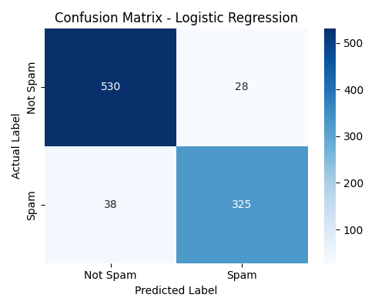
(venv) PS C:\Users\aayus\Desktop\Study Materials\AD\Lab4>

