Q. Build a logistic regression model to classify emails as spam or not spam.

Accuracy: 92.83387622149837 %
Confusion Matrix:
[ [530 28]
[ 38 325] ]
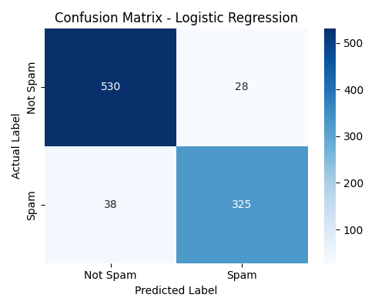

Classification Report:
precision recall f1-score support
Not Spam 0.93 0.95 0.94 558
Spam 0.92 0.90 0.91 363

accuracy 0.93 921
macro avg 0.93 0.92 0.92 921
weighted avg 0.93 0.93 0.93 921

