Q. How can a Support Vector Machine (SVM) be used to classify MNIST handwritten digits and evaluated using accuracy, confusion matrix, and classification report?

Ans:
1. Linear SVM – Predictions:

Linear SVM Accuracy: 90.25%
Confusion Matrix:
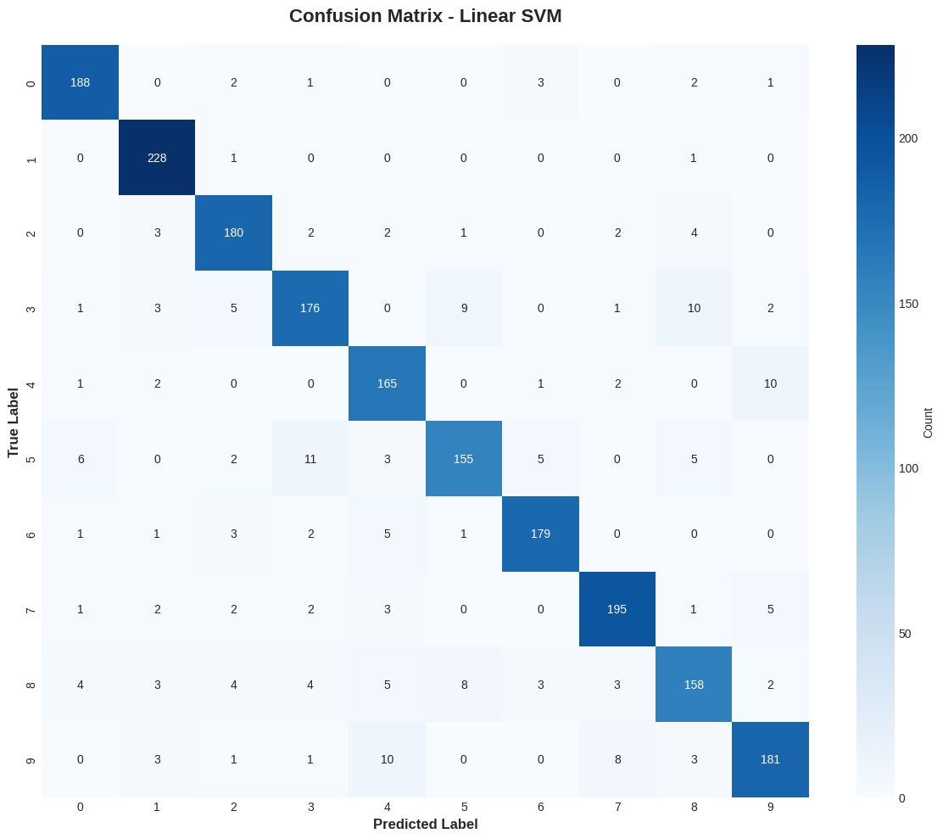

Linear SVM Classification Report:
precision recall f1-score support

0 0.93 0.95 0.94 197
1 0.93 0.99 0.96 230
2 0.90 0.93 0.91 194
3 0.88 0.85 0.87 207
4 0.85 0.91 0.88 181
5 0.89 0.83 0.86 187
6 0.94 0.93 0.93 192
7 0.92 0.92 0.92 211
8 0.86 0.81 0.84 194
9 0.90 0.87 0.89 207

accuracy 0.90 2000
macro avg 0.90 0.90 0.90 2000
weighted avg 0.90 0.90 0.90 2000

2. Non-Linear SVM Predictions:

SVM Accuracy: 96.25%
Confusion Matrix (RBF SVM):
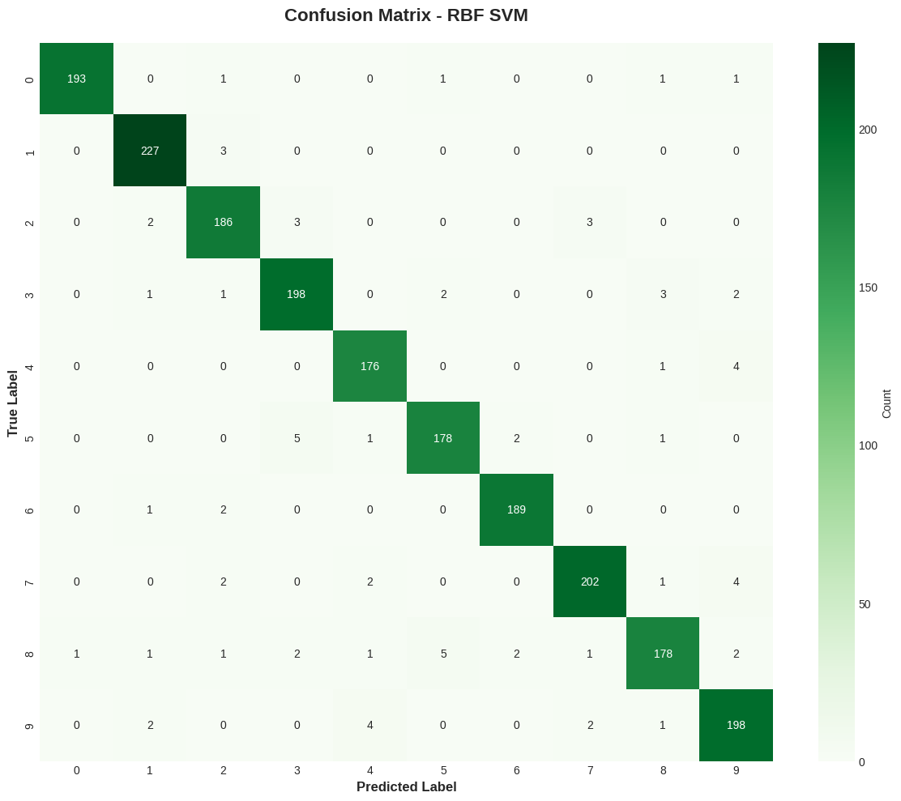

RBF SVM Classification Report:
precision recall f1-score support

0 0.99 0.98 0.99 197
1 0.97 0.99 0.98 230
2 0.95 0.96 0.95 194
3 0.95 0.96 0.95 207
4 0.96 0.97 0.96 181
5 0.96 0.95 0.95 187
6 0.98 0.98 0.98 192
7 0.97 0.96 0.96 211
8 0.96 0.92 0.94 194
9 0.94 0.96 0.95 207

accuracy 0.96 2000
macro avg 0.96 0.96 0.96 2000
weighted avg 0.96 0.96 0.96 2000

