Below is a clear, exam-oriented explanation of the Point Operator topic from Computer Vision / Digital Image Processing. I am assuming introductory to intermediate familiarity.

Point Operator (Point Processing)
Image
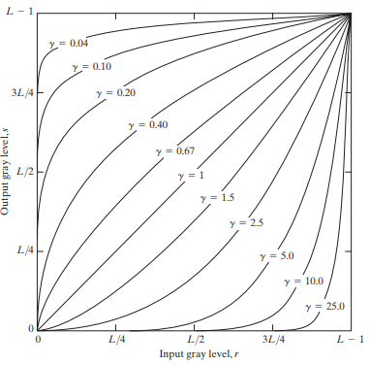
Image
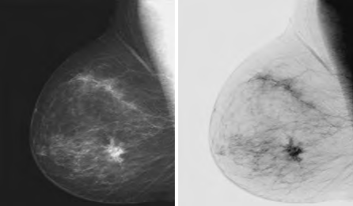
Image
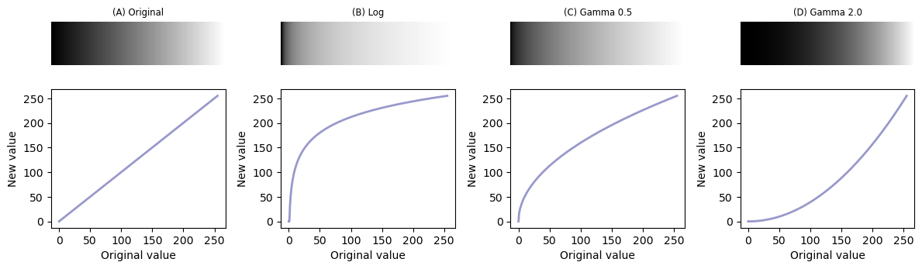
Image

1. Definition
A point operator is an image processing operation in which each output pixel depends only on the corresponding input pixel, not on its neighbors.
Mathematically:
[ g(x, y) = T(f(x, y))]
Where:
- (f(x, y)) → input pixel intensity
- (g(x, y)) → output pixel intensity

  - → transformation function

2. Key Characteristics
- Operates pixel by pixel
- No spatial neighborhood involved
- Simple and fast
- Used mainly for intensity transformations

3. What It Does (Intuition)
Think of a point operator as:
“Take a pixel value → apply a rule → replace it with a new value”
Example:
- If pixel value = 100
- Rule = new_value = 255 - old_value
- Output = 155

4. Common Types of Point Operators

(a) Image Negative
Transforms bright pixels to dark and vice versa.
Formula: [ s = L - 1 - r]
Where:

  - = number of intensity levels (e.g., 256)
Use case
- Highlight white details in dark regions

(b) Log Transformation
Expands dark pixel values and compresses bright ones.
Formula: [ s = c (1 + r)]
Use case
- Enhance details in dark areas (e.g., X-ray images)

(c) Power-Law (Gamma) Transformation
Controls image brightness using gamma value.
Formula: [ s = c r^]
Use case
- Gamma correction in displays and cameras

(d) Contrast Stretching
Improves contrast by expanding intensity range.
Use case
- Medical images, satellite images

(e) Thresholding
Converts grayscale image into binary image.
Rule: [ g(x,y) = ]
Use case
- Object detection, segmentation

5. What Point Operators Do NOT Do
- ❌ Do not consider neighboring pixels
- ❌ Do not smooth noise
- ❌ Do not detect edges
(Those are done using neighborhood/spatial operators)

6. Real-World Examples
- Image brightness adjustment
- Medical image enhancement
- Document binarization
- Camera gamma correction

7. Exam-Friendly One-Line Summary
A point operator modifies pixel intensity values independently using a predefined transformation function.

8. Quick Comparison (for viva)
Aspect | Point Operator | Spatial Operator
Pixel dependency | Single pixel | Neighboring pixels
Speed | Fast | Slower
Noise handling | Poor | Good
Example | Negative, Gamma | Smoothing, Edge detection

If you want, next you can give:
- Spatial operator
- Histogram processing
- Image enhancement
- Convolution
- Filtering
Send the next topic name only, and I will continue in the same structured format.

