1. Implement stop-and-wait protocol on top of UDP sockets using C
program.

SERVER:
#include <stdio.h>
#include <string.h>
#include <arpa/inet.h>
#include <unistd.h>

int main() {
int s = socket(AF_INET, SOCK_DGRAM, 0);

struct sockaddr_in serv, cli;
serv.sin_family = AF_INET;
serv.sin_port = htons(8080);
serv.sin_addr.s_addr = INADDR_ANY;
bind(s, (struct sockaddr*)&serv, sizeof(serv));

char msg[100], ack[20];
socklen_t len = sizeof(cli);
int expected = 0;

while (1) {
ssize_t n = recvfrom(s, msg, sizeof(msg), 0, (struct sockaddr*)&cli, &len);
if (n > 0) {
printf("Received: %s\n", msg);
sprintf(ack, "%d", expected);
sendto(s, ack, strlen(ack)+1, 0, (struct sockaddr*)&cli, len);
expected++;
}
}
}

CLIENT:
#include <stdio.h>
#include <string.h>
#include <stdlib.h>
#include <arpa/inet.h>
#include <unistd.h>

int main() {
int s = socket(AF_INET, SOCK_DGRAM, 0);

struct sockaddr_in serv;
serv.sin_family = AF_INET;
serv.sin_port = htons(8080);
inet_pton(AF_INET, "127.0.0.1", &serv.sin_addr);

char msg[100], ack[20];
socklen_t len = sizeof(serv);
int seq = 0;

while (1) {
sprintf(msg, "Packet %d", seq);
sendto(s, msg, strlen(msg)+1, 0, (struct sockaddr*)&serv, len);
ssize_t n = recvfrom(s, ack, sizeof(ack), 0, (struct sockaddr*)&serv, &len);
if (n > 0 && atoi(ack) == seq) {
printf("Received ACK %s\n", ack);
seq++;
}
sleep(1);
}
}

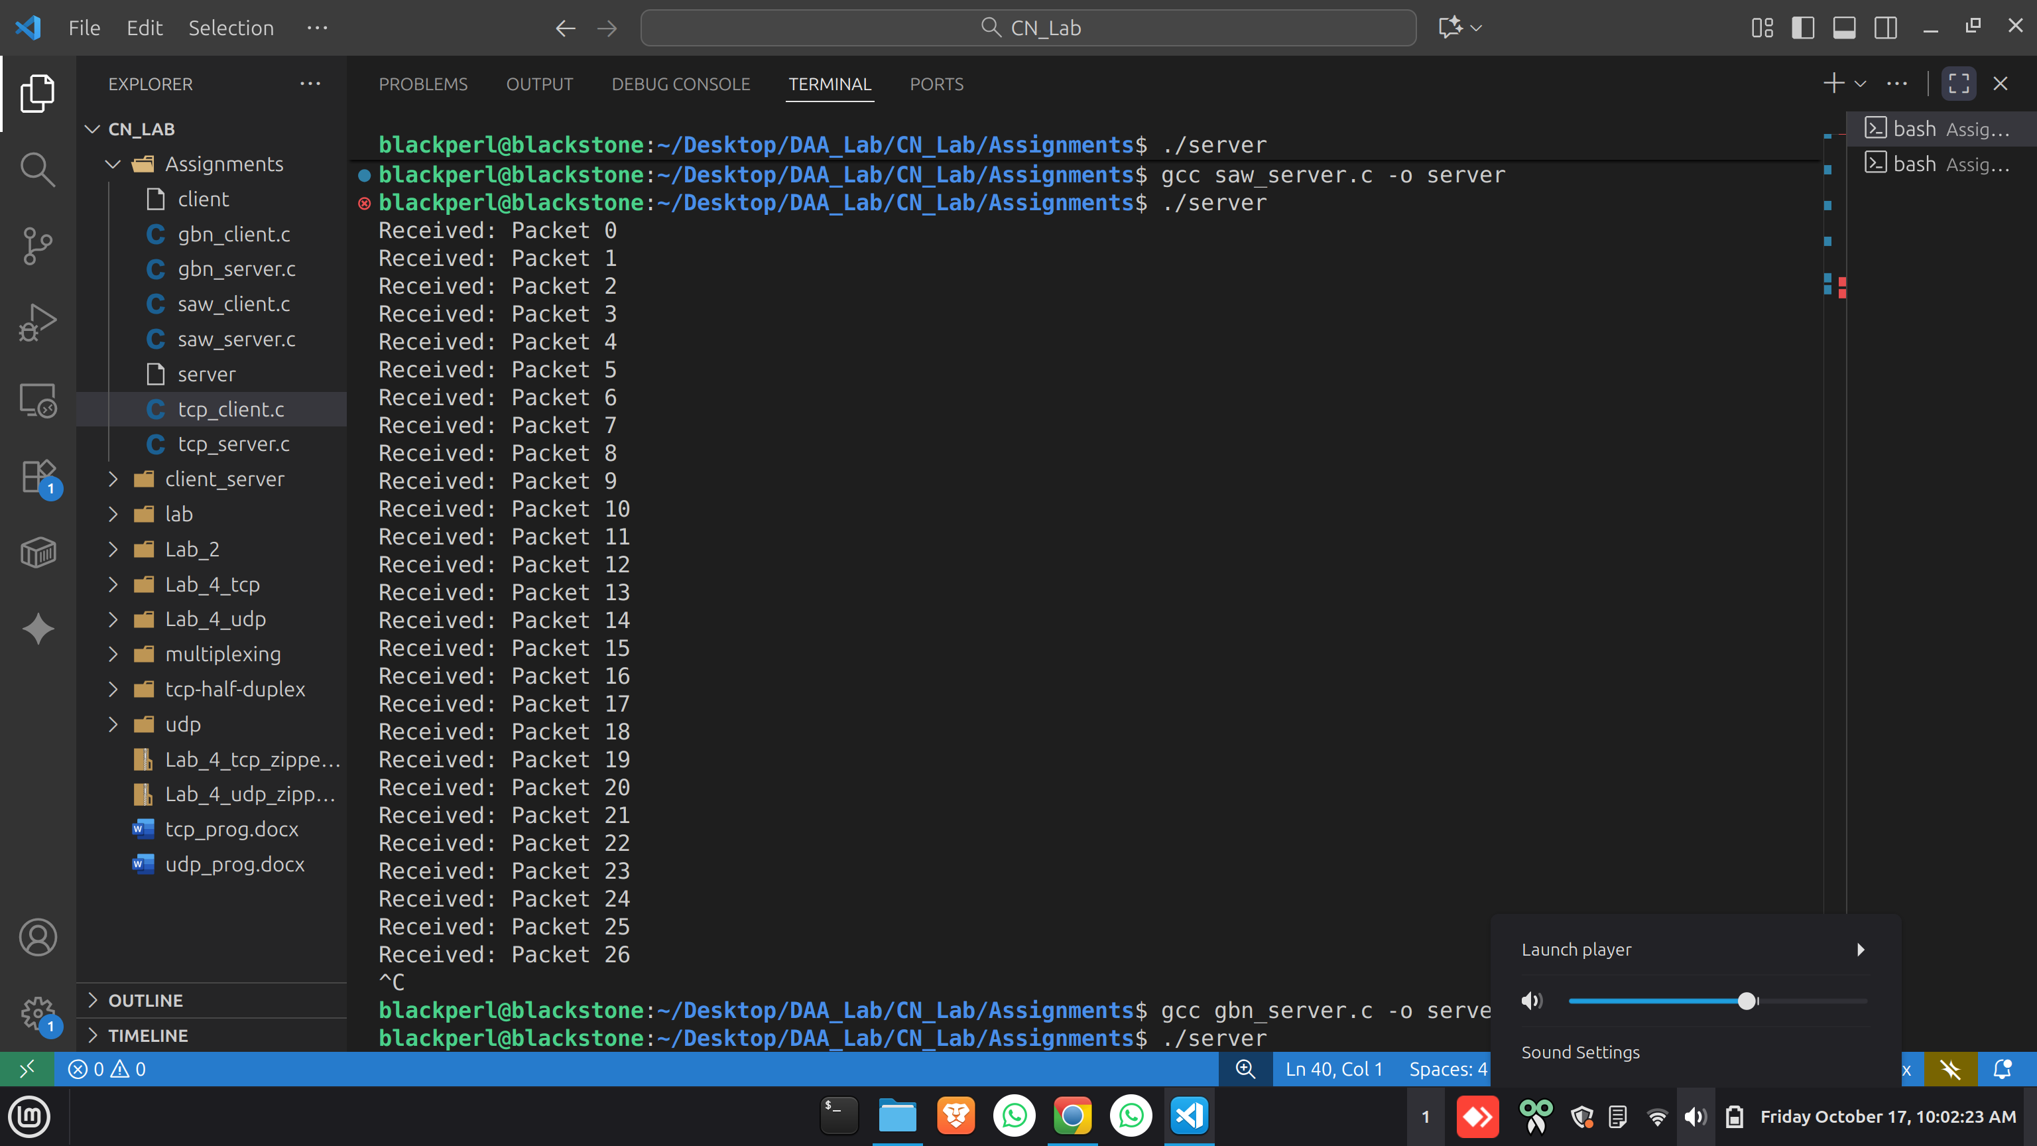

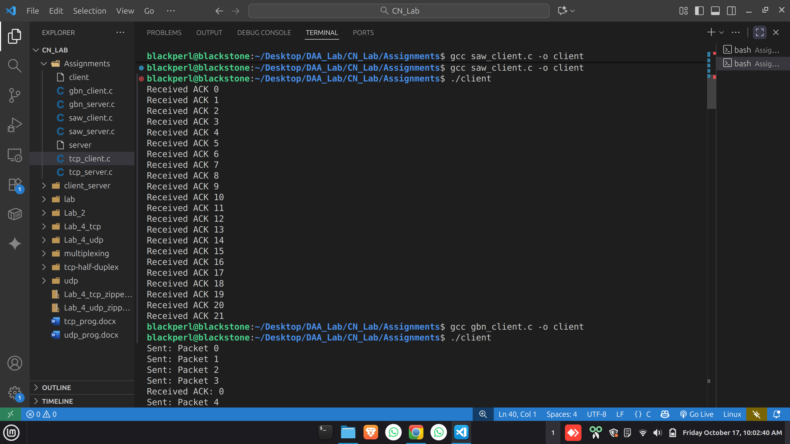
2. Implement Go-back-N protocol on top of UDP sockets using C
program.
SERVER:
#include <stdio.h>
#include <string.h>
#include <arpa/inet.h>
#include <unistd.h>

int main() {
int s = socket(AF_INET, SOCK_DGRAM, 0);
struct sockaddr_in serv, cli;
serv.sin_family = AF_INET;
serv.sin_port = htons(8080);
serv.sin_addr.s_addr = INADDR_ANY;
bind(s, (struct sockaddr*)&serv, sizeof(serv));

char msg[100], ack[20];
socklen_t len = sizeof(cli);
int expected = 0;

while (1) {
ssize_t n = recvfrom(s, msg, sizeof(msg), 0, (struct sockaddr*)&cli, &len);
if (n > 0) {
int seq; sscanf(msg, "Packet %d", &seq);
if (seq == expected) {
printf("Received: %s\n", msg);
expected++;
} else {
printf("Out of order: %s\n", msg);
}
sprintf(ack, "%d", expected - 1); // cumulative ACK
sendto(s, ack, strlen(ack)+1, 0, (struct sockaddr*)&cli, len);
}
}
}

CLIENT:
#include <stdio.h>
#include <string.h>
#include <stdlib.h>
#include <arpa/inet.h>
#include <unistd.h>

#define N 4 // window size

int main() {
int s = socket(AF_INET, SOCK_DGRAM, 0);
struct sockaddr_in serv;
serv.sin_family = AF_INET;
serv.sin_port = htons(8080);
inet_pton(AF_INET, "127.0.0.1", &serv.sin_addr);

char msg[100], ack[20];
socklen_t len = sizeof(serv);
int base = 0, nextseq = 0;

while (1) {
// send packets in window
while (nextseq < base + N) {
sprintf(msg, "Packet %d", nextseq);
sendto(s, msg, strlen(msg)+1, 0, (struct sockaddr*)&serv, len);
printf("Sent: %s\n", msg);
nextseq++;
}

// receive ACK
ssize_t n = recvfrom(s, ack, sizeof(ack), 0, (struct sockaddr*)&serv, &len);
if (n > 0) {
int acknum = atoi(ack);
if (acknum >= base) {
base = acknum + 1;
printf("Received ACK: %d\n", acknum);
}
}

sleep(1); // simulate delay
}
}

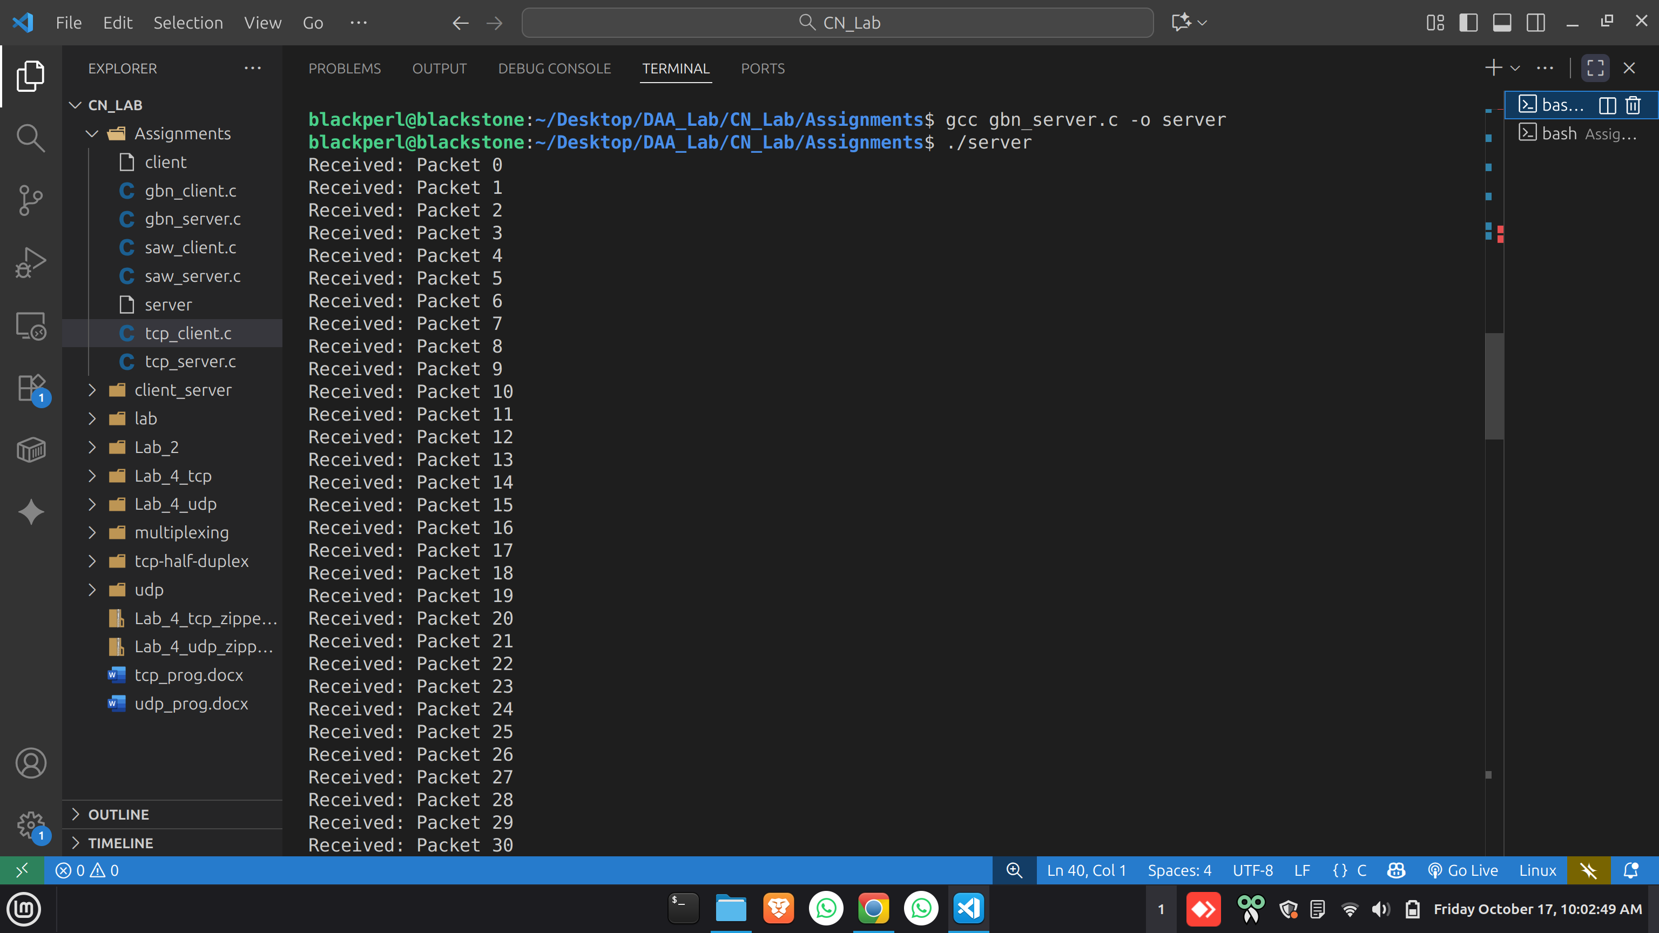
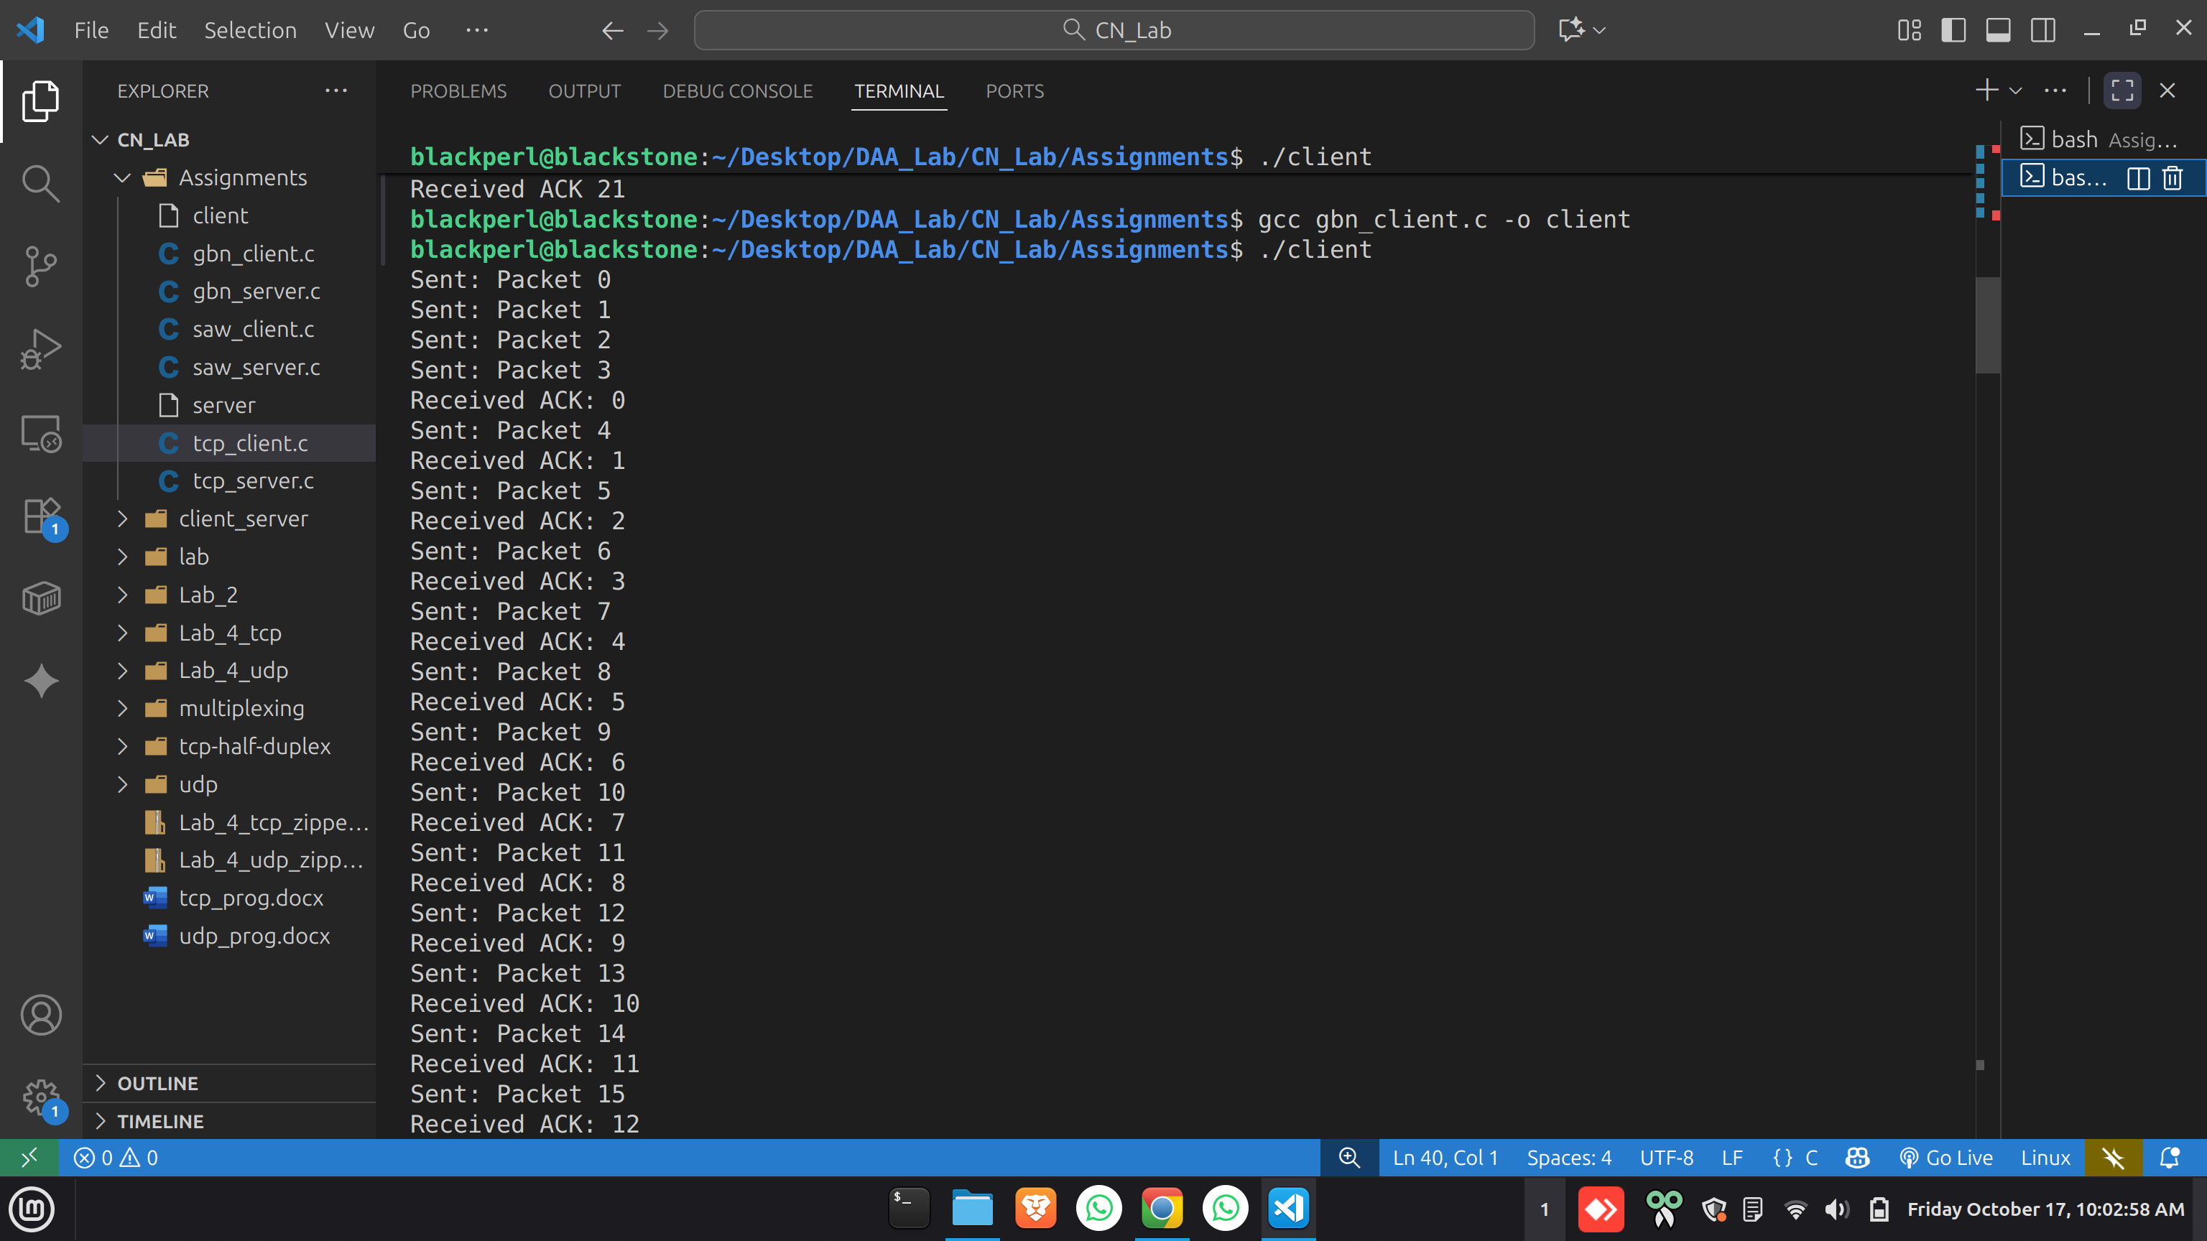
3. Write a connection-oriented client and server socket program
using C where the client will suppose to send a large buffer to the
server. Keeping fragmentation and reassembly into account the
following functionality needs
to be supported.

SERVER:
#include <stdio.h>
#include <stdlib.h>
#include <string.h>
#include <unistd.h>
#include <arpa/inet.h>

#define HEADER_SIZE 20
#define MAX_BUFFER 1024

typedef struct {
int id;
int flag;
int offset;
int hl;
int tl;
char payload[512];
} fragment_t;

int main(int argc, char *argv[]){
if(argc != 2){
printf("Usage: %s <port>\n", argv[0]);
return 1;
}

int port = atoi(argv[1]);
int sock = socket(AF_INET, SOCK_STREAM, 0);
struct sockaddr_in serv, cli;
serv.sin_family = AF_INET;
serv.sin_port = htons(port);
serv.sin_addr.s_addr = INADDR_ANY;
bind(sock, (struct sockaddr*)&serv, sizeof(serv));
listen(sock,5);
printf("Server listening on port %d\n", port);

socklen_t len = sizeof(cli);
int newsock = accept(sock,(struct sockaddr*)&cli,&len);
printf("Client connected\n");

fragment_t frags[20]; // store fragments
int count=0;
int total_size=0;
int fragmented = 0;

while(1){
fragment_t frag;
ssize_t n = recv(newsock, &frag, sizeof(fragment_t), 0);
if(n<=0) break;

if(frag.flag==1) fragmented=1;

printf("Received Fragment %d: id=%d flag=%d offset=%d hl=%d tl=%d payload_size=%d\n",
count+1, frag.id, frag.flag, frag.offset, frag.hl, frag.tl, frag.tl - frag.hl);

frags[count++] = frag;
total_size += frag.tl - frag.hl;

if(frag.flag==0) break; // last fragment
}

if(fragmented) printf("Data was fragmented. Reassembling...\n");
else printf("Data was not fragmented.\n");

// Reassembly
char assembled[MAX_BUFFER];
for(int i=0;i<count;i++){
memcpy(assembled+frags[i].offset, frags[i].payload, frags[i].tl - frags[i].hl);
}

assembled[total_size]='\0';
printf("Reassembled Data (%d bytes): %s\n", total_size, assembled);

close(newsock);
close(sock);
return 0;
}

CLIENT:
#include <stdio.h>
#include <stdlib.h>
#include <string.h>
#include <unistd.h>
#include <arpa/inet.h>

#define MAX_BUFFER 1024 // total data to send
#define HEADER_SIZE 20 // our simulated header length

typedef struct {
int id;
int flag; // 1 = more fragments, 0 = last fragment
int offset; // offset in payload
int hl; // header length
int tl; // total length (header+payload)
char payload[512];
} fragment_t;

int main(int argc, char *argv[]) {
if(argc != 4){
printf("Usage: %s <server_ip> <port> <data_size>\n", argv[0]);
return 1;
}

char *ip = argv[1];
int port = atoi(argv[2]);
int data_size = atoi(argv[3]);
if(data_size > MAX_BUFFER) data_size = MAX_BUFFER;

// Prepare data
char data[MAX_BUFFER];
for(int i=0;i<data_size;i++) data[i]='A'+(i%26);

// Detect MTU (simulate)
int mtu = 100; // small for demonstration
printf("Client MTU size: %d\n", mtu);

int max_payload = mtu - HEADER_SIZE;
int n_fragments = (data_size + max_payload - 1)/max_payload;
if(n_fragments > 1)
printf("Data requires fragmentation. Total fragments: %d\n", n_fragments);
else
printf("Data fits in single packet.\n");

// Socket
int sock = socket(AF_INET, SOCK_STREAM, 0);
struct sockaddr_in serv;
serv.sin_family = AF_INET;
serv.sin_port = htons(port);
inet_pton(AF_INET, ip, &serv.sin_addr);
connect(sock, (struct sockaddr*)&serv, sizeof(serv));
printf("Connected to server\n");

// Send fragments
int offset=0;
for(int i=0;i<n_fragments;i++){
fragment_t frag;
frag.id = 1;
frag.offset = offset;
frag.hl = HEADER_SIZE;
frag.tl = HEADER_SIZE + ((data_size-offset>max_payload)?max_payload:(data_size-offset));
frag.flag = (i==n_fragments-1)?0:1;
int payload_size = frag.tl - HEADER_SIZE;
memcpy(frag.payload, data+offset, payload_size);

printf("Sending Fragment %d: id=%d flag=%d offset=%d hl=%d tl=%d payload_size=%d\n",
i+1, frag.id, frag.flag, frag.offset, frag.hl, frag.tl, payload_size);

send(sock, &frag, sizeof(fragment_t), 0);
offset += payload_size;
}

close(sock);
printf("All fragments sent.\n");
return 0;
}

