**The File:**

**The HOME variable: The HOME directory:**

* When you log on to the system, UNIX automatically places you in a directory called the **HOME directory.**

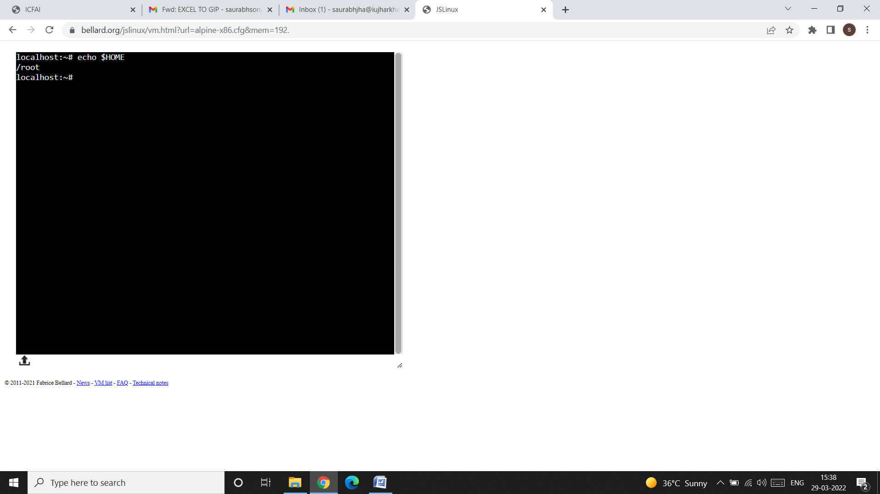

**pwd: Checking your current directory:**

* You can move around from one directory to another, but at any point of time, you are located in only one directory. This directory is known as your **current directory**.
* The pwd (print working directory) command tells you about your current directory.

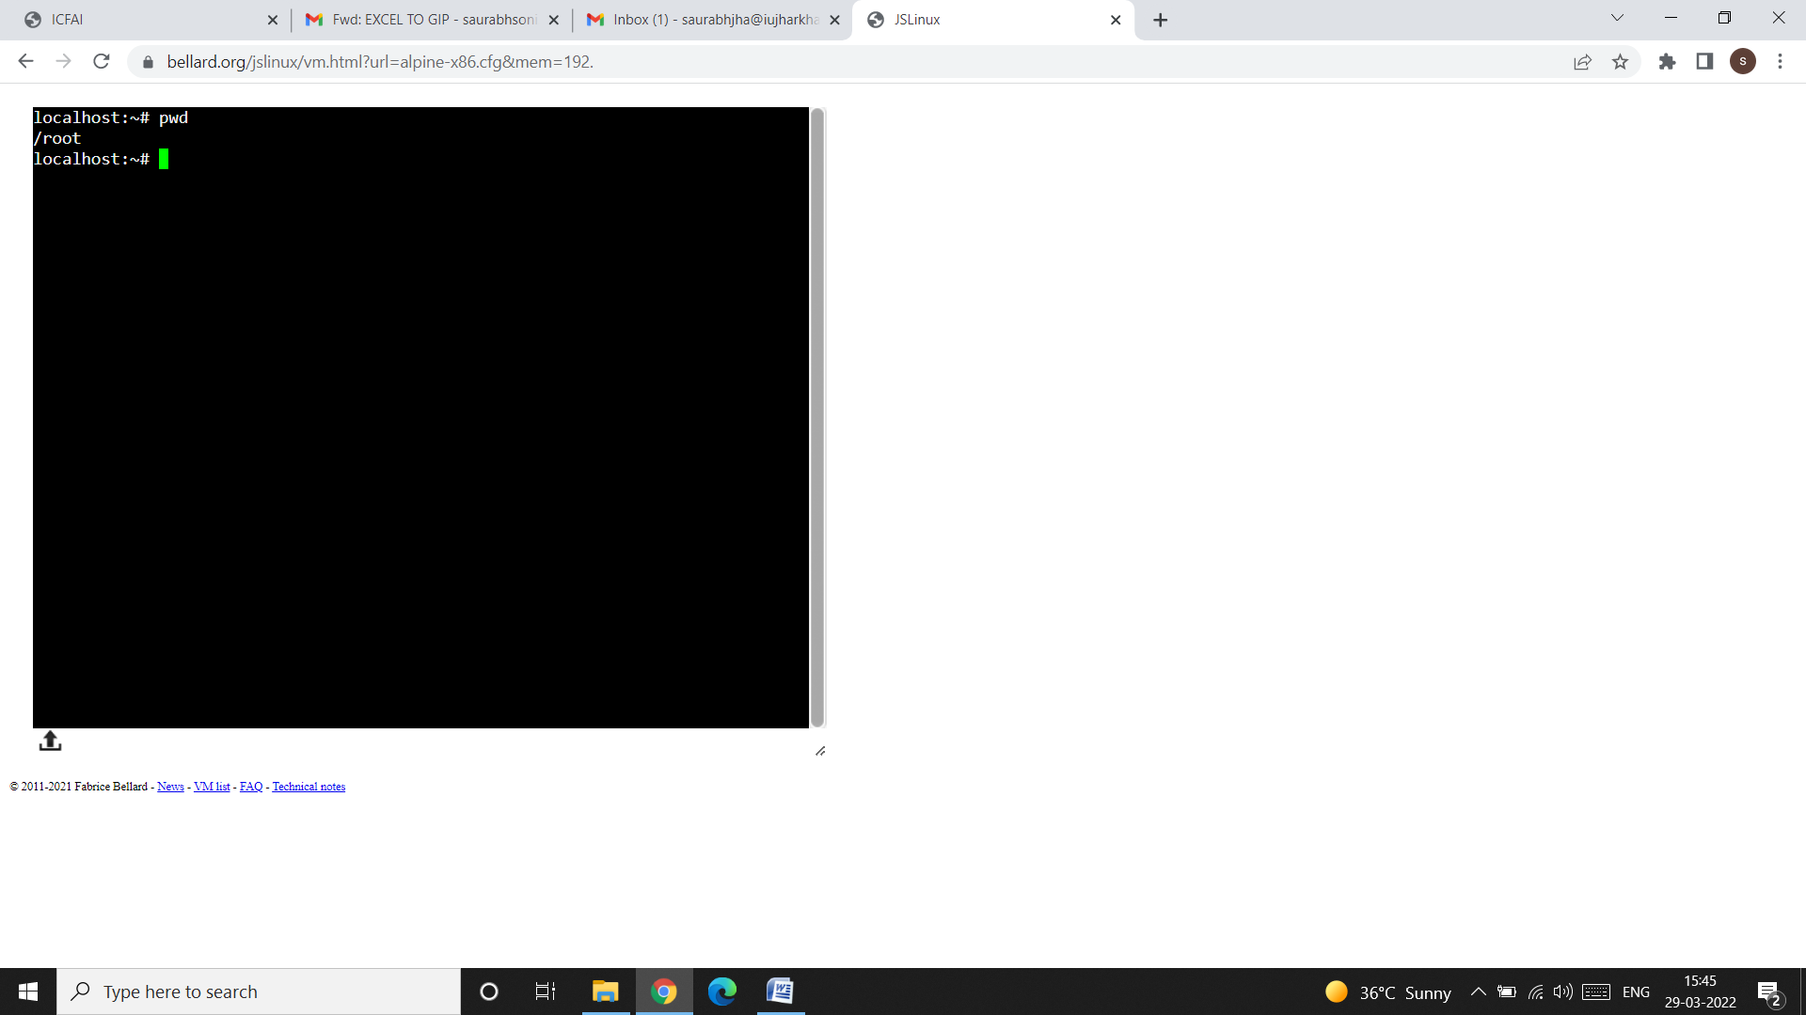

**cd: Changing the current directory:**

* You can move around in the file system by using the CD (change directory) command. When used with an argument, it changes the current directory to the directory specified as argument.
* For example:
* 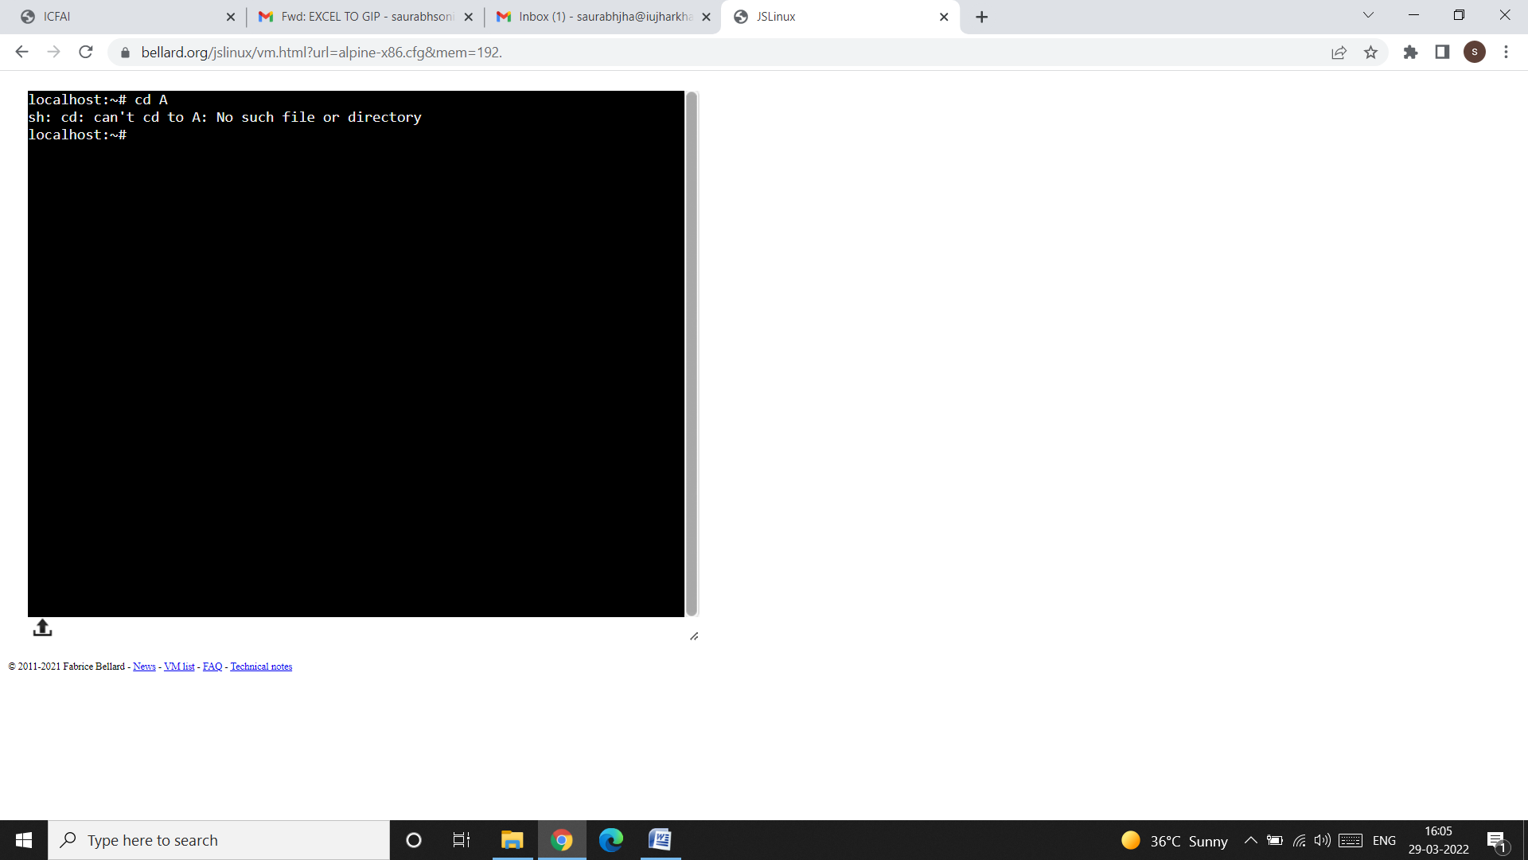
* We have used cd A command to change the directory to A. As the directory A is not created before so we get the message: No such file or directory. For this, we have to first create or make directory A using the command mkdir (Make Directory) and then we can use cd command like this:

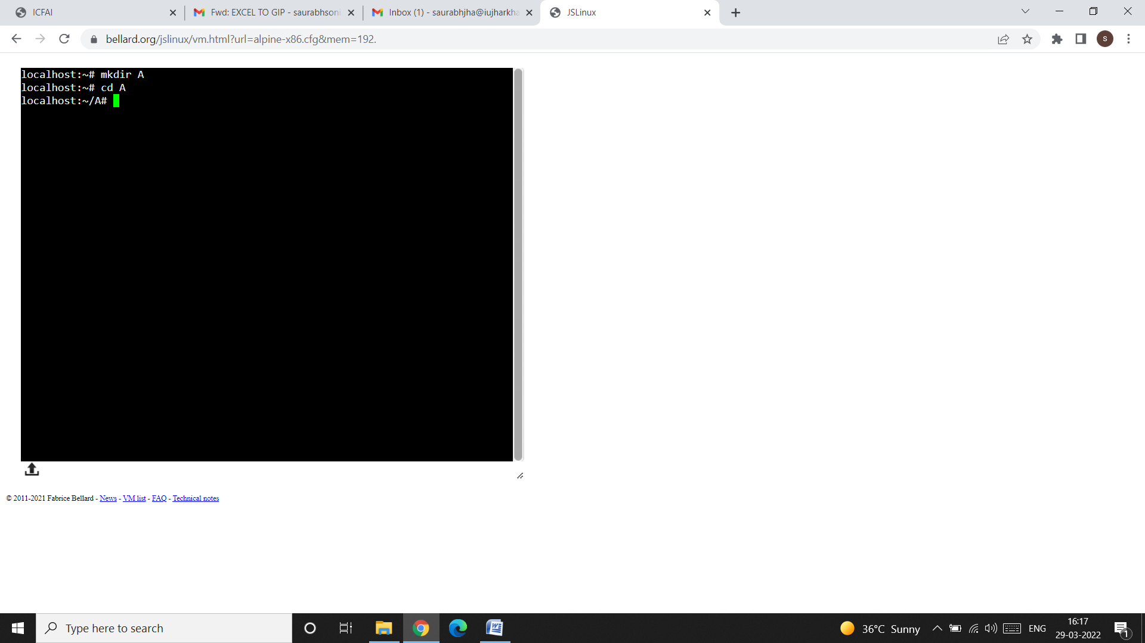

* We can get back to the previous directory by simply writing the cd command like this:

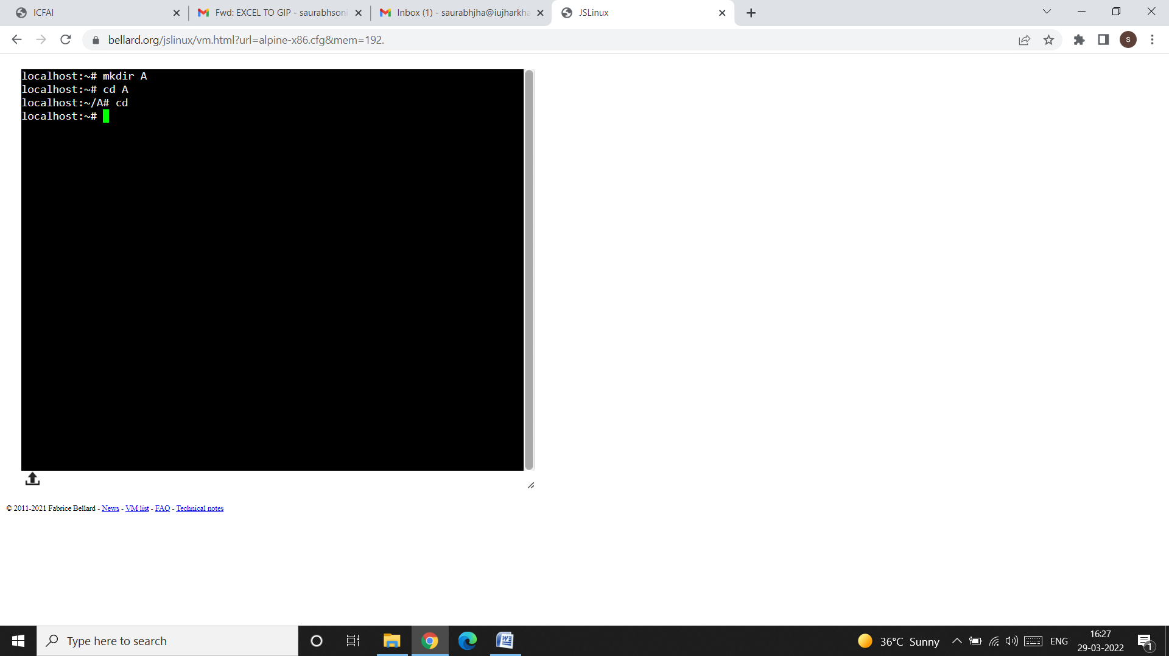

* To remove a directory, we can use rmdir (remove directory) command. After removing the directory, if you again want to use that directory then the system will display the message: “No such file or directory”. This is shown below:

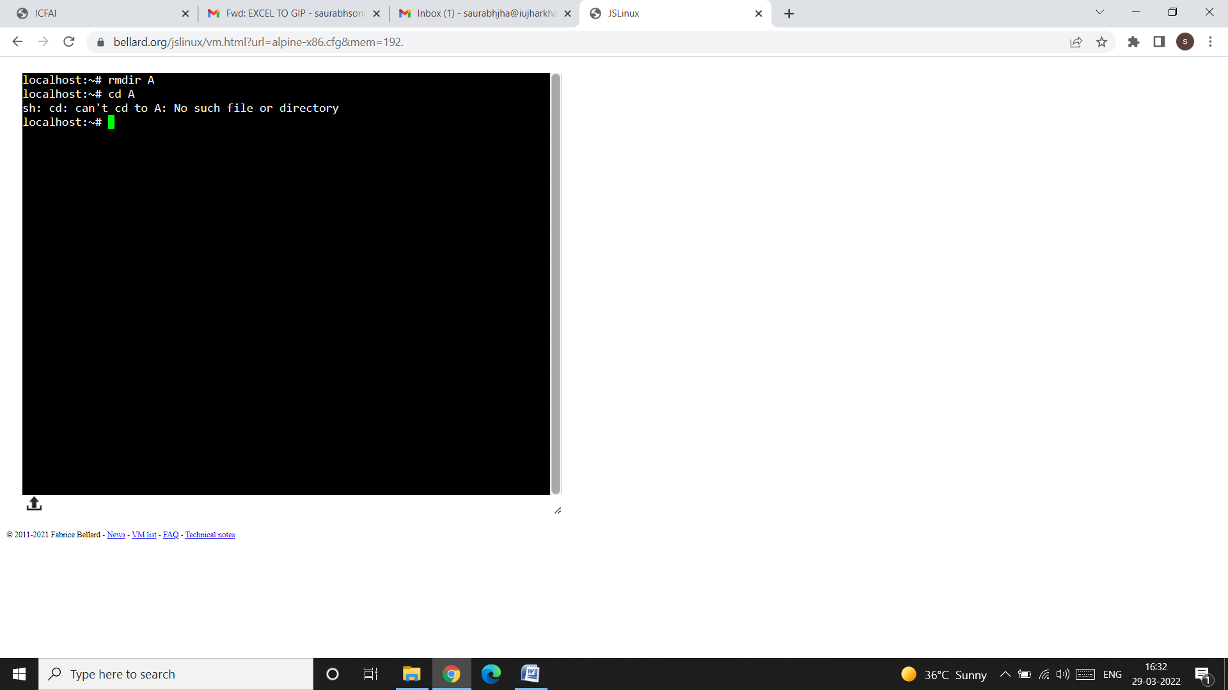

**ls: Listing Files:**

* The UNIX system has large number of files that control its functioning, and users also create files on their own.
* These files are organized in separate folder called directories.
* We can list the names of the files available in this directory with the ls command.

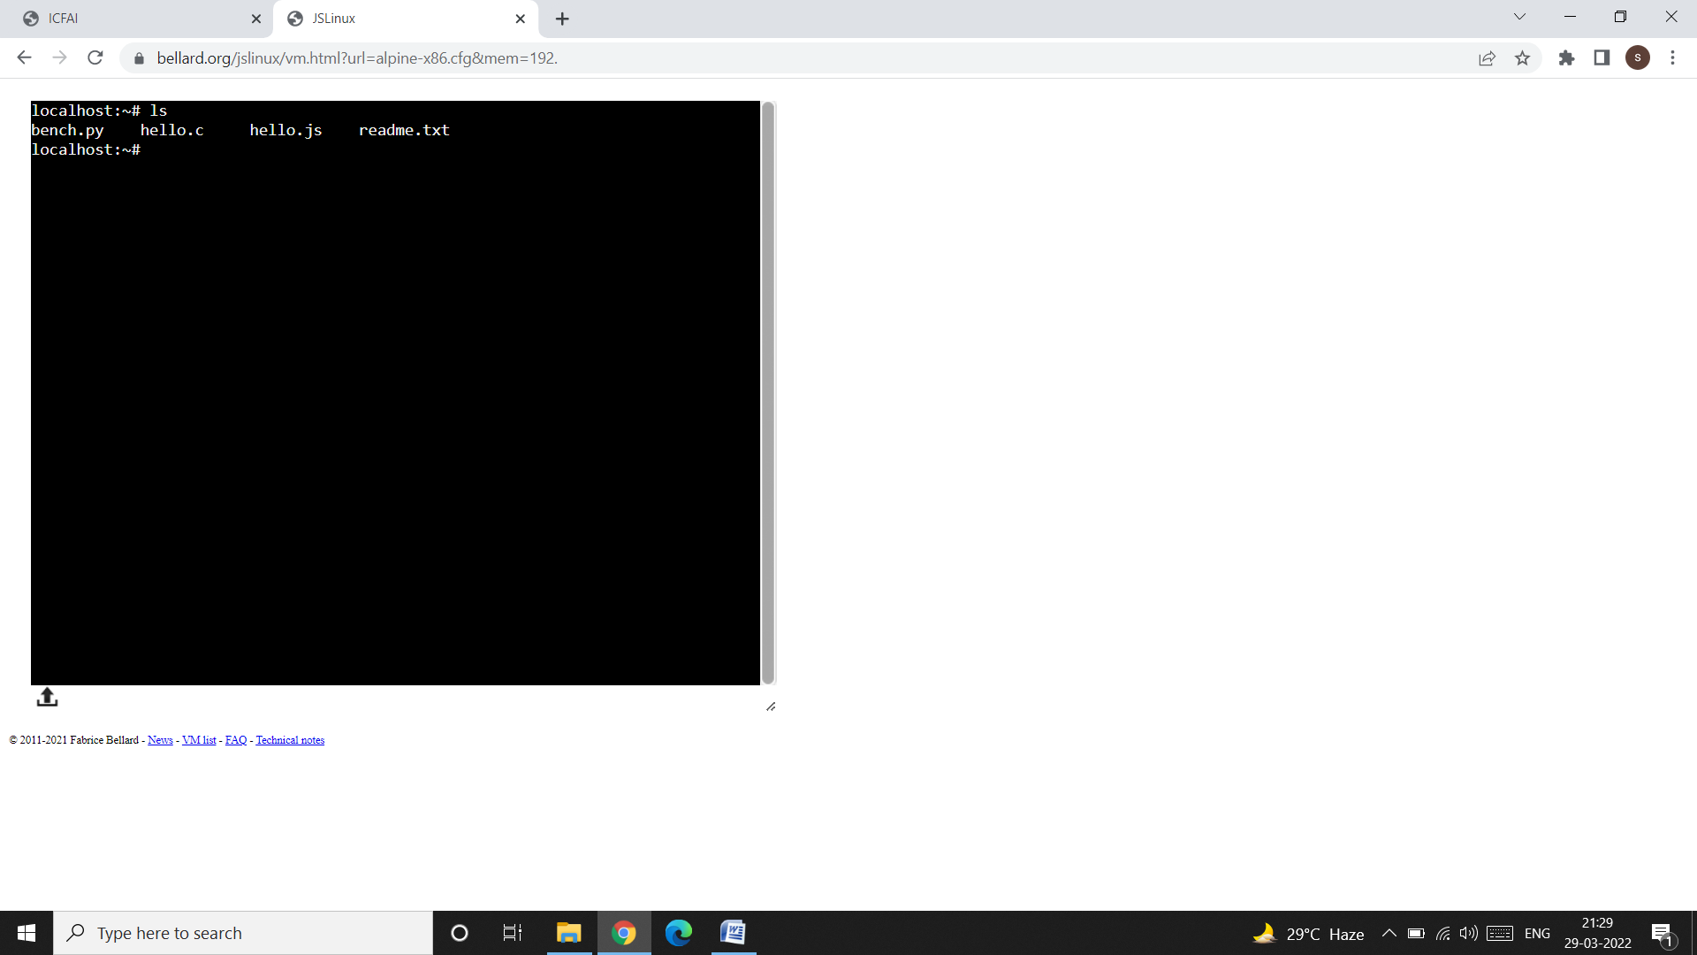

* Directories often contain many files, and we may simply be interested to know whether a particular file is available. In that case, just use ls with the filename like this:

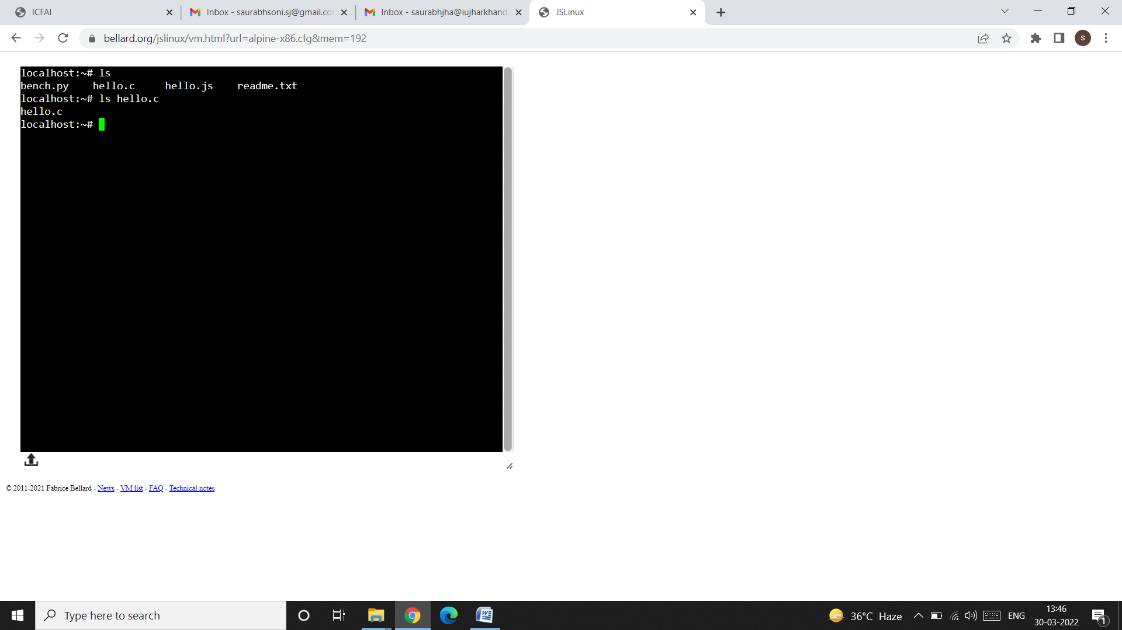

* To see the contents of any file use the cat command like this:

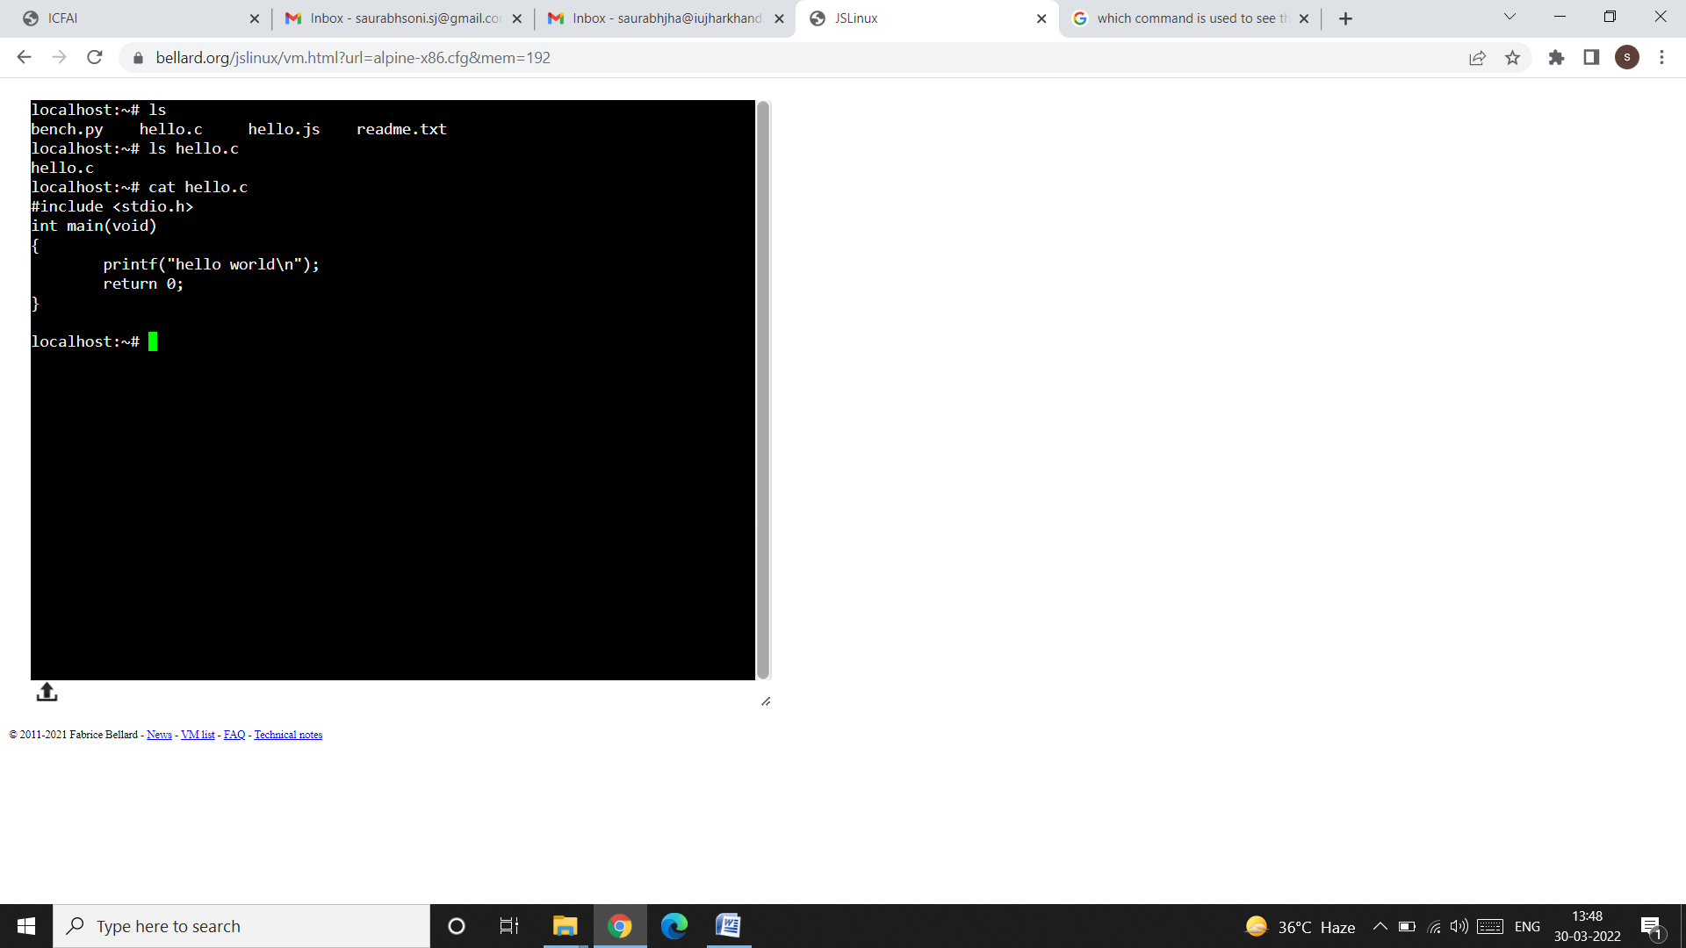

**ls options:**

**ls -x (Output in Multiple Columns):**

* When you have several files, it’s better to display the file names in multiple columns.
* Modern versions of ls do that by default, but if that doesn’t happen on your system, use the -x option to produce a multicolumn output:



**ls -F (Identifying Directories and Executables):**

* The output of ls that we have seen so far merely showed the filenames. We didn’t know how many of them, if any, are directory files. To identify directories and executable files, the -F option should be used like this:

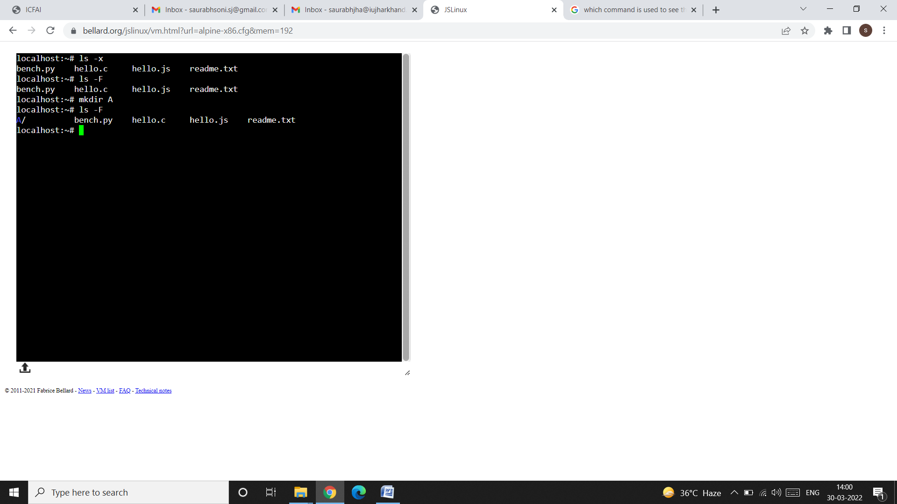

* In the above screenshot, we have first used the ls -x to fetch the names of the files column wise. After the execution of the ls -x command, we get the names of the 4 files which are available in the current directory (i.e. root directory). Out of these 4 files, we have to find out that which are the directories and which are the files. For this purpose, we used ls -F command. As bench.py, hello.c, hello.js, and readme.txt are all files (i.e. there is no directory located inside the root directory), therefore we didn’t get any directory symbol on the console. Now we have created a directory, named as A, in the current directory (i.e. in the root directory), using the mkdir command. After creating directory A, we again used the ls -F command. This time we get the directory A along with the 4 files. To identify a directory among the files, the system uses two things: colour, and / (slash) sign. Note that the directory A is represented using colour (here Blue) and with a / sign.

**ls -a (Showing Hidden Files Also):**

* ls doesn’t normally show all files in a directory. There are certain hidden files (filenames beginning with a dot), often found in the home directory that normally don’t show up in the listing. The -a option (all) lists all hidden files as well:

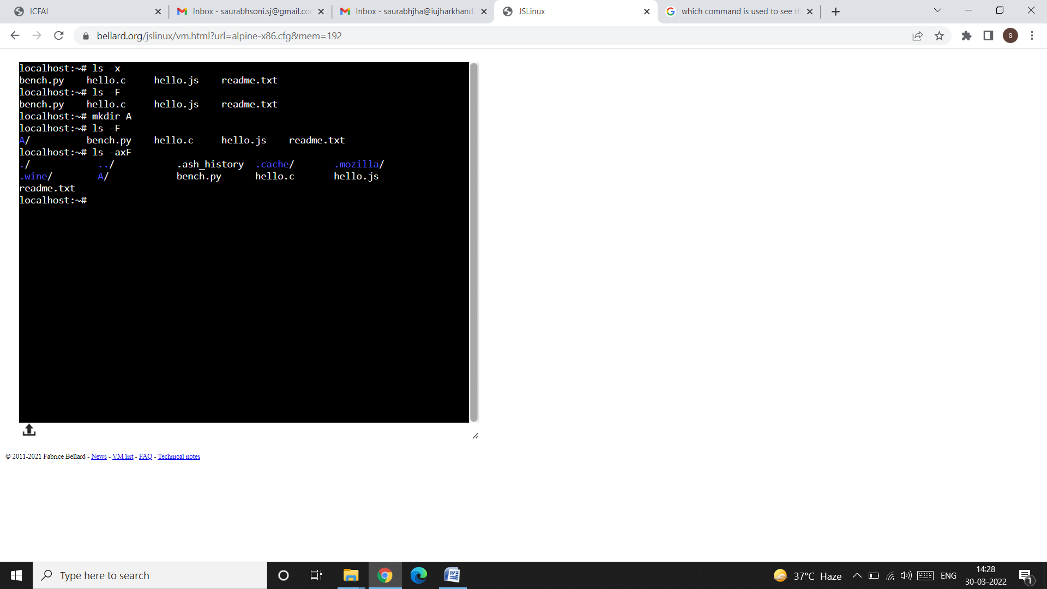

NOTE: All filenames beginning with a dot are displayed only when ls is used with the -a option. The directory (.) represents the current directory and (..) signifies the parent directory.

**ls -R (Recursive Listing):**

* The -R option lists all files and sub-directories in a directory tree.
* Similar to the DIR/S command in DOS, the ls -R command performs the traversal of the directory tree recursively until there are no subdirectories left.

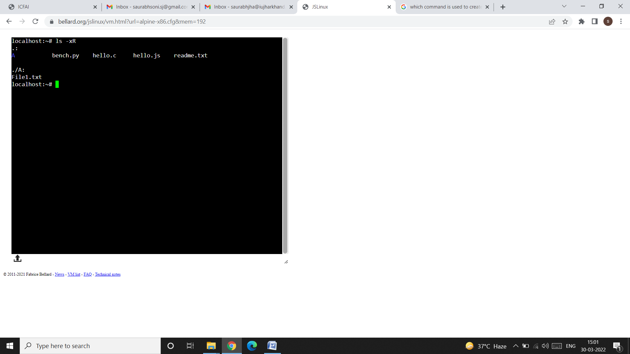

* In the above snapshot we have used the ls -R command. The output shows first the directory A, and the other 4 files that are present in the current directory (i.e. root) and second it shows a file named as “File1.txt” under the directory A (I had already created the file File1.txt inside the directory A. In the upcoming sections we will learn how to create a file in UNIX).