Unit 1: Basic Discrete Structures

By: Joon Shakya, CSIT 2nd Sem | V1.0.3 | 20th Nov 2022

Table of Contents

Sets 1

Set 1

Representation of Sets 1

Descriptive Method: 1

Tabulated Method: 1

Rule Method or Set Builder Method 1

Set Terminologies: 1

Cartesian Product of Two Sets: 2

Venn Diagram: 2

Set Operations: 2

Union 2

Intersection 2

Complement of a set 3

Difference 3

Symmetric Difference 3

Set Identities 4

Identity Laws: 4

Idempotent Laws: 4

Commutative Laws: 4

Associative Laws: 4

Distributive Laws: 4

The laws Governing Complements: 4

Complement: 4

Set Difference: 4

De-Morgan’s Laws: 4

Inclusion-Exclusion Principle 4

Computer Representation of Sets: 5

Functions 5

Basic Concept 5

Sum and Product of Functions 6

Injective Functions (One to One) 6

Surjective Functions (on to) 6

Bijective Functions (One-to-one Correspondence) 6

Inverse of a function: 6

Composition of functions 7

Graph of Functions 7

Functions for Computer Science: 7

Floor Function 7

Ceiling Function 8

Boolean Function 8

Exponential Function 8

Fuzzy Sets 8

Membership Functions 8

Fuzzy Set Operations: 9

Intersection (Fuzzy “AND”): 9

Union (Fuzzy “OR”): 9

Complement (Fuzzy “NOT”): 9

Sequences and Summations: 9

Basic Concept of Sequences 9

Geometric Progression 9

Arithmetic Progression 9

Single Summation: 10

Double Summation: 10

# Sets

## Set

A set is any well-defined un-ordered collection of distinct objects called as elements or members of the set. Some examples of set are:

* + - Set of all natural numbers
    - Set of all students of CSIT 2021 Batch

Sets are generally denoted by capital letters and the members of the set are denoted by small letters. The elements of the set must be enclosed within the curly brackets. If 1, 2, 3, are the elements of set A, then we write it as:

A = {1, 2, 3}

## Representation of Sets

A set maybe specified by the following methods:

### Descriptive Method:

In this method, a set is specified by a verbal description.

N = Set of all natural numbers.

### Tabulated Method:

In this method, a set is specified by listing all elements.

V = {a, e, i, o, u}

### Rule Method or Set Builder Method

In this method a set is specified by stating a characteristic property common to all elements in the set.

S = {x : x is an integer and 1 ≤ x ≤ 5}

## Set Terminologies:

* + - Finite Set: Containing finite number of items
    - Infinite Set: Containing infinite number of items
    - Empty Set (Φ or {}): Containing no items
    - Unit Set: Containing only one element
    - Universal Set (U): Contains all elements under consideration of situation
    - Subset: Consists of some or all elements of another set

A is the subset of B is denoted by A ⊂ B.

* + - Power Set: The number of subsets that can be formed.

Formula for power set: 2n

* + - Ordered Pair: A set of two elements ‘a’ and ‘b' written as (a, b) is called a pair.

## Cartesian Product of Two Sets:

The Cartesian product of two non-empty sets A and B is defined as the set of all possible ordered pairs (a, b) such that a ∈ A and b ∈ B.

Mathematically, we can write,

A × B = {(a, b) : a ∈ A, b ∈ B}

Let A = {1, 2} and b = {3, 4, 5}. Then:

A × B = {(1, 3), (1, 4), (1, 5), (2,3), (2, 4), (2, 5)}

B × A = {(3, 1), (3, 2), (4, 1), (4, 2), (5, 1), (5, 2)}

## Venn Diagram:

Subsets and operation on sets can be represented by diagrams. Such diagrams are called Venn diagrams. We usually represent the universal set by a rectangle and its subset by a circle. The elements of U are represented by the points within the rectangle while the elements of the subset of U is represented by the points within the circle. For illustration let us consider the set of vowels as V which is the subset of the universal set U, the English alphabets.

Then, V = (a, e, i, o, u) is represented in Venn diagram

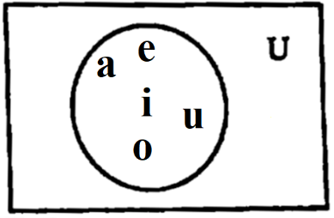

## Set Operations:

### Union

The union of two sets A and B, denoted by A ∪ B is the set of only those elements which belong to either A or B or both A and B. Symbolically, we write this as:

A ∪ B = {x : x ∈ A or x ∈ B or x ∈ both A and B}

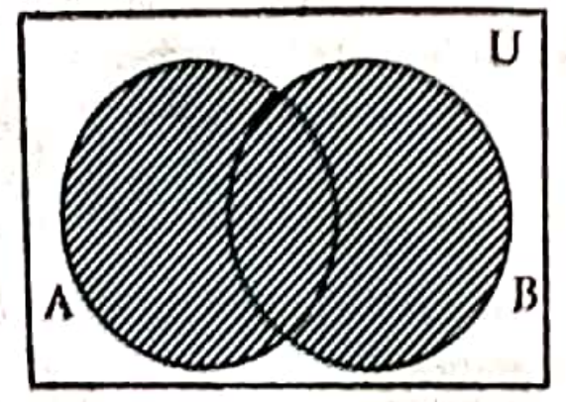

### Intersection

The intersection of two sets A and B, denoted by A ∩ B is the set of only those elements which belong to both A and B. Symbolically, we write this as:

A ∩ B = {x : x ∈ A and x ∈ B}

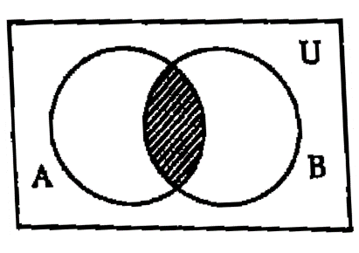

### Complement of a set

Let A be the subset of a universal set U. Then the complement of A with respect to U is the set of all those elements of U which do not belong to A and is denoted by or A' or Ac. In symbols, we write this as:

A’ = {x : x ∈ U and x ∉ A}

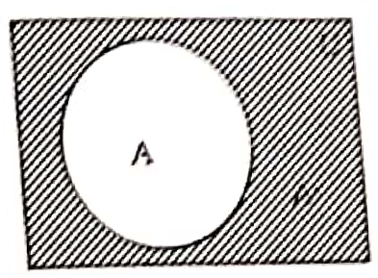

### Difference

Let A and B be two sets and each set are the subset of a universal set U. Then, A difference B denoted by A – B is the set of all those elements which belong to A but not B. In symbols, we write this as:

A – B = {x : x ∈ A and x ∉ B)

### Symmetric Difference

The symmetric difference of two sets A and B denoted as A △ B also known as the disjunctive union, is the set of elements which are in either of the sets, but not in their intersection. In symbols, we write this as:

A △ B = {x : x ∉ A ∩ B)

It is calculated as follows:

A △ B = (A – B) ∪ (B – A)

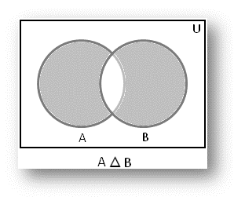

## Set Identities

### Identity Laws:

A ∪ Φ = A, A ∪ U = U

A ∩ Φ = Φ, A ∩ U = A

### Idempotent Laws:

A ∪ A = A, A ∩ A = A

### Commutative Laws:

A ∪ B = B ∪ A

A ∩ B = B ∩ A

### Associative Laws:

A ∪ (B ∪ C) = (A ∪ B) ∪ C

A ∩ (B ∩ C) = (A ∩ B) ∩ C

### Distributive Laws:

A ∪ (B ∩ C) = (A ∪ B) ∩ (A ∪ C)

A ∩ (B ∪ C) = (A ∩ B) ∪ (A ∩ C)

## The laws Governing Complements:

### Complement:

(A’)’ = A A ∪ A’ = U

A ∩ A’ = Φ Φ’ = U U’ = Φ

### Set Difference:

A – B = A ∩ B’ U – A = A’

A – U = Φ A – Φ = A

Φ – A = Φ A – A = Φ

### De-Morgan’s Laws:

(A ∪ B)’ = A’ ∩ B’

(A ∩ B)’ = A’ ∪ B’

## Inclusion-Exclusion Principle

Let A and B be any two disjoint sets then we extensively use inclusion exclusion principle. Given set A and set B the union of A and B is given by the formula

| A ∪ B | = | A | + | B | - | A ∩ B |

This is to find the number n(A ∪ B) of elements in the union A ∪ B, we add n(A) and n(B) and then subtract n(A ∩ B) i.e. include n(A) and n(B) and exclude n(A ∩ B).

Similarly, for any finite sets A, B and C we have,

n(A ∪ B ∪ C) = n(A) + n(B) + n(C) - n(A ∩ B) - n(B ∩ C) - n(A ∩ C) + n(A ∩ B ∩ C).

## Computer Representation of Sets:

One method to represent sets in computer is to store the elements of set in an unordered list. If this method is used, the operations of computing the union, intersection of sets would be time consuming because each of these operations would require large time in searching for elements. So, we use method for storing elements using arbitrary ordering of the elements.

Specify an arbitrary ordering of elements of U, for example a2, a2, ......, an represent a subset A of U with bit sting of length n, where ith bit in this string is 1 if ai ∈ A and 0 if ai ∉ A.

Example:

Let U= {1, 2, 3, 4, 5, 6, 7, 8, 9, 10}

The bit string that represents the set of odd integers in U, {1, 3, 5, 7, 9}, has a one bit in the first, third, fifth, seventh, and ninth positions. It is 1010101010.

The bit string that represents the subset of even integers in U, {2, 4, 6, 8, 10}, It is 0101010101.

The set of all integers in U that do not exceed 5, {1, 2, 3, 4, 5}, is 1111100000.

To find the bit string for the complement of a set from the bit string, change interchange 1s and 0s.

# Functions

## Basic Concept

Let A and B be two non-empty sets. A function f from A to B is a set of ordered pairs with the property that for each element x in A there is a unique element y in B. The set A is called the domain of the function and the set B is called co-domain. If (x, y) ∈ f, it is customary to write y = f(x), y is called the image of x and x is a pre-image of y. the set consisting of all the images of the elements of A under the function f is called the range of f. It is denoted by f(A).

The concept of function is extremely used in mathematics and computer science. For instance, functions are used to represent how long it takes to solve a problem of a given size. Many computers program and subroutines are designed to calculate the values of functions.

Example:

Let A = {1, 2, 3, 4, 5), B = {0, 1, 2, 3, 5, 7, 9, 12, 13) and f = {(1, 1), (2, 0), (3, 7), (4, 9), (5, 12)}, then f is a function from A to B because each element of A has an unique image in B which can be expressed by a diagram as,

## Sum and Product of Functions

### Injective Functions (One to One)

A function from A to B is one-to-one if for all x1, x2 ∈ A such that f(x1) = f(x2) implies x1 = x2. We can express that f is one to one using quantifiers as ∀ x1 ∀ x2 (f(x1) = f(x2) => x1 = x2) where universe of discourse is the domain of the function.

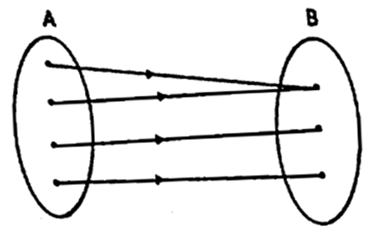

### Surjective Functions (on to)

A function f from A to B is an onto function if every element of B is the image of some element in A. We can express that f is surjective using quantifiers as: ∀ y ∃ x (f(x) = y)

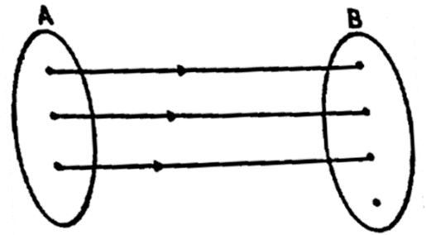

### Bijective Functions (One-to-one Correspondence)

A function f from A to B is said to be bijective if it is injective and surjective.

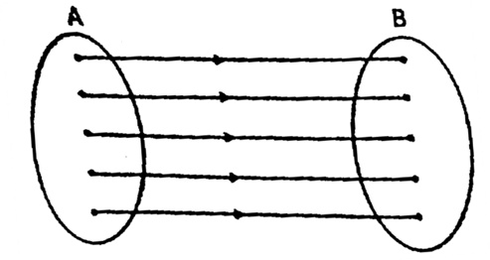

## Inverse of a function:

Let f : A → B be a function which is bijective, then the inverse function of f is the function that assigns to an element b belonging to set B, the unique element a in A such that f(a) = b. the inverse function of f is denoted by f-1. Hence f-1(b) = a when f(a) = b.

A function f : A → B is invertible if its inverse relation f-1 is a function from B to A. In general, the inverse relation f-1 may not be a function.

In the case of two functions, we define inverse function as, Let f : A → B and g : B → A be two functions then g is said to be inverse of f if gof = IA and fog = IB.

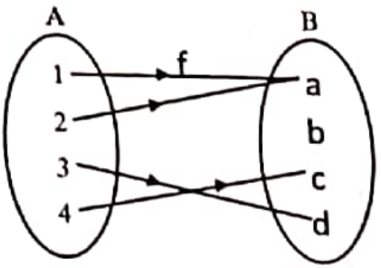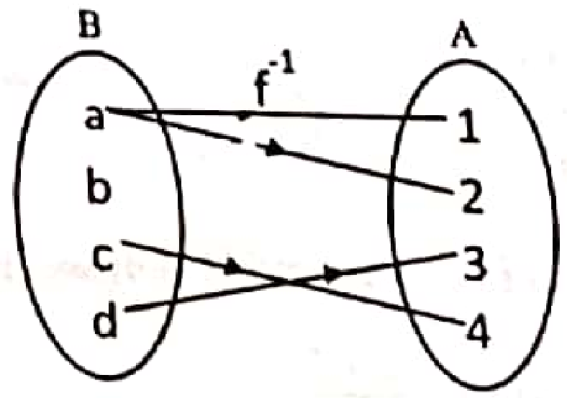

## Composition of functions

Let f : A → B and g : B → C be two functions. The composition of f and g, denoted by gof, is a new function from A to C defined by (gof)(x) = g(f(x)), for all x ∈ A.

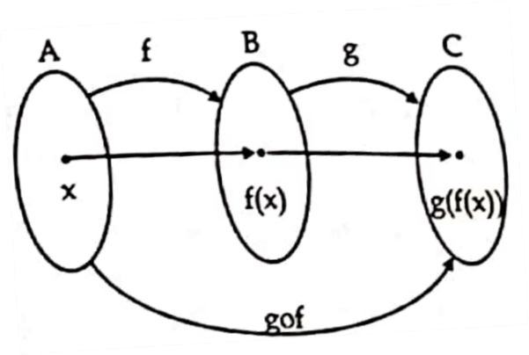

## Graph of Functions

We can associate a set of pairs in A × B to each of functions from A to B. This set of pairs is called graph of functions.

Let f be a function from set A to set B then graph of function f is set of ordered pairs {(a, b) : a ∈ A and f(a) = B}.

Example:

To find the graph of the function f(x) = x2 from the set of integers to set of integers.

The graph of f is the set of ordered pairs of the form (x, f(x)) = (x, x2) where x is an integer. This graph is displayed in figure below:

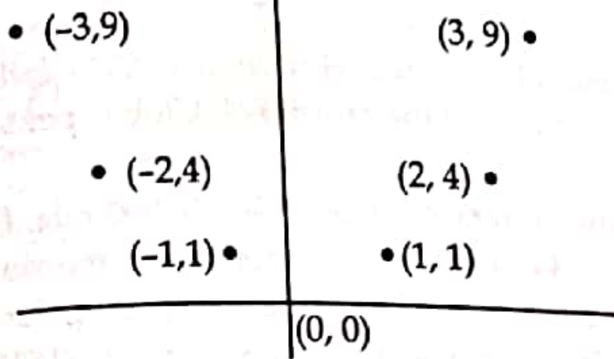

## Functions for Computer Science:

### Floor Function

Let x be a real number then ⌊ x ⌋ called the floor function of x, assigns the real number x to the largest integer that is less than or equal to x. The floor function is often also called the greatest integer function.

⌊ 65.34 ⌋ = 65

### Ceiling Function

If x is a real number, then ⌈ x ⌉ called the ceiling function of x, assigns the real number x to the smallest integer that is greater than or equal to x.

⌈ 65.34 ⌉ = 66

### Boolean Function

It is a function whose arguments as well as the function itself assumed values from a two-element set usually {0, 1}.

A Boolean function is denoted by an algebraic expression called Boolean expression which consists of binary variables (0 and 1), and the logic operation symbols.

F(A, B, C, D) = A + B + D

### Exponential Function

If b is any number such that b > 0 and b ≠ 1 then an exponential function is a function in the form

f(x) = bx

where b is called base and X can be any real number.

Example: f(x) = 2x, f(x) =

## Fuzzy Sets

If X is a universe of discourse and x is a particular element of X then a fuzzy set defined on X can be written as a collection of ordered pairs:

= {(x, (x) ), x ∈ X}

where (x) = Degree of membership of x in

Example: Let X = {a, b, c, e, e} be the reference set of students.

Let be the fuzzy set of “smart” students where smart is fuzzy term.

= {(a, 0.4), (b, 0.51), (c, 1), (d, 0.9), (e, 0.8)}

Here, indicates smartness (that smartness of b is 0.5)

## Membership Functions

Membership functions characterize fuzziness (i.e.: all the information in fuzzy set) whether the elements in fuzzy set are discrete or continuous. Membership functions are operated by graphical forms. The value of membership function of x when 0 means that x is not a member of the fuzzy set; value 1 means that x is fully a member of the fuzzy set.

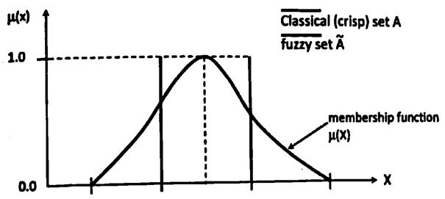

## Fuzzy Set Operations:

### Intersection (Fuzzy “AND”):

The membership function of the Intersection of two fuzzy sets A and B with functions μA and μB is respectively defined as the minimum of the two individual membership functions. This is called the minimum criterion.

μA ∩ B = min(μA, μB)

### Union (Fuzzy “OR”):

The membership function of the union of two fuzzy A and B with membership function μA and μB is respectively defined as the maximum of the two individual membership functions. This is called the maximum criterion.

μA ∪ B = max(μA, μB)

### Complement (Fuzzy “NOT”):

The membership function of the complement of a fuzzy A with membership function μA is defined as the negation of the specified membership functions. This is called negation criterion.

μA’ = 1 - μA

# Sequences and Summations:

## Basic Concept of Sequences

A sequence is a function from a subset of the set of integers (usually either the set {0, 1, 2, …} or the set {1, 2, 3, …}) to a set S. We use the notation an to denote the image of the integer n. We call an a term of the sequence. We use notation {an} to represent a sequence a1, a2, a3, …, an. Here, ai represents the individual terms of sequence {an}.

Example: Consider the sequence {an} where:

an =

The list of the terms of the sequence beginning with a1 namely a1, a2, a3, … starts with 1, , , …

## Geometric Progression

A geometric progression is the sequence of the form:

a, ar, ar2, ar3, …, arn

where the initial term ‘a’ and the common ratio ‘r’ are real numbers.

A geometric progression is a discrete analogue of the sequential function f(x) = arn.

Example: The sequence {bn} with bn = 2.5n = 2, 10, 50, 250, 1250, …

## Arithmetic Progression

An arithmetic progression is a sequence of the form:

a, a + d, a + 2d, …, a + nd

where the initial term ‘a’ and the common difference ‘d’ are real numbers.

An arithmetic progression is a discrete analogue of the sequential function f(x) = a + xd.

Example: The sequence {bn} with bn = -1 + 4n = -1, 3, 7, 11, 15, …

## Single Summation:

Submission is the operation of adding a sequence of numbers. If numbers are added sequentially from left to right, any intermediate result is a partial sum. The numbers to be summed called (addends or sometimes summands) maybe integers rational numbers or real numbers.

∑ notation is used to denote the sum of the terms am, am+1, …, an from the sequence.

From the sequence {an} we use the notation:

to represent am + am + 1 + am + 2 + … + an.

## Double Summation:

Double summations can be in many contexts (as in the analysis of nested loops in computer programming). An example of double summation is: